**Guide for colocalization_calculator.py algorithm**

Author: Austin Chiappetta, achiapp2@jh.edu

Description: this algorithm determines which spots from two separate channels are colocalized based on the maximum colocalization distance given. It requires the x and y pixel to nm conversion factors (e.g., images taken with the 63x objective lens have x and y pixel to nm conversion factors of 102.4 nm/pixel in both directions) and the zstep in nanometers, as well as the processed_data.txt files generated by using spot_calling_batch_processing.py. The algorithm generates a tab-separated values file with the data describing each pair of colocalized spots (x coordinates, y coordinates, z coordinates, intensities, number of molecules quantified in each spot, and the distances between the pairs of spots) which can be used for further downstream analysis. The algorithm also generates pie charts and histograms comparing colocalized and non-colocalized spots in each channel.

Function call usage: in the command line, type: python colocalization_calculator.py /PATH/TO/FOLDER/CONTAINING/DATA/SUBFOLDERS/ xpixel_to_nm_conversion ypixel_to_nm_conversion zstep max_distance_threshold

Note: the folder path can be either the absolute path or the relative path, and the path must contain forward slashes (“/”) instead of back slashes.

**VERY important!** Note that none of the folders in the path can contain spaces! Please use underscore (“_”) instead of spaces.

Step-by-step tutorial:

1. Organize the processed_data.txt files generated by the spot_calling_batch_processing.py algorithm into **two** separate subfolders with descriptive titles as shown below. The subfolder names are used in generating the output figures so make sure it is descriptive.  
   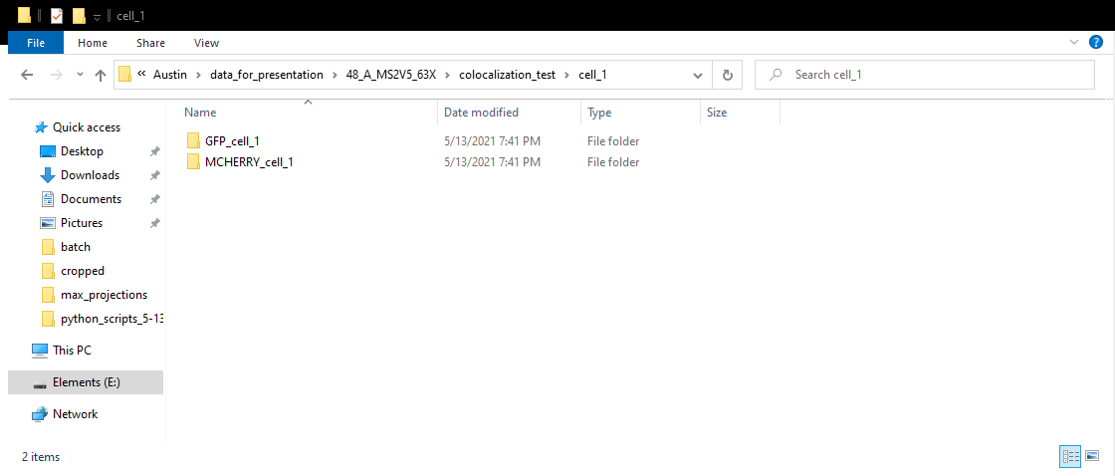  
   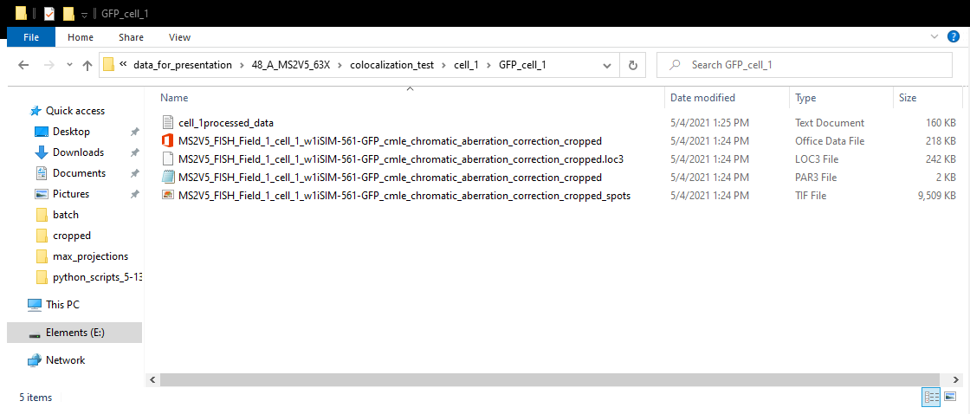
2. In the command line, navigate to the directory which contains the python script (If using Windows Git Bash, you can right click in the folder and select “Git Bash Here”).
3. 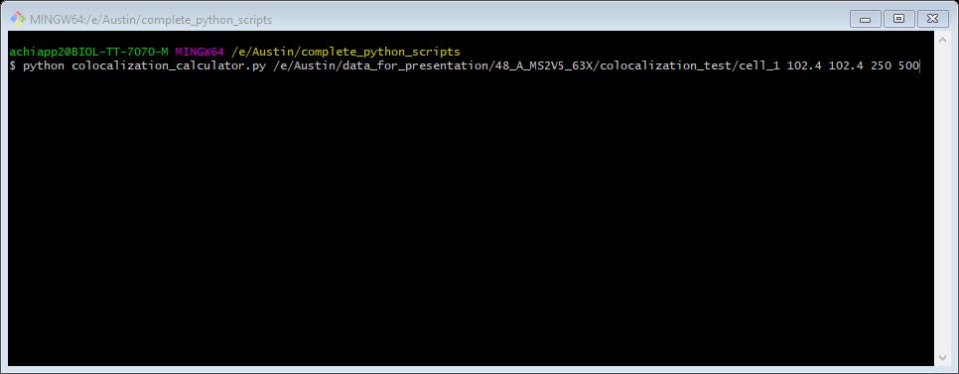Type “python spot_calling_threshold_analysis.py PATH/TO/FOLDER/CONTAINING/THRESHOLD/SUBFOLDERS/ xpixel_to_nm_conversion, ypixel_to_nm_conversion, zstep, max_distance_threshold” (all one line, without the quotation marks and commas) into the terminal.
4. Press Enter.
5. After about 30 seconds, an image of the colocalization plot (Summary of <channel_1> and <channel_2> colocalization) will be generated and pop-up automatically.  
   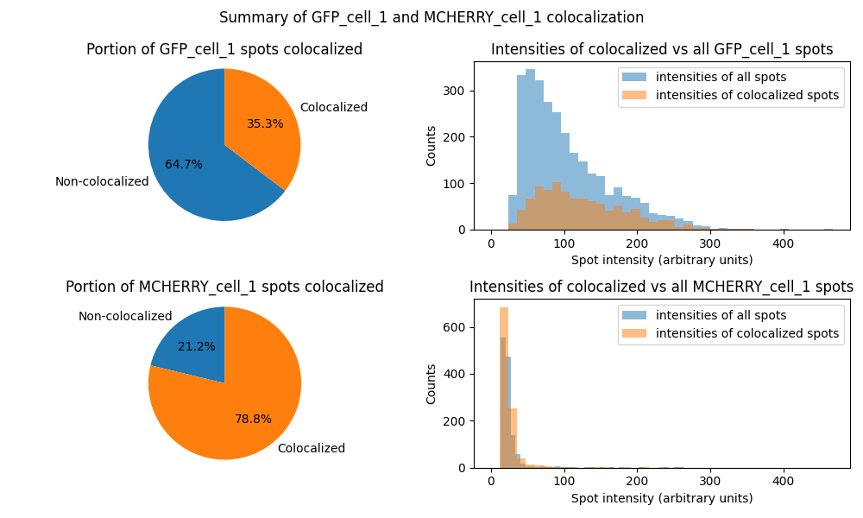
6. Upon refreshing the folder after closing the plot window, you will find that the plot has been saved to that subfolder, as well as a colocalized.tsv file and a colocalized_summary.txt file.  
   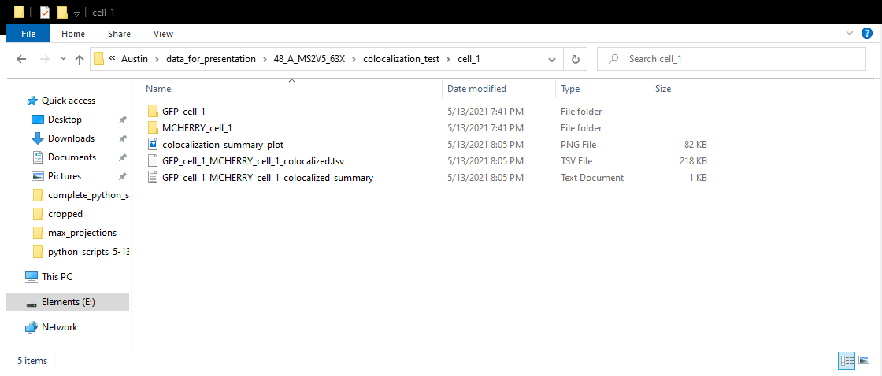

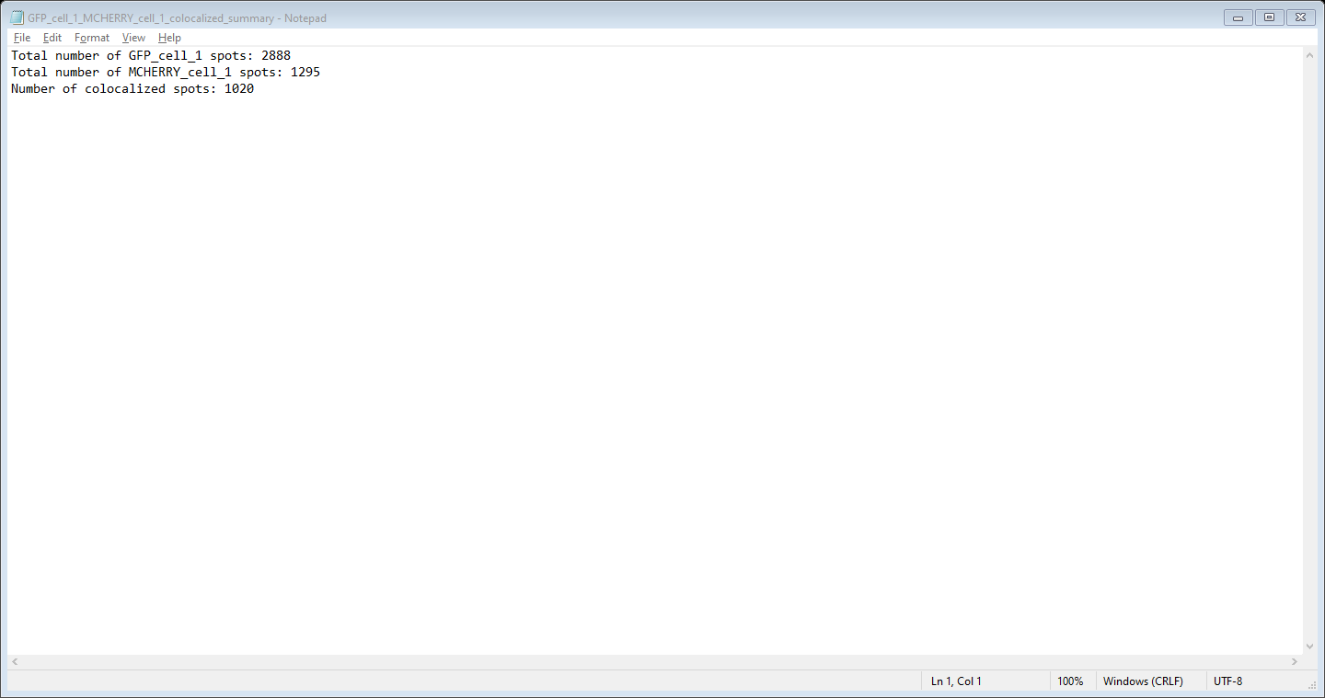

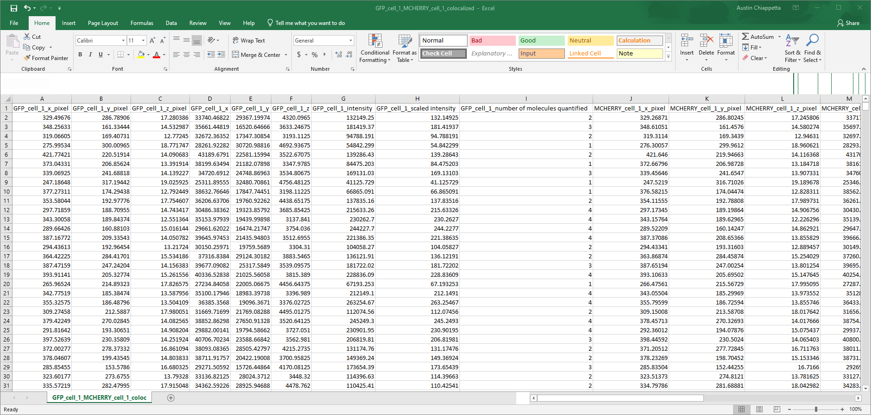  
  
  
  
  
  
  
  
  
  
  
  
  
  
  
  
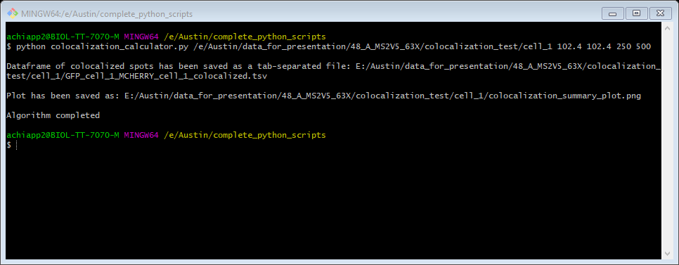

1. The end.