**Guide for spot_calling_threshold_analysis.py algorithm**

Author: Austin Chiappetta, achiapp2@jh.edu

Description: this algorithm is intended for use after using the Airlocalize program with a range of thresholds for a single image in order to determine the sweet spot threshold where noise is filtered out while retaining true signal. The algorithm analyzes the .loc files produced by Airlocalize and plots the number of spots and molecules quantified per as a function of the thresholds used.

Function call usage: in the command line, type: python spot_calling_thresholdhold_analysis.py PATH/TO/FOLDER/CONTAINING/THRESHOLD/SUBFOLDERS/

Note: the folder path can be either the absolute path or the relative path, and the path must contain forward slashes (“/”) instead of back slashes.

**VERY important!** Note that none of the folders in the path can contain spaces! Please use underscore (“_”) instead of spaces.

Step-by-step tutorial:

1. Organize the output files of Airlocalize into subfolders which are named by the threshold used as shown in the pictures below (technically only the .loc3 files are needed):  
   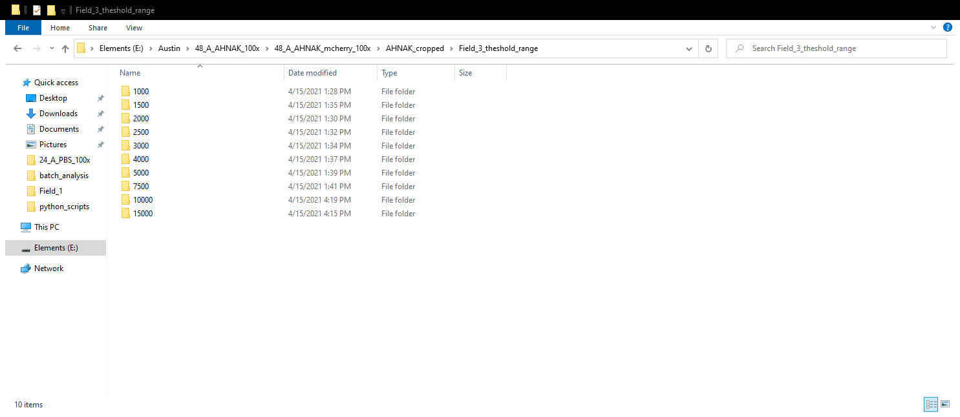  
     
   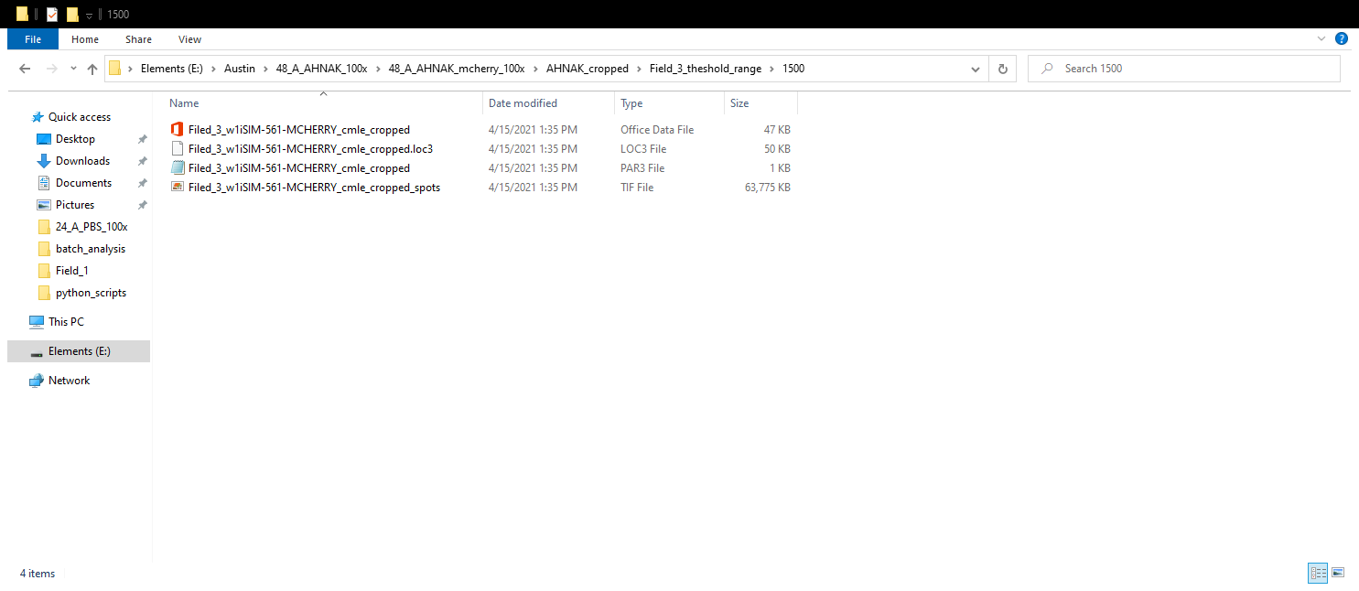
2. In the command line, navigate to the directory which contains the python script (If using Windows Git Bash, you can right click in the folder and select “Git Bash Here”).
3. Type “python spot_calling_threshold_analysis.py PATH/TO/FOLDER/CONTAINING/THRESHOLD/SUBFOLDERS/” (all one line, without the quotation marks) into the terminal.  
   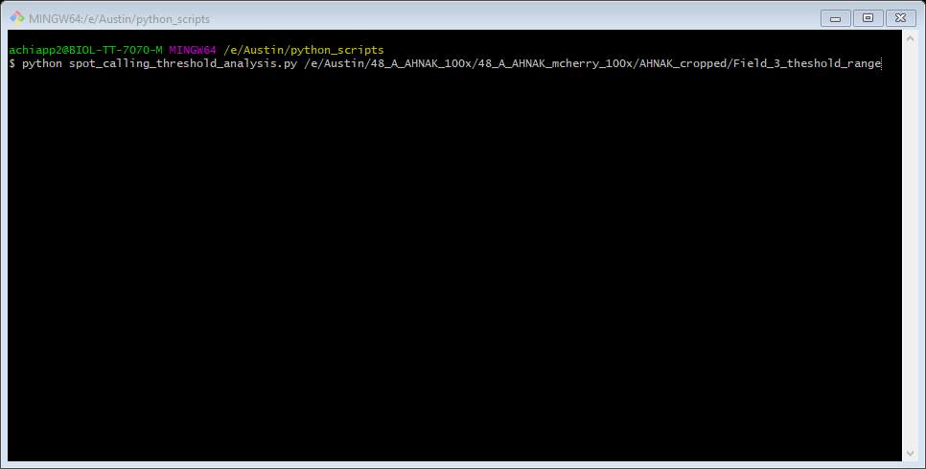
4. Press Enter.
5. After about 3 seconds, an image of the first plot (Spot Detection as a Function of Threshold) will be displayed. After closing the plot window, the next plot (Molecule Quantification as a Function of Threshold) will automatically be displayed.  
   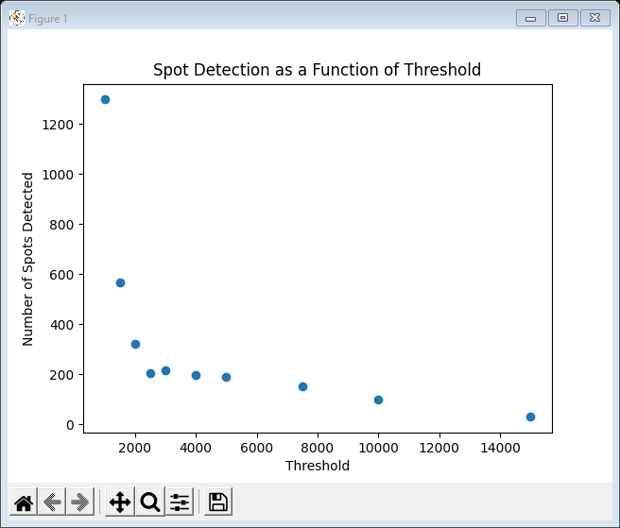  
   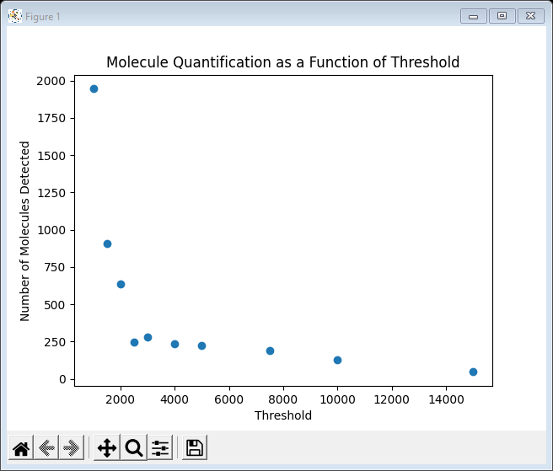
6. Upon refreshing the folder after closing the plot windows, you will find that both plots have been saved.  
   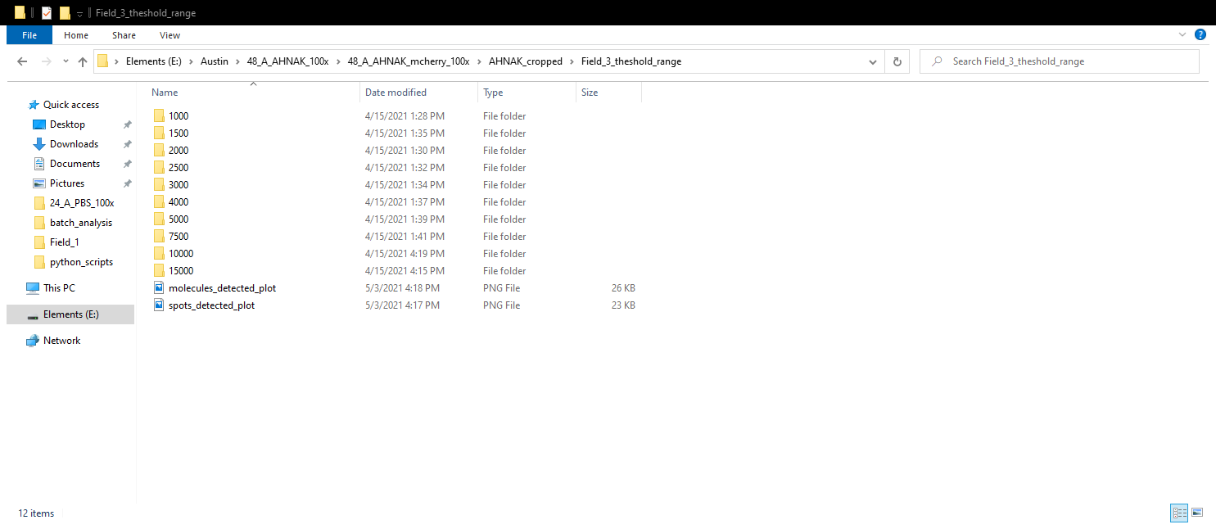
7. The end.