Austin Decker  
CS445 - Computer Security  
8 September 2024

## Part 1:

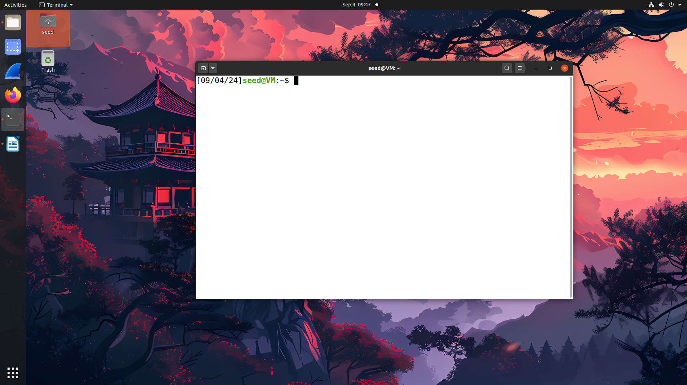

## Part 2:

**Code**

//Pre processor directives  
#include <stdlib.h>  
#include <stdio.h>  
  
  
//display sys env variables  
void display_env(){  
 const char * command = "printenv";  
 printf("===\tSystem Environment Variables\t===\n”);  
   
 //Too lazy to use getenv, this gets all environment variables.  
 system(command);  
   
}  
  
int main(){  
 display_env();  
 return 0;  
}

**Output** 