CS445 Lab Report: Secret-Key Encryption
Austin Decker
13 December 2024

Tasks:

Task 1: Frequency Analysis
Code used:
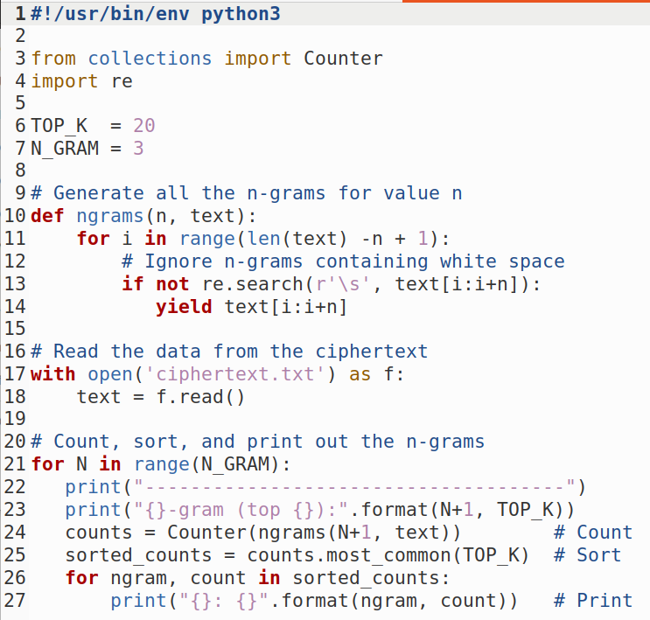
Getting Metrics from the ciphertext:

Single Letter Count
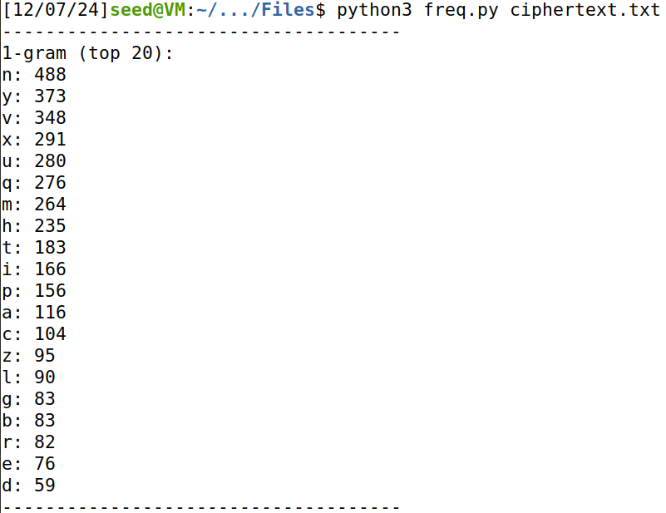

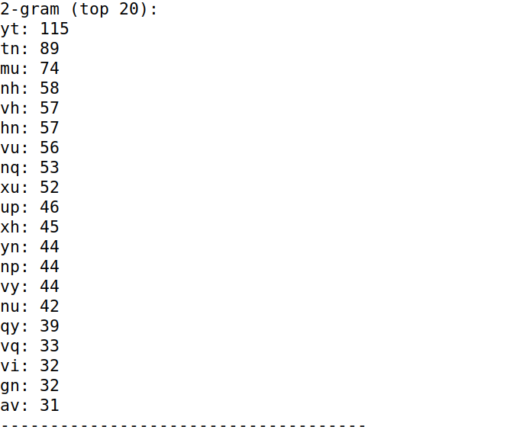
Bi letter count

Tri letter count

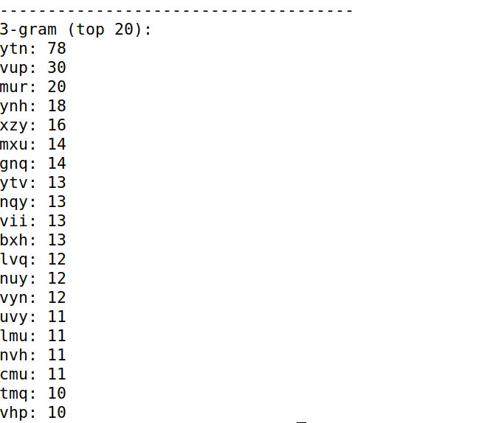
Frequency Analysis:
This is a small segment of the full text:

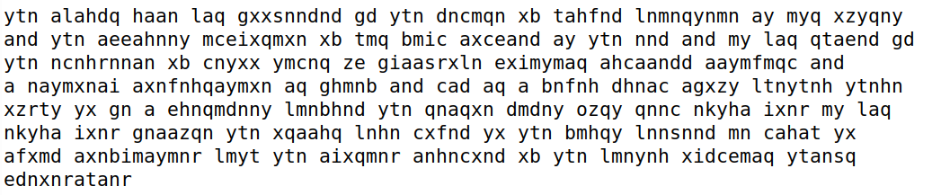
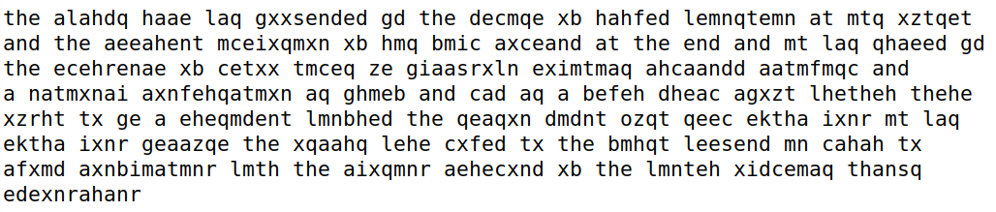
Final Results:
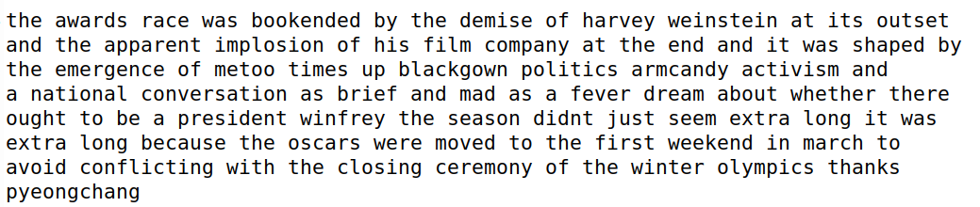

Task 2: Encryption using different Ciphers and Modes
Unencrypted Text:
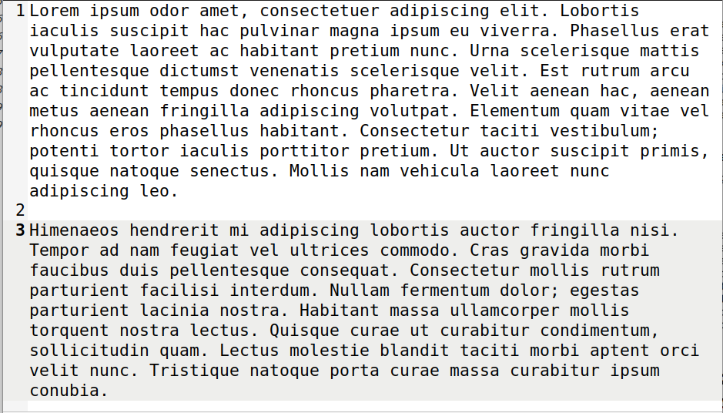
AES 128 CBC:
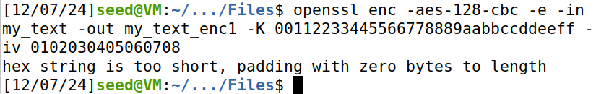
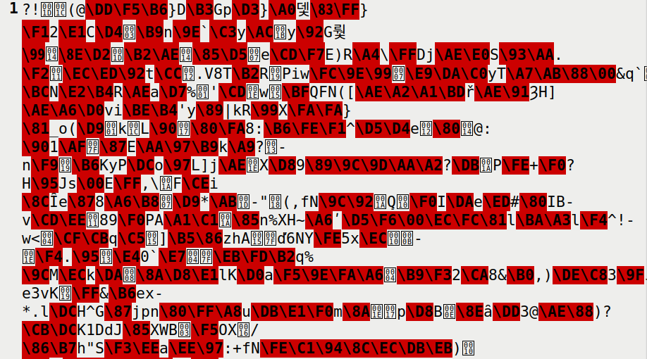
Decrypting to Verify:
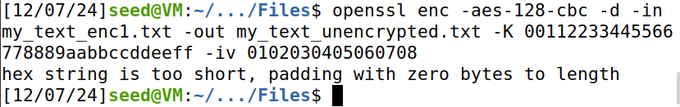

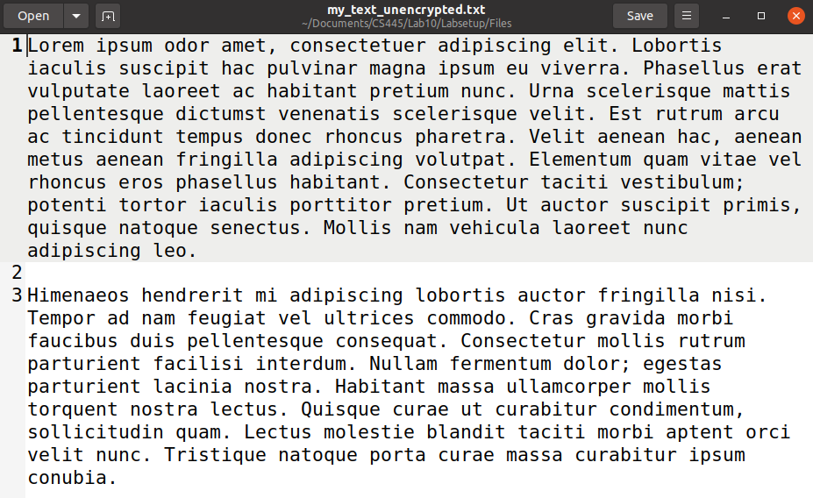
AES-128-CFB
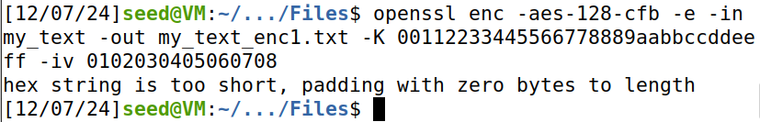

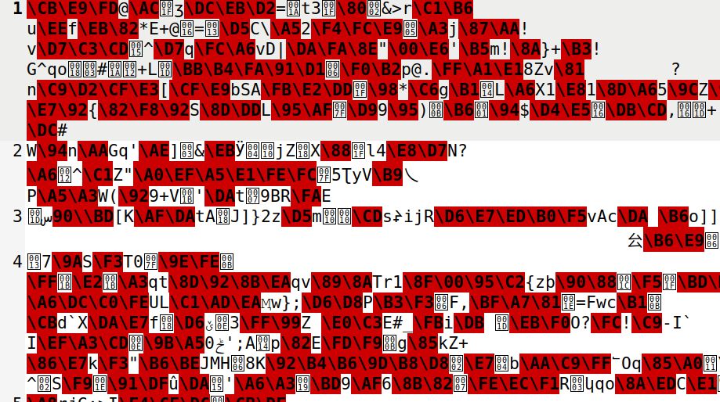
Decryption To Verify
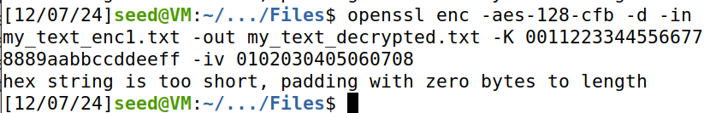

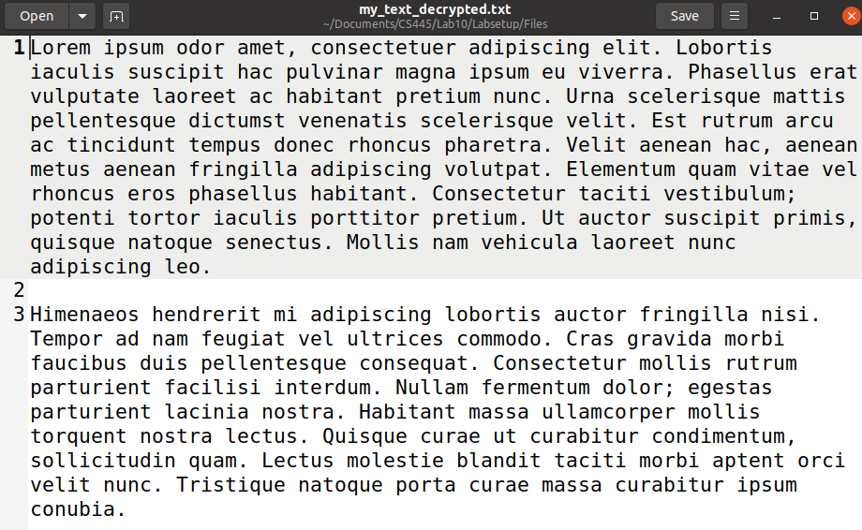

BF-CBC Encryption
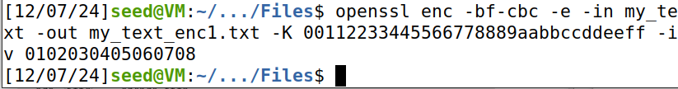
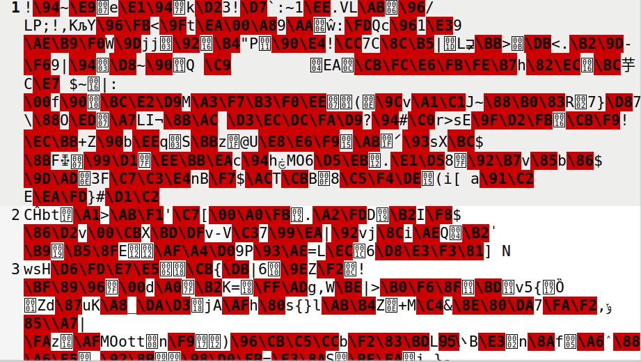
Decrypting to verify:

Task 6: Initial Vector and Common Mistakes

