CS445 Lab Report: Shellshock Attack
Austin Decker
November 12 2024

Environment Setup:

DNS Setting:
Adding mapping [10.9.0.80 www.seedlab-shellshock.com] to //etc/hosts.
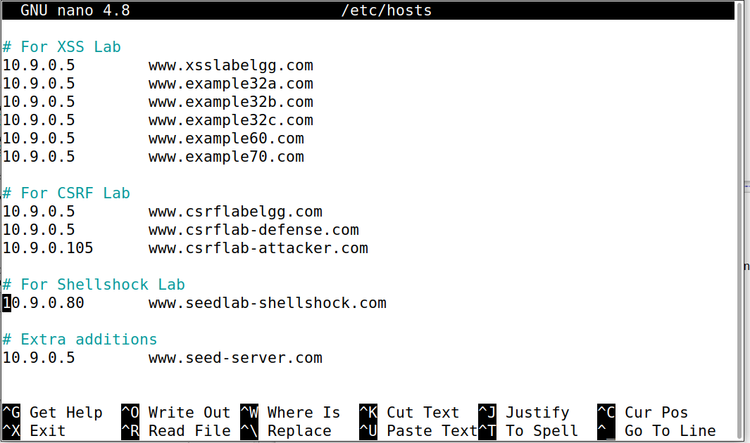

Container Setup:
Building container (output too long):
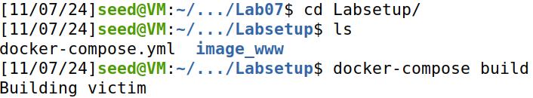
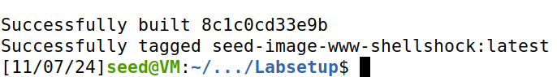
Running Container (output too long):

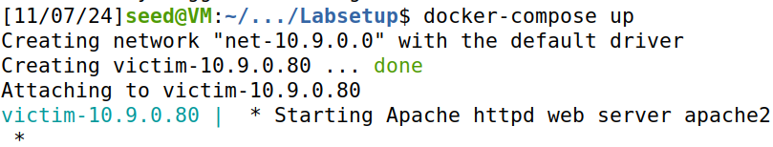

Task 1: Experimenting with Bash Functions
Exporting a shell variable and running bash_shellshock:
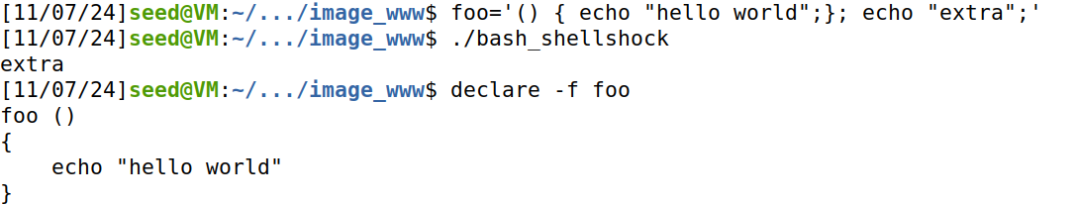
Observations:
I defined a shell variable called foo and exported it before running the vulnerable bash version. As the output shows, the vulnerability worked as it ran the extra command and exported the shell variable as a function.
Exporting a shell variable and running the updated bash:
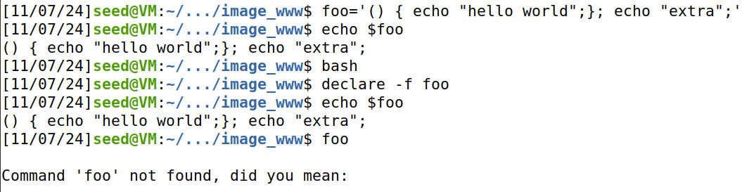
Observations:
I defined a shell variable called foo just as I did in the first experiment. This time I ran the patched version of bash with the exploit patched. As you can see from the screenshot, it did not run the extra command and it was also not turned into a bash function.

Task 2: Passing Data to Bash Via Environ Variable
Running getenv.cgi in browser:
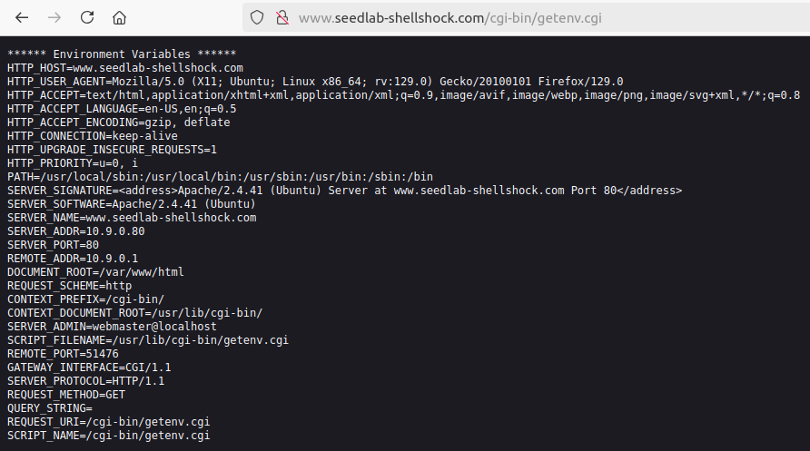

Task 2-A: Using Browser
