Austin Decker

CS445 - Computer Security

8 September 2024

Lab 01

Part 1:
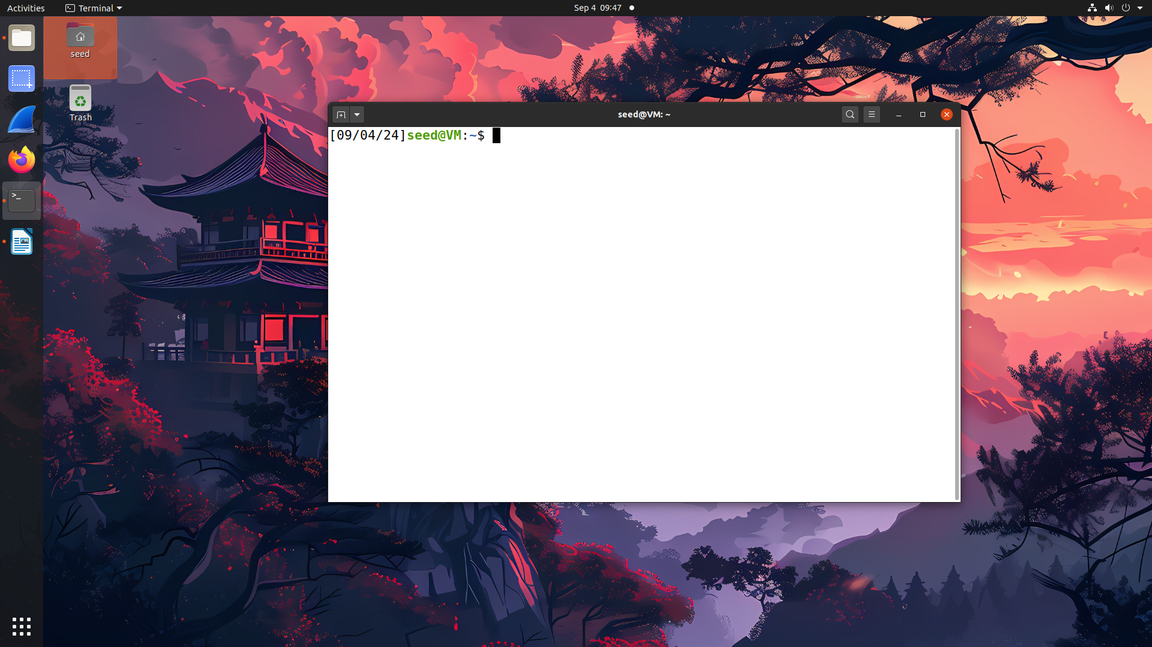
Part 2:

Code:
//Pre processor directives
#include <stdlib.h>
#include <stdio.h>

//display sys env variables
void display_env(){
const char * command = "printenv";
printf("===\tSystem Environment Variables\t===\n”);

//Too lazy to use getenv, this gets all environment variables.
system(command);

}

int main(){
display_env();
return 0;
}

Screenshots:
