CS445 Lab Report: Packet Sniffing and Spoofing
Austin Decker
22 November 2024

Environment Setup:

Container Setup:
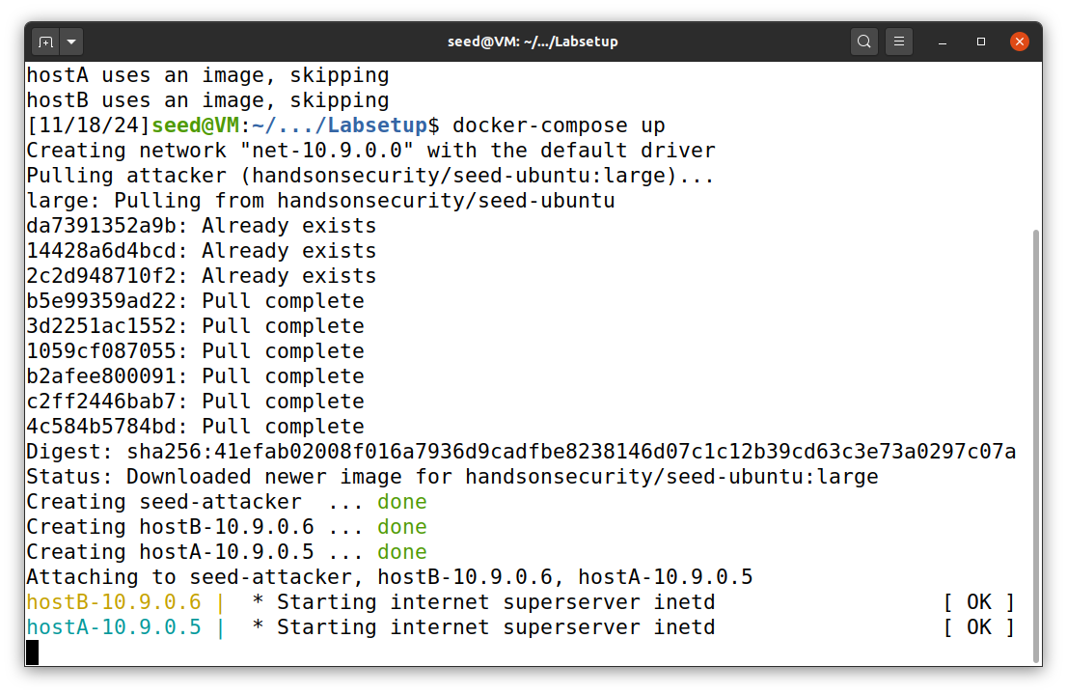
The above screenshot shows running the environment used for the next Task.

Task 01: Using Scapy to Sniff and Spoof Packets

Task 1.1: sniffing packets

Getting Network Name:
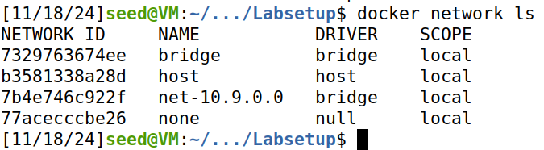
Creating Sniffer.py
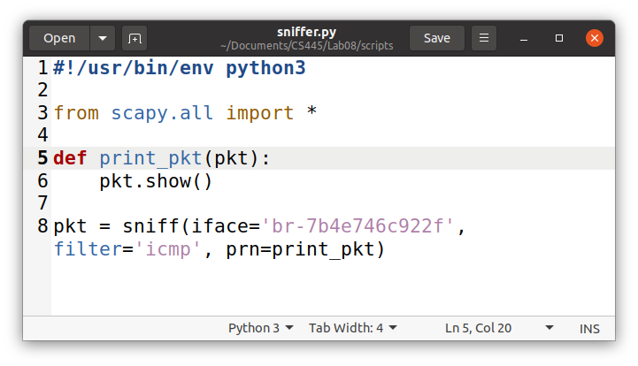

Task 1.1A
Running Sniffer.py as root:
Below is the screenshots of setting the sniffer.py script as runnable and then running it with sudo. The extra output below is what the sniffer printed out after running the command as Host A, shown in the section below.
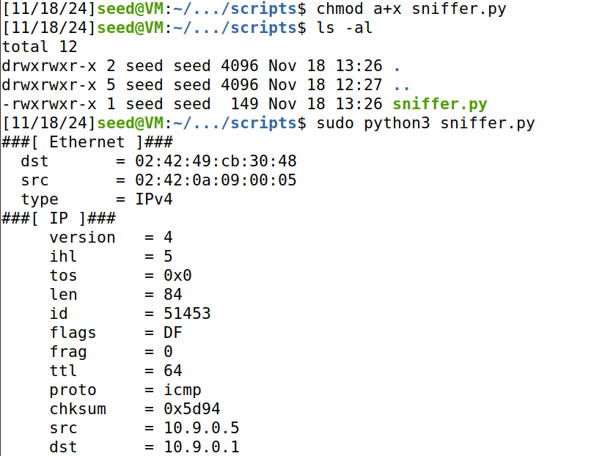
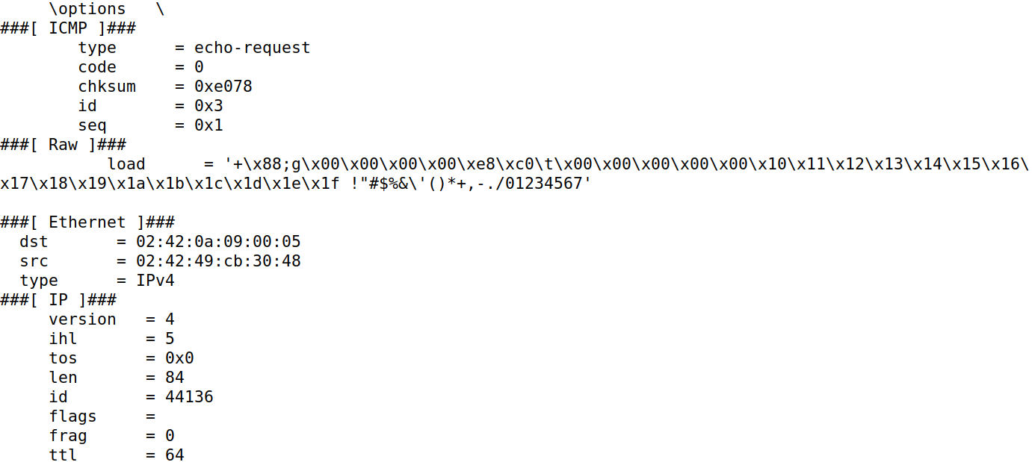
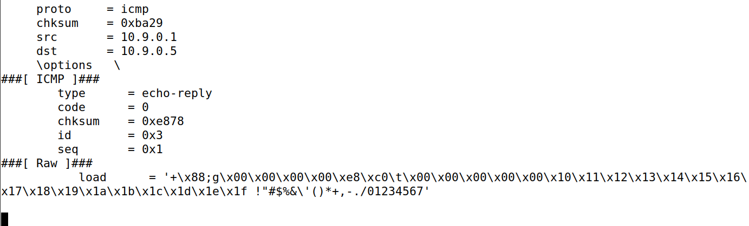
Sending packets to VM as Host A:
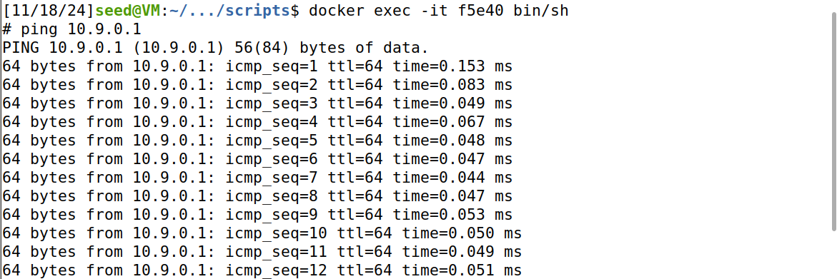
Running sniffer.py script without root:
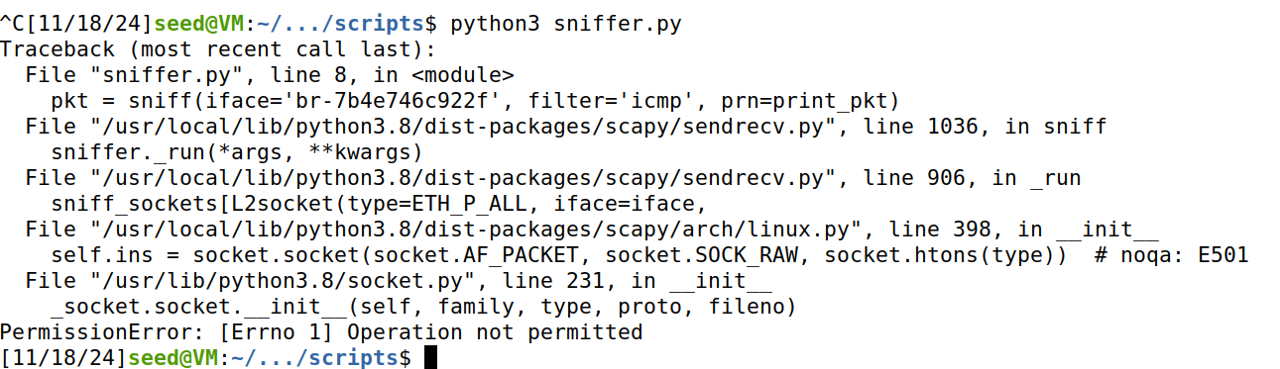
Observations:
When Running the script with the “sudo” keyword, the script runs as intended. However, when trying to run the script without the “sudo” keyword, the script outputs an error. This is because the underlying library, Scapy, requires root privileges under the hood. It uses raw sockets which require elevated privileges to work.

Task 1.1B:
Capturing only ICMP Packets
The code is the same as the screenshot at the beginning of Task 1.1. The proof of the script working is found in Task 1.1A, since the script is unchanged.
Capturing any TCP packet that comes from a particular IP and with Dest port number 23
Modified Code:
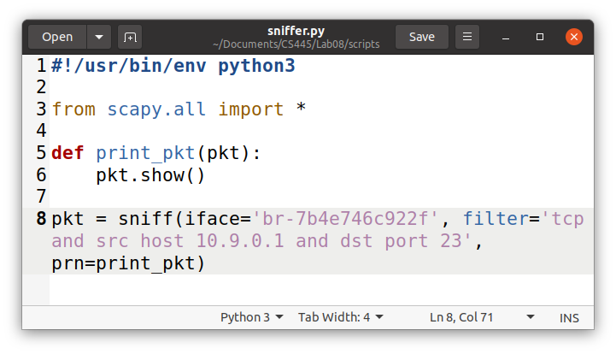
Small typo in screenshot, should be 10.9.0.5 (hostA) output was run with corrected ip
As Host A, send TCP Packet to Host (via nc):
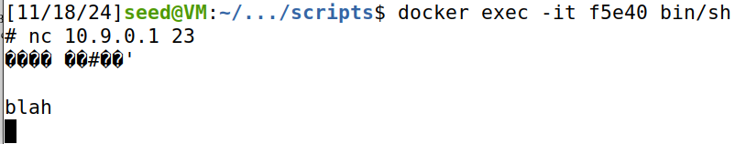
Receiving output from sniffer.py:
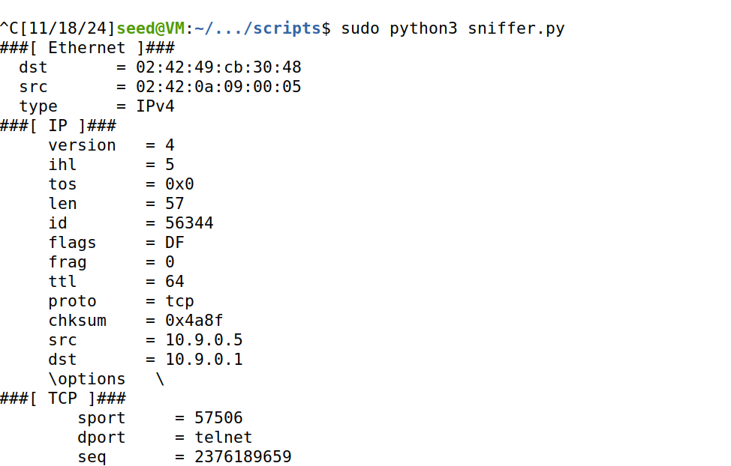

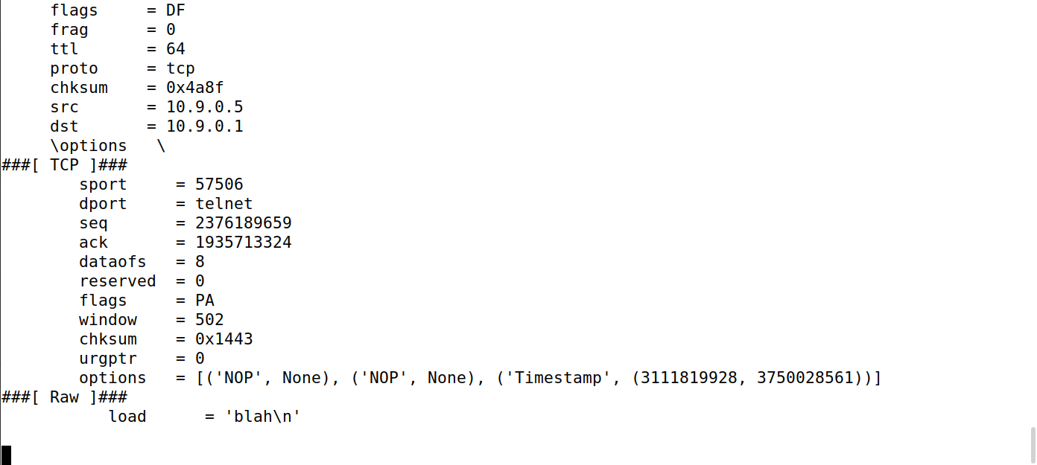
Capturing packets coming from or to go to a particular subnet
Modified Code:
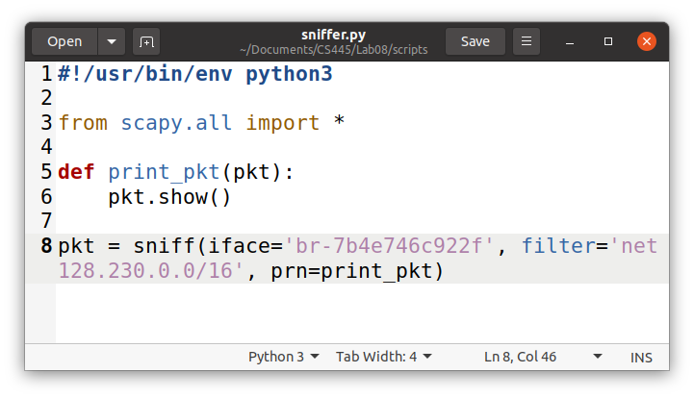
As Host A, sending TCP packet to 128.230.0.0
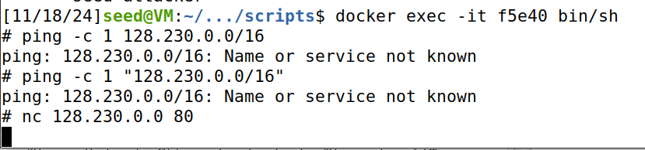
Sniffed Packets from sniffer.py
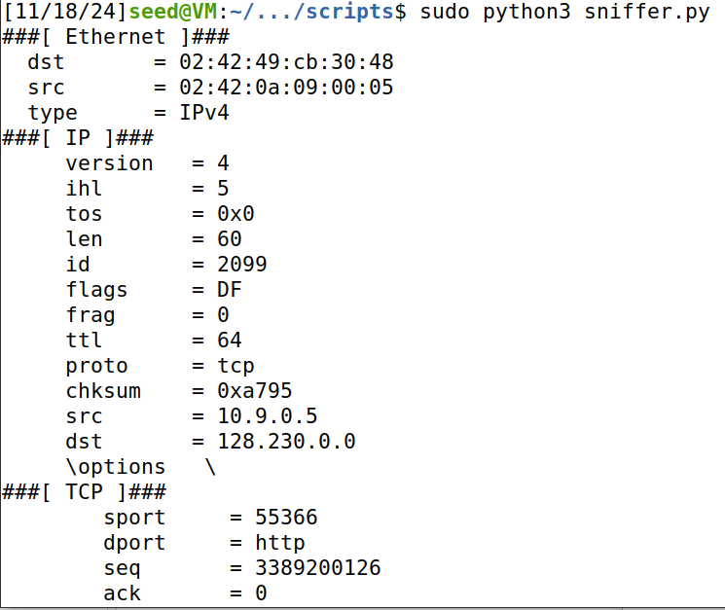

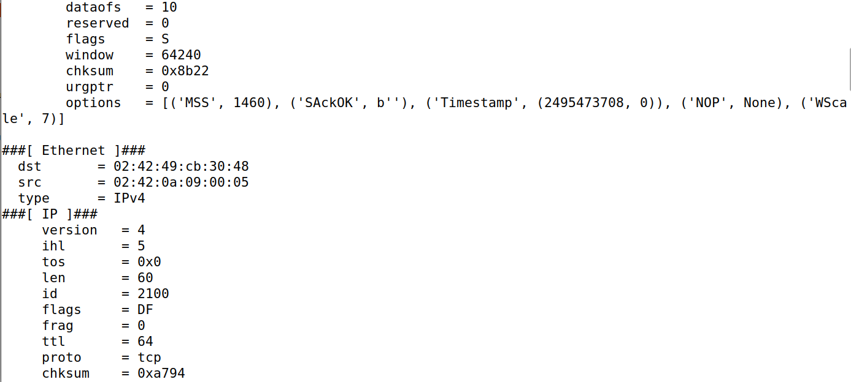

Task 1.2: Spoofing ICMP Packets
Code:
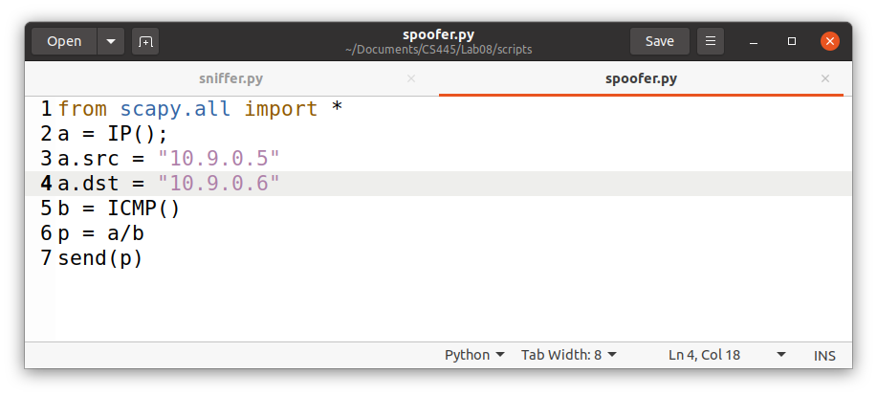
Running as 10.9.0.1 spoofing ICMP as 10.9.0.5:
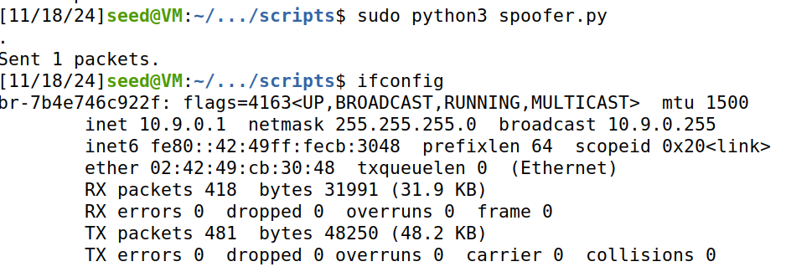
The Above screenshots shows the process and result of running the ICMP spoofing Script and the results found on wireshark. For clarification, I run the script as 10.9.0.1 and set the src address to 10.9.0.5 (host A). The destination address is host B. As the output above shows, I successfully spoofed the ICMP echo request packet.

Task 1.3: Traceroute
Code:
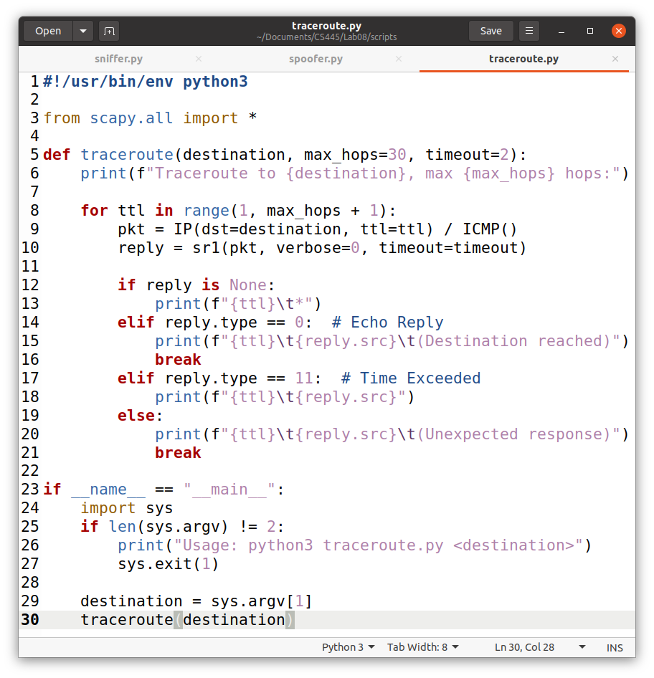
Traceroute to google.com:
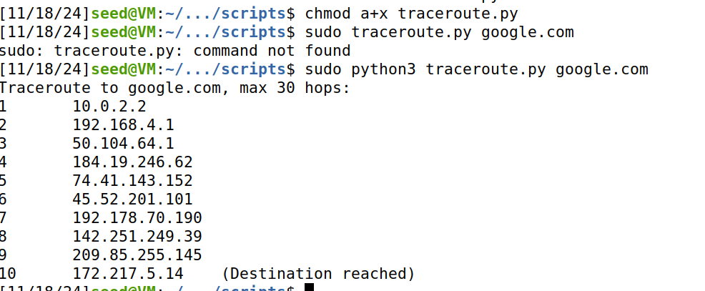

Task 1.4: Sniffing and then Spoofing
Code:
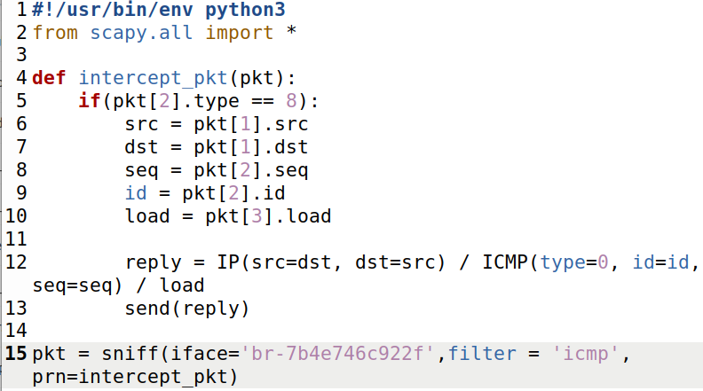
Running Script on VM:
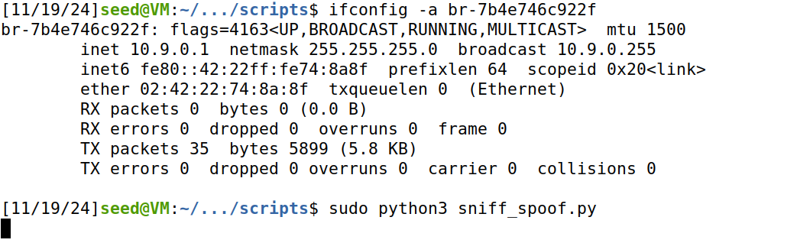
Entering Host-A:
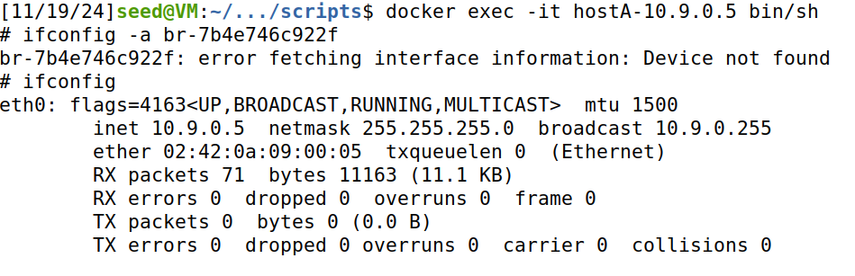
The Above screenshots is setup for the sub tasks of 1.4.

Task 1.4.1: Ping 1.2.3.4
As host A, I will ping 1.2.3.4:
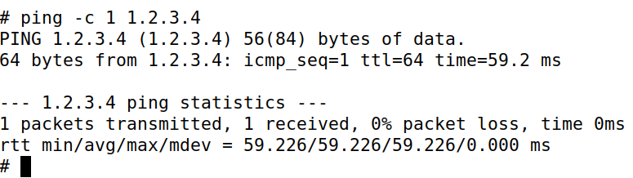
The corresponding output from the VM:
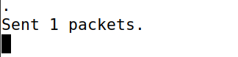
Wire shark output:
Observation:
Using wireshark to view the BR-7b4e746c922f interface as well as enp0s3 interface, we can see that inside the BR-7b4… interface that Host A received a ping response from 1.2.3.4, a nonexistent ip on the internet. To further show that our sniff_spoof.py script is working as intended, I also viewed the output on the enp0s3 interface and as you can see from the screenshot above, 1.2.3.4 failed to give a ICMP response. Given this information I can safely say that the sniff_spoof.py script worked as intended. Otherwise, we would have received a no response message inside our BR-7b4e746c922f interface.

Task 1.4.2: Ping 10.9.0.99
Pinging 10.9.0.99 (Host A):
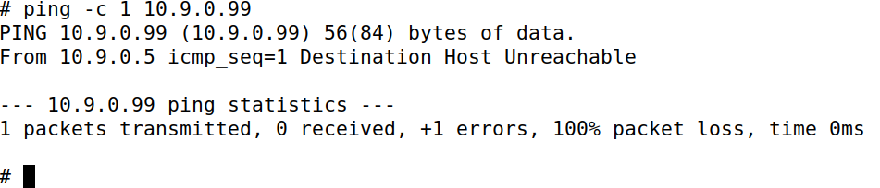
The ping was unsuccessful.
VM output:
There was no output.
Wireshark Output:
There was no traffic inside the enp0s3 interface.
BR-7b4e746c922f interface had traffic, but no ICMP echo requests. Network used ARP to try to get information about the mac address of a nonexistent local host with ip 10.9.0.99
Observation:
This time, the ping failed. This is due to ARP not being able to find the mac address of the local ip 10.9.0.99. No system on the local network was aware of the mac address of the ip, so it failed to even send the ICMP Request.

Task 1.4.3: Ping 8.8.8.8
Pinging 8.8.8.8 (Host A):
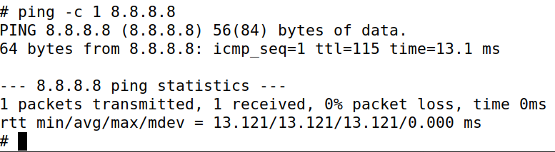
VM Output:
Wireshark output:
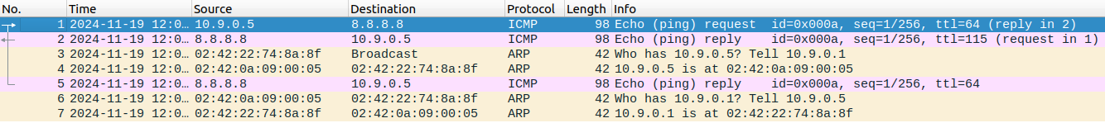
Observation:
The sniffing_spoofing script has worked similar to task 1.4.1, however, as the screenshot shows, there are duplicate ICMP replies in the interface BR-7b4e746c922f. I believe that the duplicate was from the 8.8.8.8 server.

