CS445 Lab Report: SQL Injection Attack
Austin Decker
November 01 2024

Environment Setup:

Address Mapping:
I added the following address `10.9.0.5 www.seed-server.com` mapping to the //etc/hosts/

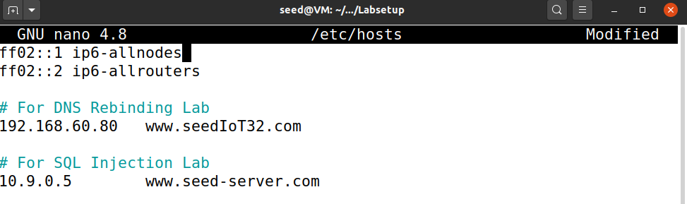
Container Setup:
I ran docker-compose build in the terminal:
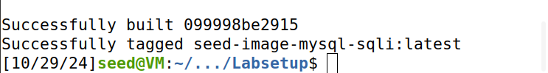

Task 1: Getting Familiar with SQL Statements:
Getting inside mysql docker container shell:
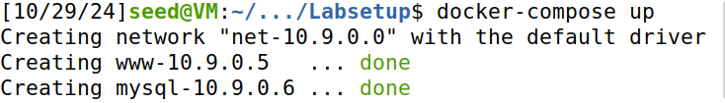

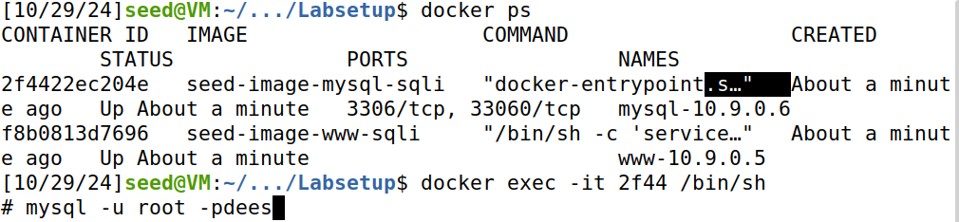
Switching to sqllab_users db and printing out the rows from credential:

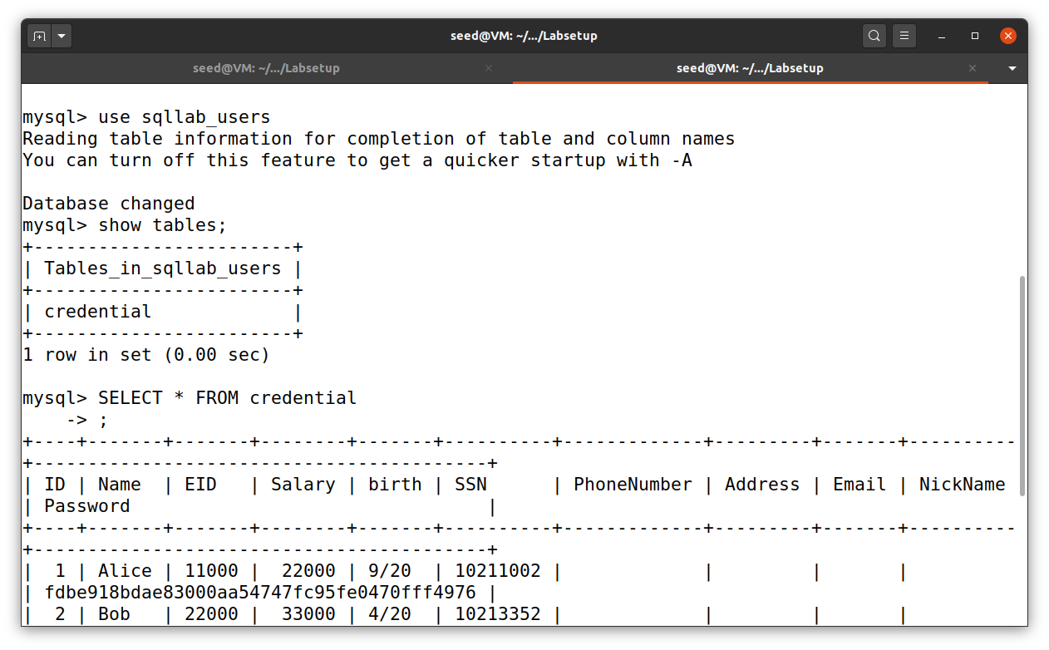
Task 02: SQL Injection Attack on SELECT statement

Task 2.1: SQL Injection Attack From Webpage

To get the admin panel, I put in the string [admin’AND 1=1;#]
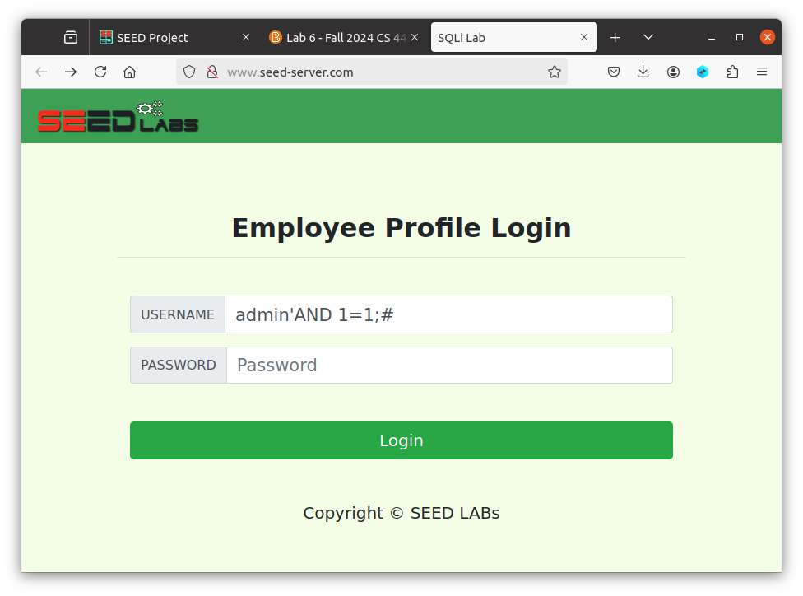
Result of SQL Injection:
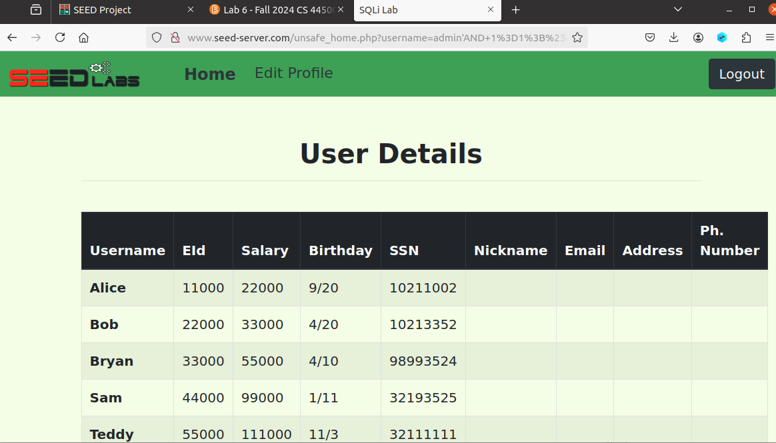

Task 2.2: SQL Injection Attack From Terminal
Using Curl Command in Terminal to gain access to the admin dashboard:
Results from Successful SQL Injection:
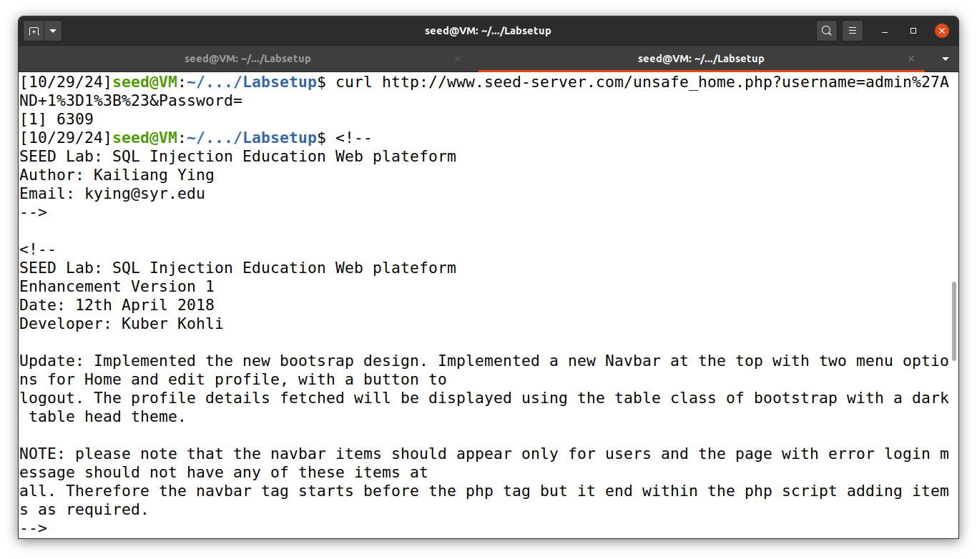
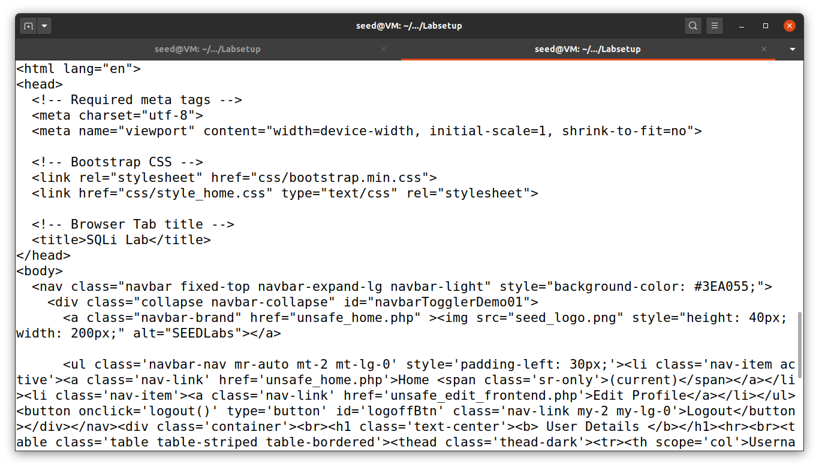
Output is too big to show in screenshots.

Task 2.3: Append a new SQL statement
I tried appending another SQL statement after the first one but I got an error:
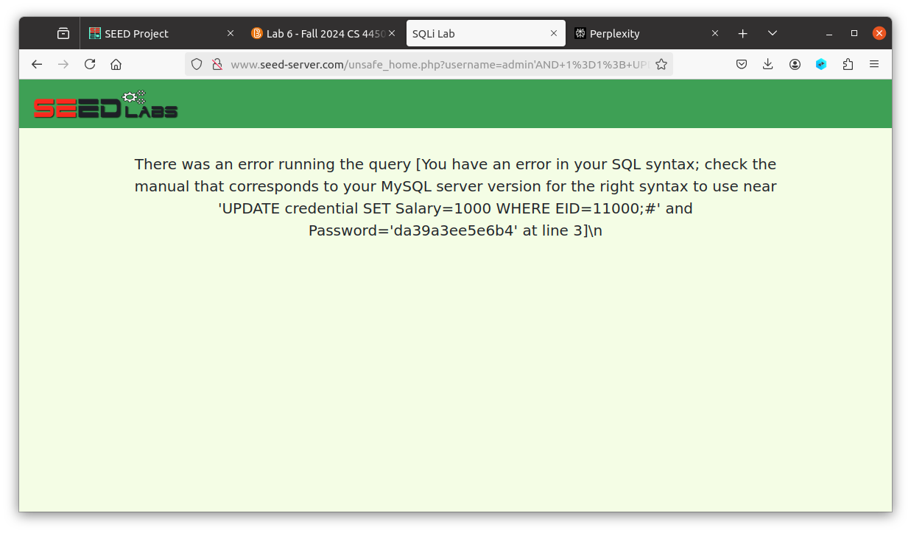
admin'; UPDATE credential SET Salary=1000 WHERE EID=11000;#

Observations:
The reason this did not work was because of the php mysqli query api. It does not allow multiple queries by default. If we want to be able to do multiple queries, the code must use multi_query().

