Using Digital Mars C++ to Support New DMI Tools
Austin Heilman
1/10/2007

1 – Launch digital mars using compiler.bat
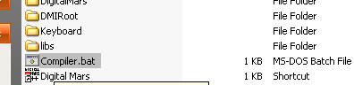

2 – Go to the Project menu and select Open.
Select the folder (ex. AHDMI, DMIRoot) and the .prj file inside.

3 – If the project file list does not appear, double click the icon at the top of the tool bar to bring it up.
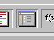

4 – Use the file browser to open and add new files. The only files that need to be edited to support new DMI tools are the ones prefixed with DMI-XXXX.cpp as these handle the external tool provided by Sony.
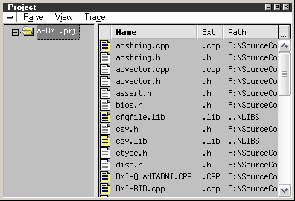

5 – To create a new DMI-XXX tool, use File and New and in the new file that opens select Add to Project.
DMIINFO.H will need to have a new #define flag added to it as well.
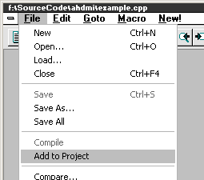
Creating New DMI Modules

1 – When a new DMI tool is created, a new comment line explaining which define number the tool will use should be added.
The #define line instructs the compiler on which code to put into the program.
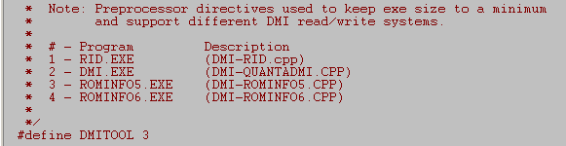

2 – Create a new file named DMI-XXXX.cpp (XXX being the EXE tool provided by GARATA)
Use ‘Add File to Project’ and copy/paste from the template DMI-EXAMPLE.CPP (not in the project list)

3 – Edit the #if DMITOOL == line to match the comment made in dmiinfo.h
Edit the pragma message so the compiler will describe the tool during compile-time.
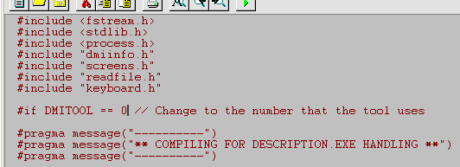
Compiling AHDMI.EXE for a Tool

1 – Adjust dmiinfo.h to use the correct DMI-XXX.cpp ID using the #define DMITOOL X line.
2 – Select Project and Rebuild All
3 – If the program is correct it will produce a .EXE file in the same location as the project file.
Any errors will be show in the Output window.

