1. Complete the set of [randomly-generated questions on randomly generated character codes and Boolean logic operation](https://www.ict.griffith.edu.au/teaching/1007ICT/2009/cgis/combined_convert_boolean.cgi) questions.

The questions are available at:

<https://www.ict.griffith.edu.au/teaching/1007ICT/2009/cgis/combined_convert_boolean.cgi>

Please take a screenshot (or use the Windows snipping tool) of your answers showing all the green ticks to show that all questions are completed, and paste the screenshot here.

This question is worth 1 mark.

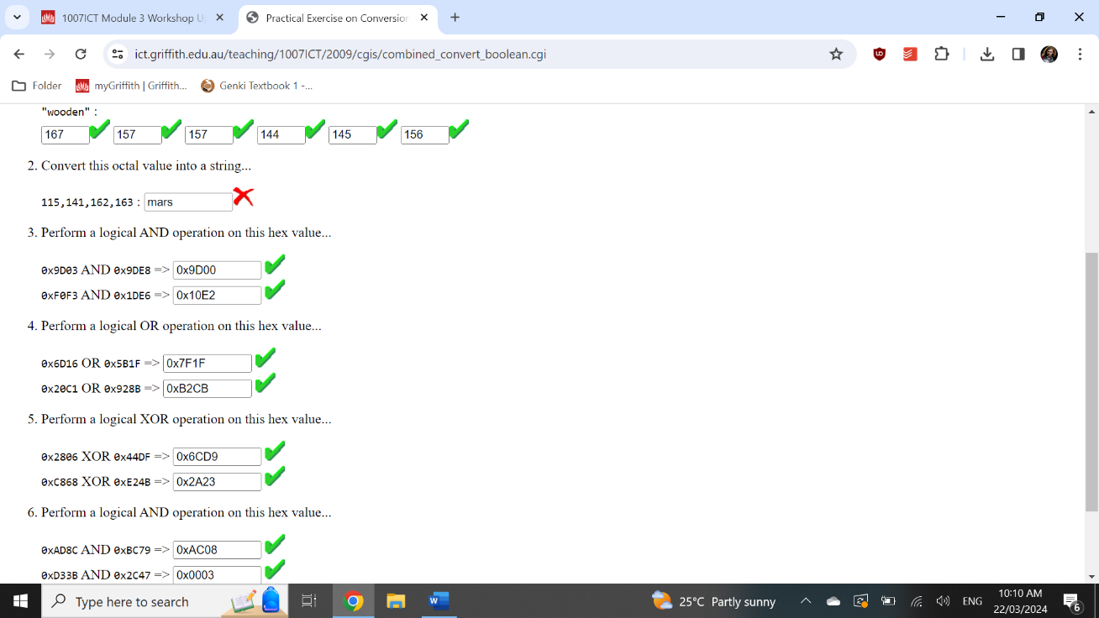

1. Using the Logisim circuit simulator, draw a working circuit for a 2-4 decoder as shown in the diagram below. This circuit is discussed in Seminar 3:

In your logisim circuit S1 and S2 must be single bit inputs, X0, X1, X2, X3 must be single bit outputs.

Your Logisim circuit page must have a Logisim label (using the Logisim text tool) on the circuit page showing your name and student number.

This question is worth 1 mark.

Please take a screenshot (or use the Windows snipping tool) of your Logisim circuit answer and paste the screenshot here.