1811ICT/2807ICT/7001ICT Programming Principles Workshop 4

School of Information and Communication Technology

Griffith University

|  |  |
| --- | --- |
| Goals | In this workshop we create interactive scripts that make decisions and/or loop. |
| When | Week 5 |
| Marks | 2 |
| Due | Workshop programming problems by 11:59pm on 16 April |

# Before your workshop class:

* Read all of this document.
* Review the lecture notes sections 1 to 13.
* **Complete the pre-workshop questions posted on the course website**.

# Workshop activities

At any stage, when you are stuck, *ask your tutor*!

## Problem 1

*Problem:* Write a program that reads whole numbers typed by the user until a zero is entered, then prints the number of positive numbers that were entered. Sample run:

Enter a number: 3

Enter a number: -2

Enter a number: 5

Enter a number: 6

Enter a number: -100

Enter a number: 70

Enter a number: 22

Enter a number: 68

Enter a number: 0   
6 positive numbers were entered.

*Answer*: Copy your code in the space given below and insert screenshots of your program output for two scenarios of your own choosing.

***Copy your code here***

positive = []

x = input("Enter a number: ")

x = int(x)

while x != 0:

    if x > 0:

        positive.append(x)

        x = input("Enter a number: ")

        x = int(x)

    else:

        x = input("Enter a number: ")

        x = int(x)

y = len(positive)

y = str(y)

print(y + " positive numbers were entered.")

***Insert your screenshots here***

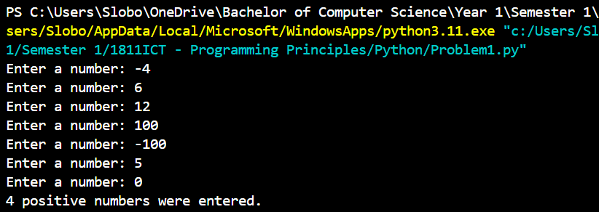

## Problem 2

*Problem:* In mathematics, the Fibonacci sequence is defined such that each Fibonacci number is the sum of the two preceding ones, starting from 0 and 1. That is, F1 = 0, F2 = 1, F3 = 1, F4 = 2, ..., Fn = F(n-1) + F(n-2). Write a program that given an input n, outputs the first n Fibonacci numbers. The format of output is that at most 4 numbers can be displayed in a row. Sample run:

|  |
| --- |
| Enter a positive number: 6  0 1 1 2  3 5  Enter a positive number: 10  0 1 1 2  3 5 8 13  21 34 |

*Answer*: Copy your code in the space given below and insert screenshots of your program output for the following two scenarios:

* Enter a positive number: 8
* Enter a positive number: 15

***Copy your code here***

n = int(input("Enter a positive number: "))

num1 = 0

num2 = 1

num3 = num2

count = 0

while count < n:

    if count == 0:

        print(num1, end= " ")

        count += 1

        num3 = num1 + num2

        num1 = 1

    elif count == 1:

        print(num1, end=" ")

        count += 1

        num1, num2 = num2, num3

        num3 = num1 + num2

    elif count == 3:

        print(num3, end=" \n")

        count += 1

        num1, num2 = num2, num3

        num3 = num1 + num2

    elif count == 7:

        print(num3, end=" \n")

        count += 1

        num1, num2 = num2, num3

        num3 = num1 + num2

    elif count == 11:

        print(num3, end=" \n")

        count += 1

        num1, num2 = num2, num3

        num3 = num1 + num2

    else:

        print(num3, end=" ")

        count += 1

        num1, num2 = num2, num3

        num3 = num1 + num2

***Insert your screenshots here***



## Problem 3

*Problem:* Given an input number n, print a diamond shape with 2*n-1 rows.

Sample run:

|  |
| --- |
| Enter a positive number: 3  xxx  xxxx  xxxxx  xxxx  xxx |

*Answer*: Copy your code in the space given below and insert screenshots of your program output for the following two scenarios:

* Enter a positive number: 1
* Enter a positive number: 5
* n = int(input("Enter a positive number: "))
* n = 2*n - 1
* for a1 in range(1, (n+1)//2 + 1): #from row 1 to 5
* for a2 in range((n+1)//2 - a1):
* print(" ", end = "")
* for a3 in range((a1*2)-1):
* print("*", end = "")
* print()
* for a1 in range((n+1)//2 + 1, n + 1): #from row 6 to 9
* for a2 in range(a1 - (n+1)//2):
* print(" ", end = "")
* for a3 in range((n+1 - a1)*2 - 1):
* print("*", end = "")
* print()

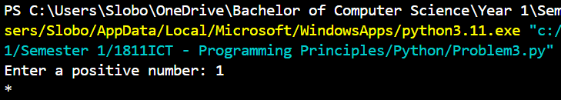

## Problem 4 (Optional, 1811ICT students are strongly encouraged to try)

*Problem:* A palindrome is a number or a text phrase that reads the same backwards as well as forwards. Examples of palindromes are 123321, 1234321, 55555, 22, 454, 1, 0. Write a program that reads in a positive integer number, and prints out whether or not that number is a palindrome. Sample run:

Enter a positive number: 12321

12321 is a palindrome

Enter a positive number: 1234

1234 is not a palindrome

*Answer*: Copy your code in the space given below and insert screenshots of your program output for the following two scenarios:

* Enter a positive number: 345543
* Enter a positive number: 92321

# Submission and marking

Please submit this document with copied codes and inserted screenshots using the provided submission link in the course website. Students get 2 marks if they complete two or more problems correctly, or 1 mark if they complete one problem correctly, or 0 marks without any attempt.