Austin Little

CS-360

SNHU

07/23/2022

**Module Four Assignment**

1. **Screen Design**

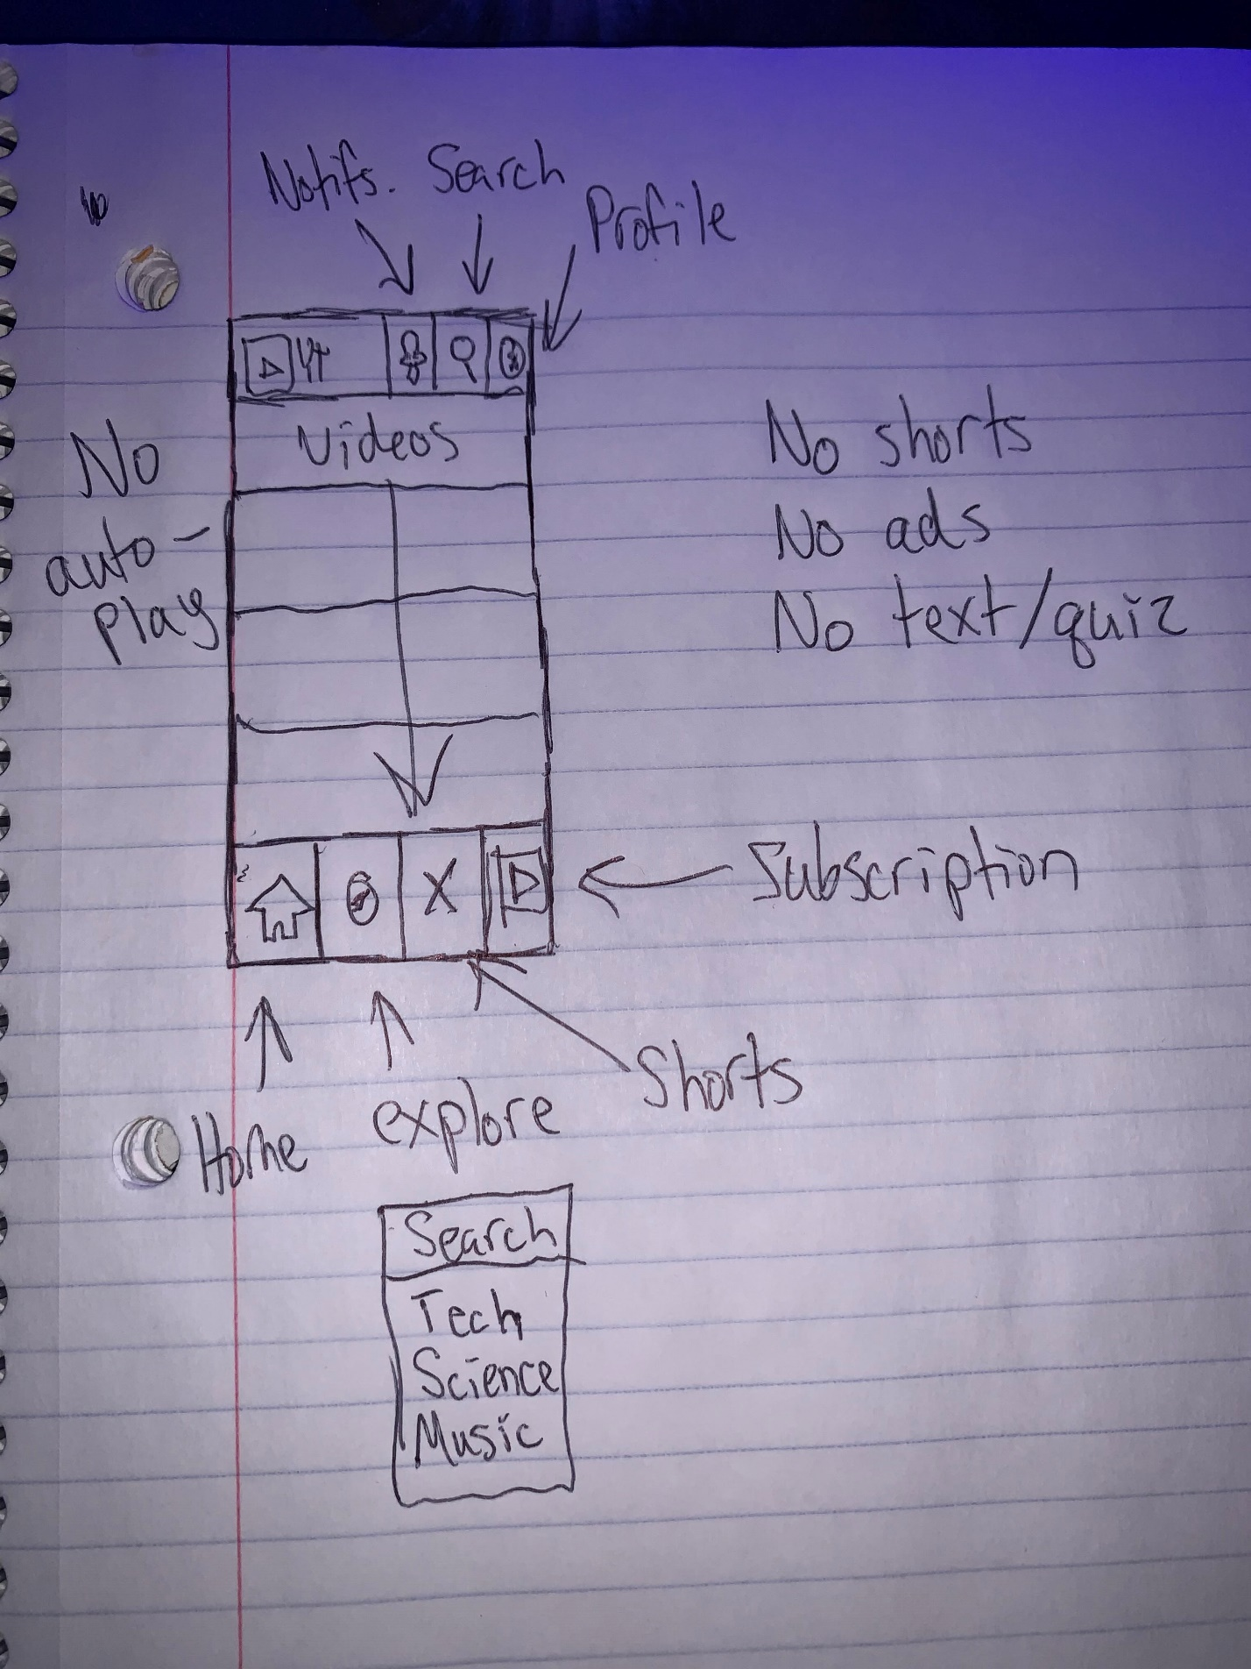

1. **Design Decisions**

I chose to remove the library button, screen share button, and the add post button from the navigation bar. This is because they clutter the navigation bars and can easily be put under the profile button. Also, the add post button should not take up space on the mobile device navigation bar in my opinion, due to most content creators publishing their content from a computer and not their smartphone.

The other choice that I made was to not show shorts, ads, or text and quiz posts on the home screen. This is because they break the flow of scrolling through videos and it can be irritating as a user to find videos that you are interested in. My final change was to turn off auto-playing of videos when scrolling on the home screen. I feel that this is too much for the application and it consistently irritates me. When you are scrolling you can accidentally pause the video or even fast forward it. What is the point of watching the entire video without audio on the home screen?