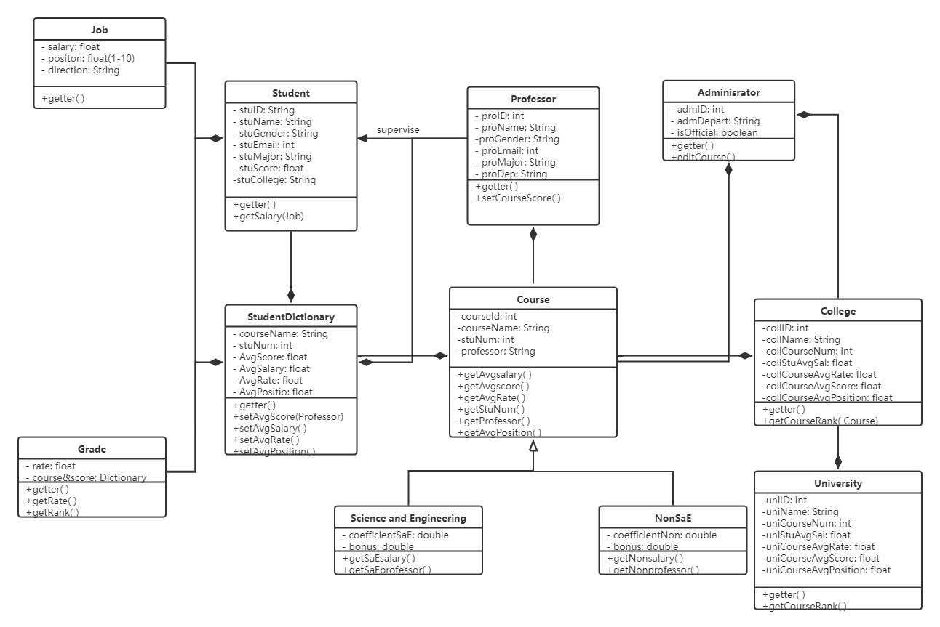Assignment 3

Yusong Zhang, Ping Chen, Zongrui Liu

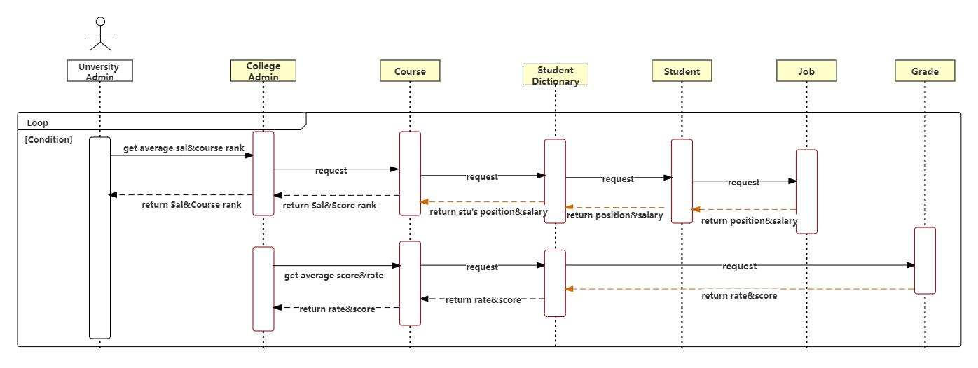

pic1.1 UML

pic1.2 Flow Chart

In order to evaluate the university education quality and enhance the students comprehensive mental health, the model has effectively solved the issues in terms of the performance assessment in university administers and the collections for ranking systems, which will provides increasing convenience for students to decide where they go for studies.

According to picture 1.1, a University class is created as the super class of this model, and some attributes(University ID, University Name, University Course Number, University Student Average Salary, University Course Rate, University Course Average Score and University Average Position) have been defined in the University class. The College class derived from the University class which has similar attributes in terms of ID, Name, Course Number and etc. Deriving from the College class, there are two classes, Administrator and Course Class. In the Course class, all courses in the university have been classified as engineering courses as well as non-engineering courses, and the course attributes(course ID, course Number) have been defined in the class. The Professor and StudentDictionary are two subclass of the Course class. The StudentDictionary is the most centralized class in the entire system, which has stored the students average course assessment(SACA). The SACA has been divided into two parts including salary assessment(SA) and teaching assessment(TA). The SA is the sum of salary (200k annual salary for the boundary, more than that will be counted as five points, less than that will be counted proportionally) and position (from level 1 to level 5, counted for different points in five) scores. In SA, it is supposed to reduce the advantages of science and engineering in terms of income, so there is a coefficient in the salary evaluation. The coefficient of science and engineering is 0.9, that is, the salary evaluation score will multiply 0.9. TA is the sum of course points (from level 1 to level 5, students’ satisfaction towards the curriculum) and course grade (students’ final grade proportionally calculated for 5 points) scores. In TA, it is supposed to reduce the advantages of non-science and engineering in teaching. the coefficient is 0.95, that is, teaching evaluation will multiply 0.95 in non-engineering class. In the SACA, it is encouraged that non engineering professors pay more attention to the salary of students, so there is a bonus in SA. The bonus judgment condition is that the Boolean value is true if the number of people with income greater than 10w exceeds 80% in non-engineering courses, adding 1 to the total score (if greater than five, equals to five), adding into SA. It is also encouraged that science and engineering professors should focus on the quality of teaching, so the bonus judgment condition is that the course registration rate is greater than 95% and the student's performance. the Boolean value is true if the average value is greater than 90, the total score is increased by 1 (if it is greater than five, it will be equal to five), adding into the TA. The Student class which defines the student individual information is the subclass of StudentDictionary. Deriving from Student class, the Job class has defined the salary, position and directions, which can reflect the students’ income, working environment as well as promotion.

Picture 1.2 is a flow chart to present the evaluation process of this model. It is a practical usage for the loop conditions in this model. The StudentDictionary is responsible for all parts of the flow chart and stores all the SACA into it. Student class send the request for Job class, and the Job class return the position and salary to Student class. Similarly, StudentDictionary class send the request for Student class, and Student class will return the SACA towards the StudentDictionary class and stores. Hence, Course, College, Administrator and University class will call the functions and data from StudentDictionary class, by students’ assessment and comprehensive performance, to achieve the course rank so that it will help students for courses selection.