Game Design Document

Fill up the Following document

1. Write the title of your project.

Train Mania

1. What is the goal of the game?

Complete the given task in the given time span to win the game.

1. Write a brief story of your game?

The player is the train company manager and he has to manage his

train and delivery goods and passengers from station A to station B.

The goods and passengers will be NPC and will be created randomly after certain times in the game. The player will be given a task in the start of the game and he will have to collect a certain amount of things and delivery it to win. If the time runs out and the player is unable to complete the task the player will lose the game.

1. Which are the playing characters of this game?

* Playing characters are the ones which respond to the user based on the input from the user
* Cars, monkeys, dinos, wizards etc, are the playing characters in the game.

|  |  |  |
| --- | --- | --- |
| Number | Character Name | What can this character do? |
| 1 | Engine | Travel from one station to another |
| 2 | Engine2 | Travel from one station to another |
| 3 |  |  |
| 4 |  |  |
| 5 |  |  |
| 6 |  |  |
| 7 |  |  |
| 8 |  |  |

1. Which are the Non Playing Characters of this game?

* Non Playing characters are the ones which don't have an action or a behaviour when the user interacts with the game.
* Hurdles, stones, bananas, coins, etc are non playing characters in the game.

|  |  |  |
| --- | --- | --- |
| Number | Character Name | What can this character do? |
| 1 | Cars | Move on a certain road in middle of track |
| 2 | Good carriage | Pick goods from the station |
| 3 | Passenger carriage | Pick passenger from the stations |
| 4 |  |  |
| 5 |  |  |
| 6 |  |  |
| 7 |  |  |
| 8 |  |  |

Draw your imagination of this game. What does this game look like?

* Draw the game either on your computer or on paper,
* Add images of scenes of the game to show each of the playing and non-playing characters at least once.

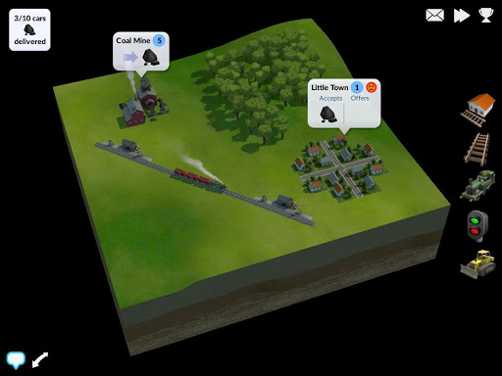 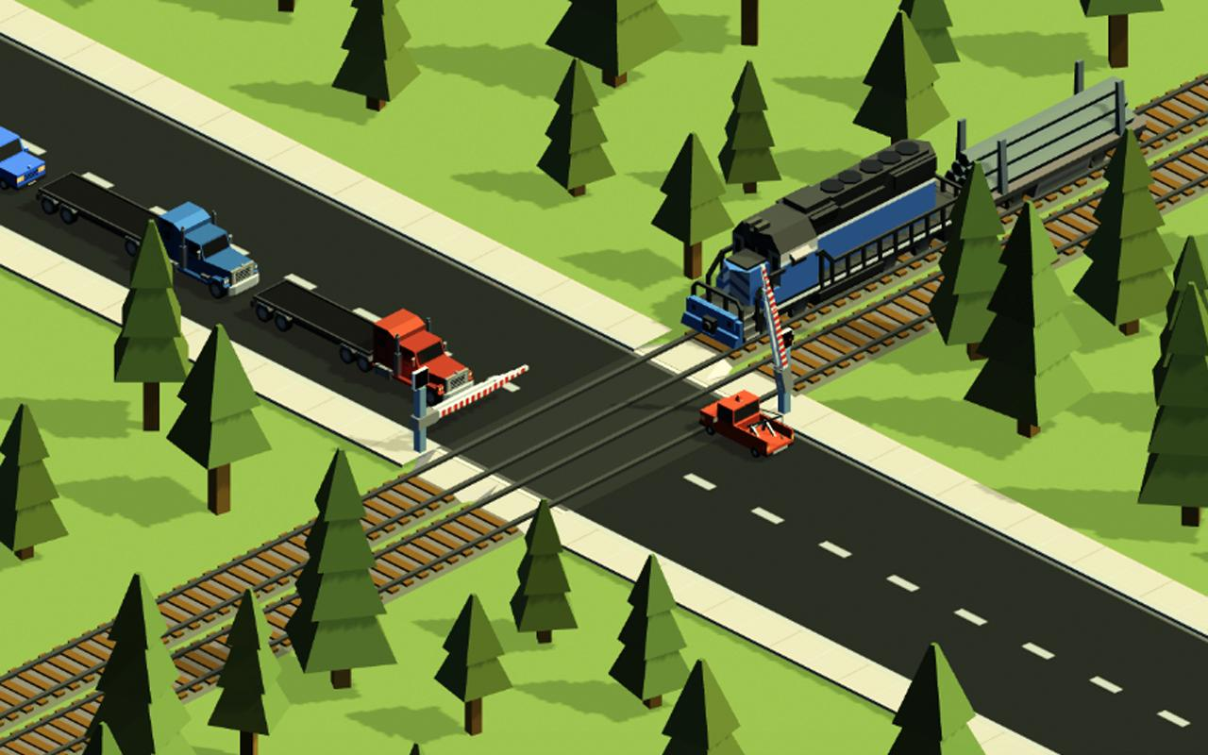

How do you plan to make your game engaging?

As the levels progress the task allotted to player will increase and accordingly the time limits also will change. The NCP will also become more frequent and come very quickly in the game. The number of engines provided will also increase and will allow more carriages to carry at a time