**Vietnamese Student Association at UNC**

***Austin Smith***

***Feb 14, 2021***

## Project Name: Website for Vietnamese Student Association at UNCC

## Project Overview:

Describe your proposed website. Must include the following information:

This website will be designed to represent the student led Vietnamese Student Association at UNCC. The intended users of this website will be UNCC student population and people associated with those students, as well as the college in general. This website will feature a basic homepage that will include a cycling gallery of images, a member application form, the address of the organization/college, and a mission statement and general description for the group. The homepage will also link to other pages such as an events page that contains various events for the organization, a board page where member info is displayed, a gallery page where pictures of events are displayed, and a contact us page where users can access email sign-up and the organizations social media.

## Client Information:

* + Duy Minh Pham
  + Vietnamese Student Association at UNCC
  + Dpham17@uncc.edu

## Site Map:

Before you start coding, you need to understand what pages you will need to create and how you will navigate between them. Below is an example of a site map. Please produce a site map for your application: (you can use https://www.gloomaps.com/or something similar).

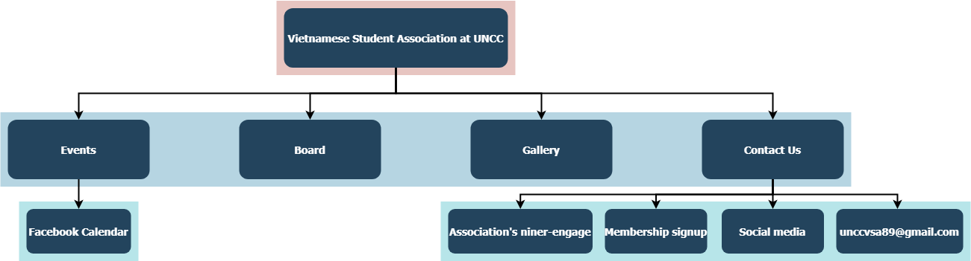

## Page Design: Main page

* + **The name of the page:** 
    - Homepage/Vietnamese Student Association at UNCC
  + **Purpose of the page:** 
    - To draw the user’s attention to the purpose of the association and provide an easy way for people to apply to become members.
  + **Audience/Users of page (customer, admin, etc.):**
    - UNCC student population and people associated with those students, as well as the college in general. Additionally, anyone that is interested in learning more about Vietnamese culture.
  + **What will be content of the page?** 
    - Mission statement for the association
    - A general description of the association
    - Cycling gallery of the group members doing activities
    - A sign-up page for new members
    - Links to the other webpages included in the footers and header.
    - Address of the organization/college included in the footer.
  + **Is this a page where you are asking users to enter data on the page?**
    - No.
  + **Will those data fields need any validations (if any)?** 
    - No.
  + **Will the page contain buttons or hyperlinks or drop downs?**
    - The page will feature buttons that link to sign-up forms for new members.
    - There will be hyperlinks contained in the footer that direct user to the association’s social media pages.
    - There will be a hyperlink contained in the footer that navigates the user to the niner-engage webpage for the association.
    - There will be a hyperlink contained in the footer that directs the user to the address of the organization on google maps.
    - There will be a hyperlink contained in the footer that directs the user to sign-up for a mailing list.
  + **What actions will happen in the page? (such as, when user clicks on a button - data saved, navigate to other page, search based on value, etc.?)**
    - The users can click a set of buttons that navigate to sign-up forms for the association.
    - The user can click on various hyperlinks in the header to be directed to pages such as events, board, gallery, and contact us page.
    - The user can click on various hyperlinks in the footer to be directed to the association’s social media, address, mailing list, and various other pages.

## Page Design: Events

* + **The name of the page:** 
    - Events
  + **Purpose of the page:** 
    - To provide the user with an easy-to-read calendar of upcoming events
  + **Audience/Users of page (customer, admin, etc.):**
    - UNCC student population and people associated with those students, as well as the college in general. Additionally, anyone that is interested in learning more about Vietnamese culture.
  + **What will be content of the page?** 
    - A calendar pulled from the association’s Facebook page.
    - A brief description of the events below
  + **Is this a page where you are asking users to enter data on the page?**
    - No.
  + **Will those data fields need any validations (if any)?** 
    - No.
  + **Will the page contain buttons or hyperlinks or drop downs?**
    - No.
  + **What actions will happen in the page? (such as, when user clicks on a button - data saved, navigate to other page, search based on value, etc.?)**
    - The users will have access to the associations event calendar via Facebook and will have a brief description of the events in a section below it.

## Page Design: Board

* + **The name of the page:** 
    - Board
  + **Purpose of the page:** 
    - To display the members of the association.
  + **Audience/Users of page (customer, admin, etc.):**
    - UNCC student population and people associated with those students, as well as the college in general. Additionally, anyone that is interested in learning more about Vietnamese culture.
  + **What will be content of the page?** 
    - This webpage will display pictures of the officers of the association and present some information about them when the images are clicked.
  + **Is this a page where you are asking users to enter data on the page?**
    - No.
  + **Will those data fields need any validations (if any)?** 
    - No.
  + **Will the page contain buttons or hyperlinks or drop downs?**
    - This page will have clickable images that expand and reveal additional information about the members.
    - The images will react by slightly enlarging when hovered over.
  + **What actions will happen in the page? (such as, when user clicks on a button - data saved, navigate to other page, search based on value, etc.?)**
    - The users can click on the images of individual members to obtain additional information about those members.

## Page Design: Gallery

* + **The name of the page:** 
    - Gallery
  + **Purpose of the page:** 
    - To display past events/activities the association partook in.
  + **Audience/Users of page (customer, admin, etc.):**
    - UNCC student population and people associated with those students, as well as the college in general. Additionally, anyone that is interested in learning more about Vietnamese culture.
  + **What will be content of the page?** 
    - A grid of clickable images with captions of past events/activities.
    - Various other images of association members.
  + **Is this a page where you are asking users to enter data on the page?**
    - No.
  + **Will those data fields need any validations (if any)?** 
    - No.
  + **Will the page contain buttons or hyperlinks or drop downs?**
    - There will be several clickable images that expand upon interaction.
  + **What actions will happen in the page? (such as, when user clicks on a button - data saved, navigate to other page, search based on value, etc.?)**
    - The users can click on a set of images to expand them.

## Page Design: Contact Us

* + **The name of the page:** 
    - Contact Us
  + **Purpose of the page:** 
    - To allow users to have access to the associations email and social media and provide a way for users to sign up for the association.
  + **Audience/Users of page (customer, admin, etc.):**
    - UNCC student population and people associated with those students, as well as the college in general. Additionally, anyone that is interested in learning more about Vietnamese culture.
  + **What will be content of the page?** 
    - The association’s contact information
    - Clickable images of the association’s social media
    - A button that links to a sign-up page for new members
  + **Is this a page where you are asking users to enter data on the page?**
    - No.
  + **Will those data fields need any validations (if any)?** 
    - No.
  + **Will the page contain buttons or hyperlinks or drop downs?**
    - Buttons for membership and mailing list sign-up forum.
    - Clickable images that link to association’s social media pages.
  + **What actions will happen in the page? (such as, when user clicks on a button - data saved, navigate to other page, search based on value, etc.?)**
    - The user can click the images of social media icons and be directed to the respective social media for the association.
    - The user can click a button that will direct them to a membership and mailing list sign-up forum.

## Dynamic Functionality on the Website:

Describe the dynamic functionality you will implement using JavaScript- this is a description of the interactivity, for example, forms, calculators, interactive images, photo gallery that you wish to implement on your website. Specify the name of your webpage where you plan to use a certain interactivity and explain the reason. Provide example of URLs of web pages/websites where you found the interactivity that you would like to implement on your website.

* Clickable/interactive images/Images that enlarge slightly when hovered.

Having interactable images will increase user engagement and be more aesthetically appealing. This feature will be implemented on the board page for each individual member.

Example: <https://csa.berkeley.edu/officers/>

* Photo gallery that cycles through a set of images

This feature will be utilized to draw the users’ eye to past events on the gallery page and potentially the main page. This will allow for faster cycling through images instead of them being completely static.

Example: <https://www.dsausa.org/>

* Interactive google calendar.

This feature will easily allow users to interact with the calendar and seek out potential future and past events. Thus, allowing users to add those events to their google calendar with ease. This feature will be implemented on the events page.

Example: <http://www.ruf.rice.edu/~csa/events.html>