|  |
| --- |
| Market Analysis |

National Automobile Dealership Market Overview

The National Automobile Dealership Association (NADA) publishes results of a year-long analysis of the U.S. auto industry with particular emphasis on the retail side of business. This study is titled “NADA Data – midyear 2019” (latest available) which is provided in the Addenda. The current state of the US auto market is summarized from the following excerpt from this report.

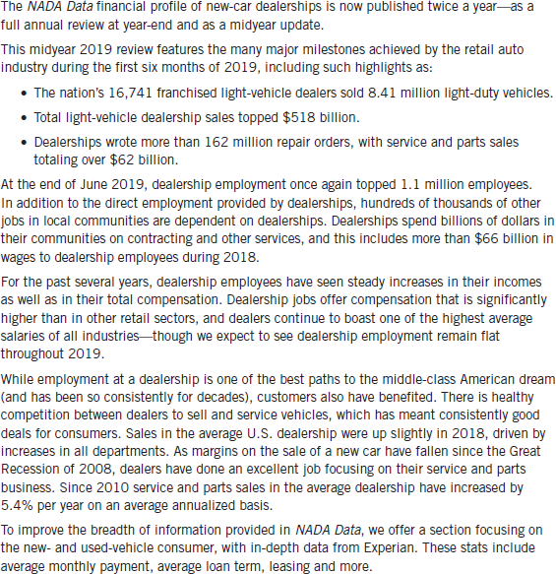

<https://www.nada.org/publications/>

Dealership Sales Data

Historically, auto dealerships generate revenue from several different components including new vehicle sales, used vehicle sales, vehicle service, and parts retailing. The NADA summary profiles break down the sales figures for each of these components. Provided following is a chart which summarizes historical sales trends for the average dealership profile from 2016 to year end-2018.

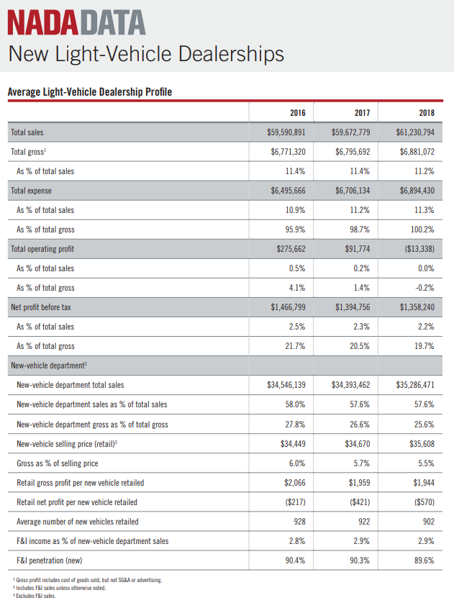

<http://www.nada.org/Publications/NADADATA/>

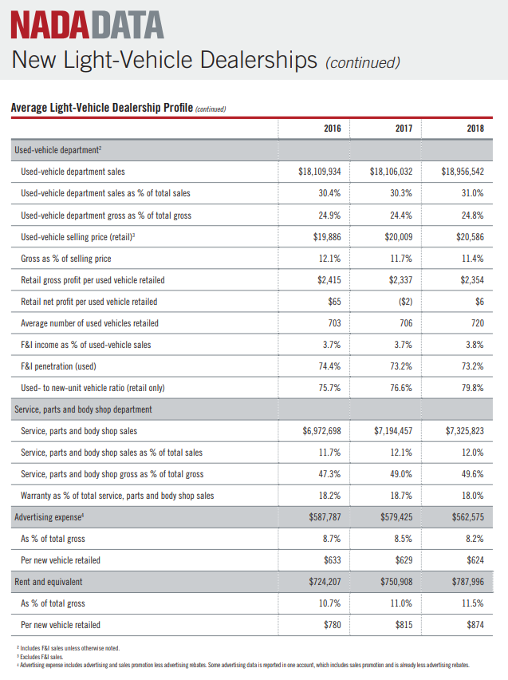

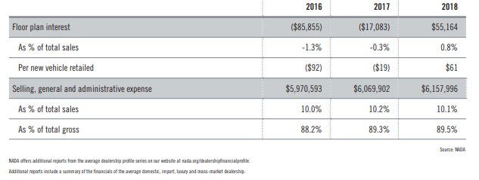

As noted in the preceding chart, new vehicle sales growth was posted a 2.6% increase from the 12 months prior to December 2017 versus the year prior to December 2018 (better than the tepid -0.4% annual decrease from the year prior to this period). In contrast, used vehicle sales increased by a slightly higher margin at 4.7% over this same period (up from -0.1% decrease from year end 2016 to year end 2017). In addition, service and parts sales experienced an increase of 1.8% from the previous year end, up from the prior year over year increase of 3.2%.

On an updated basis, the August 2019 average dealership financial profile (most recent available) shows a recent softening of conditions as compared to August 2018. Vehicle sales results were mixed from the previous year with a slight -0.5% decrease in new vehicle sales, a 3.7% increase in used vehicle sales, with service and parts sales up strongly at 5.6% growth. Overall, total sales were up at 1.6% over a year earlier. It should be noted that the pace of the increase has definitely slowed compared to the past 24 to 36 months.

Conclusion of National Trends

In summary, the current market for auto sales continues on a path of strengthening and stability, both in terms of number vehicles sold and total sales. However, there continues to exist constant price pressures due to healthy competition, which has generally resulted flat profitability for the average new auto dealership. Discussions with the subject auto dealership owner representative indicate that monthly sales have been steady and on an overall continued increase since 2010. Additional interviews with other local dealership operators also generally concur with continued flat conditions expected in 2019-2020. This is further evidenced by the sales recap by NADA as discussed preceding.

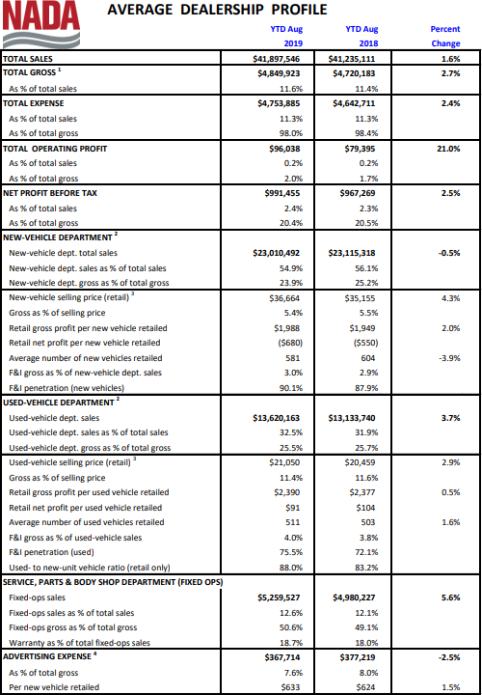

<https://www.nada.org/publications/>

Local Competitive Market Assessment

With respect to specific trends in the larger Salem metro market and immediate area, the following summarizes the general trends associated with the subject’s larger auto dealership market as well as details the various individual automobile dealerships considered competitive with the subject property.

As a general overview for the subject’s larger market, automotive sales and service lots are concentrated in several areas of the Salem metropolitan area: 1) in the subject’s immediate vicinity along Salem Parkway at Cherry Avenue NE, 2) along Commercial Street NE at the north end of downtown Salem, 3) along Commercial Street SE in South Salem, 4) along Mission Street SE (Hwy 22) just west of I-5 in south Salem, and 5) in the vicinity of Market Street NE along I-5 in northeast Salem. A map showing the locations of major dealerships is provided following this market overview.

There is a small core group of major auto dealers with multiple new car brands in the Salem area, which includes Capitol Auto Group, Power Auto Group, and the Roberson, Donofrio and Withnell family dealerships. Most auto dealers are long standing competitors, with very few new participants added over the last two decades, with the exception of the Lithia Motors buying into the Salem dealership market. This has as much to do with the high barrier to entry related to the large capital requirements for real estate and inventory, as well as the general lack of suitable, affordable sales sites throughout the Salem area.

Existing Supply

Overall, there is currently adequate brand-name representation in the immediate Salem market. A map showing the locations of new auto dealerships in Salem is provided on the following page.

Currently in transition is the auto row which historically existed along the subject’s Mission Street SE corridor at the intersection of 25th Street SE, west of the Santiam Hwy 22 interchange with Interstate 5. Until 2011-2012 Capitol Auto Group had operated its Chevrolet-Cadillac, Toyota and Subaru dealerships for decades on a site at the NEC of 25th Street SE. However, these dealerships were all closed, with the Toyota and Subaru properties demolished and removed. The remaining 17.521-acre site was marketed and sold for full price of $7,500,000 or $9.83 per SF in June 2017. The buyer is Jerry’s Home Improvement Center (Eugene-based), which plans a big box store on the site (details yet to be made public, though reportedly will include a 250,000 SF store to be completed in 2020). The Willamette Pontiac Jeep Eagle dealership between 25th Street and Airport Road was sold in February 2013 to Power Auto Group for $3,450,000 and was converted to Power Nissan of Salem in 2013. Remaining dealerships along Mission Street include the subject Roberson Motors Chrysler-Jeep at the NWC Hawthorne Avenue SE, and Withnell Hyundai at 20th Street SE.

Concentrated near / along Interstate 5 at Market Street NE are Power Mazda, Power Kia and Power Buick-GMC of Salem. In 2013, Power relocated and consolidated its existing Kia and Buick—GMC dealership from the west side of I-5 to a brand new dual-brand facility at the northeast quadrant of I-5 and NE Market Street.

In the northwest sector of Salem along the Salem Parkway at the SEC of Cherry Avenue NE, there is a growing new supply of auto dealerships, including two small auto malls. The first was the Capitol Chevrolet-Cadillac, Capitol Toyota-Scion, and Capitol Subaru constructed new in 2011 and 2012, and represented a major shift in location from Capitol Auto Group’s previous historic location in south Salem along Mission Street SE at 25th Street SE.

In a testament to the growing desirability of the Salem Parkway location, Lithia Motors added four new dealerships in a single auto mall at the NEC of Salem Parkway and Cherry Avenue NE. Completed in 2015, Lithia’s auto mall represent another major shift of the Honda of Salem, BMW of Salem, and Volkswagen-Audi of Salem dealerships from their past location at the north end of downtown Salem. The addition of the Lithia Motors dealerships along with the Capitol Auto Group dealerships solidified this area as a bona fide auto row destination location in Salem.

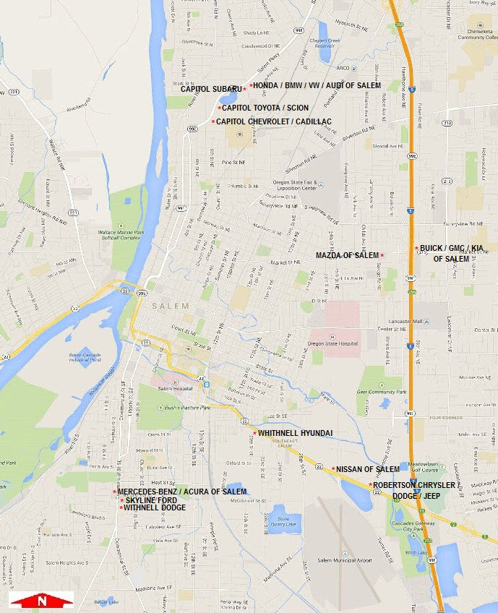

**SUBJECT**

As indicated, the Lithia’s former dealerships near downtown Salem were closed when their new facilities open 1.5 miles north along Salem Parkway. These four dealerships are considered generally functionally obsolete for most new auto sales and service, with these properties reportedly pending sale to the City of Salem (details unavailable / confidential) for redevelopment with a new police headquarters facility.

Another cluster of dealerships is situated in South Salem along Commercial Street SE between Hoyt Street SE and Fairview Avenue SE. These include Mercedes Benz of Salem, Acura of Salem, and Skyline Ford (all owned by the Donofrio family), along with Withnell Dodge.

Proposed & Recent Supply

Regarding proposed and recent new supply, other than the Lithia’s completion of new Honda, BMW, and VW-Audi dealerships in north part of Salem in 2015, there are currently no others planned in the immediate subject market area. However, as indicated, the local dealers continue to make major remodel investments (subject Roberson Chrysler Jeep in 2017), and nearby Power Nissan in 2012, as well as relocation to new stores (example – Power Kia and Buick-GMC), which shows continued growth and investment in the local market.

Based on the previous supply and demand analysis, there is a limited supply with stable to growing demand for new auto dealerships of the subject’s quality, condition and location. As the population in the surrounding areas continue to grow, the demand and marketability for this property type is likely to increase.

Subject Property Competitive Position

The subject property is considered to have a good competitive position in relation to other auto dealership facilities in the area for several reasons. First and foremost, the subject Chrysler Jeep dealership is of modern construction and design with average to good quality materials and good appeal with broad highway frontage for inventory showcasing. The subject is a full-service facility providing vehicle sales, parts and service departments. It is also considered to have good appeal that can accommodate a wide array of single franchise dealers, which is a requirement by several of the major dealer brands. The subject dealership is desirably located along a primary commercial thoroughfare with excellent exposure, nearby full freeway interchange access along I-5, and high traffic counts and several nearby big box retail stores as additional draws to the immediate area. The site and building designs are generally functional and provides for large vehicle inventory storage and display areas. As such, the subject has good overall marketability as a full-service auto dealership sales and service facility.

Conclusion

Discussions with the subject auto dealership owner representative, with general concurrence by other operators, indicate that monthly sales have been steady and, on an increase, since over the past few years. This is consistent with and supported by the NADA statistics cited at the beginning of this overview.

Please note that no gross sales trends were available from the existing subject auto dealership from which to judge the overall progress and profitability of the subject under its current use. This information is proprietary to the ownership due to their agreement with the name brands. However, it is noted that the current franchisee has operated successfully at in the Salem market for many years with the Chrysler and Jeep brands.

Based on the information we have reviewed from a national survey for the auto industry, discussions with local auto dealership owners and representatives from auto dealers, the auto market would appear to be in a state of relatively strong / stable recovery at the current time. Thus, the long-term potential for continued strong growth is very likely given the positive demographic trends.