|  |
| --- |
| Market Analysis |

Market Area Map – ${submarket} submarket

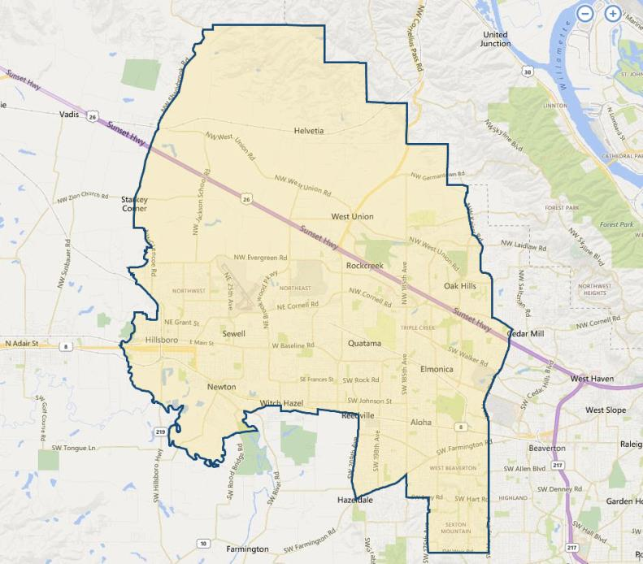

**SUBJECT**

Religious Facility Vacancy

With respect to the subject’s expanded Portland Vancouver Metropolitan Statistical Area market, the appraiser used **CoStar** to search and analyze the **religious facility market**. In this regard, we surveyed moderate size church properties of between 20,000 and 50,000 SF GBA, with a total of 85 properties meeting this criteria, as of January 2020. Of this total, none were currently vacant, and only one was listed as available for sale and is summarized in the following paragraph.

Located in the Eastside suburb of Milwaukie, at the southwest corner of the signalized intersection of Highway 224 and (13333) SE Rusk Road, is a 12.4 acre site improved with a 29,289 SF, older church facility - Clackamas Christian Center (built in 1984 / 1994). This older property is being marketed as a redevelopment opportunity with no value to the existing improvements. The site is zoned R-10 (6.7 net acres) / R-3 (5.7 net acres) by the City of Milwaukie. The property is listed for sale, but with no asking price, by Cliff Finnell of Kidder Mathews (503.221.2295). As of April 2019, discussions with the broker indicate that approximately 9 acres of the master site is currently pending sale for subdivision development, with the church seller now deciding to keep its existing religious facility on a 3.4-acre primary site. No other details are known.

Overall, the market appears to be very tight for moderate sized religious facilities in the Portland Vancouver metro area. An alternative search on Costar indicates a total 13 sales of church properties between 20,000 and 50,000 SF GBA over the past 5 years, or roughly 2.6 sales per year. This reflects fairly low turnover of properties given the size of the metro area market, and speaks to the general stability of this specialty property type. Prices for these facilities were surveyed from $800,000 to $6,762,000 for properties ranging in size from 20,000 to 49,641 SF GBA (average = 27,701 SF). Unit prices were quoted by Costar at between $40.00 and $171.23 per SF (average = $86.41 / SF). Most properties were located on residential zoned land, and as the market for developable land has become increasingly active, prices for such land has increased steadily since the strong recovery from the economic collapse which bottomed out in 2011-2012. Therefore, the prices of religious institutions has steadily increased, with an equal drop in their relative affordability due to the high cost of replacing such facilities. Only partially offsetting have been the continuation of historically low interest rates. These factors also tend to result in overall stability for such special use properties.

Conclusion

Our survey currently indicates very no vacancies of religious facilities in the immediate sub-market, with no currently available facilities in the immediate to expanded areas. Overall, properties with good access / exposure locations, and are well maintained, have continue to experience steady demand – almost exclusively from owner-users consisting of expanding church congregations. In addition, this demand has also been spurred by continued low mortgage rates which have offset the decreased affordability due to rising land prices and increased construction costs. As our survey would indicate, there is considered to be a sufficient level of demand to support existing and new religious facility projects, although exclusively on a build-to-suit basis.

The decreasing supply of available residential land is expected to continue in the future, which in turn has resulted in scarce availability for existing church properties which are located on such land. Demand is anticipated to remain stable to increasing in this developing / established market with high occupancy for well located, functional properties and no new large supply forecast. Hence, prices should continue to increase slowly during 2020-2021.