|  |
| --- |
| Market Analysis |

Market Area Map –${submarket} SUBMARKET

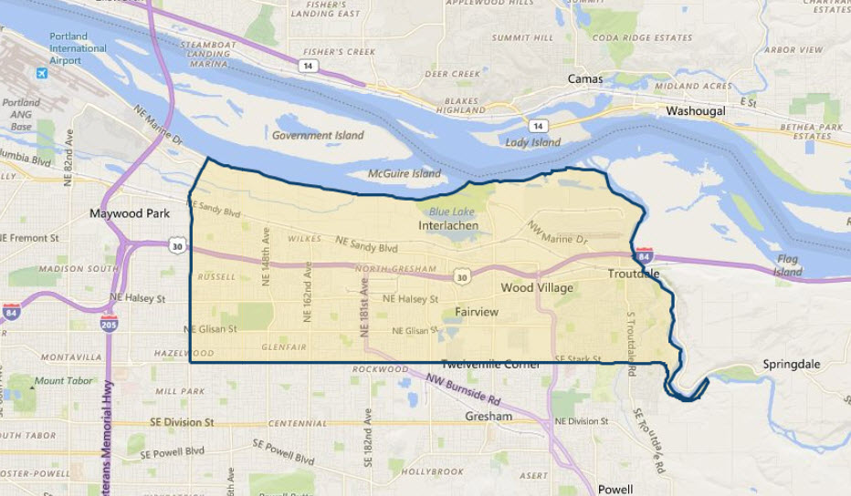

**SUBJECT**

Commercial Vacancy and Absorption

With respect to the subject’s immediate to expanded ${submarket} submarket (see map above), **CoStar** estimates a current **commercial** (office and retail) vacancy of 2.1% (104,115 SF out of 4,880,324 SF; 431 properties) as of October 2020, with positive net absorption of 500 SF over the past 12 months. Leasing over the past year has been somewhat slow only totaling 64,566 SF. However, vacancy has reached a 10-year low from the high of around 7.5% in the Q-2 2011, which correlates with rising rental rates. Higher rental rates and low vacancy has led to new construction, and currently 53,551 SF is under construction. Asking rental rates in the defined submarket area are at a current rate of $19.04 per SF per year which is well above the 5-year average asking rate at $14.44 per SF. Finally sales prices are averaging $271 per SF, which is well above the 5-year average of $185 per SF. A chart of this market activity is shown on the following page.

${submarket} Commercial (Retail & Office) Submarket

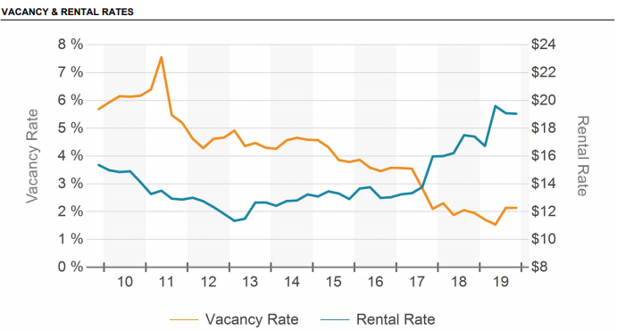

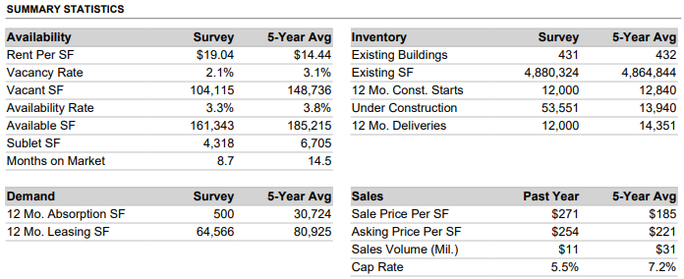

Conclusion

Our survey currently indicates that despite an overall submarket vacancy at 2.1% indicating there are very few vacancies of commercial properties in the immediate sub-market. However, with new supply hitting the market in 2019 and into 2020, vacancies are expected to decrease through at least Q-1 2020. Existing single-tenant and multi-tenant projects with similar locations and convenient access are experiencing increased tenant demand in tandem with the recent extended strong recovery in the local and national economies. At this time, there is some concern about the probability of a national economic slowdown possibly appearing in the next 2 years, a result of the typical business cycle (expansion followed by eventual contraction). Strongly offsetting is the continued relatively tight land availability in the far east Portland submarket, and general lack of overbuilding in the commercial sector relative to past expansion cycles. As our survey would indicate, there is a sufficient level of demand to support existing and new commercial projects, with significant speculative multi-tenant commercial development at the current time. Due to the relatively larger increase in average rents over the past few years, there are likely to be a leveling of the market with typical concessions and rent increases more in-line with inflation trends than in the past few years.