|  |
| --- |
| Market Analysis |

Market Area Map – ${submarket} Submarket

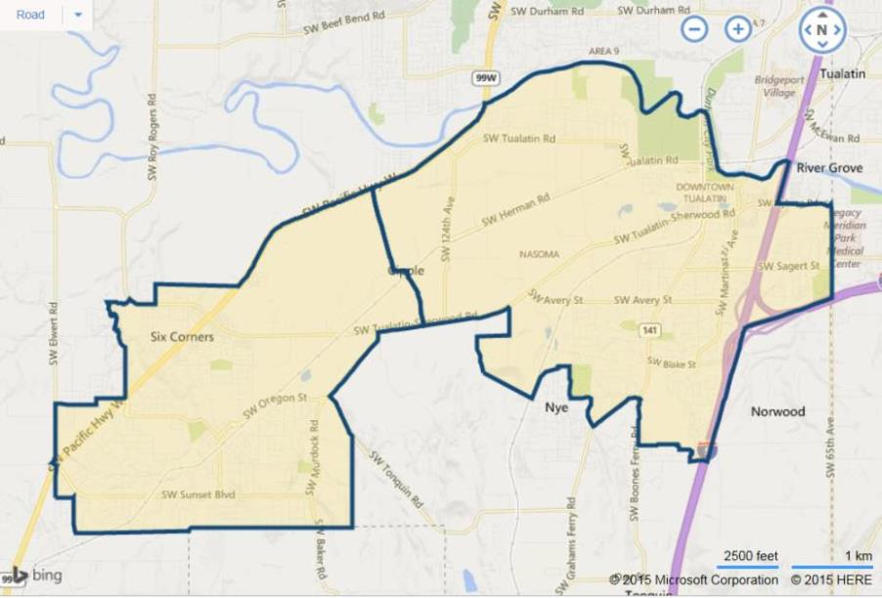

**SUBJECT**

Industrial Vacancy and Absorption

With respect to the subject’s immediate ${submarket} submarket (see map above), the appraiser used **CoStar** to produce a search. CoStar estimates a current **industrial** vacancy of 4.7% (624,072 SF out of 13,247,737 SF; 354 properties) as of August 2020. While having strong positive net absorption of 101,294 SF over the past 12 months, leasing was extremely strong at 762,472 SF over the same period. The 5-year average vacancy is slightly lower at 4.4%. Vacancy reached a high of 9.9% in the Q-2 2009 near the height of the prior recession, and has generally decreased over the last 10 years in tandem with the recovery and economic expansion. Average asking rental rates had been moving steadily upward from $4.74 per SF ($0.395 per SF blended) per year in the Q-1 2012 to a near high rate of $7.85 per SF ($0.654 per SF blended). Finally, the same service indicates limited new industrial space of 53,000 SF under construction in the immediate market, with deliveries over the past 12 months of only 496,364 SF. These amounts of construction are considered insignificant with little impact on market vacancy. A chart of this immediate market activity is shown following.

${submarket} Industrial Submarket

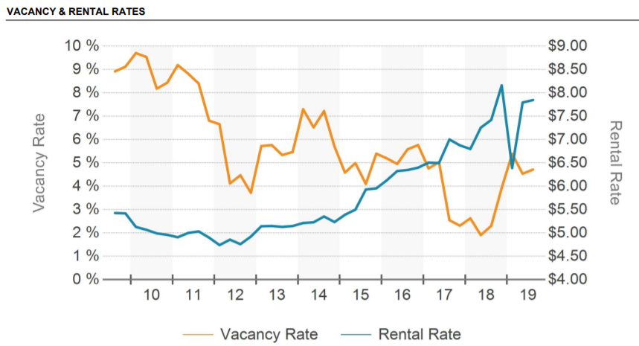

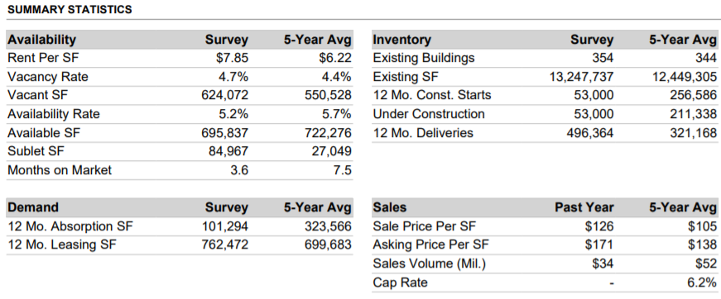

Market Conclusion

Overall, the continued conservative lending environment, coupled with a low supply of available industrial land, will likely mean that limited new large supply is forecast, and that industrial rents, as well as land and building prices, should continue to gradually increase during 2020. The scarcity of the subject submarket’s land scarcity will continue to provide a measure of stability in the immediate submarket and expanded metro market. Given the steep acceleration of price and rent increases since mid-2014, and particularly between 2016 and 2019, there will also likely be a gradual leveling of the market as it digests the affordability of these increases. In any event, there is expected to be continued reduced tenant negotiation power with a decline in offered free rent, rising rental rates, and more frequent rent escalations.