|  |
| --- |
| Market Analysis |

Market Area Map – ${submarket} SUBMARKET

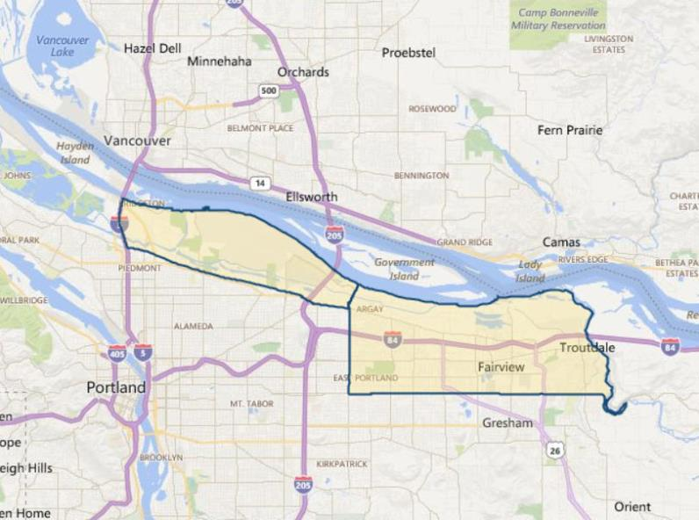

**SUBJECT**

General Industrial Vacancy and Absorption

The appraiser used **CoStar** to produce a search of the subject’s immediate to expanded ${submarket} submarket for **industrial properties**. As of November 2020, the report indicates a total vacancy of just 6.9% (2,947,074 SF out of 42,474,034 SF; 984 properties), with strong positive 12-month net absorption of 2,246,805 SF. The 5-year average vacancy is somewhat lower at 5.0%, which is the result of strong increases in industrial inventory the past few years. In spite of the supply increases, average asking rents are $7.19/SF/Yr., up very strongly from the 5-year average at $6.00/SF/Yr. Currently, there is only 1,368,607 SF under construction in the defined submarkets, with aggressive total deliveries over the past 12 months of 3,467,890 SF that definitely alleviated recent tight market conditions after vacancies had dipped as low as 3.6% in mid-2016.

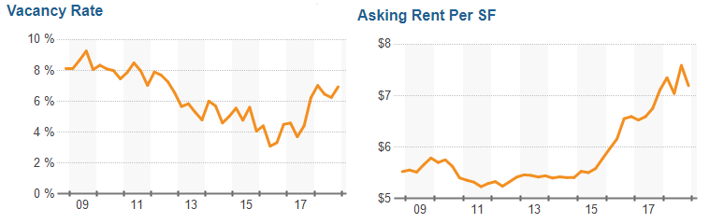

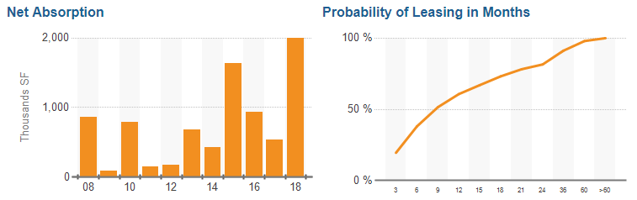

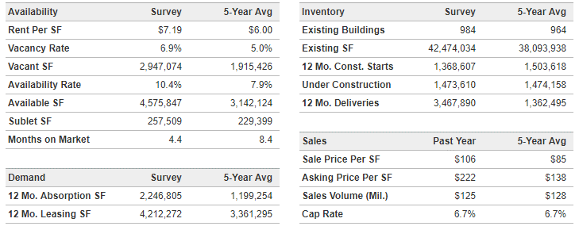

As indicated in the chart above, the current average marketing time it currently takes to lease-up an industrial space in the subject submarket is 4.4 months, down sharply from a 5-year average of 8.4 months. The trend in average lease-up times for the subject submarket is shown below. The chart at the top of this page also shows there is an approximate 60% probability of leasing a space within 12 months, and an 80% chance within 24 months of being actively marketed.

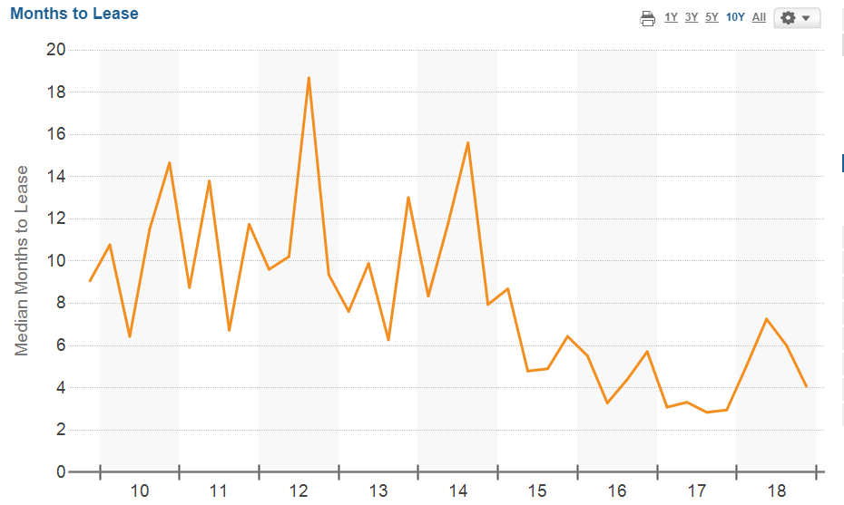

As far as future construction / absorption, the following chart generated by Costar indicates 1,504,810 SF of new space to be constructed / delivered from late 2018 through 2019. This is predicted to cause a spike in vacancy to approximately 8.5%. However, the chart assumes average quarterly absorption of 250,000 SF which would result in vacancy dropping below 5.0% by Q-4 2020 (assuming no new construction in 2020). Adding the subject project (274,738 SF GLA) to the new industrial supply would only increase the volume of new space coming line during this period by +18.3%, with the subject needing to capture 15.4% of the overall industrial market increase in supply. .

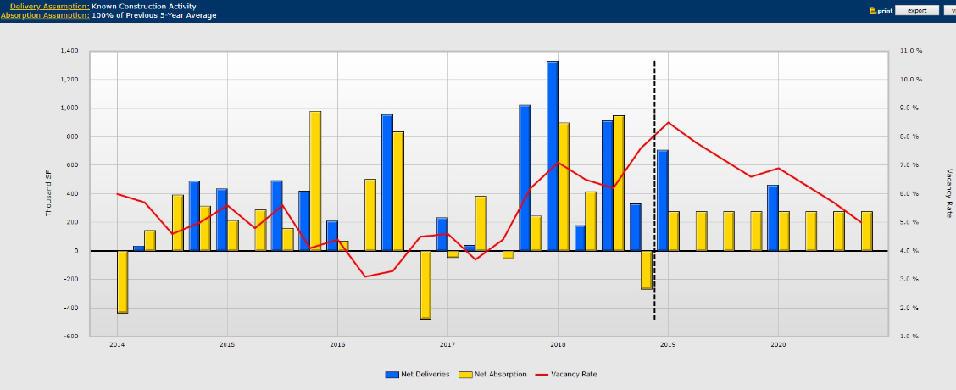

A list of individual projects to be delivered between now and 2020 is provided in the chart below.

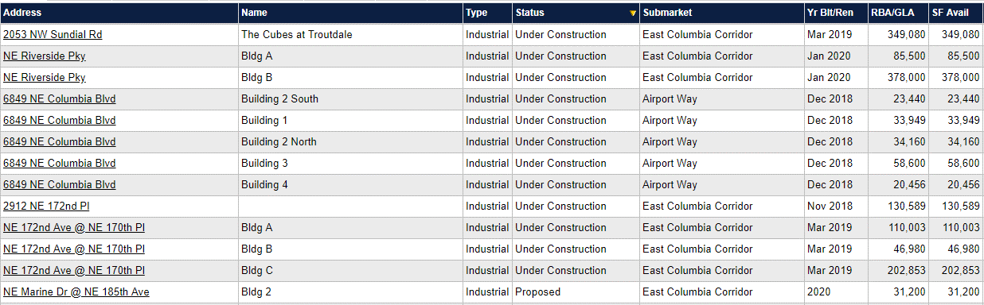

As far as absorption of large tenant space (over 100,000 SF GLA) in the Airport Way / East Columbia Corridor market, there have only been (6) deals over the past 12 months. These averaged 267,644 SF. However, omitting the USPS build-to-suit project, the average lease size drops to 157,573 SF for the defined survey size (over 100,000 SF).



Clearly the bulk of the new space being introduced to the subject submarket consist of smaller spaces – typically 10,000 to 50,000 SF size. However, large blocks of space like the subject are also relatively scarce in availability, and it is understandable that the volume of larger space leases is commensurately only a minor share of the overall market.

Conclusion

Our survey currently indicates that in spite of an overall submarket vacancy at 6.9%, there are very few vacancies of single-tenant industrial properties in the immediate sub-market. However, with anticipated new supply hitting the market in late 2020 and into 2021, industrial vacancies are expected to spike upward to 8.5% in Q-1 2020, then continue back in decline through 2021. Existing single-tenant and multi-tenant projects with similar locations and convenient access are experiencing increased tenant demand in tandem with the recent extended strong recovery in the local and national economies. At this time, there is some concern about the probability of a national economic slowdown possibly appearing in the next 2 years, a result of the typical business cycle (expansion followed by eventual contraction), and also likely future mortgage rate increases. Strongly offsetting is the continued relatively tight land availability in the East Columbia Corridor / Airport Way submarkets, and general lack of overbuilding in the industrial sector relative to past expansion cycles. As our survey would indicate, there is considered to be a sufficient level of demand to support existing and new industrial projects, with significant speculative multi-tenant industrial development at the current time. Due to the relatively larger increase in average rents over the past few years, there are likely to be a leveling of the market with typical concessions and rent increases more in-line with inflation trends than in the past few years.