|  |
| --- |
| Market Analysis |

Market Area Map – ${submarket} SUBMARKET

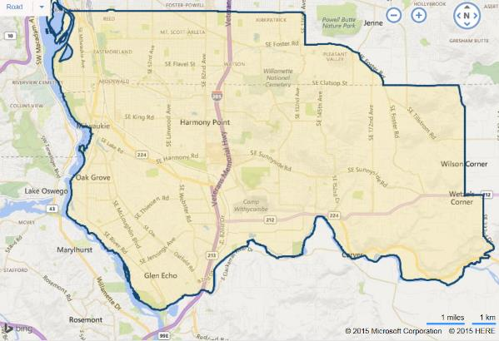

**SUBJECT**

Multifamily Market Overview

The Portland Market is seeing a cooling down from previous quarters. Landlords and developers are continuing their best efforts to meet the growing demand for housing, as political pressure mounts to alleviate the “housing emergency”, described by local politicians. According to The Barry Apartment Report – Spring 2019, the Portland metro area is on track for approximately 8,700 units to be constructed for 2019.

As the housing supply increases, vacancies are rising and rent escalations are slowing. A more balanced market between supply and demand is starting to have an impact and the apartment market is stabilizing. The Portland area continues to experience strong job growth along with increases in household incomes. While new units continue to be delivered, demand is staying steady, aided by in-migration, a very tight labor market, and a regional economy that is approaching full employment.

Additionally, the City of Portland has passed legislation for inclusionary zoning program, which requires developments with 20 or more units set aside 20% of those units for households making less than 80% of the median family income. The program commenced in February 2017, but projects already in the pipeline may not be required subject to the requirements. A noted surge in applications occurred prior to the February 2017 deadline. The surge included 54 projects with 7,050 units and 12 more projects without the number of units specified, or a jump of 28% in a two-month period.

The following chart shows the historic multifamily building permits in the Portland MSA as reported by Multifamily Northwest (from 1991 to 2018 – latest available).

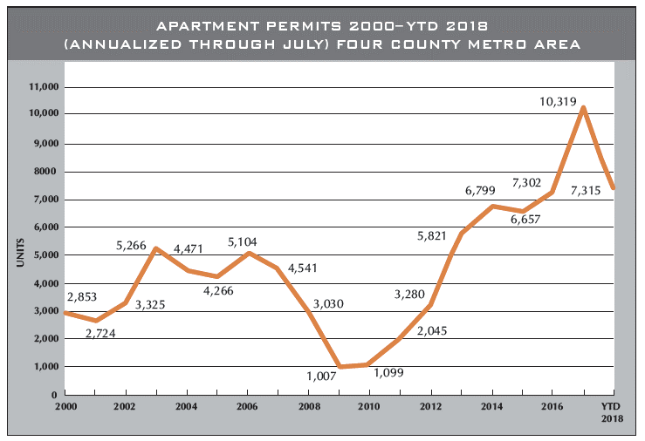

The Multifamily Northwest Report for Fall 2018 reports that there were 7,315 permits issued in 2018. This reflects an approximately -29% drop from the 10,319 permits issued for 2017, a result of the City of Portland’s adoption of the Inclusionary Zoning (IZ) rule which mandated 20% of units be classified as affordable (for projects 20 units or greater). This reduced volume is more in line with the 7,650 new apartment units in 2016, and 6,657 in 2015. However, projects currently in the design phase would suggest from between 14,000 and 18,000 permits would be issued during 2019-2020; indicating a huge increase in apartment construction of the next two years. The significance of this volume cannot be understated, as the last time the Portland metropolitan area hit over 9,000 permits in a year was in 1971-1972.

As shown in the following chart from the Multifamily NW Spring 2019 Apartment Report, vacancy is low across the Portland and surrounding area with an overall market wide average of 4.95%.

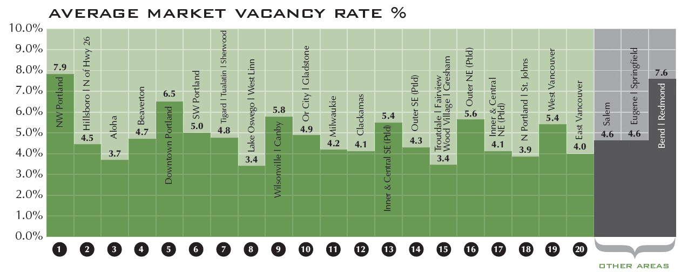

In the subject’s ${submarket} submarket, the reported Spring 2019 vacancy rates of 4.05% / 4.16% which reflects mixed trends from the Fall 2018 of 4.64% / 3.03%. The Clackamas / Milwaukie and surrounding area vacancy is up from the Spring 2017 estimated 3.67% vacancy rate (overall average), due primarily to increasing rents and new construction.

The appraiser has included CoStar data from August 2019, to create the following report showing rental rates and vacancy over the last 5 years in the subject’s ${submarket} submarket. The survey estimated a vacancy rate of 4.2% (850 units vacant out of 20,827 units surveyed) with 546 new units under construction. This shows a continuation from the 523 units delivered over the past 12 months.

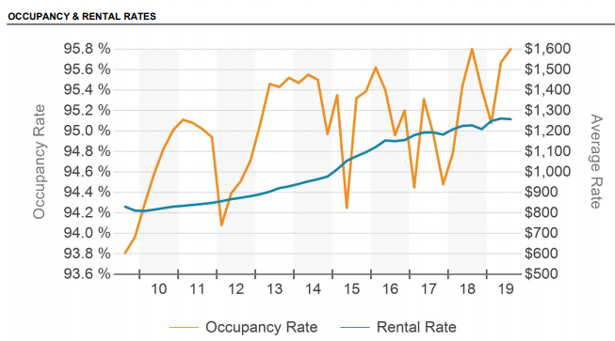

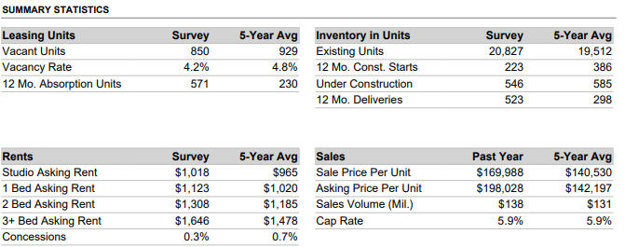

The Multifamily NW Apartment Report also reports sales volume for the Portland over the last three years as shown in the following chart.

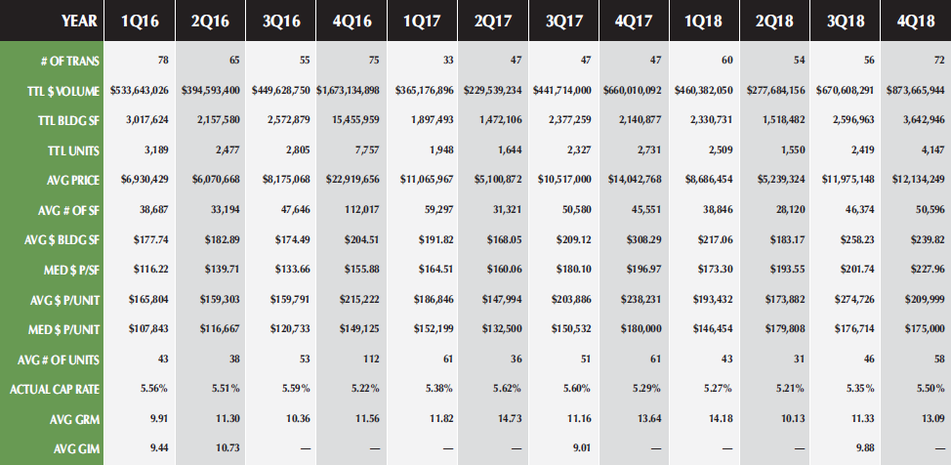

As indicated, the market is driven by sales of small to mid-sized properties, with sales volume and the average price per unit increasing over the three-year period (with incremental ups and downs), with the most recent indicator from 4Q2018 at an average of $209,999 per unit.

In summary, the Portland apartment market has fully recovered from the 2008-2009 recession, with 2014-2019 seeing a significant increase in construction with expended large increases in supply, rising rental rates, and low vacancy market-wide. The market remained strong even with supply increased by thousands of new units. As the economy continues to make steady gains, 2019-2020 should continue to be strong for the apartment market. However, the number of units pending and proposed construction will eventually begin to shift the market in the tenants favor as vacancy begins to rise slightly and rents stabilize or even begin to decrease.

Conclusion – Apartment Market

The subject property is located in ${submarket} submarket, and its demographic draw within the metropolitan area, relative to various major transportation routes and the local population trends. The area’s desirability is enhanced by good transportation routes throughout the submarket. Overall, the outlook for the subject property within this neighborhood is good with no adverse influences noted to exist in the immediate area, which would have a negative impact on the subject’s value or its marketability. Therefore, demand for multifamily residential in the subject area is expected to continue at a stable level over the long-term with expected regional population and employment growth gradually driving increasing rents and property values for the foreseeable future.