|  |
| --- |
| Market Analysis |

Market Area Map –${submarket} SUBMARKET

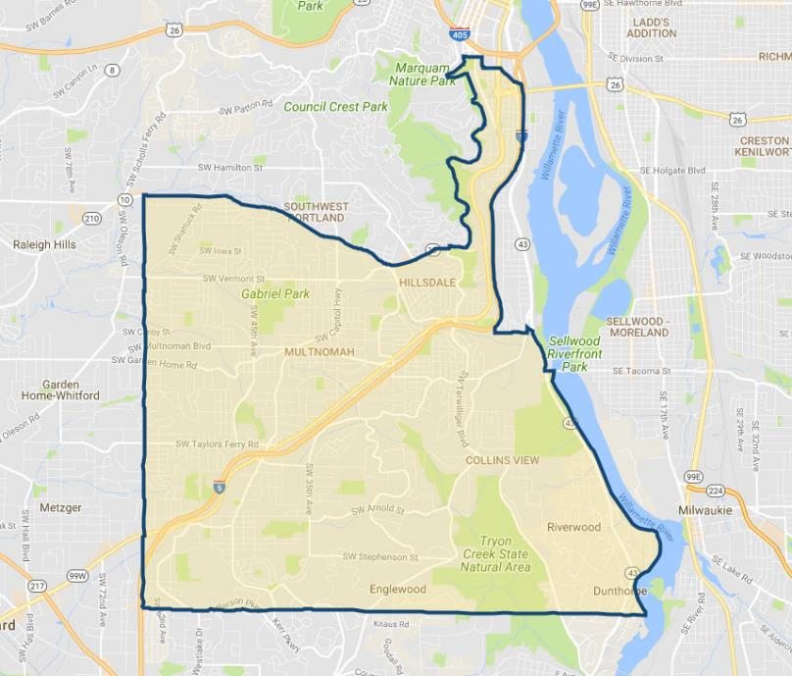

**SUBJECT**

Office Vacancy and Absorption

With respect to the subject’s immediate to expanded ${submarket} submarket (see map above), **CoStar** estimates a current **office** **vacancy** of 5.6% (90,069 SF out of 1,594,776 SF; 184 properties) as of October 2020, with positive net absorption of 4,683 SF over the past 12 months. Leasing in these submarkets over the past year has been strong at 66,193 SF, which is generally tempered in volume due to the general low inventory of available space this submarket. Vacancy reached a 10-year high of just over 12% in the Q-3 2010, and since has continued in a downward trend into the current year, which correlates with rising rental rates. No new construction is currently under way an no new deliveries have occurred over the last 12 months. The average asking rental rates in the defined submarket area are at a current rate of $18.27 per SF per year (primarily modified gross) which is slightly above the 5-year average asking rate at $16.77 per SF. A chart of this market activity is shown on the following page.

${submarket} Office Submarket

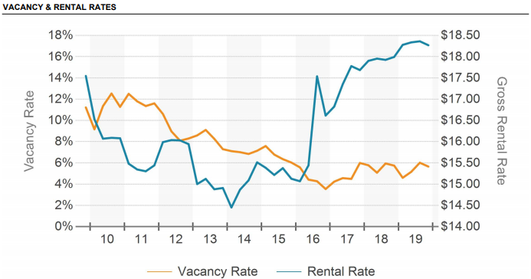

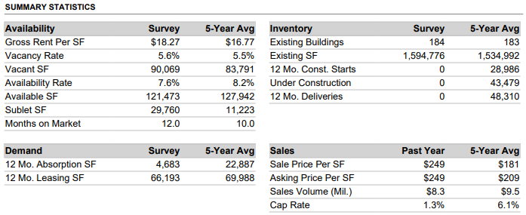

Conclusion

Our survey currently indicates that despite an overall submarket vacancy at 5.6%, there are very few vacancies of single-tenant office (owner /user properties) in the immediate sub-market. Further with no new supply hitting the market in 2020 and into 2021, office vacancies are expected to decrease through at least Q-2 2021. Existing single-tenant and multi-tenant projects with similar locations and convenient access are experiencing increased tenant demand in tandem with the recent extended strong recovery in the local and national economies. At this time, there is some concern about the probability of a national economic slowdown possibly appearing in the next 2 years, a result of the typical business cycle (expansion followed by eventual contraction). Strongly offsetting is the continued relatively tight land availability in the Portland Metropolitan Area and lack of overbuilding in the office sector relative to past expansion cycles. As our survey would indicate, there is a sufficient level of demand to support existing and new office projects, without significant speculative multi-tenant office development at the current time. Due to the relatively large increase in average rents over the past few years, there are likely to be a leveling of the market with typical concessions and rent increases more in-line with inflation trends than in the past few years.