|  |
| --- |
| Market Analysis |

Market Area Map – ${submarket} submarket

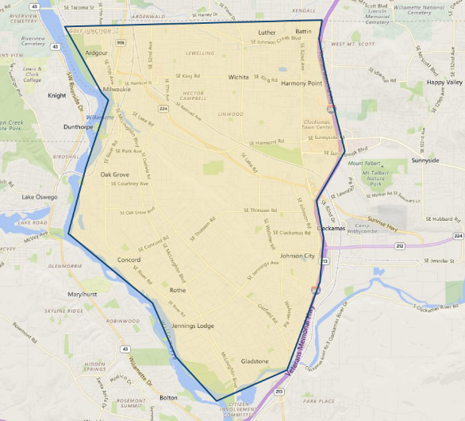

**SUBJECT**

Day Care / Preschool Vacancy and Absorption

With respect to the subject’s ${submarket} submarkets, research published by **CoStar,** estimates there are no current **day care/ preschool** vacancies of properties in the marketplace (174,746 SF, 33 properties) with 2,259 SF of absorption over the year as of the end of September 2020. Vacancy rates historically have been around 0.10% to 0.40% prior to 2015, but since have declined to near zero (0%). The 5-year average is 0.10%. Rental rates have been flat with the 5‑year average reported at $18.60 per SF. No new construction was noted in the marketplace. Properties over the past year have been selling for an average of $232.00 per SF and are on the market for generally less than a month. The service reports the current asking price is $233.00 per SF, however, no listings were noted.

${submarket} Daycare Submarket

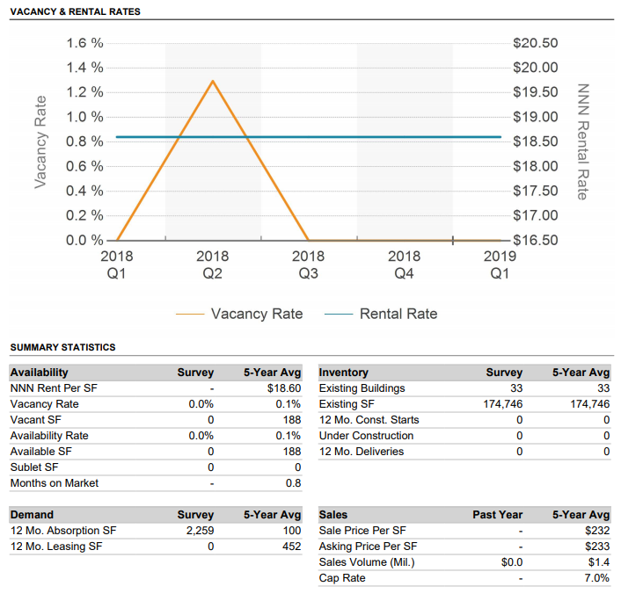

Within the immediate area there is an adequate supply of daycare related properties with no vacancies reported. Further, the location and proximity of the local day care centers to each other would indicate there is no evidence of an over-concentration of such facilities relative to one-another. The following map shows the daycare related facilities in the immediate market and their proximity to the subject property.

**NEARBY day care / preschool Map – gladstone / oak grove AREA**



**SUBJECT**

Conclusion

According to local brokers who are active in the subject’s market area, rental rates in the subject’s immediate area have been increasing as the economy continues to improve and the effects of the last recession are a distant past. McLoughlin Boulevard is a primary retail corridor in the area and benefit from heavy traffic or synergistic attributes. As a result of this, rental rates been stronger in this area and vacancies levels have been lower.

Rents for commercial space in the immediate area are generally quoted on a “triple net” expense basis, whereby the tenants are responsible for all expenses. Lease terms are normally five years or less. Tenants typically pay annual 3% rent increases. The Portland area commercial service markets have seen modest to moderate gains over the last few years as absorption and vacancy continues to improve. Improving market fundamentals have translated into increasing rental rates; especially for properties in first and second tier locations.

The subject is located within a good Clackamas County location, near a primary commercial corridor. Signs of stability are evident within the submarket as vacancy is lower and recent lease activity suggests an up‑tick in rental rates (in comparison to a couple of years ago). The demand for daycare / preschool properties continues to be encouraging with a stable supply that is evenly distributed throughout the residentially dominated marketplace which overall remains positive for the subject property.