|  |
| --- |
| Market Analysis |

Market Area Map – ${submarket} submarket

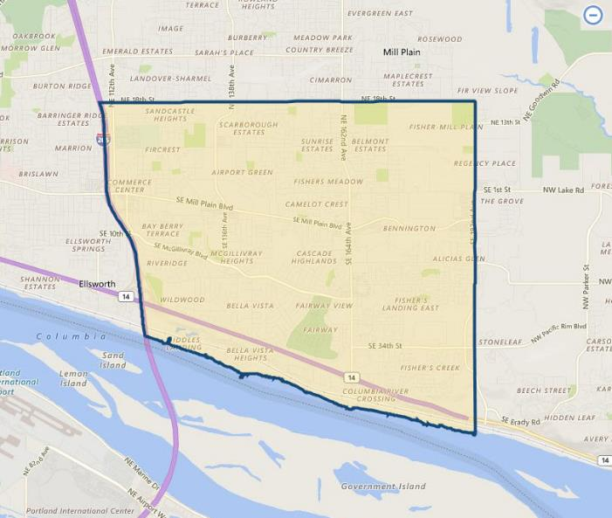

**SUBJECT**

Restaurant Vacancy and Absorption

The appraiser used **CoStar** to produce a search of the subject’s immediate ${submarket} submarket (which includes the immediate Fishers Landing and nearby Cascade Park / Mill Plain One areas) for **fastfood and sit-down restaurant properties**. As of July 2020, report indicates a total restaurant vacancy of 0.7% (1,021 SF out of 146,278 SF; 24 properties), with a 5-year average vacancy only slightly higher at 1.2%. This would infer very tight market conditions which have persisted for a number of years. The current average asking rental rates for restaurants is currently quoted at $32.00 / SF, an increase over the average of $29.31 / SF in the immediate market over the past 5 years. Most properties are leased on a triple net basis, with most national fast food restaurants leased on an absolute triple basis on typical 10 to 20-year leases. Finally, the 5-year average for sale price is $362 / SF – up significantly from the 5-year average of $175 / SF.

${submarket} Restaurant Submarket

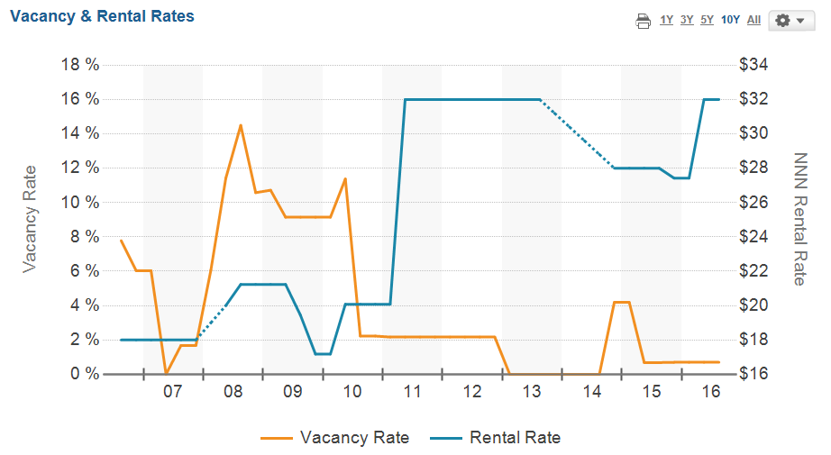

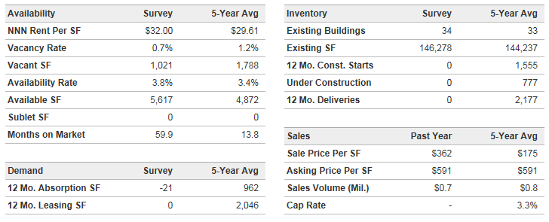

Also provided following is a map of the immediate area which locates the subject relative to other nearby fastfood competition. This map shows the subject to have typical nearby competitors that are common along the immediate primary commercial corridors. However, there exists little suitable land available for new competitors to enter the immediate market. The closest competitors are only located within a few blocks of the subject along NE 164th Avenue, to the south of SE Mill Plain Blvd. These include Subway, Taco Bell, Carl’s Jr. / Green Burrito, McDonald’s, Jack in the Box, and Burgerville fast food restaurants. Major sit-down restaurants in the area include Chipotle Mexican Grill, Panera Bread, Olive Garden, Spaghetti Factory, Red Robin, Black Bear Diner, and Gustav’s Pub & Grill. No vacant, free-standing fastfood or sit-down restaurants noted during our inspection of the neighborhood, or found on the commercial listing services. The only restaurant space available was a 1,021 SF in-line space several blocks west of the subject along SE Mill Plain Blvd.

**fastfood restaurant Map- Fishers landing AREA**

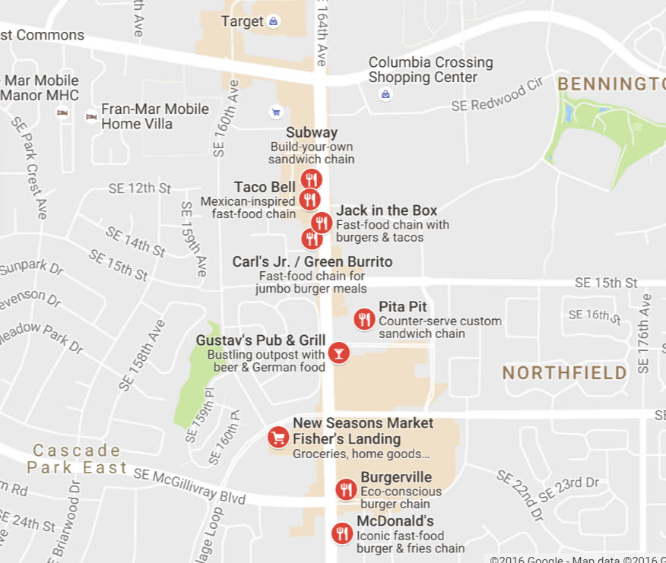

**SUBJECT**

Conclusion

As indicated preceding, fastfood restaurant properties in the subject sub-market have shown continued tight vacancy and consistent strong demand with stable to rising lease rates. In addition, there is currently no significant fastfood restaurant construction planned in the subject’s immediate to expanded market area due to a lack of suitable / available sites. Thus, occupancy is expected to remain very high with stable / strong demand over the near and long-term investment horizons.