|  |
| --- |
| Market Analysis |

Market Area Map – ${submarket} Submarket

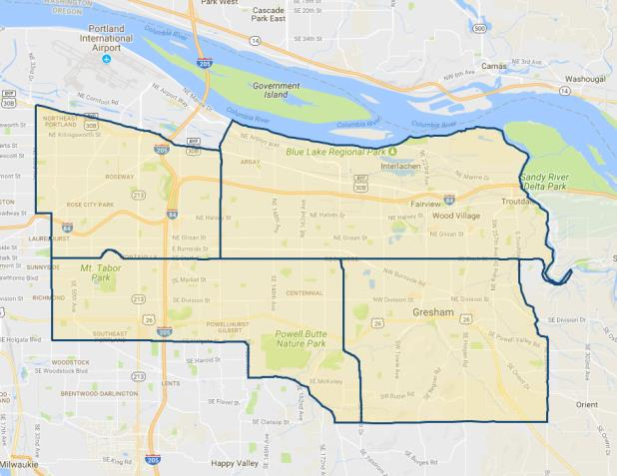

**SUBJECT**

Restaurant / Bar Vacancy and Absorption

The appraiser used **CoStar** to produce a search of the subject’s expanded and competing ${submarket} submarket for **restaurant / bar properties**. As of January 2020, report indicates an extremely low total sit-down restaurant / bar vacancy of 0.7% (8,297 SF out of 1,130,903 SF; 256 properties), with a 5-year average vacancy only a bit higher at 2.6%, but still indicating long-term tight market conditions. In tandem with strengthening market conditions, average asking rental rates for restaurants have exhibited an upward trend over the past 5 years. The current surveyed average restaurant rent is $24.46 per SF, up from the 5-year average of $13.23 per SF per year NNN. However, these statistics can be sharply skewed by the available inventory at any given time, and may be fully reflective of the market as a whole. Finally, the past year average sale price was $219 / SF – up from the 5-year average of $164 / SF, with a 5-year average cap rate of 6.7%.

${submarket} Submarket

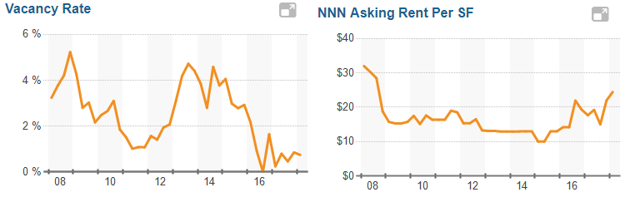

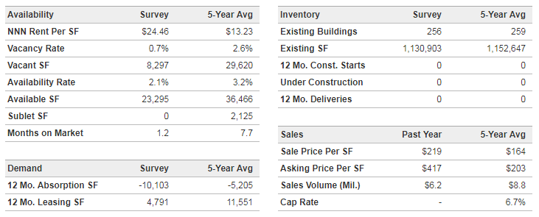

Also provided following is a map of the immediate area which locates the subject relative to other nearby sit-down restaurant and bar / tavern competition. This map shows the subject to have typical nearby competitors that exist along the immediate SE Division Street commercial corridor, as well as the expanded Centennial neighborhood. Overall, there exists somewhat limited suitable land available for new competitors to enter the immediate market, though the market appears in a stabilized mode with not large enough demand for new restaurant / bar construction. The closest competitors in proximity to the subject include Lariat Lounge (subject), Pub 181, Time Out Pub, Spearmint Rhino Strip Club, Kelli’s Café, Duke’s American Bar & Grill, Rachel’s Bar & Grill, and the Rumpus Room. In addition, there are a number fastfood restaurant chains are also concentrated in the immediate area, including Dairy Queen just east of the subject, plus McDonald’s, Burger King, Burgerville, KFC, Carl’s Jr., Taco Bell, Taco Time, Subway and Little Caesar’s Pizza.

**restaurant / BAR location Map**

**SE DIVISION COMMERCIAL CORRIDOR / CENTENNIAL AREA**

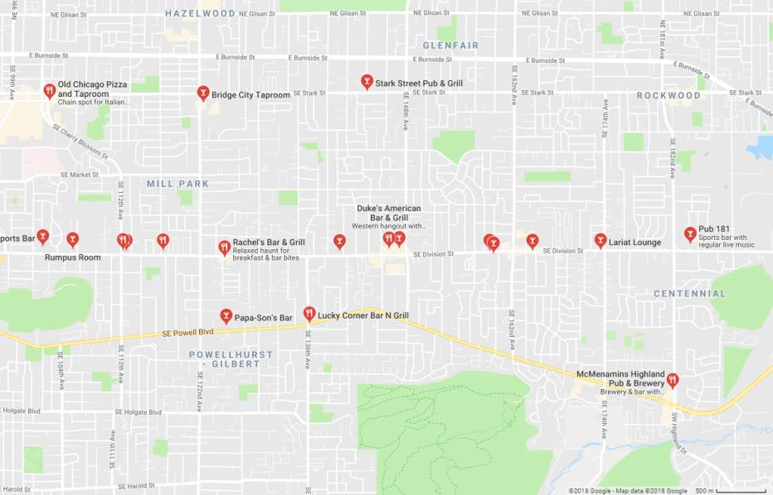

**SUBJECT**

Conclusion

As indicated preceding, sit-down and fastfood restaurant properties in the subject sub-market have shown continued tight vacancy and consistent demand with stable to rising lease rates. In addition, there is currently no significant sit-down restaurant or bar construction planned in the subject’s immediate to expanded market area due to a lack of suitable / available sites. Thus, occupancy is expected to remain very high with stable / strong demand over the near and long-term investment horizons.

The subject is located SE Division Street – one over several primary east-west commercial corridors serving the area and the immediate area’s direct linkage to Interstate 205. Signs of market strength are evident within the submarket, with vacancy near 5-year lows. Overall, we believe that the short and long-term outlook for the subject property remains positive.