|  |
| --- |
| Market Analysis |

Market Area Map – ${submarket} submarket

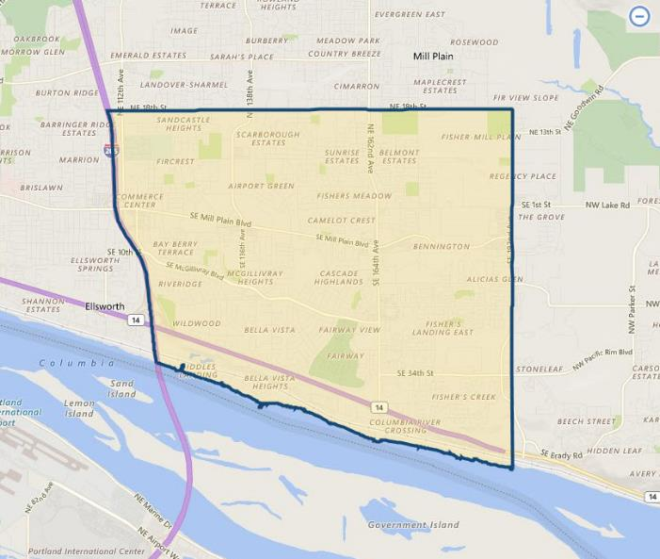

**SUBJECT**

Fastfood Restaurant Market Overview

As of June 2020, **CoStar** shows the overall **fastfood restaurant vacancy** in ${submarket} submarket at 0.0% (0 SF out of 16,227 SF; 7 restaurants averaging 2,318 SF). This on-line survey is considered sufficiently comprehensive and obviously omits several properties along the immediate highway corridor. Note that a wider survey of all restaurant space (sit-down and fastfood) indicates a current market vacancy of 0.0% out of roughly 52,000 SF of total restaurant inventory. However, the focus of our survey is those restaurants with drive-thru capability and appeal to a wide array of fastfood operators. Vacancy in this submarket has held fairly consistent at around 0.0% to 1.0% for most of the past several years. Most properties are either corporate-owned, long-term leased to franchisees, or owner-occupied.

${submarket} Restaurant Submarket

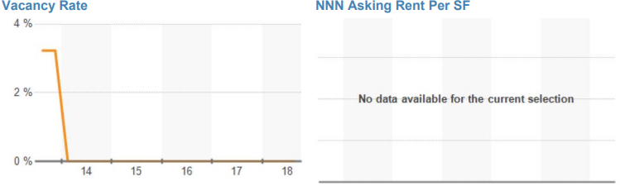

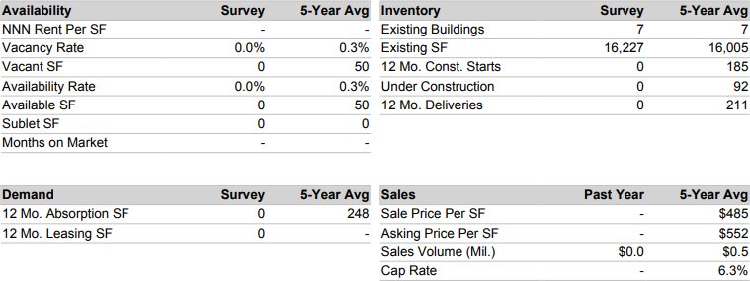

Also provided following is a map of the immediate area which locates the subject relative to other nearby fastfood competition. This map shows the subject to have typical nearby competitors that are common along the immediate primary commercial corridors. However, there exists little suitable land available for new competitors to enter the immediate market. The closest competitors within a few blocks of the subject along Newberg Highway 214 (east of I-5) include Burger King, McDonald’s, KFC, Taco Bell, Dairy Queen, Subway fast food restaurants, plus a Dutch Bros. coffee drive-thru. West of I-5 at its NW quadrant and near the outlet mall are Arby’s, Jack in the Box and Subway fast food restaurants, as well as Panera Bread and Red Robin. McDonald’s, Carl’s Jr. / Green Burrito, Burger King, Arctic Circle and Subway restaurants are located at the opposite / east end of town along Mt. Hood Avenue (Hwy 214) and Pacific Highway 99E. No vacant fastfood or sit-down restaurants noted during our inspection of the neighborhood, or found on the commercial listing services.

**fastfood restaurant location Map**

**west woodburn / interstate 5 AREA**

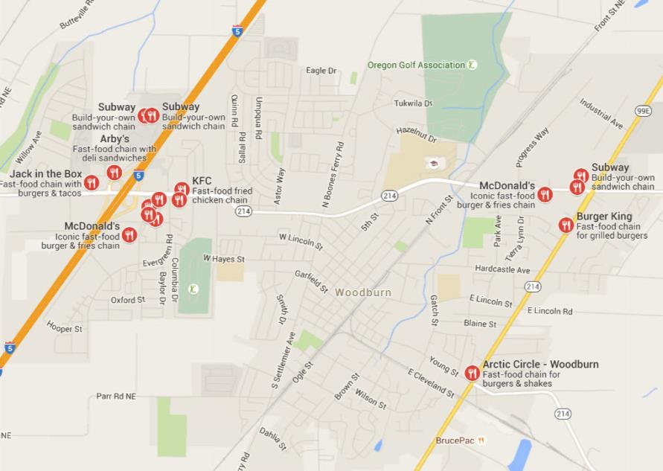

**SUBJECT**

Conclusion

As indicated preceding, retail properties in the subject sub-market continue to be in high demand, and slightly undersupplied. In addition, the market for fastfood restaurant space is very strong with no vacancy and strong rental rates. Discussions with brokers active in the immediate market indicate that properties in good condition with parking typically rent / sell at a premium due to the scarcity of such properties. Gradually increasing rental rates are forecast over the next 12 to 24 months due to continued good market conditions with limited new supply anticipated.