|  |
| --- |
| Market Analysis |

Market Area Map – ${submarket} submarket

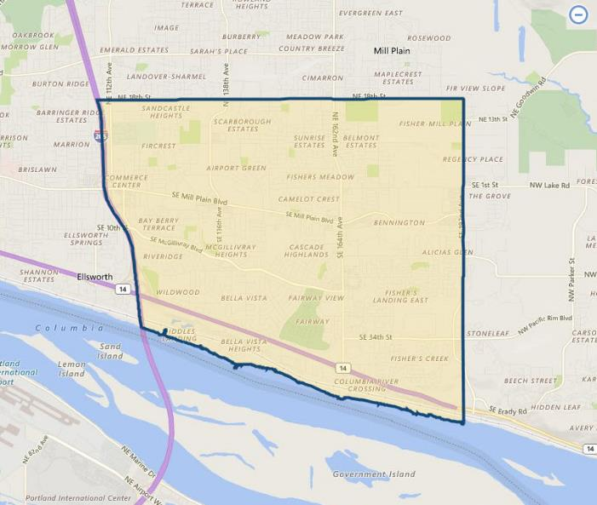

**SUBJECT**

Restaurant Vacancy and Absorption

The appraiser used **CoStar** to produce a search of the subject’s expanded ${submarket} submarket (which includes the immediate Fishers Landing and nearby Cascade Park / Mill Plain One areas) for **sit-down restaurant properties**. As of March 2020, report indicates a total restaurant vacancy of 3.0% (15,756 SF out of 532,824 SF; 106 properties), with a 5-year average vacancy only slightly higher at 4.2%. This would infer very tight market conditions which have persisted for a number of years. The current average asking rental rates for sit-down restaurants is currently quoted at $13.94 / SF, an increase over the average of $17.54/ SF in the subject market over the past 5 years. Most properties are leased on a triple net basis. Note that the average rent is a function of the quality of the available pool of properties, and not a good indicator of average rents on a market-wide basis. Finally, the 5-year average for sale price is $366 / SF – up significantly from the 5-year average of $242 / SF.

${submarket} Restaurant Submarket

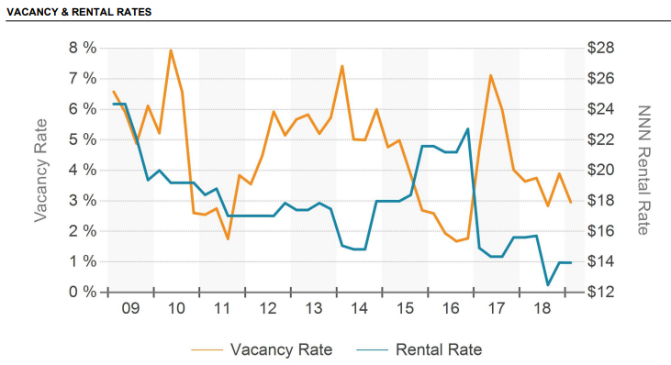

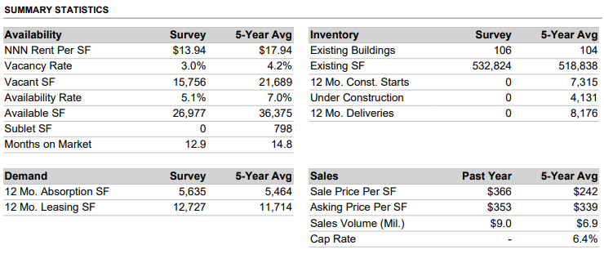

Also provided following is a map of the immediate area which locates the subject relative to other nearby fastfood competition. This map shows the subject to have typical nearby competitors that are common along the immediate primary commercial corridors. However, there exists little suitable land available for new competitors to enter the immediate market. Major sit-down restaurants in the area include Chipotle Mexican Grill, Panera Bread, Olive Garden, Spaghetti Factory, Red Robin, Black Bear Diner, and Gustav’s Pub & Grill. The closest competitors are only located within a few blocks of the subject along NE 164th Avenue (mostly to the south of SE Mill Plain Blvd.) and include Subway, Taco Bell, Carl’s Jr. / Green Burrito, McDonald’s, Jack in the Box, Burgerville, and Killer Burger fast food restaurants.

No vacant, free-standing fastfood or sit-down restaurants noted during our inspection of the neighborhood, or found on the commercial listing services. The only restaurant space available was a 6,000 SF restaurant building at 16519 SE McGillivray Blvd. (two blocks south of the subject) which is listed for lease at $30.00 per SF, modified gross (tax and insurance included – equivalent NNN rate is probably closer to $26.00 per SF). This property has been on the market for 12 months and continues to be occupied by Eastland Sushi & Asian Cuisine, and is currently owner-occupied. Discussions with the listing broker indicate the owners would lie to retire, and that it has proved tough to re-tenant this property with a more traditional sit-down restaurant due to its dated interior layout / design.

**NEARBY restaurant Map- Fishers landing AREA**

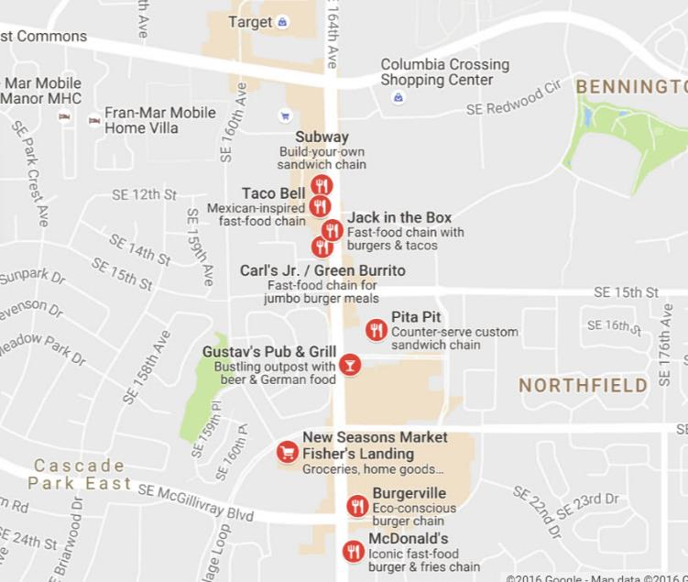

**SUBJECT**

Conclusion

As indicated preceding, restaurant properties in the subject sub-market have shown continued tight vacancy and consistent strong demand with stable to rising lease rates. In addition, there is currently only one free-standing, sit-down restaurant available in the subject’s immediate to expanded market area, primarily due to strong economic conditions and a lack of suitable / available sites for new properties. Thus, occupancy is expected to remain very high with stable / strong demand over the near and long-term investment horizons.