|  |
| --- |
| Market Analysis |

Market Area Map – ${submarket} SUBMARKET

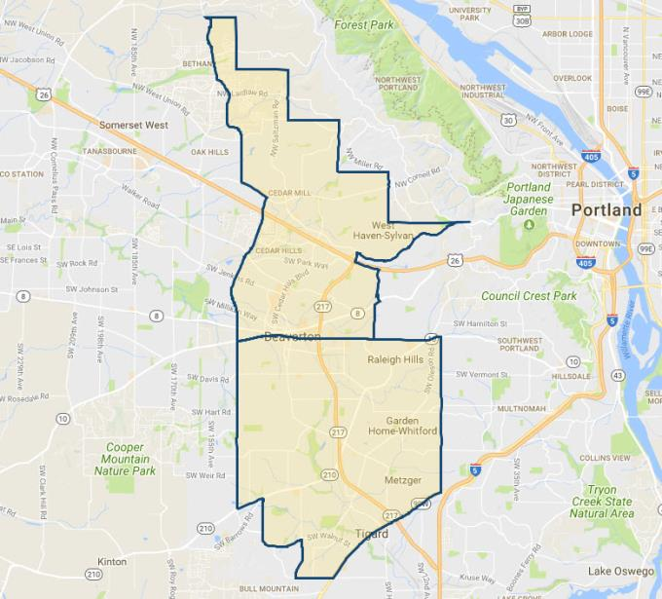

**SUBJECT**

Retail Vacancy and Absorption

With respect to the subject’s immediate to expanded ${submarket} submarket (see map above), **CoStar** estimates a current **retail vacancy** of 2.8% (305,903 SF out of 10,947,388 SF; 727 properties) as of January 2020, with modest positive 12-month net absorption of 84,369 SF. Average asking rents are $22.11/SF/Yr., up from the 5-year average is $18.55/SF/Yr. The has been modest new retail construction occurring within the past 12 months with 141,852 SF in starts, but only 23,337 SF delivered over the past 12 months. Hence, this nominal new supply should result in continued tight market conditions and rising market rents. Charts of this activity are shown following.

${submarket} Retail Submarket

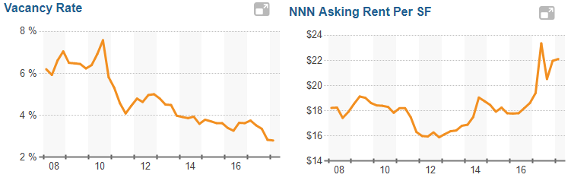

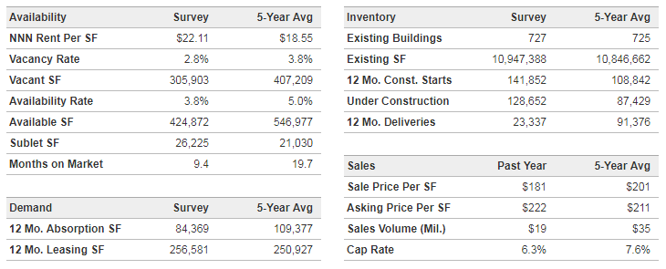

Conclusion

As indicated preceding, retail properties in the subject sub-market continue to be in high demand, and slightly undersupplied. Discussions with brokers active in the immediate market indicate that properties in good condition with parking typically rent / sell at a premium due to the scarcity of such properties. Gradually increasing rental rates are forecast over the next 12 to 24 months due to continued good market conditions with no new supply anticipated.