|  |
| --- |
| Market Analysis |

Market Area Map – ${submarket} SUBMARKET

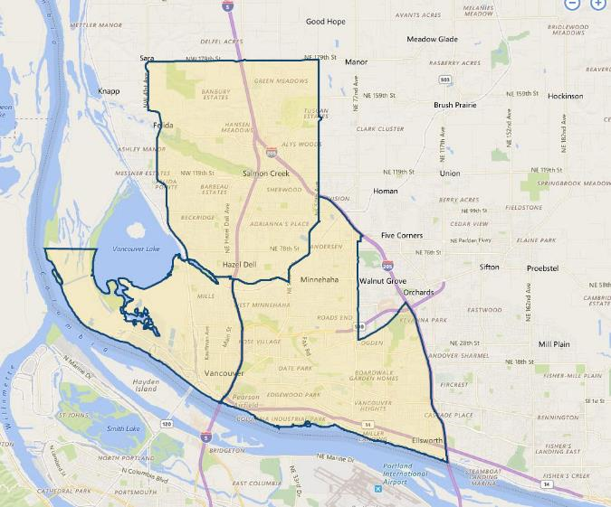

**SUBJECT**

Vehicle Service and Repair Vacancy and Absorption

With respect to the subject’s immediate to expanded marketplace consisting of ${submarket} areas, market research published by **CoStar**, estimates a total **vehicle service and repair** vacancy of just 0.6% (2,148 SF out of 367,095 SF, 70 properties) as of October 2020. Vacancy rates have been running below 1.5% for the past 3-years and below 4% since mid-2014. The 5-year average is similar at 0.7%. Leasing / absorption has been insignificant at 2,148 SF, primarily due to the lack of available properties which generally operate at or near full occupancy. The average asking rent in this market area is $12.00 per SF (primarily NNN), with the 5-year average slightly less at $10.58 per SF. As is typical in this largely built-up area, no new construction was noted in the past year.

${submarket} Vehicle Repair Submarket

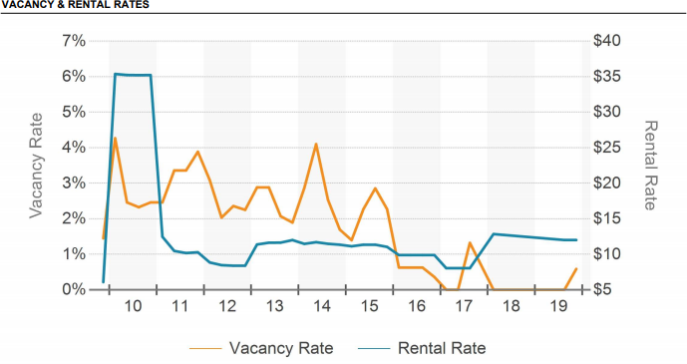

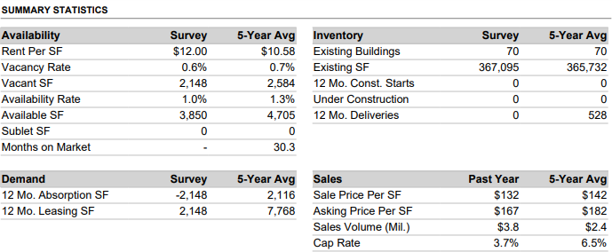

In addition to the preceding, the appraiser used CoStar to produce a search of the subject's expanded Portland / Vancouver vehicle service and repair market. CoStar estimates a current vacancy of 2.0% (118,624 SF out of 5,981,579 SF, 1,002 properties surveyed) as of October 2019, with negative net absorption of -56,244 SF over the past 12 months, generally offset by even more positive leasing of 59,439 SF over this same period. Vacancies historically have ranged below 3% in the past five years with the 5-year average at 1.7%. Average asking rental rates were quoted at $13.88 per SF which is slightly higher than the 5-year average of $12.75 per SF.

Portland / Vancouver Metropolitan Vehicle Repair Market

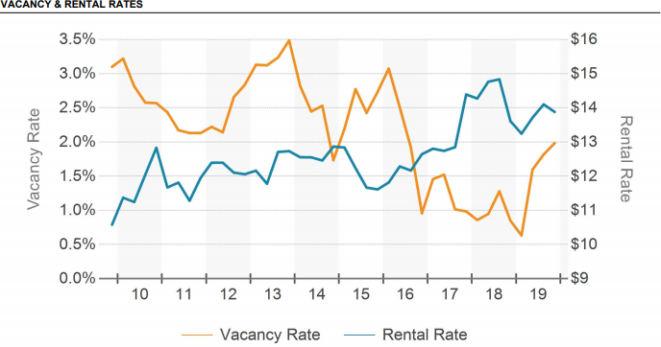

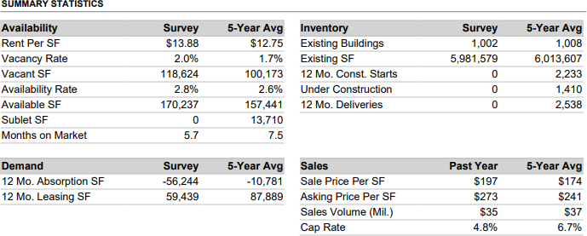

Conclusion

As indicated preceding, auto service and repair properties in the subject-market have historically been strong most likely due to the downtown periphery location with a heavy population base of auto commuters that work nearby. Demand is strong as suggested by the low vacancy rates for this property type over the past five plus years. Competition with the owner-user market has put upward pressure on vacancy and downward pressure on lease rates, especially in the auto service sector. Thus, occupancy is expected to remain relatively stable with continued minimal downward trending in the near future.

Rents for commercial space in the immediate area are generally quoted on a “triple net” expense basis, whereby the tenants are responsible for all expenses. Lease terms are normally five years or less. Tenants typically pay annual 3% rent increases. The Vancouver area commercial service markets has seen very good gains over the last few years as absorption and vacancy have hit historic lows which has translated into increasing rental rates; especially for properties in first and second tier locations.