|  |
| --- |
| Regional Analysis |

Location

A market area is defined as a geographic area characterized by a similarity of users and/or uses within which any change has a direct and immediate effect on the subject property and its market value. The subject property is located in Albany, Oregon in Linn County. Reference to the Market Area Map identifies the subject property and its location within the general region.

Since the mid-19th century, Albany has been a regional center of trade, manufacturing and services in the central Willamette Valley. While the traditional wood products and agricultural industries continue to be an important part of the local economy, the area business environment has become one of the most stable and diverse in Oregon. The city of Albany was incorporated in 1864. It is located in the Willamette Valley 45 miles north of Eugene, 69 miles south of Portland, 24 miles south of Salem. Albany is Oregon’s 12th largest city and contains 16 square miles (city limits) and 21.7 square miles (urban growth boundary.)

The region area is characterized by a moderate marine climate with few temperature extremes, and many seasonal changes. The area is tornado and earthquake free and is known for its moderate climate conditions. Average annual rainfall is 40 inches. The average winter temperature ranges from the middle or low 30s at night to the middle and high 40s during the day. The average summer temperature ranges from the low 50s at night to the low 80s during the day with some extreme temperatures upward to 100 degrees. Linn and Benton Counties are in the center of the 100-mile long Willamette Valley. This broad valley, lying between the Cascade Mountains and the coast range are soils and a climate that rank it among the world’s most productive agricultural areas.

Population

Over the last decade, the City of Albany has continued as a population growth leader within the immediate Mid-Willamette Valley. As of 2019, the population of Albany is 55,007. The following table summarizes the population figures for Albany, Lebanon, and the surrounding communities.



Accessibility/Linkage

There are three highways which provide primary access to the City of Albany. Interstate 5 runs north / south along the east side of the City, while US Highway 20 travels in an east / west direction through the north end of Albany. Highway 99E transverses the City at the north end before turning southward through the west side of the City. Amtrak provides train service to Albany from its station at 10th Avenue SW on two routes. Long-haul train route, the Coast Starlight (with service from Los Angeles to Seattle) stops in Albany daily in both directions. Amtrak Cascades commuter trains operate between Vancouver, British Columbia and Eugene, Oregon, and serve Albany several times daily in both directions. Public transportation within Albany is provided by Albany Transit System (ATS). Connections to Corvallis are provided by bus service via the Linn-Benton Loop and the Valley Retriever Thruway inter-county bus systems. ATS, the Linn-Benton Loop, and the Valley Retriever all provide bus service to and from the Amtrak station. The nearest commercial air service is located at Mahlon Sweet Airport in Eugene, Salem Municipal Airport, and the Portland International Airport in Portland.

Economy/Employment

Albany has historically been known as the rare metals capitol of the world with noted production of zirconium, hafnium, and titanium. Agriculture (Linn County is known as the "grass seed capital of the world"); wood products, food processing, and manufactured homes production have also been major employers. The decline of the timber industry and the outsourcing of manufacturing jobs have left Linn County with a relatively high unemployment rate over the last decade.

According to the State of Oregon Employment Department, Linn County had an estimated 4.6% unemployment rate (seasonally adjusted) in June2019, with the YTD figures slight lower. This is up slightly from one year ago at 4.1%, though down from 5.8% in January 2015. Comparatively, Oregon State posted a 4.1% unemployment rate in June 2019, down from 5.5% unemployment rate in August 2015. These current rates are near National average was 3.7% as of June 2019. Linn County has historically exhibited higher unemployment and lower per capita income than its neighboring counties, with particular disparity to neighboring Benton County. The following charts and table show unemployment rates for Oregon, the Albany MSA and neighboring areas.

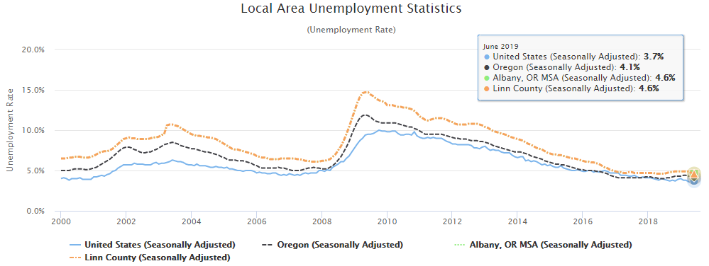

Source: [www.qualityinfo.org/ed-uesti/?at=1&t1=4101000000,4121010540,4104000043~unemprate~y~2000~2019](http://www.qualityinfo.org/ed-uesti/?at=1&t1=4101000000,4121010540,4104000043~unemprate~y~2000~2019)





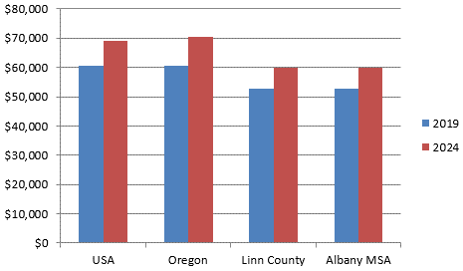

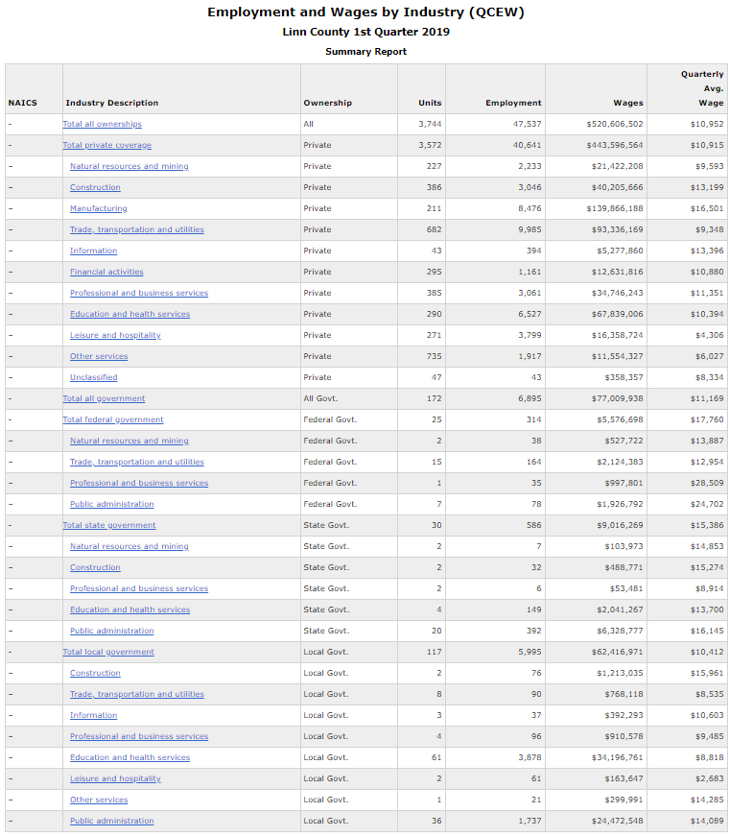

[www.qualityinfo.org/ed-ewind/?at=1&t1=0~4104000043~00~1~0000~00~00000~2019~01&t2=0~4101000000~00~5~0000~00~00000~2019~01](http://www.qualityinfo.org/ed-ewind/?at=1&t1=0~4104000043~00~1~0000~00~00000~2019~01&t2=0~4101000000~00~5~0000~00~00000~2019~01)

Also of influence on the Albany area is nearby Corvallis, the Seat of Benton County, which has a highly educated, middle- to upper-income population. Oregon State University and major firms including CH2M Hill, Hewlett Packard, Evanite Fiber Corporation, Good Samaritan Hospital, and The Corvallis Clinic are the economic backbone of the community and their presence enables Corvallis residents to enjoy a standard of living uncommon in many Oregon communities. As of 2019, statistics show that the Corvallis MSA (Benton County) has a Household Income of $58,988 was only slightly below Oregon State's $60,427, but significantly above Linn County's $52,862. *

* <https://datausa.io/profile/geo/oregon/>

The economic downturn beginning in 2008 resulted in significant job losses for the Albany / Corvallis area with many small firms closing or downsizing, including Albertson's, Rays Food Place, Kmart and Sears in Albany.

The single biggest job creation came with the opening of a new Wal-Mart store at 1330 Goldfish Farm Road SE, Albany, in 2012. This is an 187,000-square-foot store featuring a grocery, a general merchandise department including home and living sections, a garden center, a drive-up pharmacy and a Subway sandwich outlet.

The store anchors a larger development on the west side of Goldfish Farm Road, south of Santiam Highway and employs 300 full and part-time workers. In addition, both Hobby Lobby and Marshalls opened in Albany in 2014 employing 65 and 60 people, respectively. Finally, Winco is currently constructing a new store at the former Kmart location, on the south side of Highway 99E, just off of I-5. The store is planned for an opening by mid-2017.

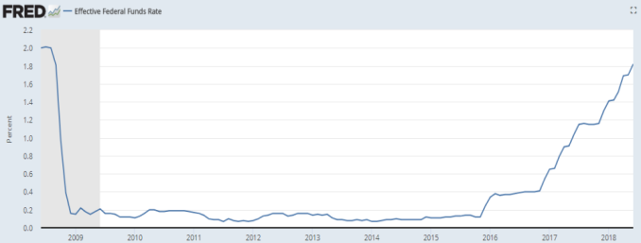Since the past recession (shaded portion of the graph below) the Effective Federal Funds Rates have remained compressed below 0.25% since late 2008 through 2015. Over the first half of 2017, the FOMC continued to gradually reduce the amount of monetary policy accommodation. On June 14, 2018, the Federal Open Market Committee directs the Desk to undertake open market operations as necessary to maintain the federal funds rate in a target range of 1-3/4 to 2%, including overnight reverse repurchase operations at an offering rate of 1.75%. On a 12-month basis, both overall inflation and inflation for items other than food and energy have moved close to 2%. Indicators of longer-term inflation expectations are little changed, on balance.

<https://fred.stlouisfed.org/series/FEDFUNDS>

Consistent with its statutory mandate, the Committee seeks to foster maximum employment and price stability. The Committee expects that further gradual increases in the target range for the federal funds rate will be consistent with sustained expansion of economic activity, strong labor market conditions, and inflation near the Committee's symmetric 2% objective over the medium term. Risks to the economic outlook appear roughly balanced.In view of realized and expected labor market conditions and inflation, the Committee decided to raise the target range for the federal funds rate to 1-3/4 to 2%. The stance of monetary policy remains accommodative, thereby supporting strong labor market conditions and a sustained return to 2% inflation.

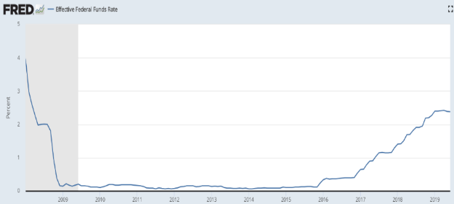Since the past recession (shaded portion of the graph at left) the Effective Federal Funds Rates have remained compressed below 0.25% since late 2008 through 2015. Over the first half of 2017, the FOMC continued to gradually reduce the amount of monetary policy accommodation. On June 18-19, 2019, the Federal Open Market Committee indicates that the labor market remains strong and that economic activity is rising at a moderate rate. Job gains have been solid, on average, in recent months, and the unemployment rate has remained low. Although growth of household spending appears to have picked up from earlier in the year, indicators of business fixed investment have been soft. On a 12-month basis, overall inflation and inflation for items other than food and energy are running below 2.0%. Market-based measures of inflation compensation have declined; survey-based measures of longer-term inflation expectations are little changed.

<https://fred.stlouisfed.org/series/FEDFUNDS>

Consistent with its statutory mandate, the Committee seeks to foster maximum employment and price stability. In support of these goals, the Committee decided to maintain the target range for the federal funds rate at 2-1/4 to 2-1/2 percent. The Committee continues to view sustained expansion of economic activity, strong labor market conditions, and inflation near the Committee’s symmetric 2 percent objective as the most likely outcomes, but uncertainties about this outlook have increased. In light of these uncertainties and muted inflation pressures, the Committee will closely monitor the implications of incoming information for the economic outlook and will act as appropriate to sustain the expansion, with a strong labor market and inflation near its symmetric 2 percent objective.

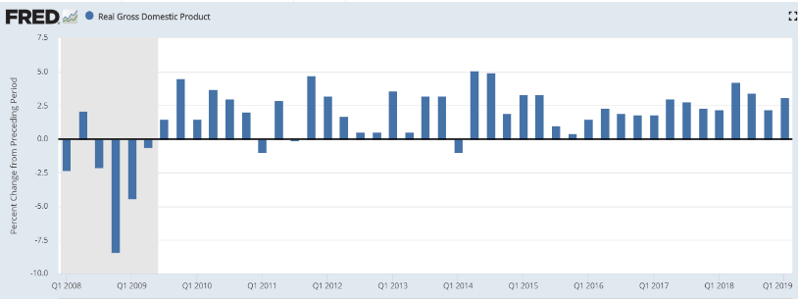The projection for U.S. economic activity prepared by the staff for the June FOMC meeting was revised down somewhat on balance. Real GDP growth was forecast to slow to a moderate rate in the second quarter and move down to a more modest pace in the second half of the year, primarily reflecting a more downbeat near-term outlook for business fixed investment.

<https://fred.stlouisfed.org/series/A191RL1Q225SBEA>

The projection for real GDP growth over the medium term was little changed, as the effects of a higher projected path for the broad real dollar and lower trajectory for foreign economic growth were largely counterbalanced by a lower projected path for interest rates. Real GDP was forecast to expand at a rate a little above the staff’s estimate of potential output growth in 2019 and 2020 and then slow to a pace slightly below potential output growth in 2021. The unemployment rate was projected to be roughly flat through 2021 and remain below the staff’s estimate of its longer-run natural rate. With labor market conditions judged to be tight, the staff continued to assume that projected employment gains would manifest in smaller-than-usual downward pressure on the unemployment rate and in larger-than-usual upward pressure on the labor force participation rate.

The staff’s forecast for inflation was little changed on balance. The forecast for total PCE price inflation this year was revised down somewhat, reflecting a lower near-term projection for energy prices. The core inflation forecast for this year was unchanged at a level below 2 percent. Both total and core inflation were projected to move up slightly next year, as the low readings early this year were expected to be transitory, but nevertheless to continue to run below 2 percent.

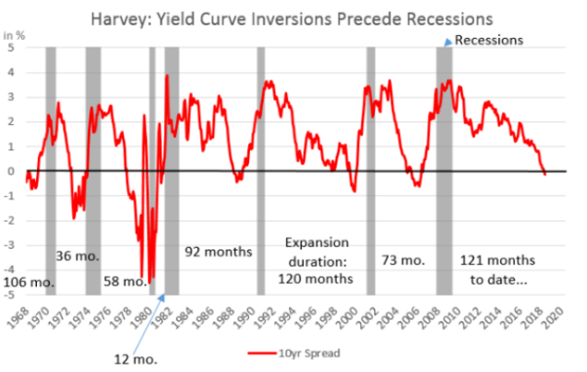In spite of very low unemployment and low inflation numbers, over the first half of 2019 one key sign may be starting to point to a coming U.S. recession. This sign is known as the “Inverted Yield Curve” which has been an economic indicator that has preceded every recession over the past five decades. Yield curve inversion is a condition known among economists and Wall Street traders that refers to when long-term interest rates are paying out less than short-term rates. That curve has been flattening out and sloping down for more than a year, raising worries among some analysts that investors' long-term view of the market is not positive and that an economic downturn is looming. A history of the yield curve since 1968 to present is shown in the chart above, which clearly shows the yield curve starting its inversion in the first half of 2019.

In late June 2019, an inauspicious milestone was achieved: the yield curve remained inverted for three months, or an entire quarter, which has for half a century been a clear signal that the economy is heading for recession in the next 9 to 18 months, according to Campbell Harvey, a Duke University finance professor who spoke to NPR. His research in the mid-1980s first linked yield curve inversions to recessions.

How this inverted yield curve will impact the Albany / Linn County metro real estate market remains to be seen. Certainly any extended business expansion can expect a cooling period where the market digests its gains – a natural part of the business and real estate cycles. With the exceptions of the apartment and mini-storage sectors, there has been no over-building in subject’s metro area with vacancies in most commercial retail, office and industrial sectors remaining tight and consistent rent increases the norm. Any general slowdown in the local and national economies may ease vacancy and rent increase conditions a bit, but at this point there are no predictions for a major downturn in the various real estate sectors of Albany / Linn County.

Government and Utilities

Albany represents a full-service city with typical urban services such as police and fire departments, zoning / planning regulations, and public education. Linn County Courthouse is located within the City of Albany CBD. Major County functions include tax assessments, county tax collections, maintenance of county roads and bridges, law enforcement services, and the recording of public records and property transactions.

Public water and sanitary services are provided by the City of Albany. Electrical services are provided by Pacific Power and Consumers Power. Northwest Natural Gas Company provides natural gas service, Qwest provides telephone service, and Comcast provides Cable TV service.

Education

Education is an essential part of community life in Corvallis, due in part to the presence of Oregon State University. Area residents are served by the Corvallis School District, which includes 11 elementary schools, three middle schools, two high schools, and one alternative school. There is a total enrollment of over 7,200 students.

The Albany school system consists of two high schools, three junior high schools, 14 elementary schools. Albany is located 15 minutes west of Oregon State University. Linn-Benton Community College also serves the cities of Albany and Corvallis area. It is the fifth largest of Oregon’s community colleges and offers 50 associate degrees.

Conclusion

The future for real property in Linn County appears positive as a direct result of the region’s UGB and the development constraints that limit urban sprawl. As such, the land supply will remain stable to decreasing and yield rising prices. The life cycle of dated improvements will eventually make way for redevelopment opportunities in the industrial, commercial and residential segments of the market.

Overall, the county’s central location is rated above average on a convenience, demographic and amenity basis. The future demand for the Linn-Benton County region appears stable, with a healthy recovery from national/local economic recession during 2008-2010. The economic viability of the area is expected to improve. Population projections for the area are favorable as growth expands outward from the historic core areas. As the economy continues to expand and diversify, the probable future of the area is good.