|  |
| --- |
| Regional Analysis |

Location

Situated in the Rogue Valley, Medford is the seat of Jackson County. Jackson County lies in southwest Oregon between Josephine County to the west, Klamath County to the east, Douglas County to the north, and the State of California to the south. The county covers approximately 2,800 square miles and encompasses a wide array of geography including major mountain ranges and river basins. The City of Medford is the largest city in the county, is the county seat and is located in south central areas along Interstate 5. Medford is approximately 30 miles north of the California border, 260 miles south of Portland, and 100 miles east of the Pacific Ocean, and a regional trade center for southern Oregon and northern California.

The City of Ashland is located approximately 15 miles south of the City of Medford and 16 miles north of the Oregon/California border. Ashland is one of the cultural centers of the region with venues such as the Oregon Shakespeare Festival, Oregon Cabaret Theater, and numerous art galleries and museums. Ashland’s economy is based on three industries, the first being tourism followed by education and wood products. In recent years several high-tech companies have been established or relocated to the area. The two major employers in Ashland are Southern Oregon University (SOU) and the Oregon Shakespeare Festival. Retail trade plays an important role in the Ashland economy due to these employers, as well as the influx of Californians.

The county enjoys views and access to the Cascade Mountains and the Coastal mountain range which is part of the Siskiyou National Forest. A majority of the county is classified as forestland containing Douglas Fir and hardwoods. Approximately 60% of the land area is held in public ownership. Gently rolling hills to fairly steep mountain ranges and river basins typify the topography. The climate is typical of Southern Oregon with moderate summers and winters, with summer month’s temperatures averaging 86 to 88 degrees and winter temperatures averaging 28 to 32 degrees. The County averages about 18 inches of precipitation per year with a growing season of 160 days.

The Rogue River, the primary drainage tributary in southern Oregon, flows through central and northeastern portions of the County. Major tributaries to the Rogue River in Jackson County are the Applegate River, Elk Creek, Butte Creek, Evans Creek, and Bear Creek. The largest body of water within the county is Lost Creek Lake located on the Rogue River in northeastern areas of the County. All provide abundant recreational opportunities.

Transportation

Jackson County is serviced by primary transportation routes serving both sides of the county and southwestern Oregon. Interstate 5 runs through the central and western portions of the county, and is the main travel route for western Oregon and the Pacific Northwest. Local State Highways 62, 66, and 140 link Medford and the larger Rogue Valley with areas to the east including Klamath Falls and other areas of central Oregon. State Highway 238 runs west from Medford providing access to the Applegate River and on to the City of Grants Pass, located approximately 30 miles west of Medford. All the highway systems converge in the Medford-Ashland area.

Public transportation options include the Rogue Valley Transportation district (RVTD), which provides bus routes throughout Rogue Valley communities, including Medford, Ashland, Central Point, Jacksonville, and White City. Greyhound Bus also maintains regular travel route schedules from their Medford terminal. Other transportation includes several taxicab companies.

The Rogue Valley International-Medford Airport is located in north Medford off Crater Lake Highway (State Highway 62). This facility provides commercial air service (passenger and cargo) to the larger southern Oregon and Pacific Northwest area. Major carriers include United, Alaska, Delta, and Allegiant airlines, primarily servicing flights to the largest airports in the western United States.

Rail service is provided by Southern Pacific Railroad. There are several trucking companies (including TNT/Reddaway Truck Lines), which ship all types of cargo and equipment throughout the county.

Population Trends

Jackson County’s population grew at a rate similar to that of Oregon State between 2000 and 2010, at approximately 1.2% per year. Growth has slowed to approximately 0.90% per year in the following 9 years and is anticipated to continue at 1.1% annual growth over the next 5 years, right in step with the state’s average rate of 1.2%.

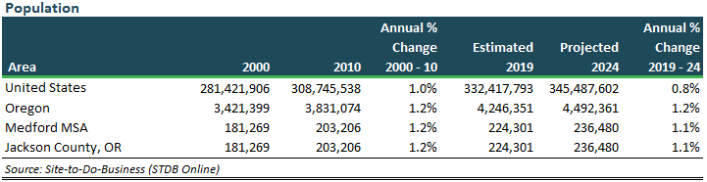

Governmental & Community Services

The population of Jackson County is serviced by adequate public utilities and government services. Police and fire protection as well as all necessary urban utilities are available in all major residential, commercial and industrial areas. Major utility providers in the area include Pacific Power and Light (PP&L), Avista Utilities (natural gas), CenturyLink, City of Medford water and sewer services, and Rogue Valley Sewer Services. The City of Medford has a Mayor-City Council form of government. The mayor is elected for a four-year term and presides over Council meetings. Jackson County operates with a three-member board of county commissioners.

The Jackson County area is served by two major hospitals; Asante Rogue Regional Medical Center, a full service 378-bed facility, and Providence Medford Medical Center, a full service 168-bed facility. Asante Rogue Regional Medical Center, which recently completed a major expansion and renovation, is the largest medical center in southern Oregon and northern California, providing regional health care with several specialized services. Numerous doctors and clinics are located in Medford-Ashland and the surrounding area.

The area's school system provides education for grades one through twelve and is comprised of 10 school districts with 34 elementary schools, 3 junior high schools, 8 middle schools, and 11 high schools. There are over 15 private schools. Higher education is provided by Rogue Community College, a two-year accredited public community college offering vocational and technical instruction serving Jackson County from Grants Pass. Southern Oregon University, a four-year accredited institution, is located in Ashland.

The Jackson County library system provides access to library services for all county resi­dents. Other cultural amenities include several theaters, museums, and art galleries. The most prominent cultural facility is the Shakespearean Theater located in Ashland which includes indoor and outdoor theaters for many types of performances, including the nationally renowned Shakespearean Festival, which runs annually from February to November. It is a major attraction for over 250,000 tourists that frequent the area annually.

Numerous recreational facilities are located throughout the area including state, county and city parks. The Rogue River provides many recreational activities including fishing, boating, and swimming. Other major attractions include Crater Lake National Park located in the far northeast part of the county, and the Oregon Caves National Monument located off U.S. Highway 199, southwest of Grants Pass. Numerous parks in the area provide outdoor activities such as hiking and camping.

Developmental Trends

The top 6 employers in Jackson County, according to The Chamber of Medford/Jackson County as of September 2019 are Amy’s Kitchen, Asante Health System, Harry & David, Lithia Motors, Pacific Retirement Services and Providence Health.

Industrial Development

Manufacturing and industrial production has played a large role in the region due to timber and mining. However, the timber and wood products sector has experienced a decline over the past decade due to environmental issues impacting private and public forest lands. Presently, the manufacturing sector represents approximately 9% of the total employment, with the largest notable industrial employer being Harry & David (fruit & gift products) with approximately 2,000 employees.

Commercial Development

About 91%of the local economy is made up of non-manufacturing related service industries (i.e. mining, construction, trade, government, services, finance, insurance, real estate, transportation, communication, health services, and utilities). Some of the largest non-manufacturing related employers include health systems and hospitals (Asante, Rogue Valley Medical Center, Providence Health), Lithia Motors, Inc. (auto-truck dealers), and Allegiant Air (commercial airline).

Medford serves as the prominent retail and office center in Jackson County and the larger southern Oregon and northern California area. County offices are located in the downtown area along with a variety of neighborhood service and re­tail businesses. Over the years, a large amount of retail and strip commercial development grew outward from the downtown core. Today, several shopping cen­ters serve the area including the Rogue Valley Mall, a regional shopping center anchored by J.C. Penney and Macy’s. Target is located adjacent to the mall. The center is approximately 540,000 square feet in size. Other centers include the redeveloped Medford Center, located in downtown Medford off Biddle Road, which includes Tinseltown Theatres, Sears, Rite-Aid, and Safeway as anchors; and the Fred Meyer shopping center located in north Medford on Crater Lake Highway near Interstate 5. A second Fred Meyer of approximately 142,000 square feet is located in the South Gateway Center near the south Medford I-5 interchange. Within this center is the Harry & David Country Store, a strip retail center, Sprint Communications (former Ernst Store), McGrath’s Fish House, and The Rink, an ice-skating facility. A newly developed Walmart superstore is located just to the south of Harry & David. Businesses in the Crater Lake Plaza power center off Crater Lake Highway in north Medford include Costco, Walmart, Lowe’s, Office Depot, Safeway, Outback Steakhouse, and AmericanWest Bank. Just south of this center, at the southwest corner of the intersection of Crater Lake Highway and Delta Waters Road, is Delta Center, a 29-acre PUD anchored by a 45,200 SF Sportsman’s Warehouse. Strip retail development surrounds the Sportsman’s including recently developed Buffalo Wild Wings and Texas Roadhouse restaurants.

Recent commercial construction near the Rogue Valley Mall includes Northgate Marketplace, a power center with two phases of retail-commercial completed, totaling 257,863 SF and including anchors such as Trader Joe’s, REI, PETCO, Dick’s Sporting Goods, Homegoods, and Marshalls. The third phase of the project broke ground in December 2017 with three leases signed to DaVita Dialysis, Stanton Optical, and Starbucks. The third phase has a less intensive commercial-professional zoning code and will include a mix of retail and office buildings. The developer of this project, Regency Centers, operates ten Oregon retail centers. Regency indicated that Northgate Marketplace is intended for a total of 417,000 SF on 40 acres, and will eventually employ up to 1,000 people.

In addition to these developments in Medford there is a factory outlet center at the I-5 interchange in Phoenix, with approximately 70,000 square feet of retail space. Commercial projects completed several years ago in Jackson County include Amy’s Kitchen in White City, an organic frozen food processor; Furniture Row at the I-5 interchange in Central Point; a Home Depot store in Phoenix at the I-5 interchange. A Walmart superstore in Eagle Point north of Medford, and a Lazy Boy store adjacent to Home Depot in Phoenix were also completed in the last several years.

The Medford office market is mainly comprised of low-rise and single-story office buildings, with a good number being owner occupied. Most office space users are county and state offices, lawyers, banks, Realtors, stockbrokers, insurance agents, and accountants. In recent years development of class A office space has occurred along McAndrews Road in east Medford, including the three-story, twin McAndrews Place and McAndrews Place II buildings; and the three-story AmeriTitle building. The newest commercial development is “The Commons” project, a multi-story office and retail development located in downtown Medford that opened in 2012. It is the corporate office headquarters for Lithia Motors. In addition, Navigator’s Landing, a 50-acre planned unit development near the Medford Airport, was established in 2003 and is slowly being developed with higher-quality Class A/B office buildings by individual land owners.

Residential Development

Since the bottom of the last housing crises in 2012, the Jackson County housing market experienced a 7-year growth cycle in which prices of residential properties increased each year. The latest average home priced reported by the Federal Reserve FRED database is $279,520 in Q-2 2019. This current average reflects a +73% increase in the average home price in the Medford MSA since 2012.

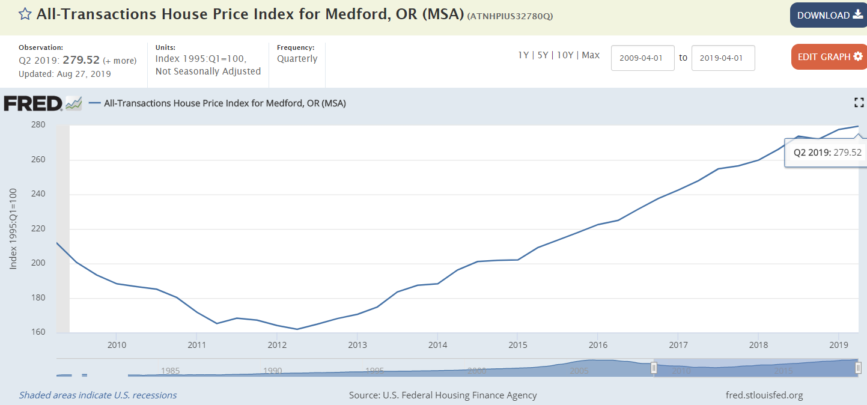

<https://fred.stlouisfed.org/categories/27319>

The demand for housing closely followed the County's population trends as discussed earlier, with significant residential development taking place primarily in Medford, Ashland, Central Point, White City, and Eagle Point. Housing has been oriented primarily around single-family units. Based on the desirability of the area and in-migration by retirees and out of state residents, as well as continued historically low mortgage rates, home pricing throughout the region increased significantly in recent years.

Economic Trends

The region has solid economic indicators. According to CoStar, over 2018, local employment growth was almost double national performance. Though Medford’s current 5.4% unemployment rate (refer to following unemployment discussion) is a bit higher than the statewide rate, the local economy is essentially at full employment. While the median household income in Medford sits below the national rate, at around $56,000, local incomes exhibited nearly 6% annual growth in 2018. Education and health services, along with natural resources, mining, and construction, were the two most-rapidly growing sectors in 2018 – each experienced annual growth near 9%.

At the height of the Great Recession, the Jackson County unemployment rate reached an all-time high of 14.7% in March 2009. This recession dispelled any notions that County and State government provides insulation from a deep national economic down turn. Recovery from the 2009 high was similar to that of the rest of the state with unemployment falling dramatically, reaching a low of 4.1% in May 2018, though has increased to 5.1% as of August 2019, as reported by the Federal Reserve FRED database.

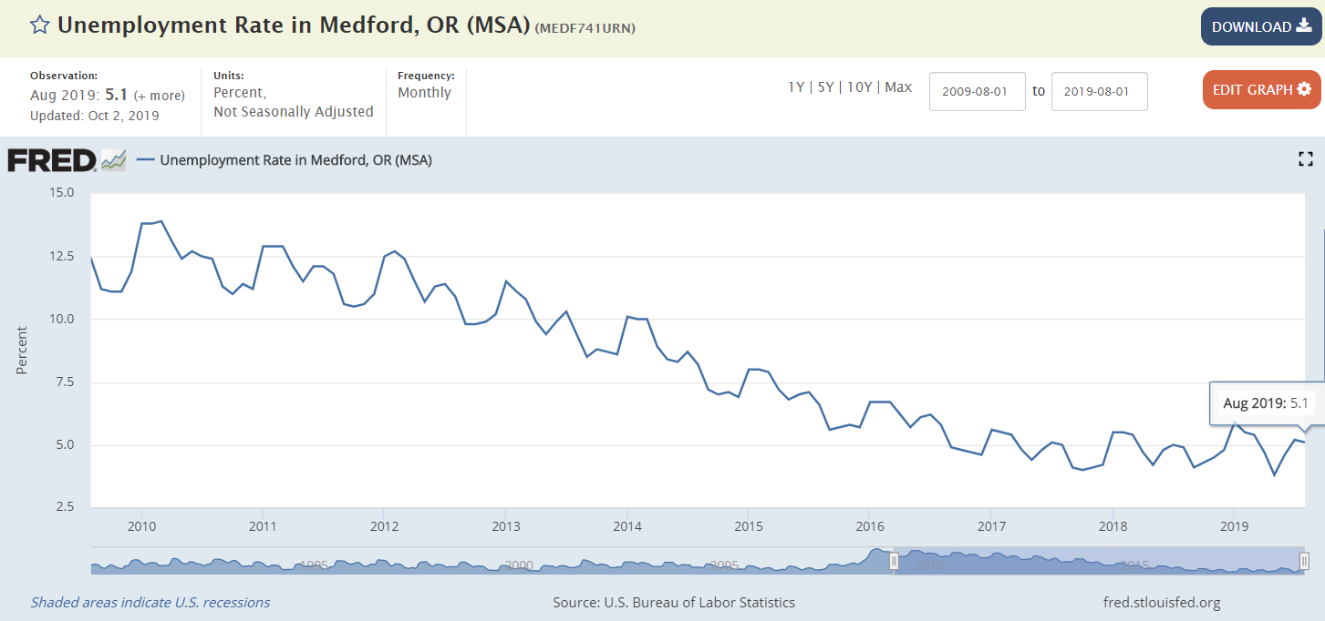

<https://fred.stlouisfed.org/categories/27319>

Medford’s economy is well-diversified, boasting many sizable employers across an array of industries. Of Oregon’s two Fortune 500 companies, one – Lithia Motors – is headquartered in Medford (Nike is the other, Headquartered in Portland). Lithia Motors is the fourth-largest automotive retailer in the United States, with 167 dealerships in 18 states.

Like much of Oregon, Medford’s economy was historically centered on agriculture and timber. This remains evident in Jackson County’s robust viticulture, with 31 wineries and 13 vineyards. The Medford Metro also boasts 37 cannabis farms and 19 retail stores. Even with much of its product shipped north to Portland, in April 2018 alone, revenue from retail cannabis stores in Jackson County totaled $2.3 million.

Two large food processing companies are among Medford’s largest employers. Organic food company Amy’s Kitchen completed a $30 million expansion of its White City campus in 2015, expanding their footprint to 450,000 SF and their metro workforce to about 1,000. Headquartered in Medford, gourmet gift basket retailer Harry & David is situated on a 55-acre campus. Among Southern Oregon’s largest employers, the company’s headcount is 1,700 much of the year, swelling to 6,700 workers during the holiday season.

Medford’s healthcare sector is supported by the region’s increasing draw among retirees. This also underlines the fortunes of Pacific Retirement Services, headquartered in Medford with 3,000 total employees companywide. Also based in Medford, Asante is the largest health care provider in nine counties and employs 5,700 companywide. Asante operates one of two hospitals in Medford, Rogue Regional Medical Center. Medford’s other hospital, Providence Medford Medical Center, also ranks among the metro’s largest employers.

Medford’s most notable institution of higher education, Southern Oregon University, is located in Ashland and enrolls 6,200 students. As of 2015, the university generated $195 million in annual economic activity and 1,800 jobs in Jackson and Josephine Counties.

Conclusion

The Jackson County and Medford metro area had exhibited significant turnaround over the past several years. This continued growth was attributed to a variety of factors, including strong in-migration, a relatively inexpensive operating environment for relocating businesses, and superior quality of life factors. The result has been a continued diversification of the local economy, which has enabled the region to become less susceptible to dramatic cyclical swings typical of other cities in the State of Oregon more reliant on a single firm or industry.

Generally, the local economy has recovered from the 2008-2013 recession and continues to exhibit signs of improvement reflective of economic conditions in the national economy. Market participants continue to anticipate improving conditions over the short term, with a more cautious outlook extending beyond 2019, commensurate with the larger economy of the state and nation. However, the region still remains exposed to its natural resource-based ties to the larger economy (particularly timer and lumber processing / sales), so any wide-spread slowdown in the economy would presumably impact the Medford MSA more than other densely populated, MSA areas of Oregon.