|  |
| --- |
| Regional Analysis |

Location

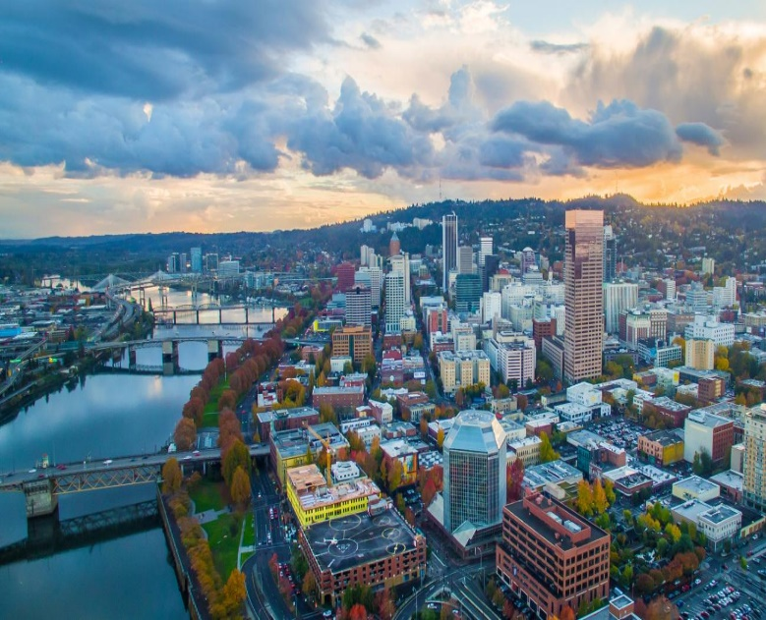The subject property is located within the Portland / Vancouver Metropolitan Statistical Area (MSA). Provided on the preceding page is a regional map of the Portland metropolitan area which locates the subject. The Portland / Vancouver area is the largest metropolitan area between Seattle and San Francisco. The combined Portland/Vancouver area is designated as a Primary Metropolitan Statistical Area (PMSA) which covers 4,413 square miles in two states and is comprised of seven counties Multnomah, Washington, Clackamas, Columbia and Yamhill Counties in Oregon, as well as Clark and Skamania Counties in the State of Washington.

Portland is situated near the northwest corner of Oregon at the confluence of the Willamette and Columbia Rivers. The area is approximately 110 miles inland from the Pacific Ocean and is a major freshwater port. The Columbia River separates Portland, Oregon from Vancouver, Washington, while the Willamette River divides Portland's east and west sides.

Population

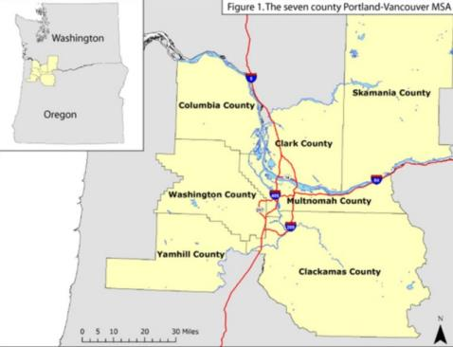The Portland / Vancouver PMSA encompass portions of seven counties: Multnomah, Washington, Clackamas, Columbia and Yamhill Counties in Oregon, as well as Clark and Skamania Counties in the State of Washington. Currently, the Portland / Vancouver PMSA has an estimated 2020 population of 2,533,321. Roughly 47.0% of Oregon's population resides in the PMSA (excluding Clark and Skamania Counties). Between 2000 and 2010, the Portland / Vancouver PMSA grew at an average rate of 1.5% per year, with most growth focused in the outlying suburban areas. The rate is anticipated to remain constant between 2020 and 2025, at 1.3% per year.

The rising cost of housing within the City of Portland fueled substantial population growth in the surrounding suburbs as those priced out of the Portland housing market pursued lower priced alternatives. Outlined in the following chart are the population trends for the Portland / Vancouver PMSA, the States of Oregon and Washington, and the nation.

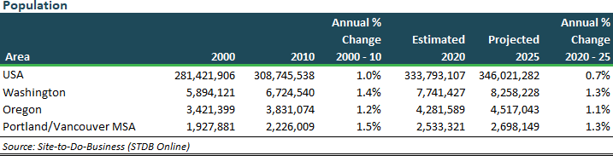

Economy/Employment

Portland's location, straddling major land and water transportation linkages, provides the base for a diverse economy. Portland has consistently been listed as one of the country's best places to do business, evidenced by its being one of the few areas in the nation to show consistent job growth over the past two decades. This has led to strong growth in the manufacturing sector. The Portland Metropolitan Area is home to over 63,000 businesses. Of these, nearly 1,200 are classified as headquarter firms. Eighty major manufacturing companies maintain their headquarters in the Portland area, including the Fortune 500 firm, Nike Inc. Nike – the largest sports marketing company in the world, continues to expand at its global HQ campus. Nike had $36.4 billion in sales in 2018, which projects global sales to increase to $50 billion by 2020. In 2015, Precision Castparts (prior Fortune 500 company) was acquired by Warren Buffett’s Berkshire Hathaway Inc. for $37 billion. In addition to its manufacturing base, Portland is the region's main financial center, and a regional headquarters for U.S. Bancorp. In addition, the area also serves as national headquarters for other major corporations such as FLIR Systems, StanCorp Financial, Schnitzer Steel Industries, Portland General Electric, and Columbia Sportswear.

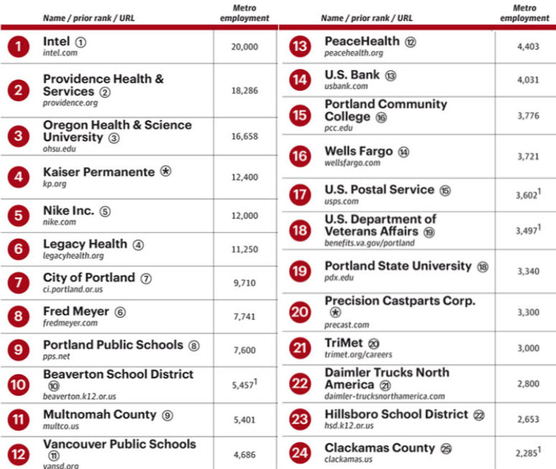The Portland area is generally characterized by an abundance of smaller firms representing a variety of industries. This increasing industrial diversity, along with a relatively small average company size and absence of defense industry, has given Portland more stable growth and increased freedom from large cyclical swings typical of cities dominated by a single firm or industry. The major employers in Portland tend to be distributors of goods and services, as well as a large hi-tech presence, with the once dominant wood products industry in decline for several decades. As of 2018, the largest employers in the Portland Metro area are listed in the chart at right.

<https://www.bizjournals.com/portland/digital-edition?issue_id=10984>

The Sunset Corridor in the West Metro area is noted throughout the region as the high technology core of the Portland metropolitan area. Various large employers include Intel Corp., Oracle, IBM, Nike, Tektronix and MCI. The largest private employer in the Hillsboro area (and the State of Oregon) is Intel Corp., which produces semi-conductor components and systems. The firm employs roughly 20,000 people statewide (as of 2018; an increase of 2,500 since 2014). In fact, Intel’s commitment to the local area received a significant boost in 2010 when the employer announced plans to upgrade two existing research fab plants (D1C & D1D), plus build a new research factory – D1X, with a combined investment of roughly $4 billion. Situated adjacent to its existing Ronler Acres facility, this project was completed in 2013 and ultimately will result in 800 to 1,000 long term tech jobs. Although Intel has not specified the exact size, In February 2019, the company announced plans for a third module of D1X that should be similar in size to the first two modules at 1.1 million square feet each. Josh Lehner of the Oregon Office of Economic Analysis said, “This proposed investment and expansion signals that Oregon will remain the home to significant, cutting-edge (research and development) operations for the foreseeable future.”

Portland’s employment in manufacturing, services and government is at a lower percentage than the country as a whole, while Portland's trade and finance/insurance/ real estate sectors are higher. Otherwise, the employment proportions in Portland are similar to the overall national pattern. The similarity in employment distribution explains why the Portland / Vancouver PMSA generally parallels the national economy. The following charts included Unemployment Rates, Median Household Income, and Employment by Industry for the Portland/Vancouver Metro Area.

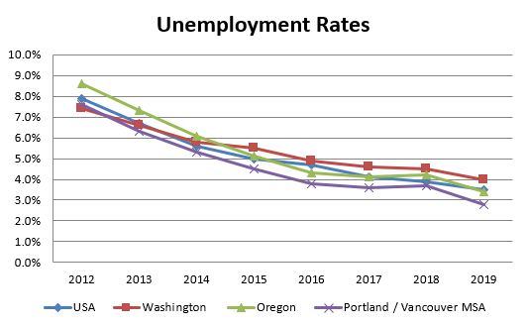

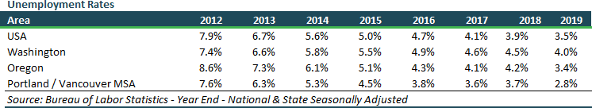

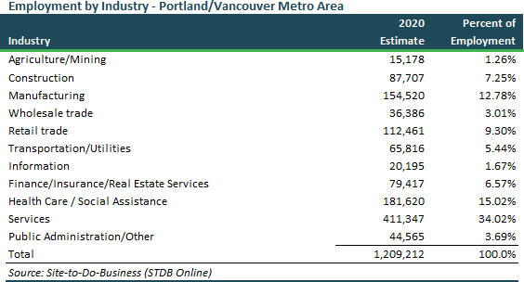

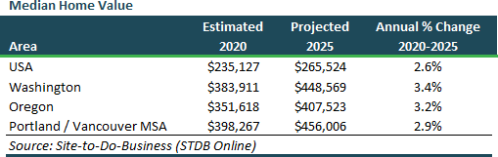

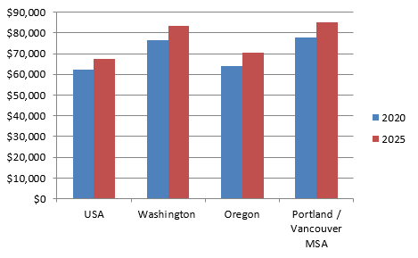

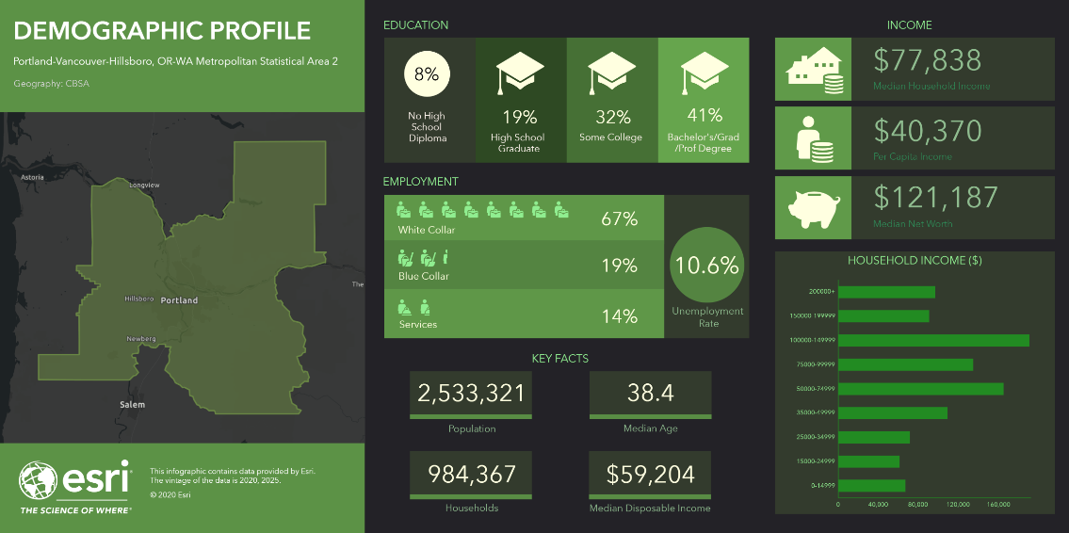

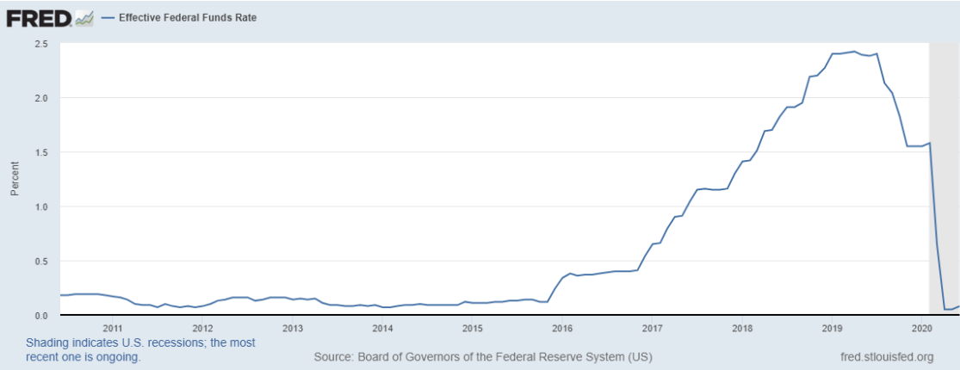

<https://fred.stlouisfed.org/series/FEDFUNDS>

Since the past recession (2009 prior to above graph) the Effective Federal Funds Rates have remained compressed below 0.25% since late 2008 through 2015. Over the first half of 2017, the FOMC continued to gradually reduce the amount of monetary policy accommodation. On March 3, 2020, the Federal Open Market Committee indicates the fundamentals of the U.S. economy remain strong. However, the coronavirus poses evolving risks to economic activity. In light of these risks and in support of achieving its maximum employment and price stability goals, the Federal Open Market Committee decided today to lower the target range for the federal funds rate by 1/2 percentage point, to 1 to 1‑1/4 percent. Shortly after on March 23, 2020 the Federal Open Market Committee directs the Desk to undertake open market operations as necessary to maintain the federal funds rate in a target range of 0 to 1/4 percent. The Committee directs the Desk to increase the System Open Market Account holdings of Treasury securities and agency mortgage-backed securities (MBS) in the amounts needed to support the smooth functioning of markets for Treasury securities and agency MBS. The Committee also directs the Desk to include purchases of agency commercial mortgage-backed securities in its agency mortgage-backed security purchases. The coronavirus outbreak is causing tremendous human and economic hardship across the United States and around the world. The virus and the measures taken to protect public health are inducing sharp declines in economic activity and a surge in job losses. Weaker demand and significantly lower oil prices are holding down consumer price inflation. The disruptions to economic activity here and abroad have significantly affected financial conditions and have impaired the flow of credit to U.S. households and businesses. The Committee expects to maintain this target range until it is confident that the economy has weathered recent events and is on track to achieve its maximum employment and price stability goals. In determining the timing and size of future adjustments to the stance of monetary policy, the Committee will assess realized and expected economic conditions relative to its maximum employment objective and its symmetric 2.0% inflation objective. This assessment will take into account a wide range of information, including measures of labor market conditions, indicators of inflation pressures and inflation expectations, and readings on financial and international developments.

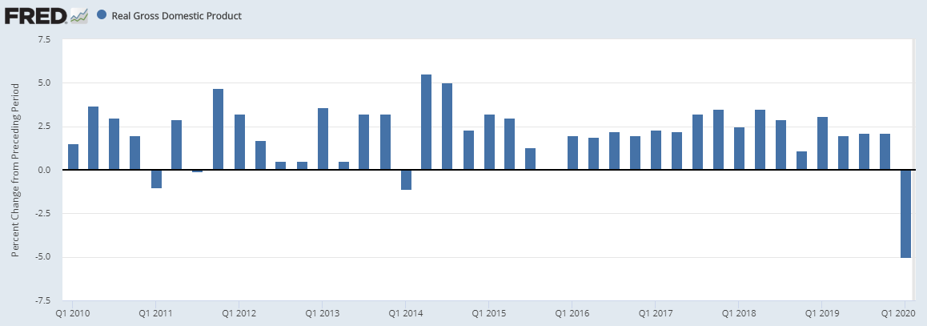

<https://fred.stlouisfed.org/series/A191RL1Q225SBEA>

With first quarter 2020 GDP down to -5.0% (annualized) over the last quarter of 2019 the National Bureau of Economic Research (NBER) recently declared that the US economy officially entered recession in February. Given the timing of COVID-19 pandemic and the ‘lockdown’ seen around the country, however, we expect to see a much deeper contraction in Q2 with the worst pain concentrated in April.

May and June, fortunately, showed a solid rebound as the economy began to come back online. However, recent spikes in cases in various parts of the country are a cause for concern as they delay further reopening and may result in new lockdowns in various states. Presently, under our baseline scenario, we do not expect a large second wave of cases to sweep the country in the autumn, but do expect weak consumer demand due to persistently high unemployment and the expiration of various government stimulus programs.

The Conference Board currently has three recovery scenarios for the US economy. Our base case forecast, which we call the ‘Double Dip’, includes a second quarter GDP contraction of nearly 40% (annualized). This large drop is driven by a fall in consumer spending of nearly 40%, a drop in real capital spending of just over 30%, and a fall in exports of more than 50% (all annualized). Following a large rebound of over 20% in Q3, we expect growth to slow to around 1.0% in Q4 which will bring the December 2020 level of economic output to about 93% of what it was a year earlier.

Based on our updated forecast, US GDP will contract by 7 percent for 2020 on the whole. However, upside and downside risks for the economic recovery remain. In the event that COVID-19 is rapidly brought under control, unemployment could ease further, and consumer confidence could rise, resulting in a stronger ‘Swoosh’-shaped recovery which brings the economy back to pre-COVID-19 levels of output by the end of 2021. On the other hand, a large second wave of COVID-19 cases in the autumn that results in widespread economic lockdowns could yield a weaker ‘W’-shaped recovery that would hurt fourth quarter growth and extend this economic crisis into 2021.

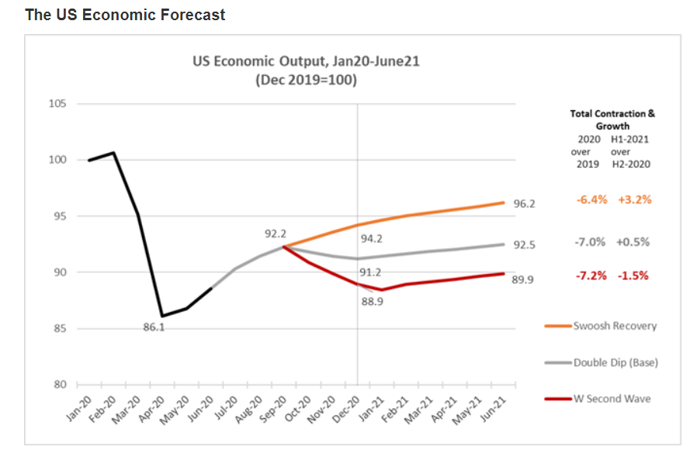

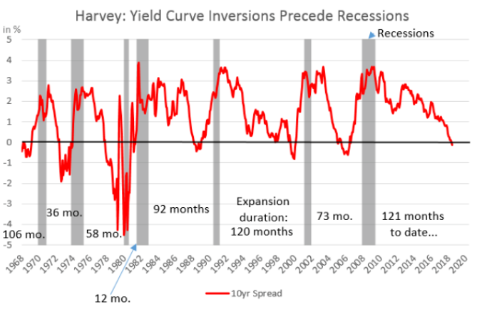In spite of very low unemployment and low inflation numbers, over the first half of 2019 one key sign may be starting to point to a coming U.S. recession. This sign is known as the “Inverted Yield Curve” which has been an economic indicator that has preceded every recession over the past five decades. Yield curve inversion is a condition known among economists and Wall Street traders that refers to when long-term interest rates are paying out less than short-term rates. That curve has been flattening out and sloping down for more than a year, raising worries among some analysts that investors' long-term view of the market is not positive and that an economic downturn is looming. A history of the yield curve since 1968 to present is shown in the chart above, which clearly shows the yield curve starting its inversion in the first half of 2019.

The following is portions of a recent interview with Professor Cambell Harvey, regarding the current marketplace. “I think that it is really important to draw distinctions between this particular episode and previous episodes. I think that it is really helpful in understanding the economic implications of this event. This is not a black swan event. We have had pandemics throughout history. In 1918, we had a terrible pandemic, where on a population adjusted basis, 200 million people died. Six times more Americans died from the Spanish Flu than in World War I. We have had other episodes, we have had SARS in 2003, MERS, Ebola, HIV. This is something we have to get used to. I think the key thing to understand here is that the cause of this economic crisis is biological.”

“In 2008, we had a structural problem in the economy, many of these banks over levered, operating like hedge funds, backed by government insured deposits, and they were far offside. And we can point our finger at that sector, and basically say, that is the cause of the crisis. It was a financial cause. Whereas this crisis is a biological cause. We cannot point our finger at a particular sector or particular company and say, you were offside and now we have to bail you out. No, this was completely different. Again, there was no structural problem. We had high-quality firms out there. Essentially, we need to provide some aid.”

“The unemployment is staggering. 17 million people in three weeks. That is more than the entire job losses during the Great Recession. But it is not unexpected. The people that work in restaurants and bars and retail, that is 30 million people right there. It is not unreasonable to think that 15 million will lose their jobs. And there is another 37 million people in sensitive industries, think airlines. I think that it is reasonable to expect that we will have unemployment that will be record unemployment. It happens very quickly.”

“There is a horizon, and the horizon has got two aspects to it. The first is a pharmacological solution that reduces the risk of death. And that will likely come in the fall. And the second is a vaccine. And the vaccine with high probability will be deployed at the beginning of 2021. And the vaccine is effectively an all clear. So in this particular situation, there is an end because it is biological.”

“When there is uncertainty, then consumers are really hesitant to spend. Businesses are hesitant to deploy capital for new projects. Businesses are hesitant to hire people. All of that uncertainty delays the recovery. Whereas, this particular episode, while painful both on the health front and the economic front, it is painful in the short-term. Because we can see that there is a biological solution to this particular problem that we are having. And in my opinion, we will see some recovery in the fourth quarter. By the first quarter of 2021, we will see the equivalent, staggering numbers, where unemployment is decreasing, not increasing.”

“If you are considering a one-year masters or a two-year masters, this is an ideal time. In the global financial crisis, it was not so obvious when the recession was going to be over. This time, we have clarity. And it is why this particular episode is unique in terms of previous recessions. Previous recessions just did not know how long they were going to last. Whereas this one, given the biological cause, there is a biological solution with high probability that will be implemented. There is a high probability that we can jump out of this quickly.”

“In the global financial crisis, we talk about people losing their jobs. If you lost your job at Lehman Brothers, and many of my students lost their job at Lehman Brothers, or were going to go to Lehman Brothers before they went bankrupt, there was no expectation that you would go back to Lehman Brothers because they did not exist. And to go to another company, very difficult. Whereas the people that are being furloughed, notice the difference in language-furlough-they expect to go back.”

“This uncertainty will be resolved, and I think that it makes the prospects very favorable for next year. And I do think the policymakers finally understand that, essentially, they need to keep these high-quality businesses alive, long enough, to get the biological solution, and then it is back to work. And back to work is really important.”

How this inverted yield curve will impact the Portland-Vancouver metro real estate market remains to be seen. Certainly any extended business expansion can expect a cooling period where the market digests its gains – a natural part of the business and real estate cycles. With the exceptions of the apartment and mini-storage sectors, there has been no over-building in the Portland-Vancouver metro area with vacancies in most commercial retail, office and industrial sectors remaining tight and consistent rent increases the norm. Hospitality and retail will likely seen significant slowdowns and any general slowdown in the local and national economies may ease vacancy and rent increase conditions a bit, but at this point there are no predictions for a major downturn in the various real estate sectors of the metro area.

Residential Development

The Portland metro area has historically provided quality, low-cost housing with a wide range of choices. A majority of the new single-family construction has occurred in areas experiencing increased employment opportunities; specifically, the areas of Beaverton, Tigard, Sunset Corridor, Clackamas area, South I-5 Corridor, and Clark County, Washington.

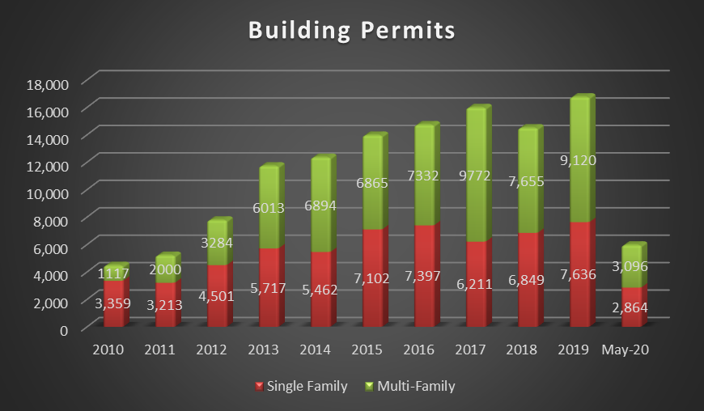As the following chart indicates, both single-family and multi-family development in terms of permits issued have returned to number prior to the downturn in 2008 to 2012. The pace of building activity dropped steeply between 2008 and 2011, a result of the deflating national housing bubble, as well as over-building in some markets. In addition, housing affordability has increasingly become a major issue with buyers as prices ratcheted up rapidly between 2000 and 2007. This precipitated a collapse of the mortgage lending industry in 2007-2008 due to previous loose credit policies, which in turn has led to a widespread national / worldwide economic downturn. However, in tandem with an economic recovery which began in 2012, house permits have trended upward ever since and have returned to housing permit levels not seen since 2006-2007 prior to the downturn. House values are anticipated to increase between 2.7% to 4.5% per year over the next five years.

<https://www.census.gov/construction/bps/>



Governmental Influences

The State of Oregon has been a pioneer in land use planning. The Land Conservation and Development Commission (LCDC) was established in 1973 and has mandated central uniform planning based on statewide goals in all communities. The LCDC has had a major impact on development and remains controversial.

The government of the City of Portland consists of a commission with a mayor and four commissioners. Government services and activities that directly impact the local economy and indirectly affect real estate values include the Port of Portland, Portland Development Commission, and the Tri‑County Metropolitan Transit District (Tri-Met).

The Port of Portland, a municipal corporation, operates the Portland International Airport, Hillsboro Airport, Troutdale Airport, Portland Harbor, and four marine terminals. The Portland International Airport operates more than 400 flights daily, while the port is the largest wheat export port in the US. The Port of Portland operates six commercial and industrial parks: Rivergate Industrial District, Swan Island Industrial Park, Mocks Landing, Portland International Center, Troutdale Industrial Park, and Brookwood Corporate Park.

In Portland, a regional agency known as METRO, provides additional input regarding Multnomah, Clackamas and Washington Counties. METRO is governed by a paid executive and 12 elected unpaid district counselors. Its major responsibility is to review and coordinate city and county planning, solid waste management, and transportation planning. METRO also administers the Washington Park Zoo.

In response to continued anticipated growth in the metropolitan area and pressure on the existing urban growth boundary (UGB), METRO adopted a master regional land use and transportation plan in 1995 known as Region 2040 Growth Concept. After two years of public input and technical analysis of growth concepts, METRO developed a recommended alternative, which includes the following main concepts and ideas:

* Use compact development (increased densities) to reduce land consumption.
* Create more permanent public and private open spaces and set aside current open spaces within the UGB.
* Encourage substantial development and redevelopment in downtown Portland.
* Establish regional centers, town centers, corridors, main streets, and neighborhoods with increased densities and transit improvements.
* Protect key industrial and employment centers. Set aside minimal urban reserves outside the current UGB.
* Major highway improvements on selected corridors (Sunrise, I-5, Highway 217 and Sunset Corridors).

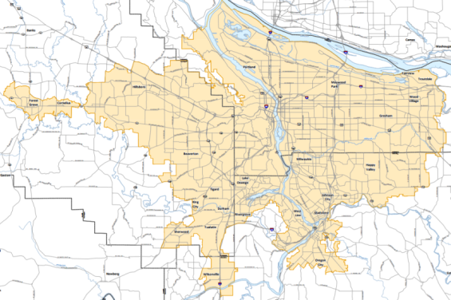In 1998, METRO adopted the Regional Framework Plan and it was approved by the state; hence, the plan is binding on local governments. After lengthy policy discussion and debate, the Region 2040 Growth Concept plan was implemented as a master plan of all cities, unincorporated areas, and properties located within the Metro UGB. Periodic reviews and updates are made to the UGB which allows for incremental expansion in order to satisfy a 20-year supply of urban lands within the UGB. Further, Rural Reserve area (located outside the UGB, but considered for eventual UGB expansion) have been master planned and protected even further out to 2060.

Oregon has no sales tax, which has been consistently reinforced by voters in recent years. Measure 5 was approved by Oregon voters in 1990, which limited property taxes beginning July 1, 1991 (1991/1992 tax year) through July 1, 1996 (1995/96 tax year).

The maximum allowed millage rate was decreased over a five-year period from $25.00 per $1,000 of value to $15.00 per $1,000 of value (plus special assessments and bond indebtedness). Additional taxes are allowed for voter approved bonded indebtedness. Overall, government influences are generally considered to be favorable.

In 1996, Measure 47 was approved by Oregon voters. This “Cut and Cap” measure decreased property taxes beginning July 1, 1997 (1997/1998 tax year) by the lesser of 1994-1995 taxes, or the 1995-1996 taxes less 10% (not including bond indebtedness). In addition, future property tax increases were not to exceed 3% per year, unless voter approved.

The preceding tax relief measure was superseded by the Oregon State Legislature via the successful passage of Ballot Measure 50 in late May 1997. This measure has decrease assessed property values beginning July 1, 1997 (1997/1998 tax year) to the 1995-1996 assessed value less 10% (not including bond indebtedness). The existing tax rate is then to remain frozen. Similarly, future property tax value increases cannot exceed 3% per year, unless voter approved.

The net impact of this approved measure was a substantial reduction in real property taxes for most classes of properties in the subject's area. The real estate market and governmental authorities have generally determined the effect of Measure 50 to be very positive, which has not only provided discounts in property taxes, but has also provided certainty regarding future tax liabilities. Hence, this measure has been very favorable for the real estate market. Overall, the government influences are generally considered to be favorable.

Transportation

The transportation network in the Portland PMSA includes a comprehensive system of transcontinental railroads, regional and interstate highway, national and international air transportation, and two major freshwater ports for both ocean shipping and river barge traffic.

Interstate 5 runs between the Mexican and Canadian borders, and is the longest continuous freeway in the United States providing north/south access to Portland. Other major freeways in the metropolitan area include Interstate 84 (east-west), US Highway 26 (the westerly extension of I-84), and Interstate 205 (a north-south bypass on the east side of the PMSA). In addition, State Highway 217 is a north-south bypass between US Highway 26 and I-5. Portland's highway connections are considered excellent, evidenced by its flourishing trucking business (with over 150 truck lines, including 30 interstate carriers). A western bypass is under study that would link Highway 26 in the vicinity of Cornelius Pass Road, or SW 185th Avenue, to I-5 near its interchange with I-205. Lack of funding and political opposition has delayed this plan.

The metro area is also well served by Portland International Airport (PDX), the only international air gateway in the state. In 2007, PDX finally managed to set an all-time record of over 14.65 million passengers. However, in tandem with the economic recovery, 2019 passenger volume had increased significantly to 19.89 million, with a large increase from 2015 volume of 16.85 million passengers. PDX accounts for 90% of the passenger travel and 95% of the air cargo volume in the state. Note that with the onset of the Covid-19 pandemic, passenger air travel had dropped steeply with the YTD June 2020 statistics showing a volume decline to 4.08 million versus 9.40 million passengers for YTD June 2019.

Portland International Airport has direct flights and connections to most major airports throughout the United States, and non-stop international flights to Canada, Germany, Iceland, Japan, Mexico, the Netherlands and the United Kingdom. The airport is a secondary hub for Alaska Airlines and Horizon Air, with Seattle–Tacoma International Airport as the primary hub for Alaska Airlines and Horizon Air. From 2013 to 2016, J.D. Power and Associates rankings for US "Large Passenger Airports" lists PDX at the #1 spot and overall highest amongst passenger satisfaction criteria.

The Portland PMSA is a major rail distribution point for the Northwest, with freight arrivals and departures to the East, Midwest, South, and Pacific Coast, as well as Canada. Three transcontinental rail lines offer service to the Portland area, including Burlington Northern, Union Pacific, and Southern Pacific railroads.

The PMSA has two deep draft freshwater ports that are approximately 110 miles from the Pacific Ocean. The Port of Portland maintains five marine terminals that can accommodate container ships, grain ships, break bulk carriers, and auto carriers. In 2007, overall freight volumes through the Port of Portland’s marine terminals reached an all-time record of 14,440,298 tons. While holding fairly steady on this peak level of volume in 2008 at 14,109,432, import volume collapsed -27.1% in 2009 to 10,281,130. While there were signs of recovery with volume up in 2010-2011 to +13,300,00 tons, volume collapsed again when the Port’s largest container shipper – Korean-based Hanjin Shipping, plus German-based Hapag-Lloyd and Westwood Shipping suspended service to Portland which has effectively left Terminal 6 vacant. With these pull-outs, Portland lost more than 95% its container service. Additional cited reasons were also that carriers complained it was taking too long to load and unload ships because of a nearly 3-year labor dispute between longshoreman and the company that employed them. With a lack of large container shipment ability, volume fell as low as 8,380,949 tons in 2015, and as of 2018 had topped out to 11,213,530 tons, before declining by -13.6% in 2019 to 9,694,017 tones. As of 2019, the Port of Portland is focused on establishing mixed-use options at Terminal 6 to increase shipping and transportation opportunities for regional shippers. They are encouraged by the intermodal railway shuttle service with BNSF offered at Terminal 6, delivering containers to and from the Puget Sound area, and expect moderate growth in that business. The Port’s recent partnership with Vestas, bringing wind turbine tower sections through Terminal 6, is a good example of the creative solutions they have been exploring. They plan to promote more mixed-use/breakbulk cargo deliveries through Terminal 6 in the future.

Though auto imports expanded greatly in recent years, volume collapsed to 234,038 vehicles in 2011, rebounding modestly in 2019 to 341,503 vehicles. Prior to the last economic collapse in 2008-2009, Hyundai, Honda and Toyota combined to bring in 407,803 autos in 2008, 449,307 autos in 2007 and a record 463,557 vehicles offloaded in 2006.

In addition, the private company – Cascade General maintains the Portland Ship Repair Yard, which is one of the largest, most complete ship repair facilities in the world. The Port of Vancouver is 106 miles from the ocean at the terminus of the Columbia River's deep-water channel. This Port operates a 400‑acre area with three marine terminals and 40 industrial tenants and receives vessels from over 300 ports and 60 countries. In addition, the Port of Vancouver recently purchased 1,280 acres of industrial land known as Columbia Gateway, which has 1.5 miles of waterfront. The Columbia/Snake River system provides freshwater barging to 34 ports along the rivers, reaching as far east as Lewiston, Idaho, which marks the transshipment point for Midwest cargo.

The Portland area has been the recipient in recent years of Federal and private funding for four light rail public transportation lines. Since MAX (Metropolitan Area Express) began operation, it has exceeded ridership expectations. The East Side MAX was completed in 1986, a $214 million light rail system and Interstate 84 highway improvement project. The 15-mile Banfield Transitway project links central Portland to the City of Portland to the east. The West Side MAX Project, a 12-mile light rail extension from downtown Portland to downtown Hillsboro was completed in two stages between 1993 and 1998. In 2001, a privately funded, 4-mile extension from the Gateway area of East Portland (along Interstate 205) to Portland International Airport was completed via a private-public joint venture accomplished by trading long term leases on Port of Portland lands in exchange for a private construction company covering the cost of this light rail extension. In 2004, the North Interstate MAX Line was completed at a cost of $350 million. This 5.8-mile extension runs from the Rose Quarter Transit Center to the Expo Center near Jantzen Beach.

A light rail extension south from Gateway along I-205 to the Clackamas area was completed in 2009. This was Phase I of the South Corridor Project. Phase II extended light rail from downtown Portland to Milwaukie. This new 7.3-mile MAX line opened in 2015. A connector bus line also runs eastward to the Clackamas Town Center (a regional shopping center). A proposed light rail extension north to Vancouver continues to be studied, and though has yet to garner the necessary public support and funding, is moving forward in the planning stages. All these light rail extension lines have had significant positive impacts on the areas adjacent to their lines, particularly near the transit stations.

Finally, it is important to note the completion of the Washington County Commuter Rail which runs between Wilsonville, through Tigard and Tualatin, and links to the MAX line in downtown Beaverton. These stations provide commuter access along an upgraded / existing 14.7-mile freight line. Service began in 2009. However, on August 13, 2018, the steering committee recommended a preferred alternative for the proposed MAX light rail line that will serve Southwest Portland, Tigard and Tualatin. The route travels south from the Portland Transit Mall on Barbur Boulevard until the Barbur Transit Center. From there, it crosses I-5 on a new bridge and then runs adjacent to I-5 to Tigard. The route serves the Tigard Triangle with two stations, crosses Highway 217, serves downtown Tigard and then runs adjacent to the railroad tracks to the end of the line at Bridgeport Village. Construction is anticipated to commence in 2023, with the line opening by 2027.

Education

Portland is becoming the educational hub for the state, although the two major state universities are located 100 miles south in the cities of Corvallis and Eugene. In the Portland metropolitan area, state-run colleges include Portland State University, the Oregon Health Science University, and three community colleges; Mt. Hood, Portland, and Clackamas. Private colleges include Lewis and Clark College, Northwestern School of Law, George Fox University, Concordia College, Oregon Graduate Institute, Pacific University, Reed College, Warner Pacific College, and the University of Portland. These schools not only provide liberal arts programs, but also specific technical, scientific and professional training for business and industry.

With regard to elementary school education, the outlying suburbs of the Portland area, including Portland, Beaverton, Hillsboro, Sherwood, Clackamas, and Oregon City, continue to add new facilities, which can hardly keep up with growing population demands. In addition, a number of private schools (mostly kindergarten through Grade 6) have either established new facilities or have added to existing campuses to serve the expanding population needs.

Community Facilities

The Portland metro area maintains a symphony orchestra, junior symphony, opera company, art museum, museum of science and industry, public zoo, and an extensive public library system. The Portland Center for the Performing Arts includes the Civic Auditorium, the Arlene Schnitzer Concert Hall, the Winningstad Theater, and the Intermediate Theater; which combine for over 7,000 seats. Also located in Portland are the Historical Preservation Gallery, Japanese Gardens, Western Forestry Center, and the International Rose Test Gardens. The City of Portland has the most park land per capita in the country, which includes the 5,000-acre Forest Park. Portland supports a National Basketball Association professional basketball team, a Major League Soccer team, a Western Hockey League junior ice hockey team, and a minor league baseball team. The Oregon Convention Center (400,000 SF) was completed in 1990 and expanded to 907,500 SF in 2003 making it the largest convention facility in the northwest. This facility attracts many national, regional, and local events.

In 1995, the Trail Blazers completed a $262 million, 20,340-seat arena which consists of a multi-purpose sports and entertainment facility known as The Moda Center (Formerly: The Rose Garden). The development of this sports arena is expected to generate an estimated $26 million in new economic activity annually and create hundreds of new and part-time jobs. Nearby is the Memorial Coliseum, a 12,666-seat structure which formerly hosted the Portland Trail Blazer basketball team. This arena is still the venue for the Portland Winter Hawks hockey team. In 2000, Providence Park (formerly PGE Park, and prior to that, Civic Stadium) was renovated at a cost of $38.5 million for use by both professional baseball and soccer teams. The renovation allowed Portland to attract a Triple A baseball team, the Portland Beavers, back to the city for the first time since 1993. However, in 2009, the stadium was upgraded at a cost of $31 million for sole professional use by the Portland Timbers, which elevate the team to the top professional league in the country (2015 MLS Cup Champions). Portland’s minor league team relocated and renamed the Hillsboro Hops - a Short Season Single A team that started in the 2013 season and is associated with the Arizona Diamondbacks.

Conclusion

In the years since the last economic slowdown in the region between 2008 and 2011, the metro area has experienced a sustained recovery that began in 2012 and continues today. Thus, the long-term prospects for continued growth in the region remain good and should have a positive influence on the suburban markets of the Portland-Vancouver area. Overall, the general attitude among investors and developers in Portland and Vancouver metro markets is one of optimism relative to the real estate market. The local economy continues to exhibit signs of improving conditions (increases from historically low housing permit activity, strongly increasing real estate prices across all property classes, decreased unemployment, increasing Port activity, etc.) that is reflective of economic conditions in the national economy. Hence, after experiencing continued improving conditions during 2014-2018 for most real estate sectors, market participants expect general cooling of pricing through 2019-2020 as the market reaches the upper levels of affordability. The pairing of continued job growth, low interest rates and low inventories (housing, commercial, industrial, etc.) have led to sharply increased real estate prices and decreased market rates of return which have rivaled the peak years of the economic boom of the mid-2000s. Hence, the potential for rising inflation and its direct impact on mortgage rates / cap rates will play a key role in whether prices continue to rise, stabilize or possibility even pull back over the next 1 to 3 years. Especially vulnerable are multi-family prices which are susceptible to both cap rate changes and elastic rents reacting to current over-building. Until the recent international downturn related to the COVID-19 epidemic, despite heated market conditions in terms of real estate prices, in-migration to the region had remained strong while development land supply and available housing remains scarce. Therefore, most professionals agree on a cautiously optimistic outlook for the region over the long-term (say 5 to 10 years), which is largely dependent of continued low interest rates, job creation and in-migration. Additional caution is anticipated with this being an election year and the market sentiment could vary greatly with an administration change so the caution is warranted.

Please refer the Market Analysis section for additional discussion regarding the ongoing COVID-19 pandemic and its impact the subject’s general and immediate market.