|  |
| --- |
| Regional Analysis |

Location

Salem is the "central city" of the SMSA. It is located along the Willamette River with populations in both Marion and Polk Counties, covering an area of 1,939 square miles in the northern section of western Oregon The City of Keizer is notably located adjacent to the northerly Salem city limits. Salem is located in the center of the Willamette Valley, 47 miles south of Portland, 64 miles north of Eugene, 60 miles east of the Pacific Ocean, and 60 miles west of the Cascade Mountains. The economics of the Salem area are dominated by State, County and City government offices and a wide variety of commercial retail, office, and service-related uses. Presented on the preceding page is map of the subject’s regional location and its location relative to the region.

The climate in the Salem-Keizer area is mild with few temperature extremes. The average annual rainfall is 40.35 inches, with 71 percent of the rain occurring between November and March. The average annual snowfall is 7.6 inches. The average maximum temperature in July is 82.3 degrees, while the average minimum is 50.9 degrees. In January the average, maximum temperature is 45.5 degrees and the average minimum is 32.2 degrees.

Salem's topography is generally level throughout the central business district, North and East Salem. The elevation is 171 feet above sea level at the state capital. Both West and South Salem have gently rolling hills with elevations as high as 900 feet above sea level. Soil and subsoil conditions are generally stable and conducive to orderly development.

Population

The Salem Metropolitan Statistical Area (MSA), as defined by the United States Census Bureau, is an area consisting of two counties in western Oregon; Marion and Polk. The principal city is Salem, which is the state capital. The Salem MSA has an estimated 2020 population of 437,048 or roughly just over 10% of Oregon's population resides in the Salem MSA. Between 2000 and 2010, the Salem MSA grew at an average rate of 1.3% per year, with most growth focused in the outlying suburban areas. The following chart summarizes the Salem MSA population compared to the State of Oregon and the nation.

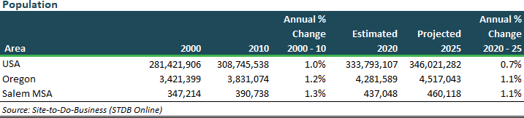

Economy/Employment

The Salem MSA is heavy in government, particularly at the state and local levels. Government jobs account for approximately 30 percent of all jobs in the Salem MSA. The manufacturing of non-durable and durable goods is a large source of employment for the area. Because of the rapid growth in population in the area, such industries as food processing, retail trade, business and professional services, leisure, and education and health services all continue to be a consistent and growing source of employment. As more high technology, financial, and government jobs become available in the region, so will the demand for consumer services. As previously noted, the dominant sectors of the Salem-Keizer economy have historically been government, food processing and wood products. Being the state's capital and Marion County seat, a large portion of the local population is employed in government.

Tourism provides substantial economic benefits to the Salem-Keizer area. Because of the state capitol’s location in Salem, the city plays host to many conventions and seminars at its various hotels and meeting halls. Historic and state governmental landmarks attract local, national and some international visitors. Attractions in and around the Salem / Keizer and Marion County areas include the Iris Gardens, Oregon State Fair, Elsinore Theatre, State Capitol and accessory buildings, and the Oregon Gardens. Salem provides many shopping locales for locals and visitors alike. The Salem Center Mall and Lancaster Mall are primary retail locations for the Salem MSA and experience high volumes of foot traffic. Occupancies in the area's surrounding hotels and motels have experienced above-average rates of 72 percent since 1989. Several new units are under development, and several more are being renovated. There is a significant concentration of hotels and motels near I-5 on both the east and west sides of the freeway, providing easy access to the capital and downtown on the west side of the freeway. Lancaster Mall and many commercial services are located on the eastside of the freeway, predominantly along Lancaster Drive and Market Street.

Marion County is home to several recreational destinations. Champoeg State Park, Willamette Mission, Wheatland Ferry, Silver Falls State Park, and Detroit Lake State Park are all popular areas for camping, fishing, hiking, and. Detroit Lake is popular for water sports, while Big Cliff Reservoir (just below Detroit Lake) is known for its fishing. The HooDoo Ski Area, just east of Detroit, is a draw for skiers from around the area, and is located near several year-round resorts.

Due to its large government employment base, the Salem MSA is mostly free from the timber dominance experienced by much of rural Oregon. The area's economy has spurred growth in employment with the services and trade industries leading the employment boost. The influx of technology-based firms has provided employment opportunities for both skilled and unskilled labor.

The following charts included Unemployment Rates, Median Household Income, and Employment by Industry for the Salem metro area.



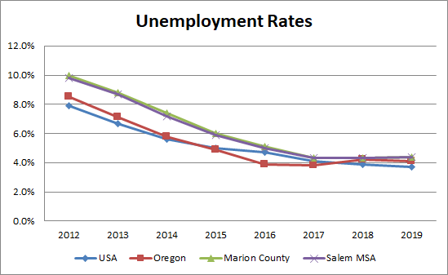



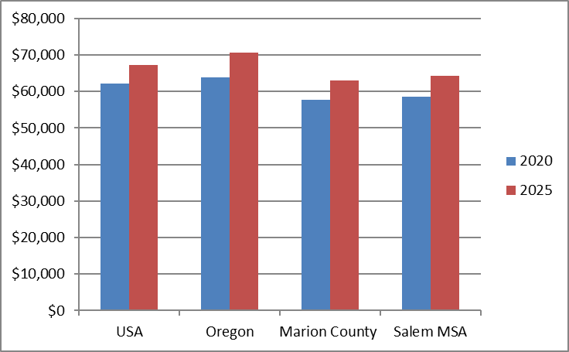

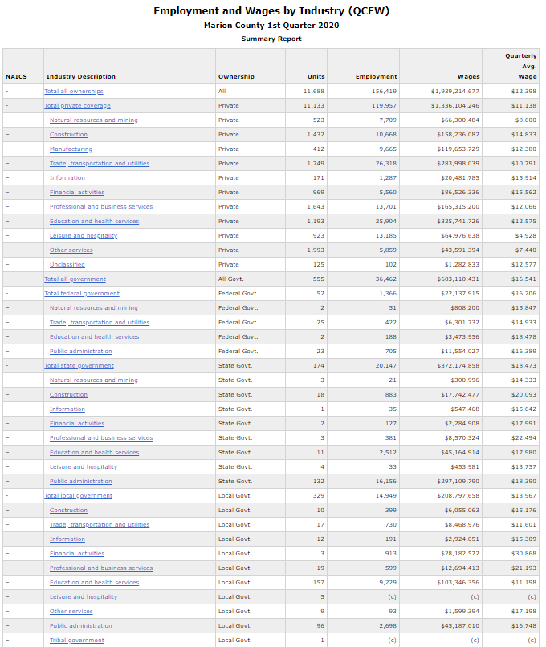

<https://www.qualityinfo.org/ed-ewind/?at=1&t1=0~4104000047~00~1~0000~00~00000~2020~01&t2=0~4101000000~00~5~0000~00~00000~2019~01>

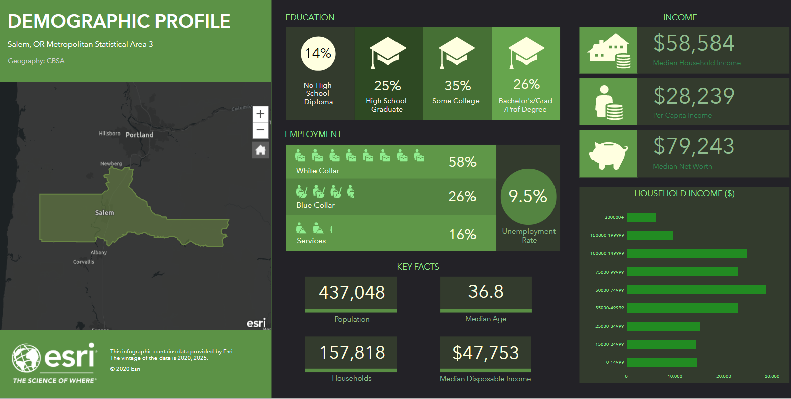

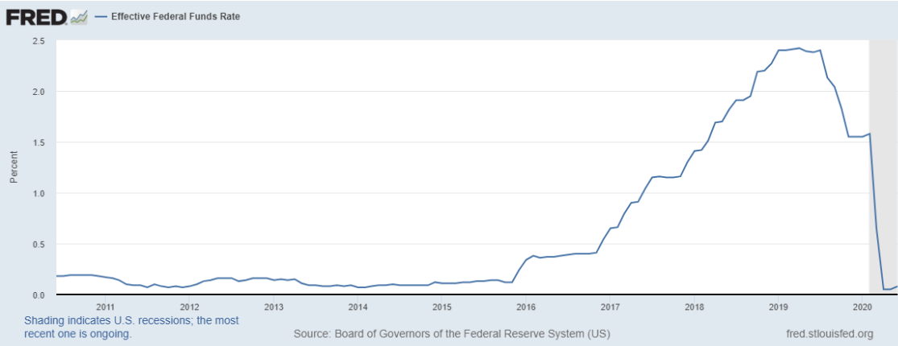

<https://fred.stlouisfed.org/series/FEDFUNDS>

Since the past recession (2009 prior to above graph) the Effective Federal Funds Rates have remained compressed below 0.25% since late 2008 through 2015. Over the first half of 2017, the FOMC continued to gradually reduce the amount of monetary policy accommodation. On March 3, 2020, the Federal Open Market Committee indicates the fundamentals of the U.S. economy remain strong. However, the coronavirus poses evolving risks to economic activity. In light of these risks and in support of achieving its maximum employment and price stability goals, the Federal Open Market Committee decided today to lower the target range for the federal funds rate by 1/2 percentage point, to 1 to 1‑1/4 percent. Shortly after on March 23, 2020 the Federal Open Market Committee directs the Desk to undertake open market operations as necessary to maintain the federal funds rate in a target range of 0 to 1/4 percent. The Committee directs the Desk to increase the System Open Market Account holdings of Treasury securities and agency mortgage-backed securities (MBS) in the amounts needed to support the smooth functioning of markets for Treasury securities and agency MBS. The Committee also directs the Desk to include purchases of agency commercial mortgage-backed securities in its agency mortgage-backed security purchases. The coronavirus outbreak is causing tremendous human and economic hardship across the United States and around the world. The virus and the measures taken to protect public health are inducing sharp declines in economic activity and a surge in job losses. Weaker demand and significantly lower oil prices are holding down consumer price inflation. The disruptions to economic activity here and abroad have significantly affected financial conditions and have impaired the flow of credit to U.S. households and businesses. The Committee expects to maintain this target range until it is confident that the economy has weathered recent events and is on track to achieve its maximum employment and price stability goals. In determining the timing and size of future adjustments to the stance of monetary policy, the Committee will assess realized and expected economic conditions relative to its maximum employment objective and its symmetric 2.0% inflation objective. This assessment will take into account a wide range of information, including measures of labor market conditions, indicators of inflation pressures and inflation expectations, and readings on financial and international developments.

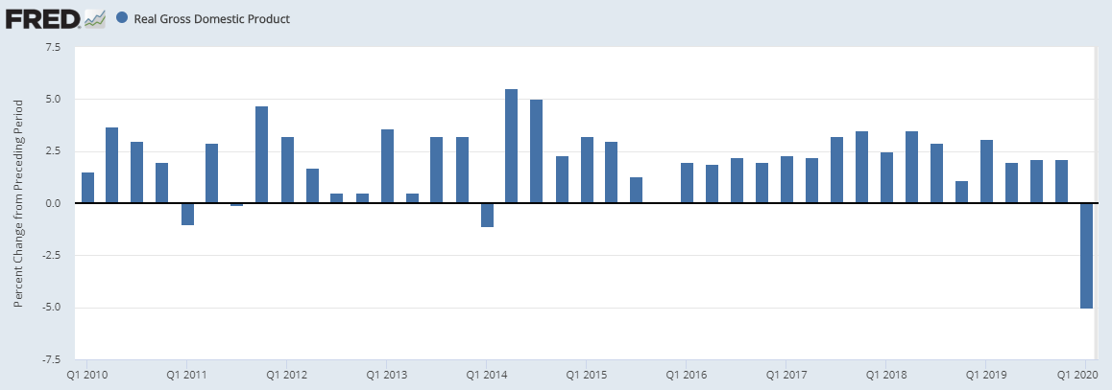

<https://fred.stlouisfed.org/series/A191RL1Q225SBEA>

With first quarter 2020 GDP down to -5.0% (annualized) over the last quarter of 2019 the National Bureau of Economic Research (NBER) recently declared that the US economy officially entered recession in February. Given the timing of COVID-19 pandemic and the ‘lockdown’ seen around the country, however, we expect to see a much deeper contraction in Q2 with the worst pain concentrated in April.

May and June, fortunately, showed a solid rebound as the economy began to come back online. However, recent spikes in cases in various parts of the country are a cause for concern as they delay further reopening and may result in new lockdowns in various states. Presently, under our baseline scenario, we do not expect a large second wave of cases to sweep the country in the autumn, but do expect weak consumer demand due to persistently high unemployment and the expiration of various government stimulus programs.

The Conference Board currently has three recovery scenarios for the US economy. Our base case forecast, which we call the ‘Double Dip’, includes a second quarter GDP contraction of nearly 40% (annualized). This large drop is driven by a fall in consumer spending of nearly 40%, a drop in real capital spending of just over 30%, and a fall in exports of more than 50% (all annualized). Following a large rebound of over 20% in Q3, we expect growth to slow to around 1.0% in Q4 which will bring the December 2020 level of economic output to about 93% of what it was a year earlier.

Based on our updated forecast, US GDP will contract by 7 percent for 2020 on the whole. However, upside and downside risks for the economic recovery remain. In the event that COVID-19 is rapidly brought under control, unemployment could ease further, and consumer confidence could rise, resulting in a stronger ‘Swoosh’-shaped recovery which brings the economy back to pre-COVID-19 levels of output by the end of 2021. On the other hand, a large second wave of COVID-19 cases in the autumn that results in widespread economic lockdowns could yield a weaker ‘W’-shaped recovery that would hurt fourth quarter growth and extend this economic crisis into 2021.

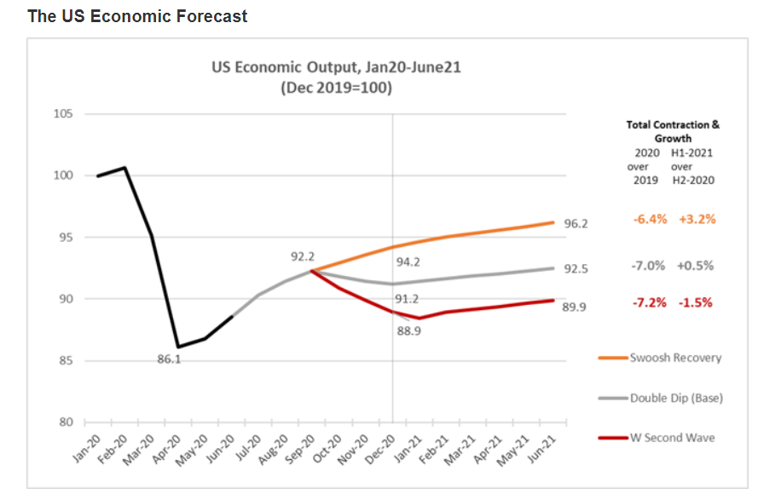

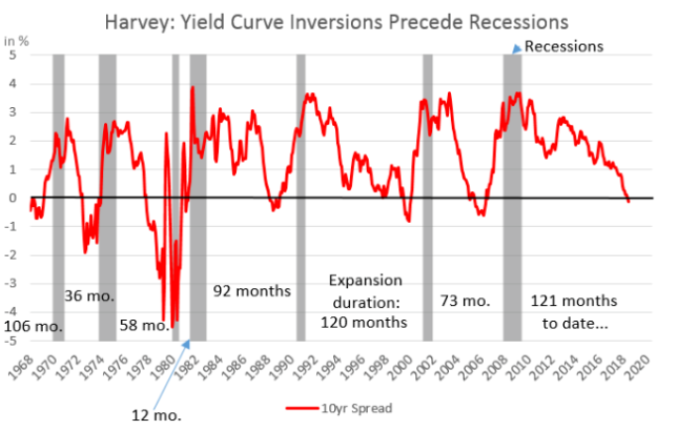In spite of very low unemployment and low inflation numbers, over the first half of 2019 one key sign may be starting to point to a coming U.S. recession. This sign is known as the “Inverted Yield Curve” which has been an economic indicator that has preceded every recession over the past five decades. Yield curve inversion is a condition known among economists and Wall Street traders that refers to when long-term interest rates are paying out less than short-term rates. That curve has been flattening out and sloping down for more than a year, raising worries among some analysts that investors' long-term view of the market is not positive and that an economic downturn is looming. A history of the yield curve since 1968 to present is shown in the chart above, which clearly shows the yield curve starting its inversion in the first half of 2019.

The following is portions of a recent interview with Professor Cambell Harvey, regarding the current marketplace. “I think that it is really important to draw distinctions between this particular episode and previous episodes. I think that it is really helpful in understanding the economic implications of this event. This is not a black swan event. We have had pandemics throughout history. In 1918, we had a terrible pandemic, where on a population adjusted basis, 200 million people died. Six times more Americans died from the Spanish Flu than in World War I. We have had other episodes, we have had SARS in 2003, MERS, Ebola, HIV. This is something we have to get used to. I think the key thing to understand here is that the cause of this economic crisis is biological.”

“In 2008, we had a structural problem in the economy, many of these banks over levered, operating like hedge funds, backed by government insured deposits, and they were far offside. And we can point our finger at that sector, and basically say, that is the cause of the crisis. It was a financial cause. Whereas this crisis is a biological cause. We cannot point our finger at a particular sector or particular company and say, you were offside and now we have to bail you out. No, this was completely different. Again, there was no structural problem. We had high-quality firms out there. Essentially, we need to provide some aid.”

“The unemployment is staggering. 17 million people in three weeks. That is more than the entire job losses during the Great Recession. But it is not unexpected. The people that work in restaurants and bars and retail, that is 30 million people right there. It is not unreasonable to think that 15 million will lose their jobs. And there is another 37 million people in sensitive industries, think airlines. I think that it is reasonable to expect that we will have unemployment that will be record unemployment. It happens very quickly.”

“There is a horizon, and the horizon has got two aspects to it. The first is a pharmacological solution that reduces the risk of death. And that will likely come in the fall. And the second is a vaccine. And the vaccine with high probability will be deployed at the beginning of 2021. And the vaccine is effectively an all clear. So in this particular situation, there is an end because it is biological.”

“When there is uncertainty, then consumers are really hesitant to spend. Businesses are hesitant to deploy capital for new projects. Businesses are hesitant to hire people. All of that uncertainty delays the recovery. Whereas, this particular episode, while painful both on the health front and the economic front, it is painful in the short-term. Because we can see that there is a biological solution to this particular problem that we are having. And in my opinion, we will see some recovery in the fourth quarter. By the first quarter of 2021, we will see the equivalent, staggering numbers, where unemployment is decreasing, not increasing.”

“If you are considering a one-year masters or a two-year masters, this is an ideal time. In the global financial crisis, it was not so obvious when the recession was going to be over. This time, we have clarity. And it is why this particular episode is unique in terms of previous recessions. Previous recessions just did not know how long they were going to last. Whereas this one, given the biological cause, there is a biological solution with high probability that will be implemented. There is a high probability that we can jump out of this quickly.”

“In the global financial crisis, we talk about people losing their jobs. If you lost your job at Lehman Brothers, and many of my students lost their job at Lehman Brothers, or were going to go to Lehman Brothers before they went bankrupt, there was no expectation that you would go back to Lehman Brothers because they did not exist. And to go to another company, very difficult. Whereas the people that are being furloughed, notice the difference in language-furlough-they expect to go back.”

“This uncertainty will be resolved, and I think that it makes the prospects very favorable for next year. And I do think the policymakers finally understand that, essentially, they need to keep these high-quality businesses alive, long enough, to get the biological solution, and then it is back to work. And back to work is really important.”

How this inverted yield curve will impact the Salem metro real estate market remains to be seen. Certainly any extended business expansion can expect a cooling period where the market digests its gains – a natural part of the business and real estate cycles. With the exceptions of the apartment and mini-storage sectors, there has been no over-building in subject’s metro area with vacancies in most commercial retail, office and industrial sectors remaining tight and consistent rent increases the norm. Any general slowdown in the local and national economies may ease vacancy and rent increase conditions a bit, but at this point there are no predictions for a major downturn in the various real estate sectors of the Salem MSA.

Conclusion

Until the recent international downturn related to the COVID-19 epidemic, despite heated market conditions in terms of real estate prices, in-migration to the region had remained strong while development land supply and available housing remains scarce. Therefore, most professionals agree on a cautiously optimistic outlook for the region over the long-term (say 5 to 10 years), which is largely dependent of continued low interest rates, job creation and in-migration.

The Salem MSA is heavily influenced by its governmental and service-based employment. It is a typical state capitol with heavy government employment resulting in lower than average unemployment rates, lower average household incomes and lower volatility in real estate markets. As long as state government employment remains stable, the Salem-Keizer area should experience a steady amount of growth over a short and long-term basis.

Please refer the Market Analysis section for additional discussion regarding the ongoing COVID-19 pandemic and its impact the subject’s general and immediate market.