|  |  |  |  |  |  |  |  |
| --- | --- | --- | --- | --- | --- | --- | --- |
|  | |  | | | |  | |
|  | |  | | --- | | ${SubjectPhoto:500:325} | | | | | | |  |
|  | | |  | |  | | |
|  | | |  | |  | | |
|  | | |  | Post Completion Inspection Report | | | |
|  | | |  | | ${propname} | | |
|  | | |  | | ${address} | | |
|  | | |  | | ${citystatezip} | | |
|  | | |  | |  | | |
|  | | |  | | Report Date: ${DueDate} | | |
| L3 Valuation | | |  | | L3 File No.: ${reportname} | | |
| 16850 SW Upper Boones Ferry Road, Suite A | | |  | |  | | |
| Durham, OR 97224 | | |  | |  | | |
|  | | |  | |  | | |
| 503.620.0881 phone | | |  | | For: | | |
|  | | |  | | ${cliname}${clides}  ${ctitle}  ${ccomp}  ${caddress}  ${ccsz} | | |
|  | | |  | |  | | |
| *L3Valuation.com* | | |  | | Client ID: ${clientref} | | |
|  | | |  | | Borrower: ${borrower} | | |
|  | | |  | |  | | |

${DueDate}

${appname}

503.620.0881

${aemail}

${cliname}${clides}

${ctitle}

${ccomp}

${caddress}

${ccsz}

RE: ${propname} L3 File No.: ${reportname}

${address}

${citystatezip}

${clisal} ${cliname}:

The purpose of this letter is to report an interim requirement pertaining to ongoing / partial completion of the above referenced project, as well as all like requirements of Stockman Bank of Montana. L3 Valuation last appraised this property on December 21, 2018 (L3V File No. 18-258).

Stockman Bank of Montana is the client in this assignment. The intended users of this report are Stockman Bank of Montana and-or affiliates.

The purpose of this report is to certify completion of new construction in compliance with lending requirements in that after construction is completed, the lender must obtain a statement from the appraiser, general contractor, project architect, or construction management firm that the improvements were completed or built with only minor deviations (if any) from the plans and specifications upon which the original estimate of value was based."

The intended use of this document is for the appraiser(s) to confirm that the assumptions and/or conditions regarding completion of the proposed asset stated in the appraisal report referenced above have been met.

The signing appraiser – ${appname}, re-inspected the subject property on ${insDate}. Photos in this regard are attached with this Post Completion Inspection Report. Note that we also met the borrower’s representative – Skip Stanaway at the inspection.

Based on our review of the available information at the time of the original appraisal (before construction), and further based on our updated inspection on ${insDate}, the subject project **has been completed** in accordance the plans and specifications which were the basis for the pre-construction appraisal.

Considering the preceding, the inspecting appraiser for this post construction completion report hereby certifies that the subject improvements were completed as proposed within reasonable similar scope as proposed in our original prospective valuation. Overall, the subject’s Concluded Prospective Market Value – At Completion (fee simple interest) is considered no less than the **$8,195,000** (effective ${effdov}; including $775,000 in surplus land value) that was stated in our original report.

Please note that this Post Completion Inspection Report does not represent an update of our original valuation. Hence, please refer to the Certifications and Assumptions and Limiting Conditions contained in our original report.

Thank you for the opportunity to assist you in this valuation assignment.

Respectfully submitted,



|  |
| --- |
| ${digsig} |
| ${appname}  ${atitle}  ${licst} Certified General  Appraiser License #${licno} |

|  |
| --- |
| Subject Photos |

|  |  |
| --- | --- |
|  |  |
|  |  |
|  |  |

|  |  |
| --- | --- |
|  |  |
|  |  |
|  |  |

|  |  |
| --- | --- |
|  |  |
|  |  |
|  |  |

|  |  |
| --- | --- |
|  |  |
|  |  |
|  |  |

|  |  |
| --- | --- |
|  |  |
|  |  |
|  |  |

|  |  |
| --- | --- |
|  |  |
|  |  |
|  |  |

|  |
| --- |
| **Site Plan** |
|  |
|  |

|  |
| --- |
| **Building Floor Plan** |
|  |
|  |

|  |
| --- |
| **Storage Mezzanine Plan** |
|  |
|  |

|  |
| --- |
| **Building Elevation Plans** |
|  |
|  |

|  |
| --- |
| Certification of ${appname} |

I certify that, to the best of my knowledge and belief:

1. The statements of fact contained in this report are true and correct.
2. The reported analyses, opinions, and conclusions are limited only by the reported assumptions and limiting conditions and is my personal, impartial, and unbiased professional analyses, opinions, and conclusions.
3. I have no present or prospective interest in the property that is the subject of this report and no personal interest with respect to the parties involved.

1. I have performed no services, as an appraiser or in any other capacity, regarding the property that is the subject of this report within the three-year period immediately preceding the agreement to perform this assignment.
2. I have no bias with respect to the property that is the subject of this report or to the parties involved with this assignment.
3. My engagement in this assignment was not contingent upon developing or reporting predetermined results.
4. My compensation for completing this assignment is not contingent upon the development or reporting of a predetermined value or direction in value that favors the cause of the client, the amount of value opinion, the attainment of a stipulated result, or the occurrence of a subsequent event directly related to the intended use of this appraisal.
5. My analyses, opinions and conclusions were developed, and this report has been prepared, in conformity with the Uniform Standards of Professional Appraisal Practice.
6. I have made a personal interior and exterior inspection of the subject property. In addition, I made exterior inspections of the comparables used in this report.
7. No one provided significant real property appraisal assistance to the person signing this certification, unless otherwise noted.
8. The reported analyses, opinions and conclusions were developed, and this report has been prepared, in conformity with the requirements of the Code of Professional Ethics and Standards of Professional Appraisal Practice of the Appraisal Institute.
9. The use of this report is subject to the requirements of the Appraisal Institute relating to review by its duly authorized representatives.
10. As of the date of this report, the undersigned has completed the continuing education program for Designated Members of the Appraisal Institute.

|  |
| --- |
| ${digsig} |
| ${appname}  ${atitle}  ${licst} Certified General  Appraiser License #${licno} |

|  |
| --- |
| Engagement Letter |

|  |
| --- |
| Development Budget – Borrower |

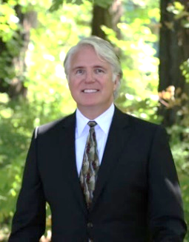

**Qualifications of Kurt M. Mueller, MAI**

**Managing Partner**

State Certifications

Certified General Appraiser

State of Oregon (C000484)

State of Washington (1100714)

Principal Broker’s License

State of Oregon (2012044882)

Education

Bachelor of Business Administration - Finance

University of Hawaii at Manoa

Qualified

Expert Witness:

U.S. District Court

Multnomah County Circuit Court

Specialties

Ground lease / leasehold analysis, complex land assignments, industrial, professional office, medical / dental office, retail, special use properties, etc. Also, condemnation, eminent domain, right-of-way & assignments.

Contact Details

503-218-4404 (o)

866-438-4213 (f)

L3 Valuation

16850 SW Upper Boones Ferry Rd

Suite A

Durham, OR 97224

kmueller@L3valuation.com

[www.L3valuation.com](http://www.L3valuation.com)

Membership/Affiliations:

Member: Appraisal Institute – MAI Designation (#9654)

2004 President: Appraisal Institute – Greater Oregon Chapter

Member: International Right of Way Association (#7956764)

Principal Broker: Kurt Mueller Real Estate P.C.

Appraisal Institute & Related Courses:

All courses completed for MAI Designation

Uniform Standards of Professional Appraisal Practice (USPAP)

7-Hour USPAP Update

Experience:

**Managing Partner / Owner**

L3 Valuation (2016 – Present), Portland, OR

**President / Owner**

Mueller and Company, Inc. (1996 – 2016), Portland, OR

Mueller and Company, Inc. (1993 – 1994), Honolulu, HI

**Commercial / Review Appraiser**

KeyBank (1995 – 1996), Portland, OR

**Senior Appraiser**

Sylva Howell & Associates (1989 – 1993), Honolulu, HI

Lesher & Company, Ltd. (1986 – 1988), Honolulu, HI

Appraisal Practice Areas:

Services includes the appraisal, appraisal review, and / or consultation for acquisition / disposition, financing, estate, arbitrations, mediations, buy/sell agreements, development, condemnation, fractional interest and court testimony purposes. Typical clients served are financial institutions, investors, developers, legal & accounting firms, and governmental. Types of properties appraised include:

Downtown & Suburban Office Medical & Dental Properties

Corporate Headquarters Office Condominiums

Anchored Shopping Centers Strip Retail Centers

Vacant Land Market Studies / Rent Studies

R&D Buildings Auto Dealerships

Industrial / Mfg. / Flex Car Wash / Mini-Lube

Business Parks Restaurants

Mixed Use Properties Bank Branches

Self-Storage Facilities Ground Lease Analysis

Churches / Schools Public Properties

Apartments Subdivisions / Single-Family

Manufactured Home Parks Condominiums

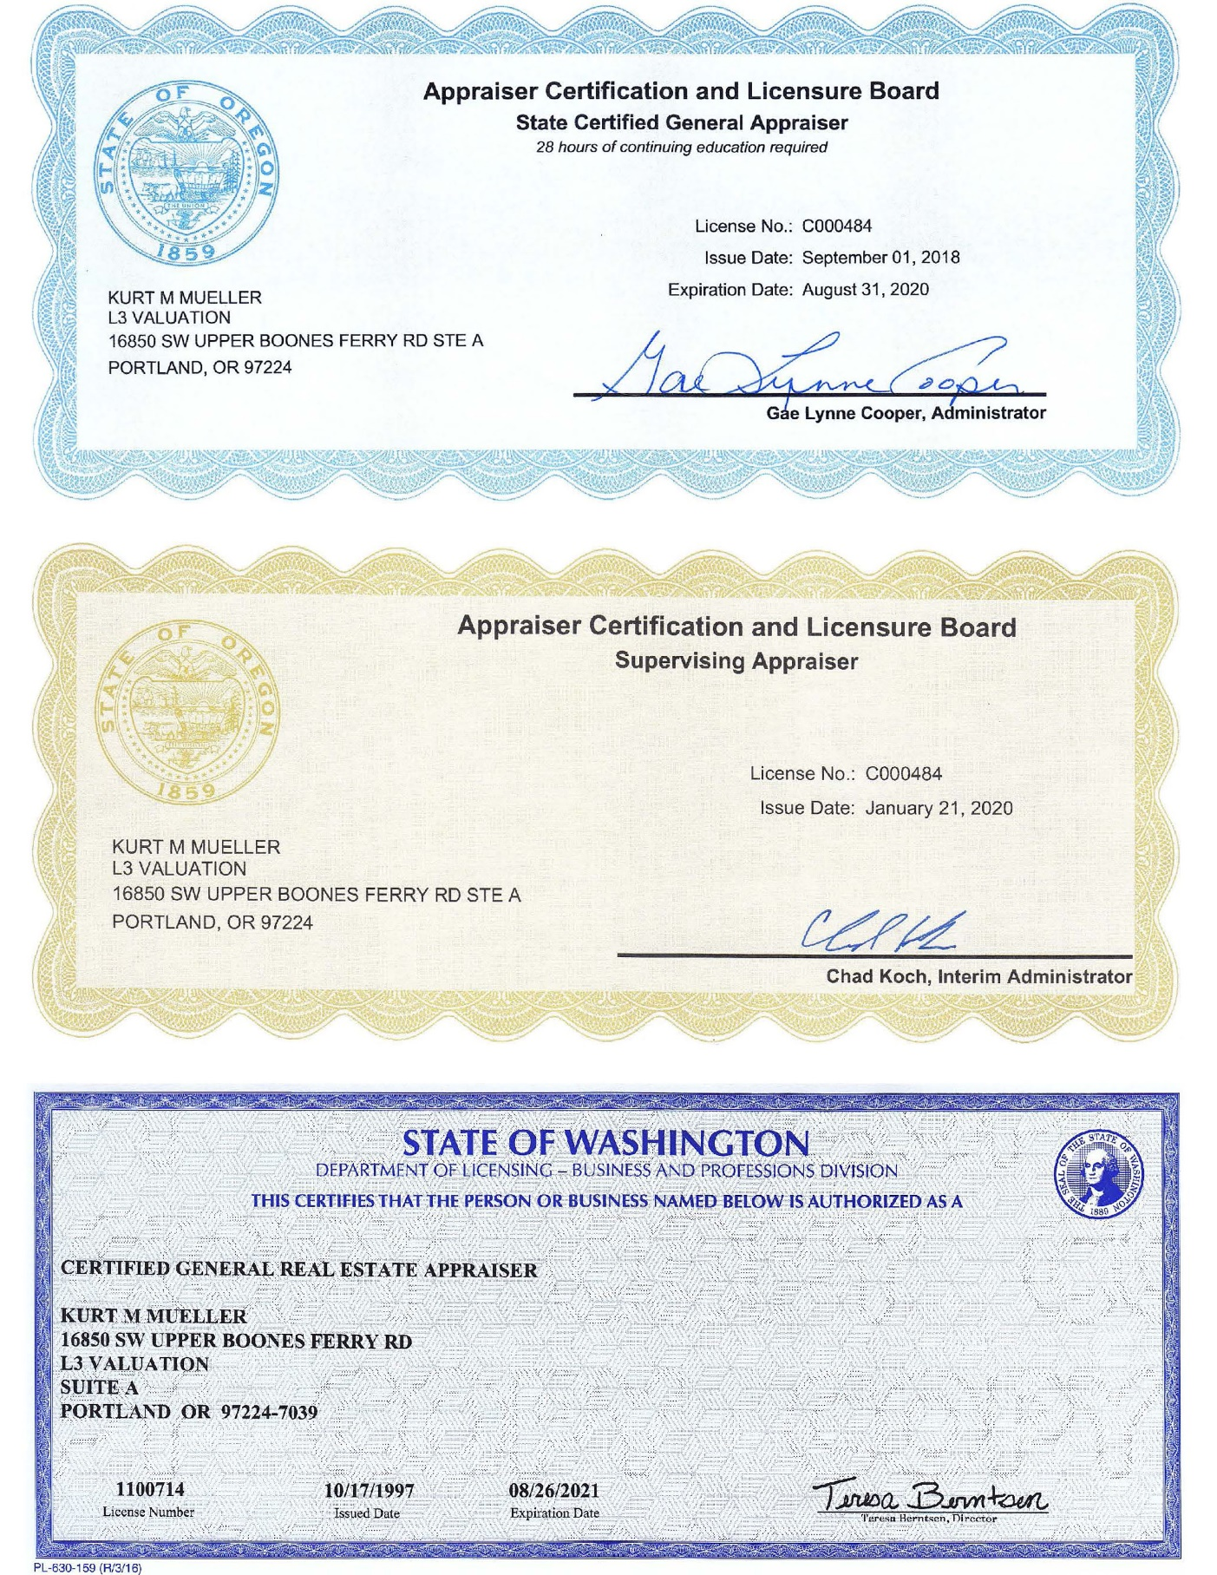



**Qualifications of Scott M Steinman**

**Real Estate Appraiser Assistant**

State Certifications

Registered Appraiser Assistant

State of Oregon (AA03393)



Education

B.S – Business Administration,

University of Oregon

Specialties

Industrial, retail, rural residential, multifamily, office, and special-purpose properties.

Contact Details

503-620-0881 (o)

L3 Valuation

16850 SW Upper Boones Ferry Rd

Suite A

Durham, OR 97224

ssteinman@L3Valuation.com

[www.L3Valuation.com](http://www.L3Valuation.com)

Appraisal Institute & Related Courses:

Basic Appraisal Procedures

Basic Appraisal Principles

National Uniform Standards of Professional Appraisal Practice (USPAP) Business Practices and Ethics

Experience:

**Real Estate Appraiser Assistant**

L3 Valuation, Portland, OR

(2019-Present)

**Account Executive**

Dealer Spike LLC, Portland, OR

(2019)

**DTC / Trade Sales**

Argyle Winery, Portland, OR

(2017-2019)

Appraisal Practice Areas:

Services include appraisal for acquisition / disposition, financing, estate, development, and fractional interest purposes. Typical clients served are financial institutions, investors, developers, legal & accounting firms, and governmental. Types of properties appraised include:

Agricultural Land Permanent Plantings

Forest Land Medical & Professional Offices

Condominiums Anchored Shopping Centers

Strip Retail Centers Vacant Land

R&D Buildings Industrial Parks

Restaurants Mixed Use Properties

Bank Branches Ground Lease Analysis

Churches Schools

Airport Hangars Public Properties

Apartments Subdivisions

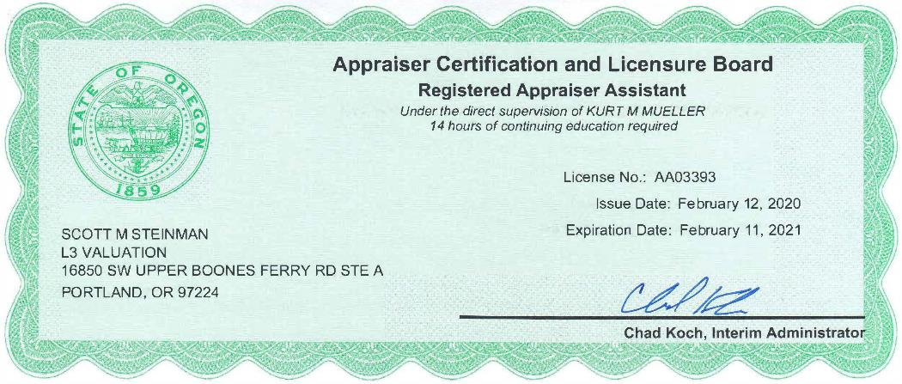

|  |
| --- |
| **Company Profile** |

L3 Valuation is a commercial real estate appraisal and consulting firm located in Durham, Oregon. The goal of the company is to offer appraisal, review, and consulting services to clients in a professional and timely manner in covering all types of real estate. Though the firm's primary focus is the State of Oregon, we also provide appraisal services for properties located in the southwestern portion of the State of Washington.

To better serve our clients, L3 Valuation created and implemented a proprietary analytical mobile app capable of real-time access to confirmed data via cloud-based technology. Confirmed data includes local, regional and national sales, leases and resource data. L3 Valuation makes certain that our team members have access the necessary tools and information relevant to solving the client’s issues and assuring their needs are satisfied. As a top regional boutique firm, L3 Valuation maintains deep connections within the local brokerage, investment and development communities allowing it access to information unavailable to firms more national in focus.

L3 Valuation considers its clients to be its most valuable assets. We are privileged to serve various small and large financial institutions, pension funds, insurance companies, corporations, developers, private individuals, attorneys, accountants and government agencies. Past assignments have been conducted to serve various functions, including mortgage financing, property purchase & disposition, lease rent arbitration & negotiation, charitable donation & gifting, partnership & divorce settlement, litigation support & expert witness services, condemnation, property tax analysis, appeal services and corporate planning purposes.

The partners and team members are dedicated to the company's goal, to providing a fresh new approach to any real estate problem, and to working with each client on a personal basis. The firm was founded by managing partners - Kurt M. Mueller, MAI and James F. Kurasz, MAI, AI-GRS; each with +25 to 30 years of experience in commercial real estate. Being members of the Appraisal Institute (AI), Mr. Mueller and Mr. Kurasz, as well as our AI designated staff associates, must adhere to strict codes of professional practice and ethics in serving the public.

The firm also includes a team of very seasoned associates, including professionals with over 25 years of experience. All are either designated members of the Appraisal Institute, including the prestigious MAI and SRA designations, or candidates for one of these professional designations. All have extensive experience in providing appraisal and consultation services for a wide array of types of real property and real property interests throughout the Pacific Northwest.

|  |
| --- |
| **Company Profile** |

Mr. Mueller has been actively involved in commercial real estate and consulting fields since 1986. Before relocating to Portland, he was the owner of the commercial appraisal firm of Mueller and Company in Honolulu, Hawaii, and holds an expert knowledge of ground leases and the valuation of leasehold properties. His specialties include subdivisions, complex land assignments, and a wide array of special use properties such as new auto dealerships, schools / religious facilities, R&D and hi-tech facilities, aircraft hangars, etc. Mr. Mueller is licensed in Oregon and Washington and is also an active real estate developer / investor, and licensed broker in Oregon. Mr. Mueller has direct experience in arbitration, settlement services, tenant lease negotiation, marketing, site selection, and project general contracting.

Mr. Kurasz started his commercial real estate appraisal career with Mason & Mason in 1987 in Los Angeles, California. In 1992, he relocated to Portland, and originally worked with some residential firms, then committing to commercial work in 1994. After working with several commercial firms over the years, including Mueller and Company, he started his own firm, Kurasz Consulting, Inc. in 2003. Mr. Kurasz is licensed in Oregon, Washington, and Idaho. Mr. Kurasz is a generalist whose specialties include appraisal review, as well as appraising multi-family / manufactured home parks, retail, office, industrial, land and subdivisions.

In addition, the principals of the firm – Mr. Mueller and Mr. Kurasz offer expertise in eminent domain, right-of-way and condemnation assignments. Both are members of the International Right of Way Association (IRWA), and pursuing the requirements to obtain the prestigious SR/WA designation.

Senior members of our team include those holding the MAI and SRA designations from the Appraisal Institute, with a deep level of experience appraising in Oregon and Washington, as well as California, Hawaii, and Virginia. The team members at L3 Valuation are all licensed to appraise in the States of Oregon and Washington, and all have extensive commercial appraisal experience. All our team members are adept at traditional retail, office and industrial properties, while specialties provided by these team members include such specialties as urban core redevelopment / mixed-use properties, medical / dental properties, veterinary clinics & hospitals, schools / religious facilities and public facilities, investment grade properties (office, industrial and apartment), hi-tech / R&D properties, historic office, breweries and distilleries, new and used auto dealerships, self-storage facilities, bank branches, car wash, restaurant (sit-down and fastfood), auto service & repair, quick lube, manufactured home parks, subdivision and complex land assignments, high value and unique residential properties, and a variety of agricultural and ranch properties. Areas of specific geographic focus include the Oregon Coast, Columbia River Gorge, Willamette Valley &Yamhill County areas, and Central / Southern Oregon.

|  |
| --- |
| **Professional Services** |

Valuation Reports

The market valuation of real property interests (fee simple, leasehold, leased fee, etc.) in various types of properties is the primary focus of most real property appraisal assignments performed by L3 Valuation. It involves defining the real property interests to be appraised, collection and verification of market data, analysis of the highest and best use of the property, and the market valuation of the property via the most applicable appraisal methods. Other valuation studies may involve the estimation of investment value for various real property interests based on client specific data and/or criteria. Our services also include reports intended to assist in a team approach to Valuation for Financial Reporting.

Real Estate Consulting

In order to better serve our clients with unique properties and/or investment problems, L3 Valuation can also conduct consulting assignments covering all property types. Providing competent, unbiased, professional guidance on diversified problems in real estate has taken on ever increasing importance as a method of reducing the risks associated with the real estate field. The firm has undertaken such tasks as highest and best use analysis, market studies, rent renegotiation consulting, subdivision analysis, office/retail analysis, project planning studies, and market and feasibility analysis.

Estate Planning, Litigation Support, and Expert Witness Services

L3 Valuation also offers services for real estate matters involving arbitrations (ground rent renegotiations, tenant space lease renegotiations, etc.). We offer estate planning tax support for accounting firms and litigation support services to attorneys. It is our goal to provide not only offensive, but defensive strategies, in a fair and unbiased manner, in order to expose the strengths and weaknesses of a particular case. Finally, Mr. Mueller and Mr. Kurasz are experienced in working with attorneys in providing expert witness testimony.

Appraisal Review Services

An appraisal review serves the purpose of analyzing the content and conclusions of an appraisal report. It is the reviewer's responsibility to assess the relevancy, adequacy and analysis of the market data used; to form an opinion as the appropriateness and logical consistency of the appraisal methods and techniques used; to comment on the overall presentation of the report, and its general conformance with accepted appraisal practice. Clients consider an appraisal review to be a valuable tool in determining the credibility of an appraisal report, in order to reduce the risks associated with important lending, legal, and investment decisions.

|  |
| --- |
| **Partial List of Clients** |

|  |  |  |
| --- | --- | --- |
| AEGON USA Realty Advisors, Inc. | FDIC | Portland Development Commission |
| Albertson's Companies | First Citizens Bank | Port of Cascade Locks |
| Arbor Custom Homes | First Tech Credit Union | Rabobank, N.A. |
| Armed Forces Bank | First Community Credit Union | Roberson Auto Group |
| Ball Janik LLP | First Interstate Bank | Riverview Community Bank |
| Bank of America | Garvey Schubert Barer | Royal Moore Auto Group |
| Bank of the West | Gevurtz Menashe | SAFECO |
| Banner Bank | Goodwill Industries | Schwabe Williamson & Wyatt |
| Belmar Properties | Gramor Development | Standard Insurance Company |
| Beneficial State Bank | Heritage Bank | State Farm Bank |
| Bittner & Hahs, P.C. | Hillsboro School District | St. Helens Community Credit Union |
| Black | Helterline LLP | HomeStreet Bank | Stockman Bank of Montana |
| BOK Financial Corporation | Intervest Mortgage Company | Stoel Rives LLP |
| Buckley Law P.C. | International Paper | Summit Bank |
| California Bank and Trust | JP Morgan Chase Bank | Tigard-Tualatin School District |
| Capitol Auto Group | Kendall Motors | The CIT Group |
| City of Banks | KeyBank | Tonkin Torp. LLC |
| City of Happy Valley | Lanphere Enterprises, Inc. | Tonkin Auto Group |
| City of North Plains | Lehigh Hansen Corporation | Tri-Met |
| City of Sherwood | Lewis & Clark Bank | Twinstar Credit Union |
| Citizens Bank | Lithia Motors | Umpqua Bank |
| Clackamas County Bank | MAPS Credit Union | Union Bank |
| Coca Cola Enterprises | MBank | Unitus Community Credit Union |
| Columbia Bank | METRO | U.S. Bancorp |
| Columbia Credit Union | Mid-Columbia Medical Center | Venerable Properties |
| Columbia Distributing | M&T Bank | Washington Capital Management |
| Davis Wright Tremaine LLP | National Mortgage Company | Washington Trust Bank |
| DePaul Industries | Northwest Bank | Wauna Credit Union |
| Department of Veteran Affairs | Northwest Farm Credit Services | Wells Fargo Bank |
| Draneas & Huglin, P.C. | OnPoint Community Credit Union | Winco Foods, Inc. |
| Farleigh Wada Witt | Oregon Department of Transportation | Zions Bank |
|  | Pacific Western Bank |  |