Austin Small

CIS-581 Project 3 Results

* **Final Stitched Mosaic:**

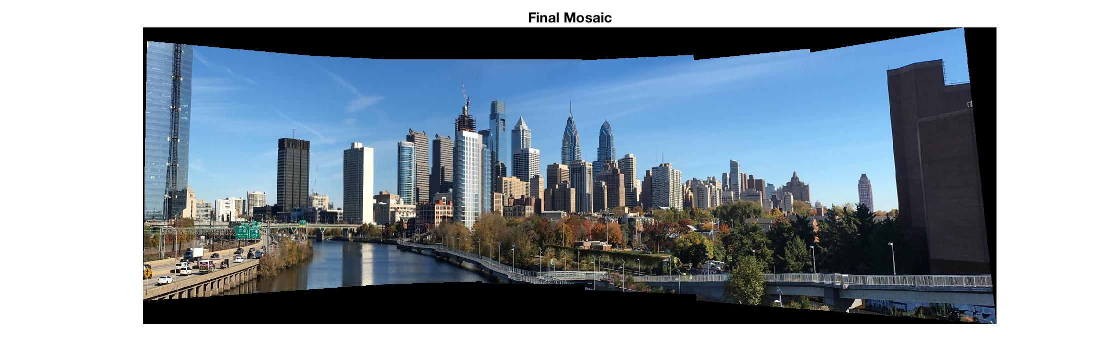

* **Corner Detection Result (First Image):**

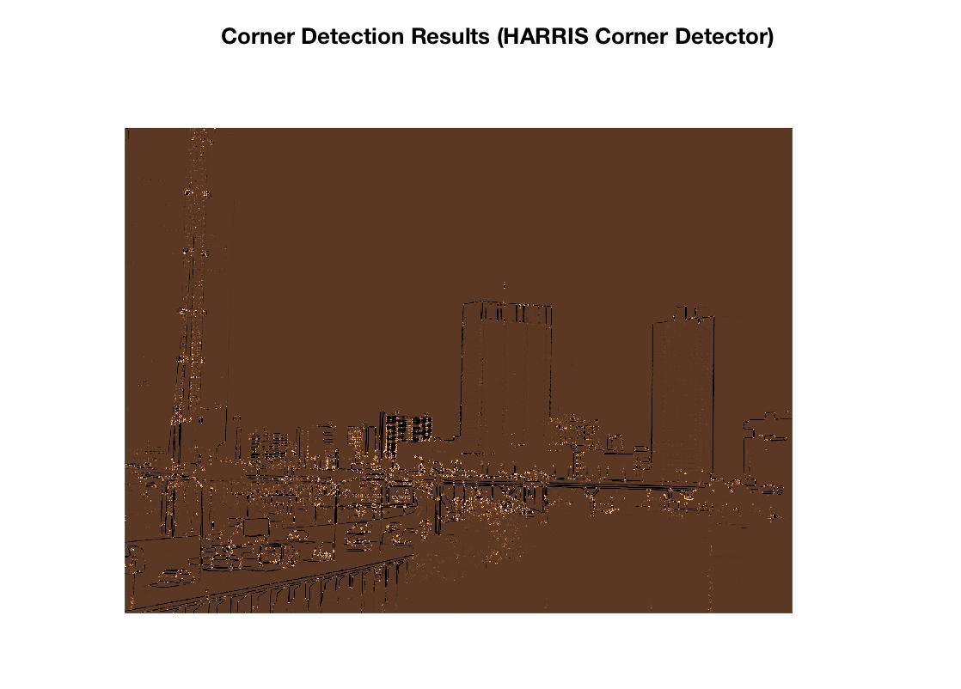

* **ANMS (First Image):**

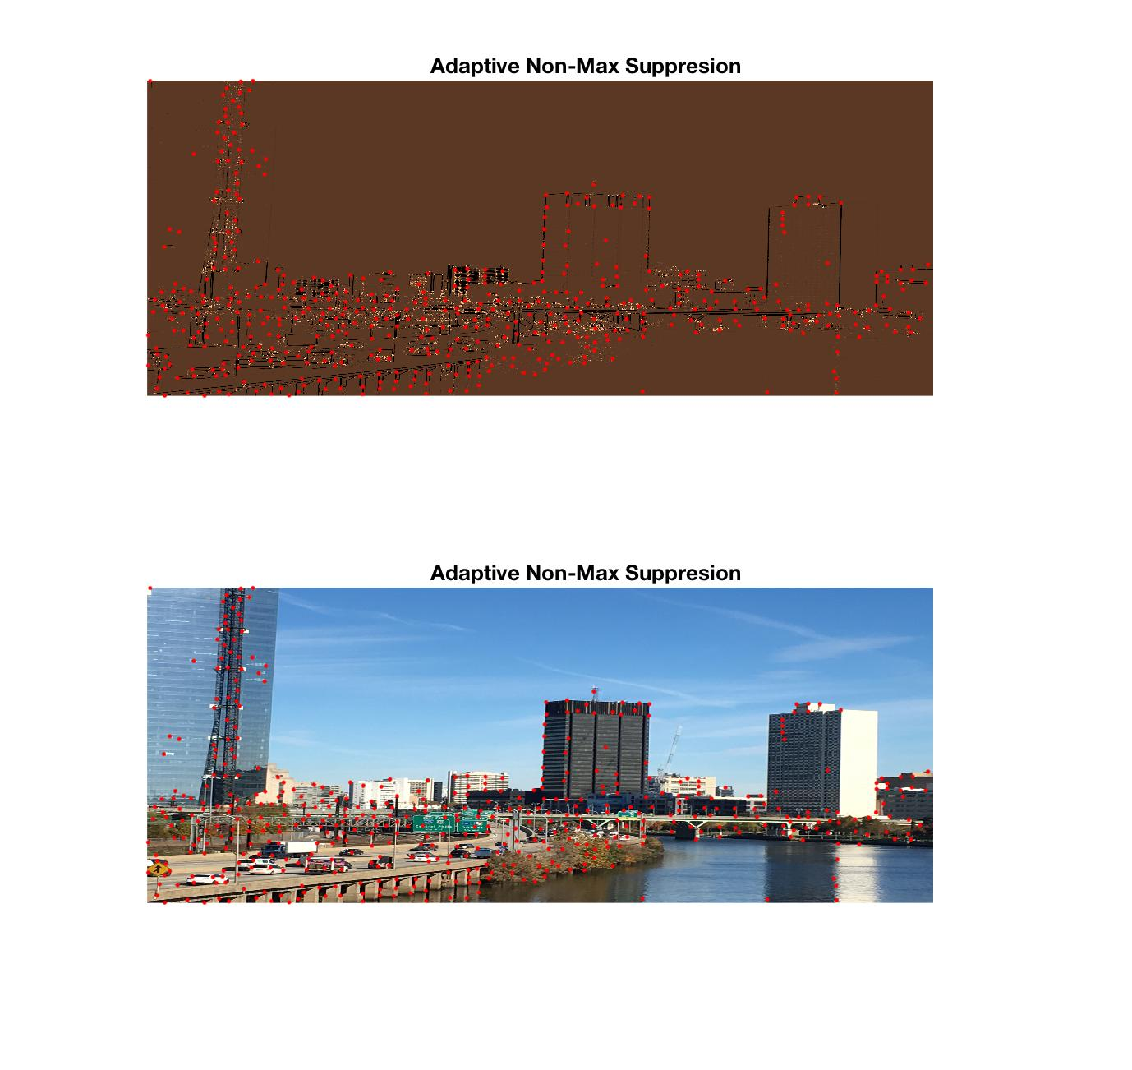

* **Final Matching Results:**
  + First Pair

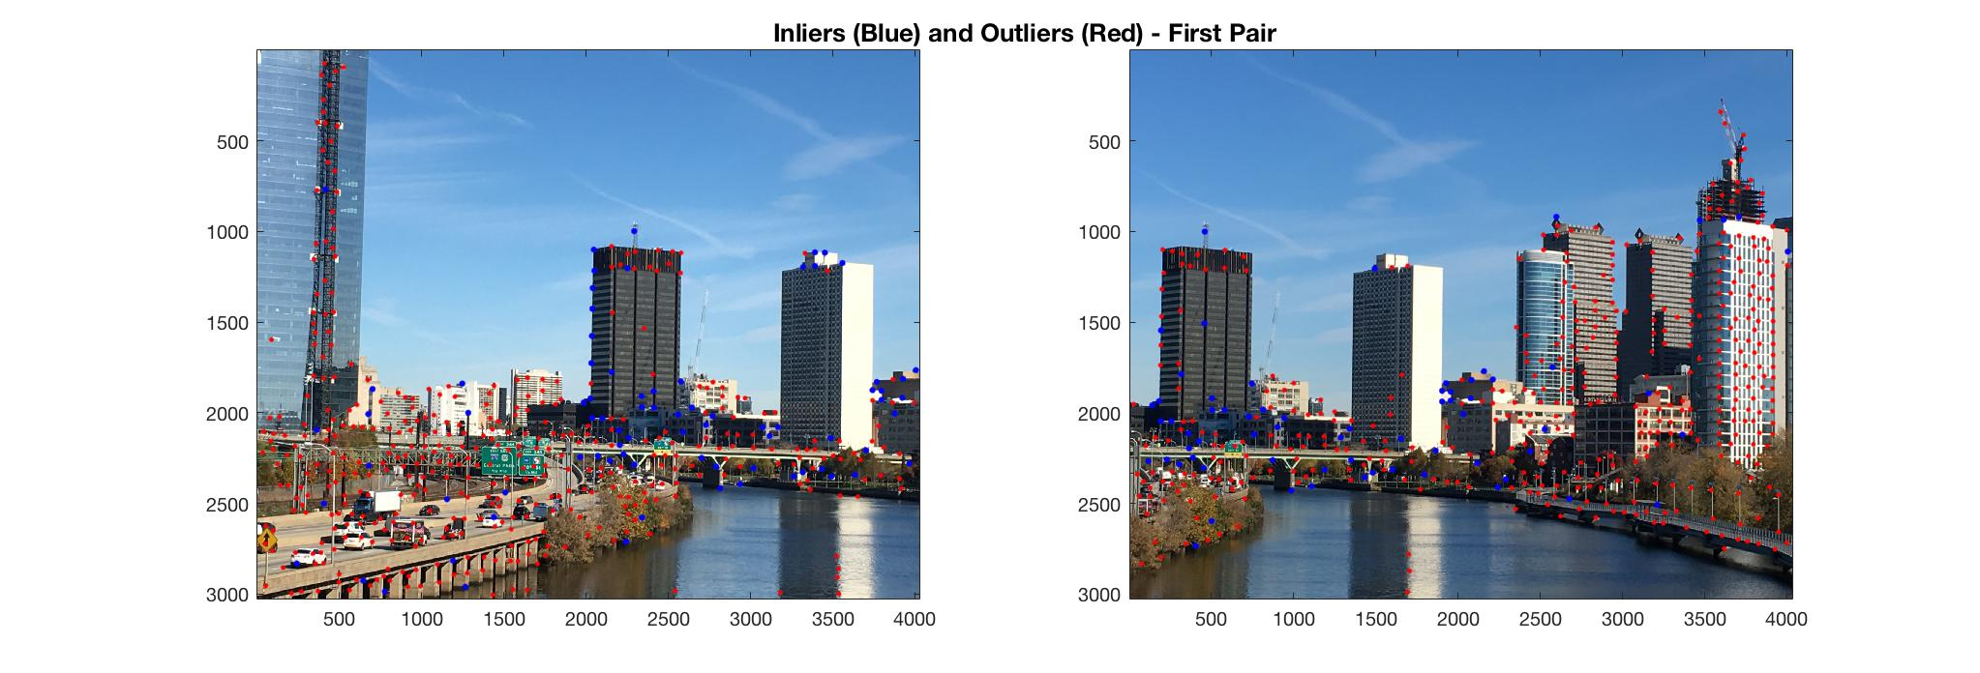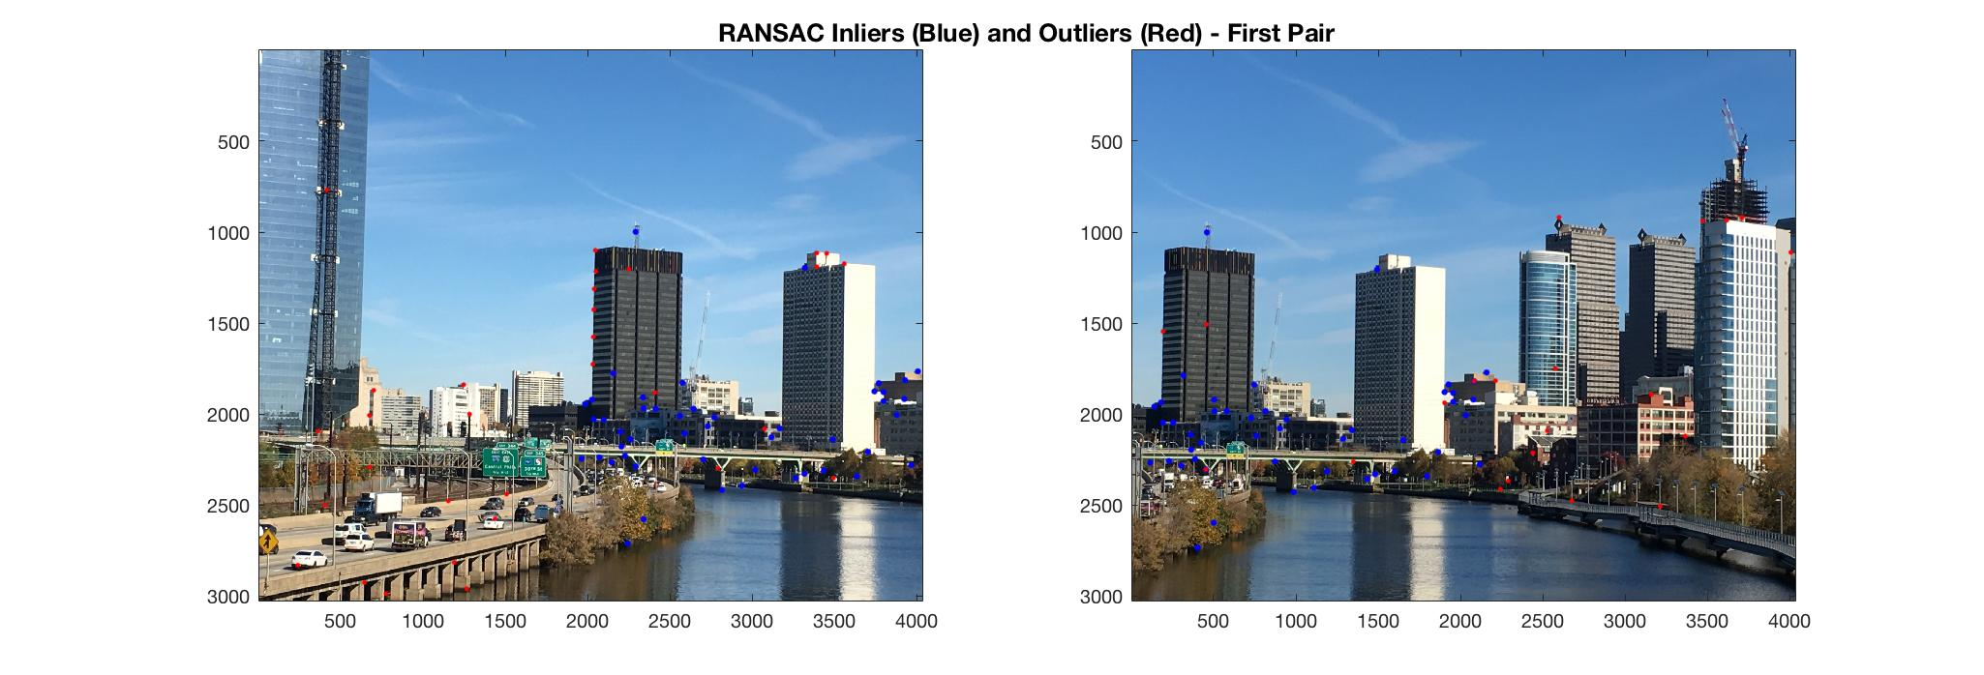

* + Second Pair

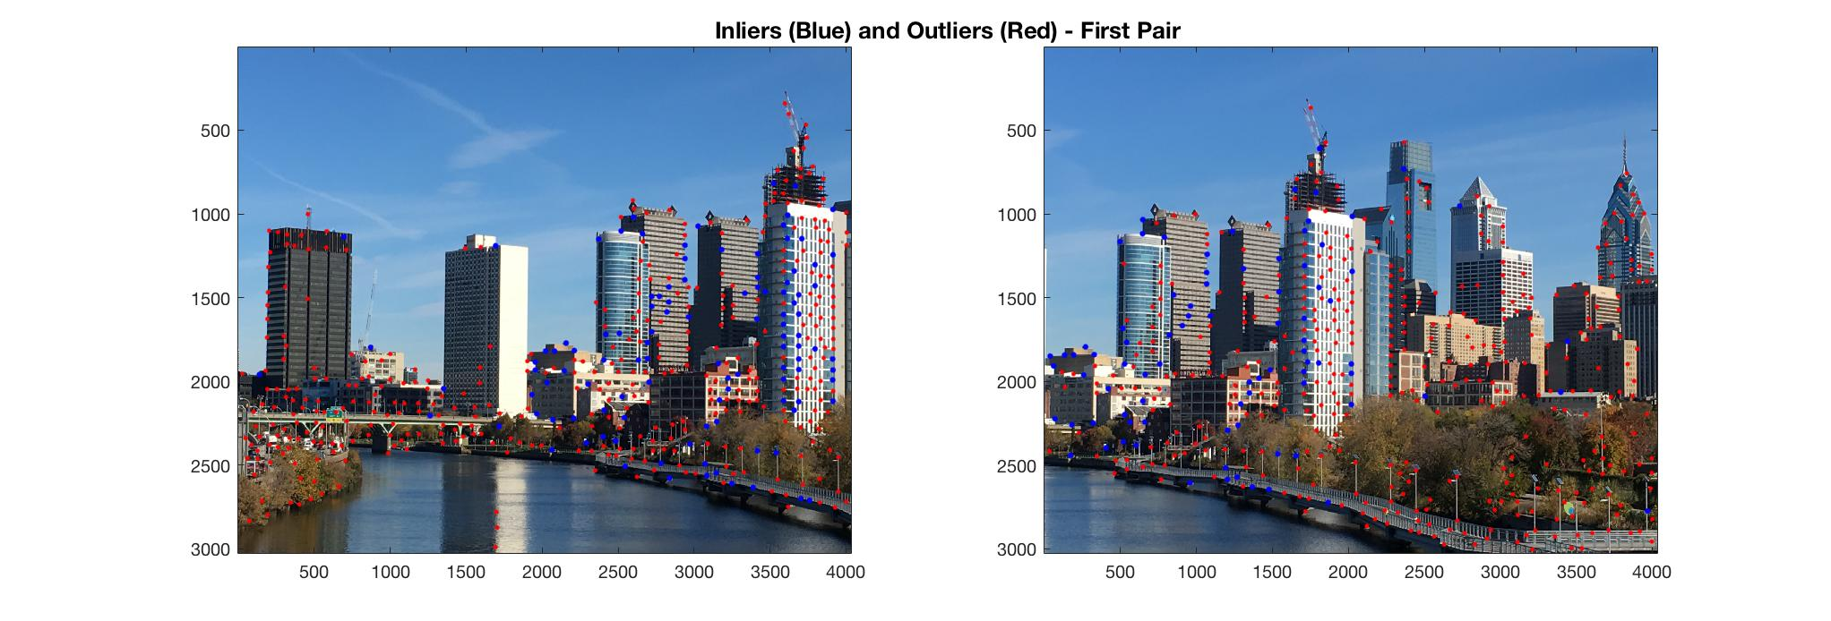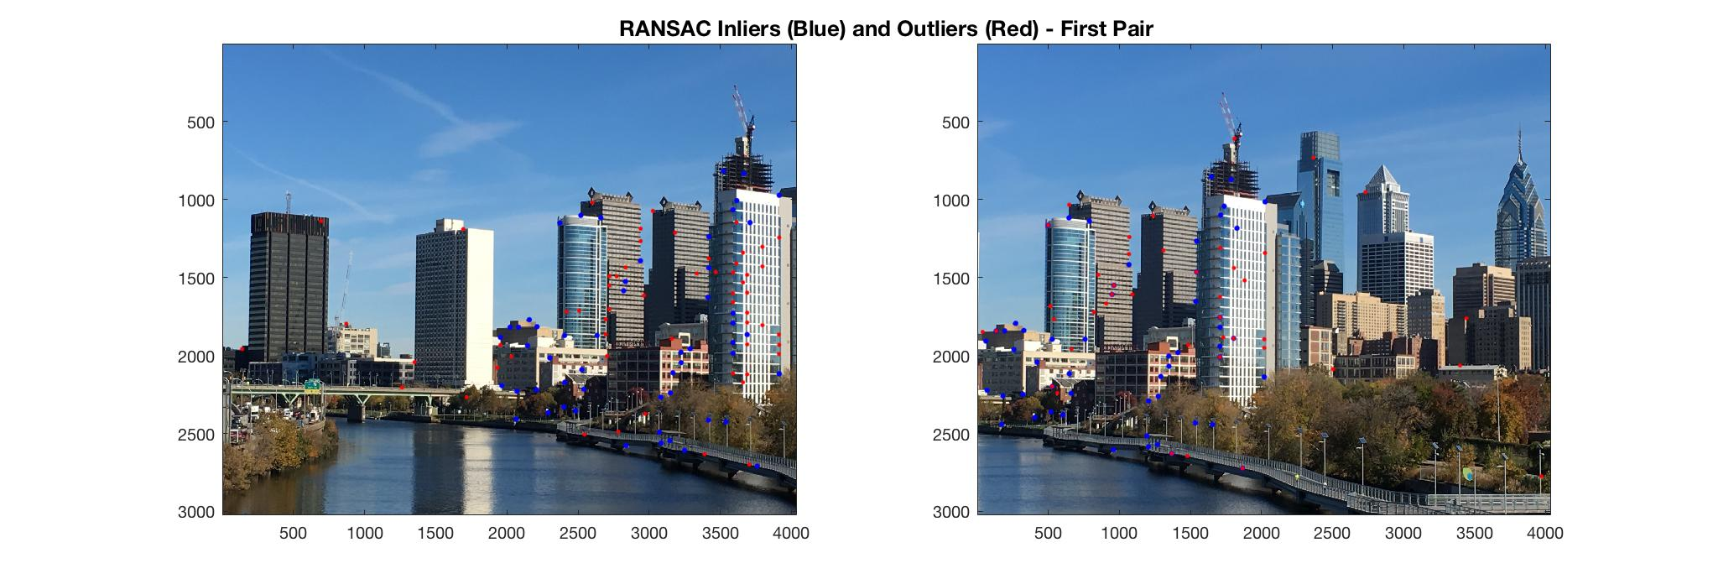

* + Third Pair

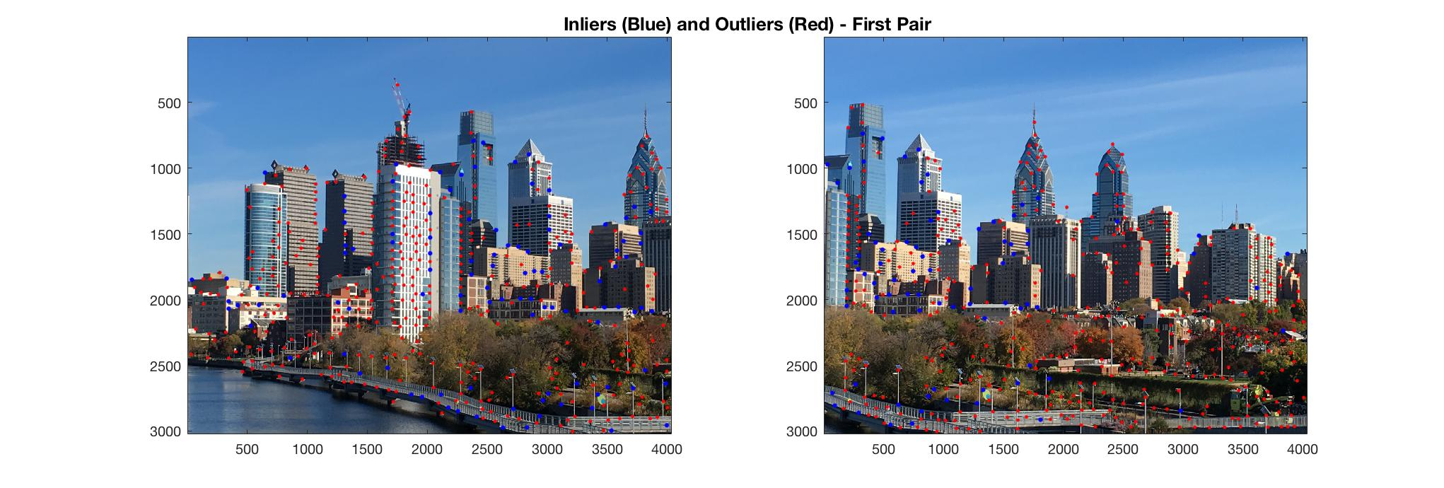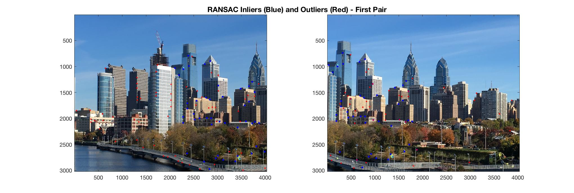

* + Fourth Pair

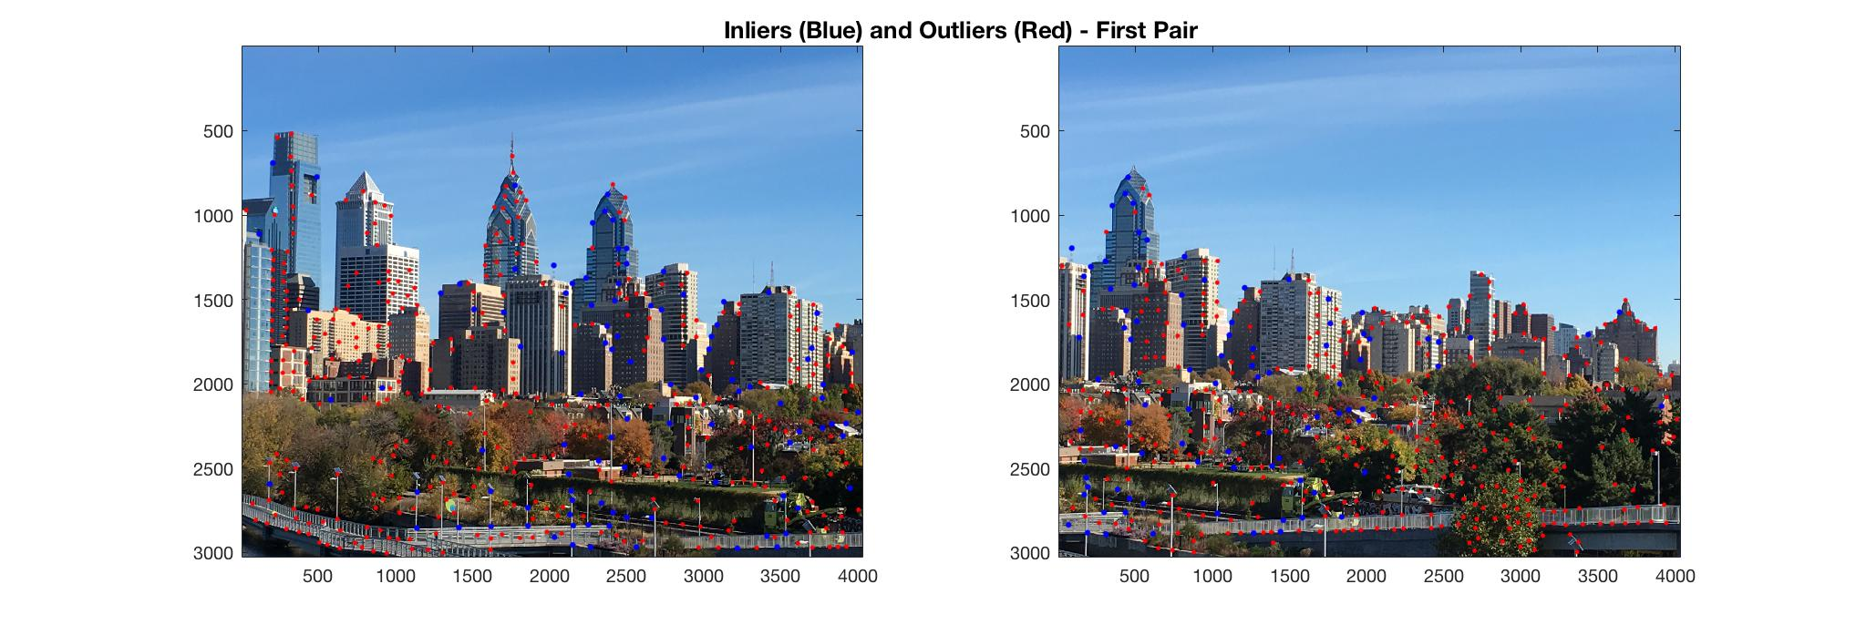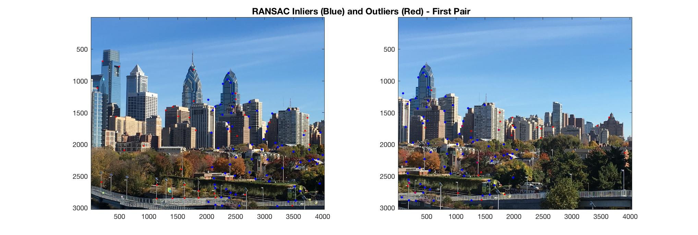

* + Fifth Pair

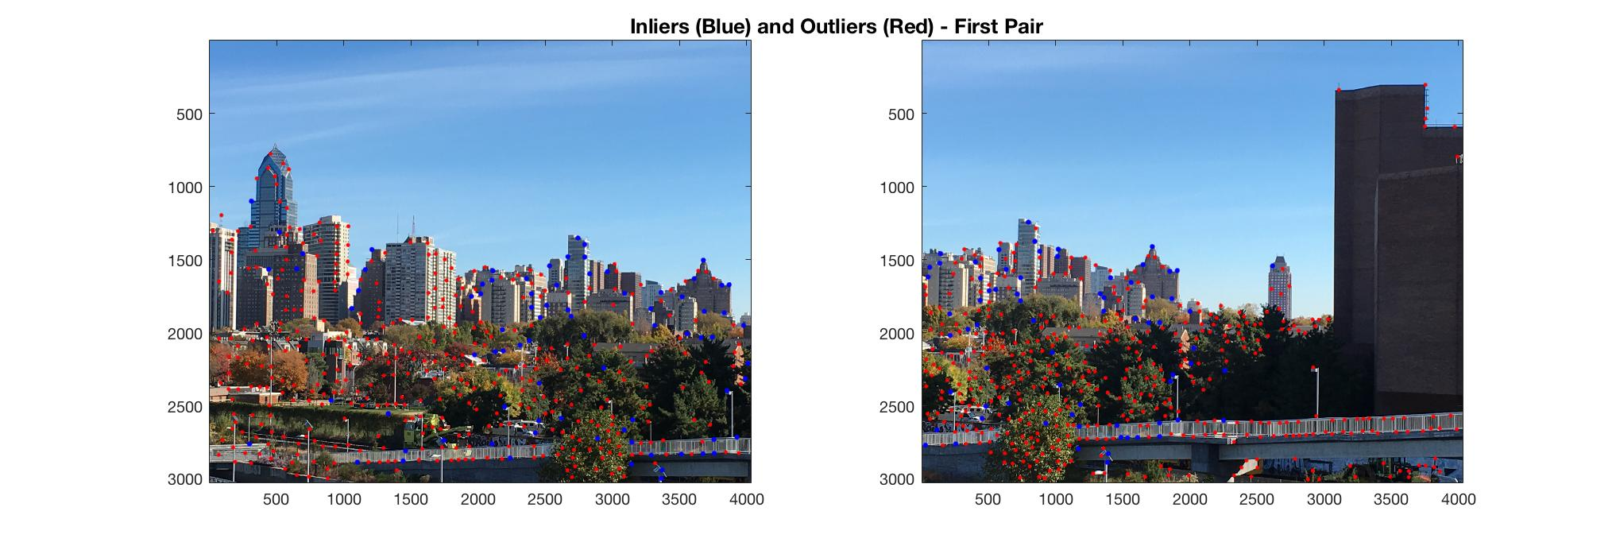

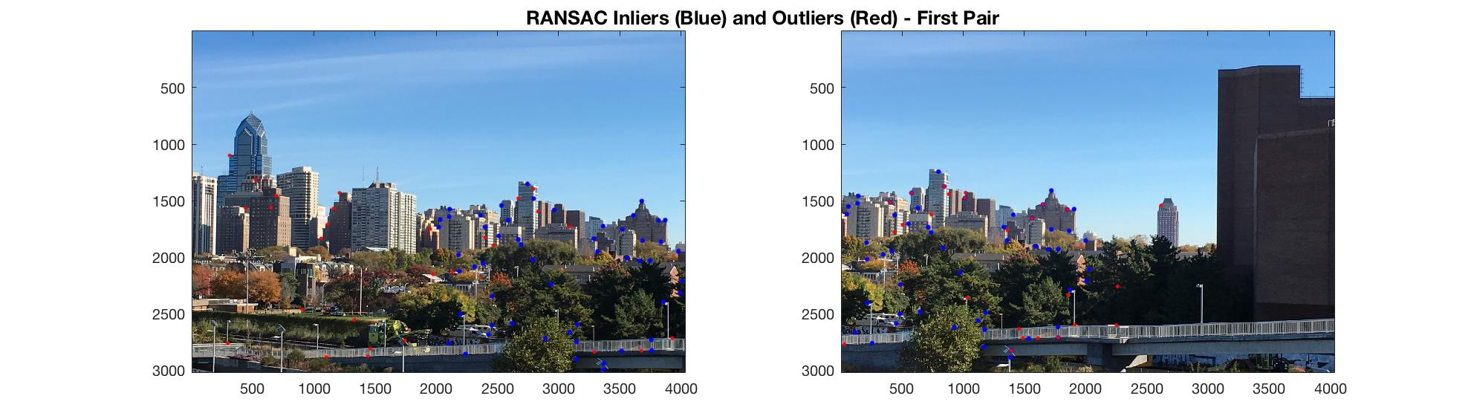

* **Additional Features:**

I implemented alpha blending / feathering. As can be seen below, the results are fantastic. The first image is the mosaic prior to alpha blending. The second image is the final result – you can’t even tell where the images merge!

