 | BUILDING  SOLUTIONS  performance based design Brief


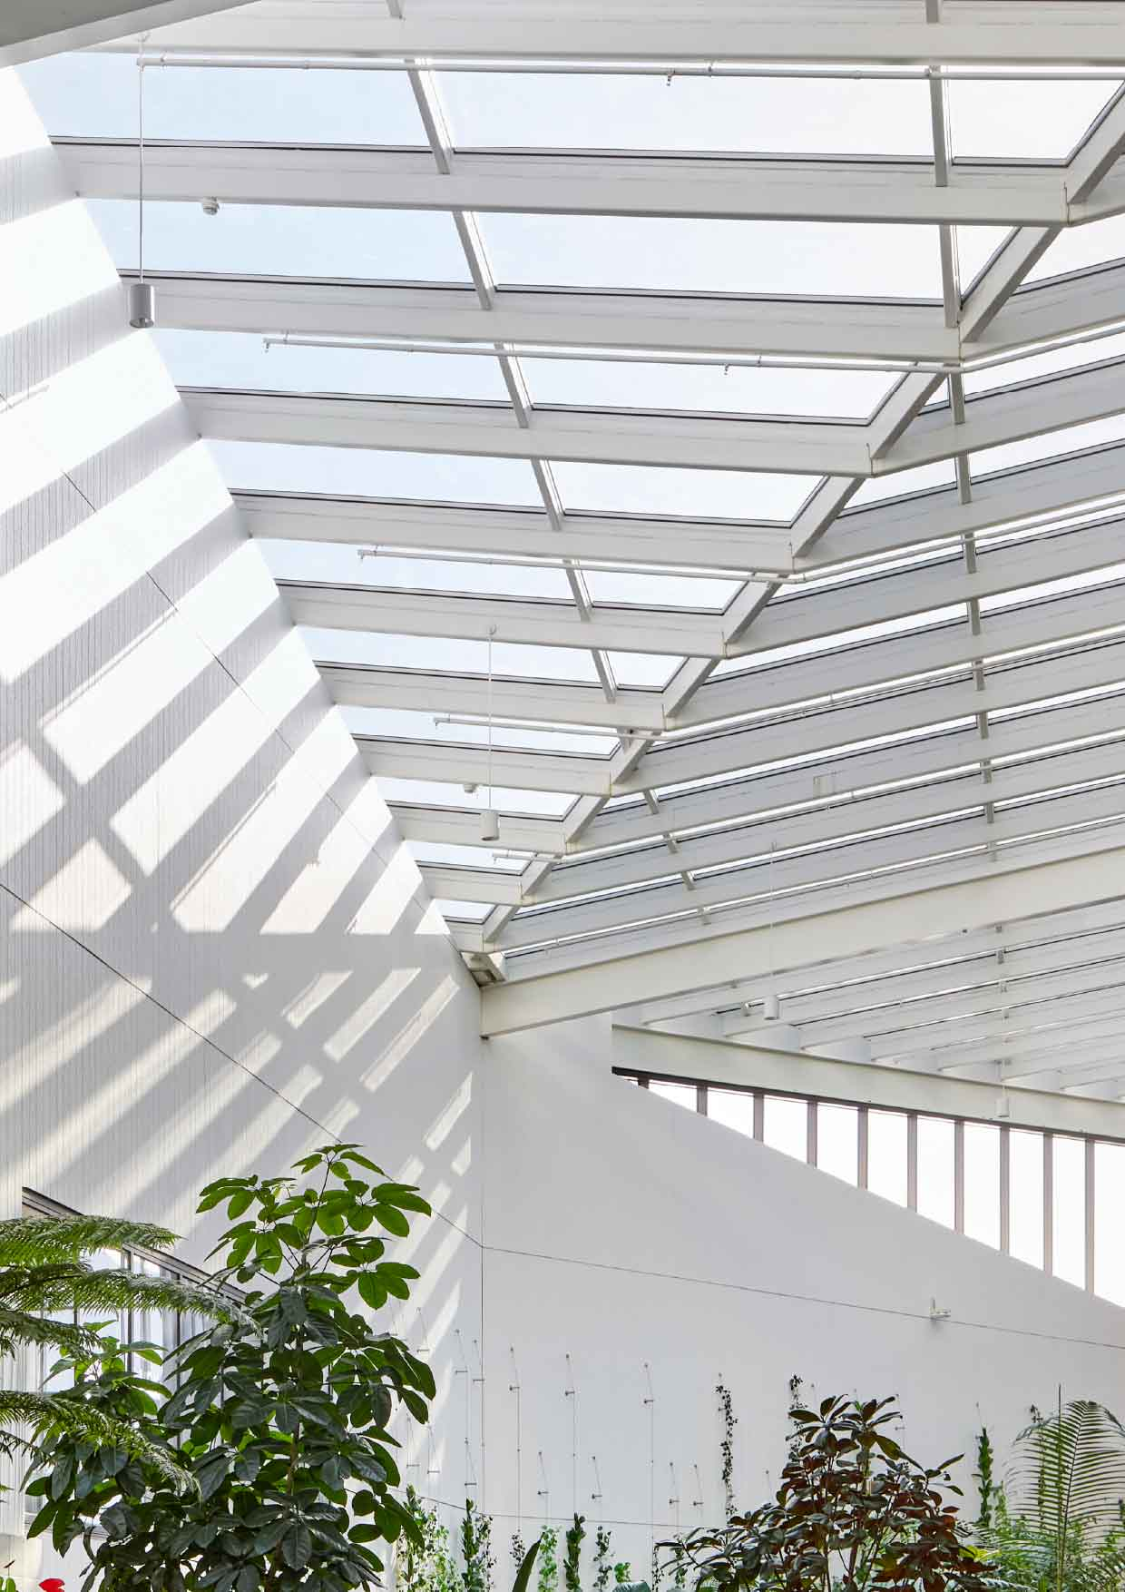
Address | 42 Waterfront Drive, Hope Island QLD
Project no. | 10042-S
Date | 24/06/2026
Revision | 0
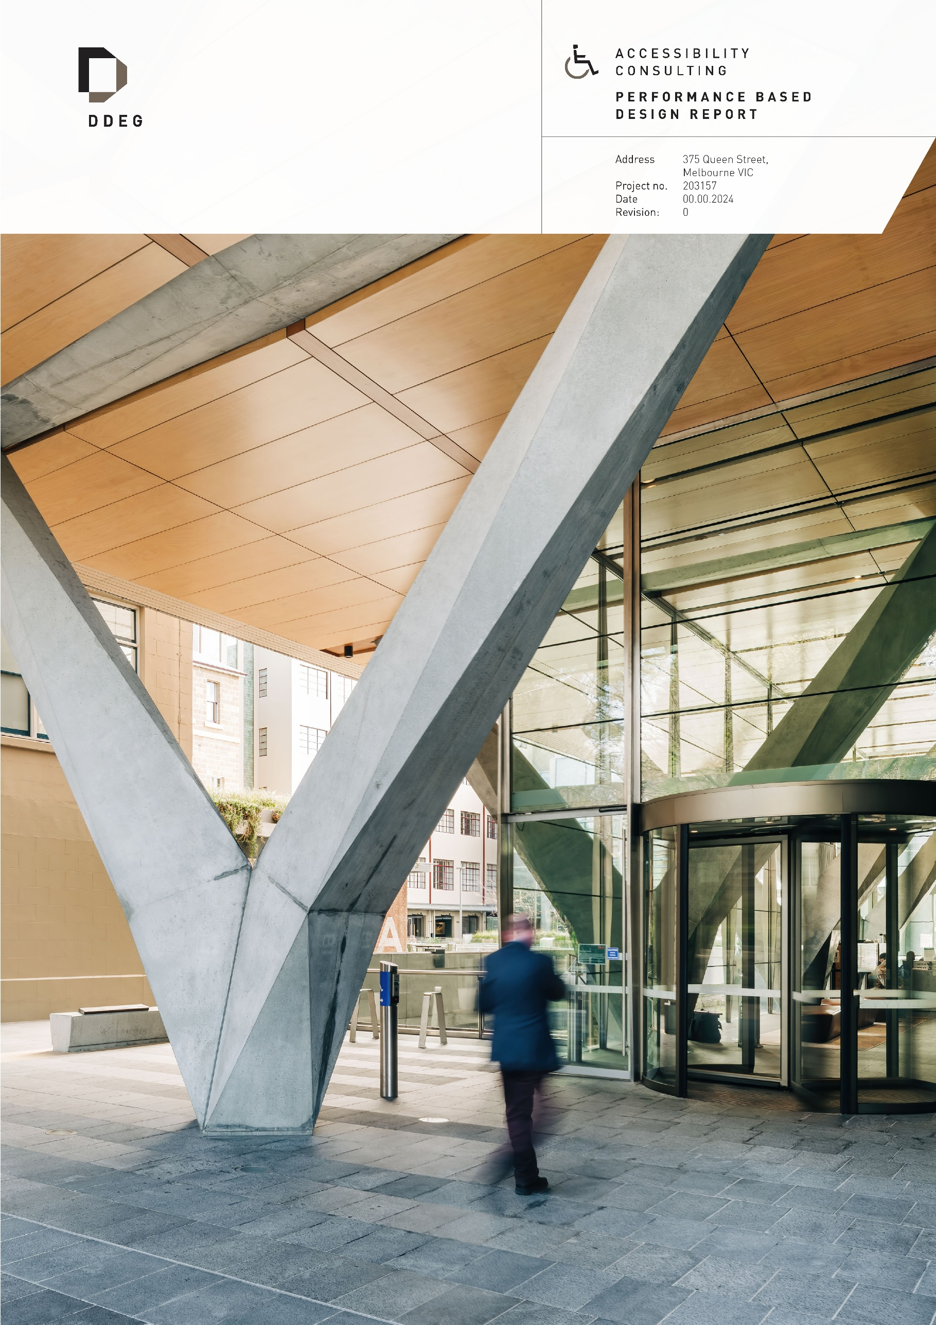

Document Title | Building Solutions – Performance Based Design Brief
Project Address | 42 Waterfront Drive, Hope Island QLD
Project No | 10042-S
Prepared For | Halcyon Constructions QLD Pty Ltd
Prepared By | DDEG  ABN: 90 657 239 926  Level 3, 127 Creek Street  Brisbane, QLD 4000  1300 470 578
Authorised by | Kieran Doherty  kieran.d@ddeg.com.au  FIEAust CPEng EngExec NER APEC Engineer IntPE(Aus)  RPEQ (QLD) 21904 | 

Revision history

DOC | REV | DATE | PURPOSE | PREPARED BY | REVIEWED BY
PBDB | 0 | 24/06/2026 | Stakeholder Review |  | Kieran Doherty
This report is private, confidential, and intended solely for the use of the individual or entity to whom it is addressed. No part of this document may be reproduced, shared with third parties, or uploaded to any Artificial Intelligence (AI) systems, Large Language Models (LLMs), or automated data processing tools without the express written consent of DDEG Pty Ltd.

Executive Summary
Halcyon Constructions QLD Pty Ltd has appointed DDEG to undertake an evaluation for 42 Waterfront Drive, Hope Island QLD.
This Performance Based Design Brief (PBDB) identifies the variations to the National Construction Code (NCC) Deemed to Satisfy (DTS) Provisions, proposes Performance Solutions, and sets the framework for evaluation.
The following variations to the Deemed-to-Satisfy provisions have been identified and are proposed to be addressed as Performance Solutions:
- Proposed Performance Solution and Reference Criteria
Proposed Performance Solution | National Construction Code
 | DTS Provision | Performance Requirement
To provide the technical justification to support an alternative flashing design between the external cladding of the building and glazed assemblies. | H1D7(4), H2D6(4)  (HP 7.5.6(a)(i)) | H2P2
To provide technical justification to support a minimum reduced grade of 1:100 across the entire external paved/concreted areas in lieu of a 1:20 grade over the first 1 m from the building. | H2D2(b)  (3.3.3(a)(ii)) | H2P1
The proposed Performance Solution has been evaluated, and it is our considered opinion that the building design meets the NCC Performance Requirements with the inclusion of the following specification of required performance measures:
- Specification of Required Performance Measures
System | Performance Standard
Construction Requirements | Performance Solution 1 – Alternate Window Head Flashing  The building’s external glazed assemblies will be provided with an alternate head flashing detail (as shown in FIGURE 5) that is to be installed to maintain the weatherproofing intent of Performance Requirement H2P2, including drainage to the outside face of the wall/cladding and continuity of the water-shedding/drained plane around openings.  The alternate window head flashing arrangement is to comply with the following minimum requirements:  - Flashings to wall openings are to be formed from materials complying with AS/NZS 2904:1995.  - The head flashing is to be installed such that water collected at the head of the opening drains to the outside face of the wall or cladding, consistent with the intent of ABCB Housing Provisions Clause 7.5.6(a)(iii).  - Where the head flashing cannot extend not less than 110 mm beyond the reveals due to the nominated vertical sheet cladding profile/jointing arrangement, the head flashing will be terminated, with continuity of weatherproofing achieved via an extended Damp Proof Course (DPC) membrane extending from the head flashing down the full height of the window frame on each side.  - DPC membrane is to be fully sealed or lapped to the head flashing.  - DPC membrane is to sit behind the cladding.  - DPC membrane is to be continuous for the full jamb height.  - The head flashing will extend a minimum of 110 mm horizontally past the window assembly measured from the window jamb.  - Flashings are to be securely fixed at least 25 mm under the cladding and are to extend over the ends and edges of the framing of the opening, consistent with Clause 7.5.6(e)  - Where joins in the flashing occur, the joins are to:  - overlap by not less than 75 mm in the direction of flow; and  - be securely fastened at intervals of not more than 40 mm; and  - have sealant installed between laps consistent with Clause 7.5.6(b).  - The pliable building membrane / wall wrap is to be dressed and lapped to provide continuity of the drained plane around the opening and is to be integrated with the alternate flashing arrangement such that water is directed to the exterior and reverse laps are avoided.  The window assemblies will otherwise comply with AS 2047:2014, and glazing will comply with AS 1288:2021 where applicable.  The James Hardie external cladding system (including Axon™ / EasyLap™ where applicable) is to be designed and installed in complete accordance with the relevant manufacturer installation guide and specifications, including any applicable CodeMark® certification requirements.  Performance Solution 2 – Alternate Grading to External Areas  A minimum reduced external finished surface grade of 1:100 will be provided to all external surfaces that are paved or concreted, in lieu of the minimum 1:20 grade over the first 1 m from the building as required under ABCB Housing Provisions Clause 3.3.3(a)(ii). A minimum 70 mm step-down will also be provided between the internal finished floor level and the adjacent external finished surface level at the nominated threshold locations.  Rainwater management at the external areas will be achieved through the following measures:  Roof Coverage Requirements  The external areas are to be provided with partial or full roof coverage from above to shield against wind-driven rain.  General Requirements  The entirety of the external paved surfaces must be graded away from the building at a minimum slope of 1:100 leading to an appropriate outfall or the site surface water management system (primary drainage including overflow provisions) connected to the Legal Point of Discharge.  We understand that the external paved/concreted perimeter pathway will be graded away from the dwelling with a minimum fall of 1:50 for the first metre, directing surface water to the agricultural drainage system, where applicable. It is also understood that an agricultural drainage system will be installed along the boundary wall in some cases due to proximity to adjacent units, to direct surface water away and prevent moisture from pooling against the wall.  The external area adjacent to the external threshold must not be used for the purpose of discharging overflow from the roof drainage system in a manner that could promote water ingress into the building.  External finished surface levels beyond the threshold must be no higher than the internal finished floor level of the dwelling.  Surface Drainage Requirements  Surface drainage systems, including its associated overland flow path, are required to direct surface water away from the building at the required storm intensity in the event drains are blocked.  The surface drainage systems, including the primary drainage provisions and the overland flow path for event of blockages are to be designed by the project design team in accordance with AS/NZS 3500.3:2025 for both primary and overflow systems.  A maintenance plan specific to the site conditions is required to be developed by the owner/plumber to ensure the drainage systems are clear of debris that may enter through its openings.  - Regular and robust maintenance will minimise the risk of debris causing blockage of the drainage system.  - The frequency of maintenance is to be determined based on-site conditions over the first 12 months of operation and adjusted thereon as required.  A registered and licenced plumber is to ensure that the drainage systems comply with and installed in strict accordance with the local plumbing regulations.
Other than the abovementioned requirements and the specifically addressed deviations from the NCC DTS Provisions in this report, it is assumed that all other parts of the building will be provided and maintained as required by the NCC DTS Provisions or have been granted dispensations by approval authorities / referral agencies.
Contents
1 Introduction 6
1.1 Purpose 6
1.2 Relevant Legislation 6
1.3 Reference Documentation 6
1.4 Stakeholders 7
1.5 Report Limitations 7
2 Principal Building Characteristics 9
2.1 Building Characteristics 9
2.2 Building Location 9
3 Performance Evaluations 11
3.1 Performance Solution 1 – Alternate Window Head Flashing 11
3.2 Performance Solution 2 – Alternate Grading to External Areas 17
4 References 23

- Introduction
  - Purpose
Halcyon Constructions QLD Pty Ltd has appointed DDEG to undertake an evaluation for 42 Waterfront Drive, Hope Island QLD.
This Performance Based Design Brief evaluates the proposed performance provisions against the National Construction Code (NCC) Performance Requirements. Other aspects of the building related to design and construction not specifically addressed in this report are outside the scope of this report.
This report is only to be used for 42 Waterfront Drive, Hope Island QLD with the design as described in the referenced documentation. The report is not to be used to support any other design scheme as changes to the design may affect the evaluation. DDEG takes no responsibility for any issues associated with the misuse of this report.
  - Relevant Legislation
The legislation applicable to the development is summarised in the table below:
- Relevant Legislation
Relevant Legislation
Planning Act 2016
Building Act 1975.
Building Regulation 2021
National Construction Code 2022 – Volume 2
  - Reference Documentation
The report is based on information contained in the following documents and drawings:
- Reference Documentation
Document | Prepared by | Issue
Project Submission Request  To: Online Performance Solution  Submission: Performance Solution Report Request - 42 Waterfront Drive, Hope Island QLD | [SYS_USER_NAME], Halcyon Constructions QLD Pty Ltd | 24/06/2026
Architectural Drawings  Construction Issue.  House Type: Elysian  House Type: [EXTRACT_HOUSE_TYPE]  Drawing [EXTRACT_SITE_WD_NO] Site Information Plan  Drawing [EXTRACT_ROOF_WD_NO] Roof & Stormwater Plan  Drawing [EXTRACT_FLOOR_WD_NO] Floor Plan | Halcyon Constructions QLD Pty Ltd | 24/06/2026
  - Stakeholders
The project stakeholders are listed in the table below:
- Design Team Stakeholders
Contact | Organisation | Role
Scott Ng | HIG Operations Pty Ltd as Trustee for Halcyon Greens Trust | Client/Owner
Mark Pitman | Halcyon Constructions QLD Pty Ltd | Builder/Draftsperson
Kieran Doherty | DDEG | Registered Professional Engineer
The Regulatory Authority and Referral Agency stakeholders are listed below:
- Regulatory Authority and Referral Agency Stakeholders
Contact | Organisation | Role
Rattan Sandhu | GMA Certification Group | Building Certifier
  - Report Limitations
The following limitations are applicable with respect to the advice presented in this report:
- DDEG has prepared this document for the sole use of the nominated stakeholders and referral authorities, and for the specific purpose expressly stated in the document. No other party should rely on this document without the prior written consent of DDEG. DDEG undertakes no duty, nor accepts any responsibility, to any third party who may rely upon or use this document.
- The information contained in this document provides advice specific to those areas of the building contained within Table 1. No claims are made, and no liability is accepted in respect of design and construction issues falling outside areas specifically addressed within this report.
- The report is limited to the assessment of proposed Performance Solutions for the NCC DTS variations identified in this report for compliance with relevant NCC Performance Requirements. Other aspects of the building related to design and construction not specifically addressed in this report are outside the scope of this report.
- Reports marked ‘Not for Construction’ or ‘Draft’ may be subject to change and are not released as final reports. DDEG accepts no liability pending release of the final version of the report.
- In preparing this document DDEG may have relied upon information provided by the client and other third parties. DDEG accepts no responsibility or liability for any errors or omissions which may be incorporated into this document as a result.
- The recommendations, data and methodology documented in this assessment are based on the listed reference documentation. The recommendations apply specifically to the project under consideration and must not be utilised for any other purpose. Any modifications or changes to the project from that described in the listed reference documentation may invalidate the advice provided in this document, necessitating a revision.
- Subject to the above conditions, this document may be transmitted, reproduced or disseminated only in its entirety.
- Changes in design or construction of the product(s) or building use, non-complying building elements not within the scope of this report, building and product defects, changes or amendments in the Standard(s) which form the basis for documenting compliance with the Performance Requirements, variations and differences in site conditions, building use, product selection, quality and material fatigue and management and staff policies, procedures may render this report invalid.
- Principal Building Characteristics
The building characteristics described below are informative only. The information is based on referenced documentation and is current at the time of writing this report. It is not intended to restrict or limit the design and is subject to clarification or change as the design develops.
It is the responsibility of the design team and Building Certifier to ensure compliance with all parts of the NCC DTS Provisions except where described as a proposed Performance Solution in this report or where other dispensations have been granted. A consolidated set of design criteria for design guidance is described in the Executive Summary.
  - Building Characteristics
The project comprises a residential dwelling.
- Building Parameters
NCC Parameter
Occupancy | Dwelling
NCC Classification | Class 1a
  - Building Location
The building will be located at 42 Waterfront Drive, Hope Island QLD, shown in the figure below.
- Site Information Plan
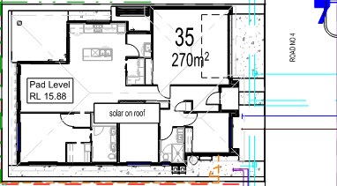
The building’s floor plans are shown in the following figures.
- Floor Plan
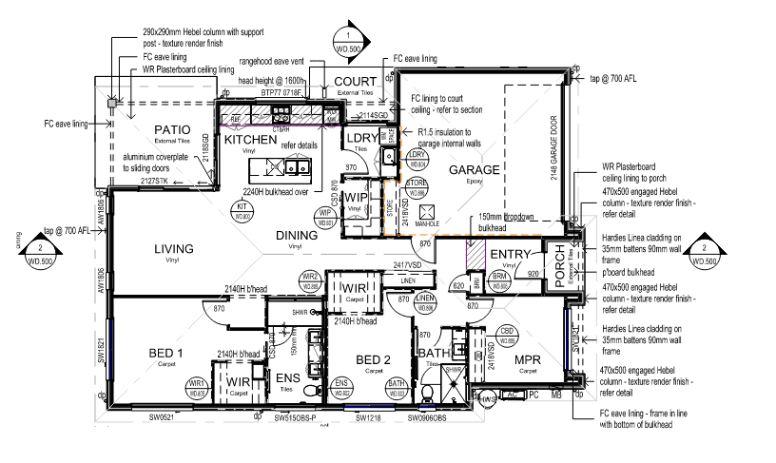
- Roof & Stormwater Plan
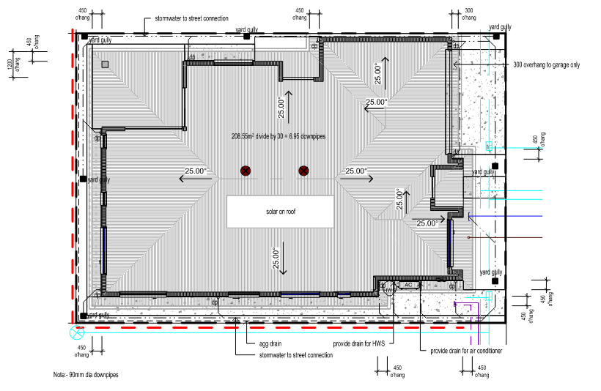

- Performance Evaluations
  - Performance Solution 1 – Alternate Window Head Flashing
    - Introduction
The following table briefly describes the proposed Performance Solution, the relevant NCC DTS Provision and Performance Requirements.
- Proposed Performance Solution and Reference Criteria
Proposed Performance Solution | National Construction Code
 | DTS Provision  (Housing Provision) | Performance Requirement
To provide the technical justification to support an alternative flashing design between the external cladding of the building and glazed assemblies. | H1D7(4), H2D6(4)  (HP 7.5.6(a)(i)) | H2P2
The proposed Performance Solution provides technical justification for an alternative window head flashing arrangement at the interface between the external wall cladding and glazed assemblies.
    - Intent of the NCC
The intent and objectives of the NCC relevant to this Performance Solution is to safeguard occupants from illness or injury and protect the building from damage caused by external water entering a building. The NCC pursues this objective by requiring compliance with Performance Requirement H2P2. Compliance with the relevant sections of DTS Provisions H1D7, H2D6 and ABCB Housing Provision Clause 7.5.6 will satisfy Performance Requirement H2P2. The relevant sections of Performance Requirement H2P2, DTS Provisions H1D7, H2D6 and ABCB Housing Provision Clause 7.5.6 that applies to this Performance Solution are as below:
Performance Requirement H2P2 – Weatherproofing
A roof and external wall (including openings around windows and doors) must prevent the penetration of water that could cause—
  - unhealthy or dangerous conditions, or loss of amenity for occupants; and
  - undue dampness or deterioration of building elements.
DTS Provision H2D6 – Roof and wall cladding
- Performance Requirement H2P2 is satisfied for roof and wall cladding if it is in accordance with H1D7(2), (3), (4) or (5) as appropriate.
DTS Provision H1D7 – Roof and wall cladding
- Performance Requirement H1P1 is satisfied for timber and composite wall cladding if it is designed and constructed in accordance with—
  - for autoclaved aerated concrete wall cladding, AS 5146.1; or
  - for wall cladding, Part 7.5 of the ABCB Housing Provisions.
ABCB Housing Provision Clause 7.5.6 – Flashings to wall openings
Openings in external wall cladding exposed to the weather must be flashed with materials complying with AS/NZS 2904 and in accordance with the following:
  - Flashings must be provided to bottom, tops and sides of openings, except as permitted by (d), and must be installed so that the flashing—
    - extends not less than 110 mm beyond the reveals on each side of the opening where practicable; and
    - is attached to the window and wall framing; and
    - at the top and bottom of the opening, drains to the outside face of the wall or cladding.
  - Joins in the flashing must—
    - overlap by not less than 75 mm in the direction of flow; and
    - be securely fastened at intervals of not more than 40 mm; and
    - have sealant installed between laps.
  - The method of flashing must be suitable for the framing and cladding used and any reveal for the window or door system or any architrave or finishing trims that may be installed.
  - The top of an opening need not be flashed where it is adequately protected by an eave of a width more than 3 times the height of the cladding above the opening (See Figure 7.5.6).
  - Flashings must be securely fixed at least 25 mm under the cladding and extend over the ends and edges of the framing of the opening.
In summary, the NCC weatherproofing provisions establish minimum requirements intended to prevent external water entry at discontinuities such as wall junctions and openings (including windows and doors). These provisions are designed to ensure that flashings provide a continuous water-shedding path and/or barrier to moisture movement, diverting water to the outside face of the wall or cladding to avoid unhealthy or dangerous conditions, loss of amenity, and deterioration of building elements. Accordingly, this Performance Solution assesses whether the proposed alternative flashing arrangement achieves an equivalent level of weatherproofing performance to that intended by the DTS provisions.
    - Approach
- Method of Approach
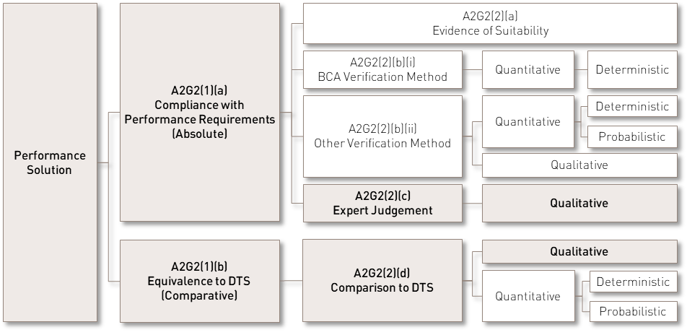
    - Design Criteria
The building’s external glazed assemblies will be provided with an alternate head flashing detail (as shown in FIGURE 5) that is to be installed to maintain the weatherproofing intent of Performance Requirement H2P2, including drainage to the outside face of the wall/cladding and continuity of the water-shedding/drained plane around openings.
The alternate window head flashing arrangement is to comply with the following minimum requirements:
- Flashings to wall openings are to be formed from materials complying with AS/NZS 2904:1995.
- The head flashing is to be installed such that water collected at the head of the opening drains to the outside face of the wall or cladding, consistent with the intent of ABCB Housing Provisions Clause 7.5.6(a)(iii).
- Where the head flashing cannot extend not less than 110 mm beyond the reveals due to the nominated vertical sheet cladding profile/jointing arrangement, the head flashing will be terminated, with continuity of weatherproofing achieved via an extended Damp Proof Course (DPC) membrane extending from the head flashing down the full height of the window frame on each side.
  - DPC membrane is to be fully sealed or lapped to the head flashing.
  - DPC membrane is to sit behind the cladding.
  - DPC membrane is to be continuous for the full jamb height.
- The head flashing will extend a minimum of 110 mm horizontally past the window assembly measured from the window jamb.
- Flashings are to be securely fixed at least 25 mm under the cladding and are to extend over the ends and edges of the framing of the opening, consistent with Clause 7.5.6(e)
- Where joins in the flashing occur, the joins are to:
  - overlap by not less than 75 mm in the direction of flow; and
  - be securely fastened at intervals of not more than 40 mm; and
  - have sealant installed between laps consistent with Clause 7.5.6(b).
- The pliable building membrane / wall wrap is to be dressed and lapped to provide continuity of the drained plane around the opening and is to be integrated with the alternate flashing arrangement such that water is directed to the exterior and reverse laps are avoided.
The window assemblies will otherwise comply with AS 2047:2014, and glazing will comply with AS 1288:2021 where applicable.
The James Hardie external cladding system (including Axon™ / EasyLap™ where applicable) is to be designed and installed in complete accordance with the relevant manufacturer installation guide and specifications, including any applicable CodeMark® certification requirements.
- Alternate Window Head Flashing Detail
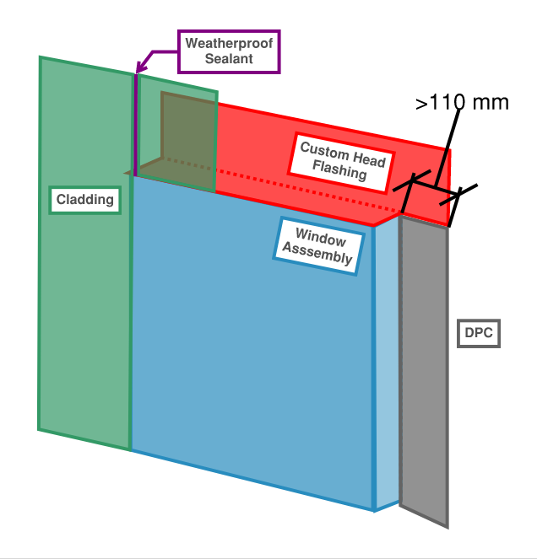
    - Method of Evaluation
A qualitative evaluation will be undertaken using:
- a comparative assessment against a DTS benchmark arrangement in accordance with the relevant NCC provisions for flashings to openings; and
- an expert judgement based on the application of established flashing and water-shedding principles, having regard to the referenced NCC / ABCB Housing Provisions requirements.
    - Design Scenario
The proposed Performance Solution will be compared with a DTS benchmark design for the same building (same location, class, use and number of storeys), where openings to external walls are flashed in accordance with ABCB Housing Provisions Clause 7.5.6 and materials complying with AS/NZS 2904.

    - Acceptance Criteria
The acceptance criterion is that the alternate head flashing arrangement will provide an equivalent level of weatherproofing performance to the DTS benchmark such that water penetration at openings in the external wall is not increased, and the design satisfies Performance Requirement H2P2 by preventing water entry that could cause unhealthy or dangerous conditions, loss of amenity, or undue dampness or deterioration of building elements.
    - Preliminary Evaluation
The proposed external wall openings within the dwelling will incorporate an alternate head flashing arrangement which differs from the DTS end-extension requirement; however, the detail is intended to maintain a continuous water-shedding path at the opening by integrating the head flashing with the wall membrane/underlay (drainage plane) and the window trim/junction detailing.
In the DTS benchmark design, openings in external walls with glazed assemblies are flashed in accordance with ABCB Housing Provisions Clause 7.5.6 and nominated manufacturer documentation. This arrangement is intended to manage water at the discontinuity by directing collected moisture to the outside face of the wall/cladding and limiting the potential for water ingress at the junction between the wall cladding and the window frame.
It is noted that the requirement under Clause 7.5.6(a)(i) for the head flashing to extend not less than 110 mm beyond the reveals applies “where practicable” because it is often impractical to extend the flashing 110 mm beyond the reveal (for example, where openings are positioned adjacent to a corner or where two windows are within 110 mm of each other). In such cases, consideration is required to ensure the flashing prevents the penetration of water into the external wall.
In the proposed Performance Solution design, the head flashing does not extend more than 110 mm beyond the reveals on each side of the opening where this is impracticable due to the nominated vertical sheet cladding profile/jointing arrangement. In lieu of the 110 mm reveal extension, the head flashing will terminate at the window jambs and will be supplemented by a Damp Proof Course (DPC) membrane to maintain continuity of the weatherproofing layer, in accordance with the Design Criteria in Section 3.1.4. In particular:
- the head flashing will extend a minimum of 110 mm horizontally past the window assembly (measured from the window jamb); and
- the DPC membrane will extend from the head flashing and continue vertically down the full height of the window frame at each jamb behind the cladding.
This approach is intended to maintain continuity of the drainage plane and limit lateral water migration at the flashing termination. Any water intercepted by the head flashing will be directed to the DPC membrane at each side of the opening, which provides a vertical water-shedding path behind the cladding and returns collected moisture to the wall drainage plane. The head flashing will also be installed to drain to the outside face of the wall/cladding, and the pliable building membrane or wall wrap will be dressed and lapped to maintain continuity of the drained plane around the opening such that water is directed to the exterior and reverse laps are avoided.
Where joints in flashings occur, joins will be lapped, fixed and sealed in accordance with ABCB Housing Provisions Clause 7.5.6. Sealant at the window/flashing interface will be provided as a supplementary measure to accommodate movement and further reduce the likelihood of water penetration at the junction.
For completeness, it is noted that ABCB Housing Provisions Clause 7.5.6 permits omission of a head flashing where an opening is adequately protected by an eave of a width more than three times the height of the cladding above the opening, as shown in FIGURE 6 below. Where such eave protection is present, the exposure of the head junction to direct rainfall is reduced; however, the proposed alternate flashing arrangement is not reliant on eave protection and is to be provided in accordance with the Design Criteria regardless.
- Figure 7.5.6: Weather Protection of Openings
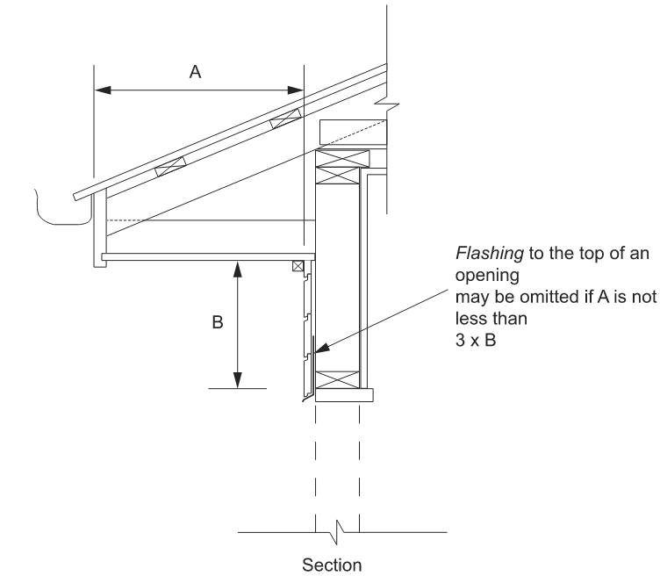
On this basis, when assessed against the DTS benchmark intent, the “where practicable” application of Clause 7.5.6(a)(i), and the nominated manufacturer documentation, the proposed alternate head flashing arrangement is expected to achieve an equivalent level of weatherproofing performance by maintaining drainage to the exterior and continuity of the water-shedding/drained plane at the opening. The proposed Performance Solution therefore satisfies the acceptance criteria for preventing water penetration at openings in external walls in accordance with Performance Requirement H2P2.
    - Preliminary Conclusion
Based on the evaluation above, the proposed alternate head flashing arrangement is expected to provide an equivalent level of weatherproofing performance to the DTS benchmark intent, by maintaining drainage to the outside face of the wall/cladding and continuity of the water-shedding/drained plane at the opening. On this basis, the proposed Performance Solution satisfies Performance Requirement H2P2, subject to installation in accordance with the Design Criteria and nominated manufacturer documentation.

  - Performance Solution 2 – Alternate Grading to External Areas
    - Introduction
The following table briefly describes the proposed Performance Solution, the relevant NCC DTS Provision and Performance Requirement.
- Proposed Performance Solution and Reference Criteria
Proposed Performance Solution | National Construction Code
 | DTS Provision  (Housing Provision) | Performance Requirement
To provide technical justification to support a minimum reduced grade of 1:100 across the entire external paved/concreted areas in lieu of a 1:20 grade over the first 1 m from the building. | H2D2(b)  (3.3.3(a)(ii)) | H2P1
The proposed Performance Solution is to provide technical justification to support a minimum reduced grade of 1:100 across the nominated external paved/concreted areas in lieu of a 1:20 grade over the first 1 m from the building. The locations and extent of the nominated external paved/concreted areas include all external surfaces that are paved or concreted.
    - Intent of the NCC
The intent and objective of the NCC relevant to this Performance Solution are to safeguard the occupants from illness or injury and protect the building and other property from damage caused by redirected surface water. The NCC pursues this objective by requiring compliance with Performance Requirement H2P1 through the satisfaction of DTS Provision H2D2 and relevant sections of ABCB Housing Provision Clause 3.3.3.
Performance Requirement H2P1 – Rainwater management
- Surface water, resulting from a storm having an annual exceedance probability of 5% and which is collected or concentrated by a building or sitework, must be disposed of in a way that avoids the likelihood of damage or nuisance to any other property.
- Surface water, resulting from a storm having an annual exceedance probability of 1% must not enter the building.
- A drainage system for the disposal of surface water resulting from a storm having an annual exceedance probability of—
  - 5% must—
    - convey surface water to an appropriate outfall; and
    - avoid surface water damaging the building; and
  - 1% must avoid the entry of surface water into a building.
DTS Provision H2D2 – Drainage
Performance Requirement H2P1 is satisfied for drainage if it is designed and constructed in accordance with—
  - AS/NZS 3500.3; or
  - provided the stormwater drainage system otherwise complies with (a), Part 3.3 of the ABCB Housing Provisions for drainage of—
    - roofs in areas subject to 5 minute duration rainfall intensities of not more than 255 mm per hour over an annual exceedance probability of 5% (as per Table 7.4.3d of the ABCB Housing Provisions) where a drainage system is required; and
    - sub-soil areas where excessive soil moisture problems may occur; and
    - land adjoining and under buildings.
ABCB Housing Provisions Clause 3.3.3 – Surface Water Drainage
Surface water must be diverted away from Class 1 buildings as follows:
  - Slab-on-ground — finished ground level adjacent to buildings: the external finished surface surrounding the slab must be drained to move surface water away from the building and graded to give a slope of not less than (see Figure 3.3.3a)—
    - 25 mm over the first 1 m from the building –
      - in low rainfall intensity areas for surfaces that are reasonably impermeable (such as concrete or clay paving); or
      - for any reasonably impermeable surface that forms part of an access path or ramp provided for the purpose of Clauses 1.1(2) or (4)(c) of the ABCB Standard for Livable Housing Design; or
    - 50 mm over the first 1 m from the building in any other case.
  - Slab-on-ground — finished slab heights: the height of the slab-on-ground above external finished surfaces must be not less than (see Figure 3.3.3a) –
    - 100 mm above the finished ground level in low rainfall intensity areas or sandy, well-drained areas; or
    - 50 mm above impermeable (paved or concreted) areas that slope away from the building in accordance with (a); or
    - 150 mm in any other case.
- Figure 3.3.3a – Site Surface Drainage
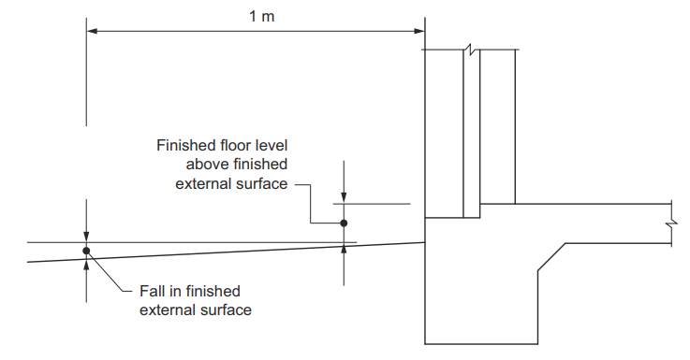
In summary, the NCC provisions are intended to ensure surface water is managed at the building perimeter, including at slab edges and adjoining external paved areas, to minimise the likelihood of water entering the dwelling or causing nuisance/damage to other property. As such, a drainage and surface grading arrangement that directs water away from the building and conveys it to an appropriate outfall (for 5% AEP events), while preventing surface water entry to the building (for 1% AEP events), will satisfy the intent of Performance Requirement H2P1.
    - Approach
- Method of Approach
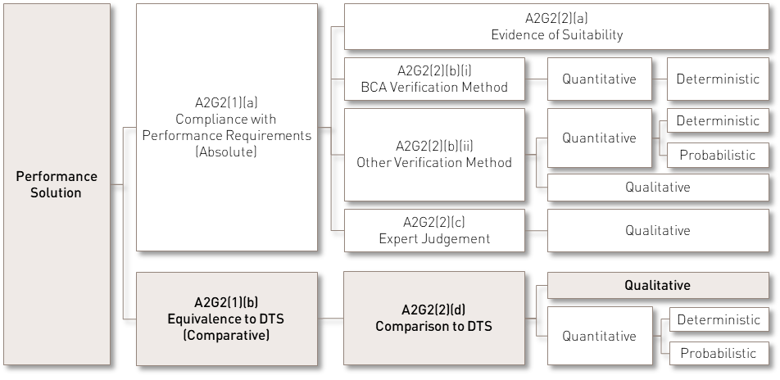
    - Design Criteria
A minimum reduced external finished surface grade of 1:100 will be provided to all external surfaces that are paved or concreted, in lieu of the minimum 1:20 grade over the first 1 m from the building as required under ABCB Housing Provisions Clause 3.3.3(a)(ii). A minimum 70 mm step-down will also be provided between the internal finished floor level and the adjacent external finished surface level at the nominated threshold locations.
Rainwater management at the external areas will be achieved through the following measures:
Roof Coverage Requirements
The external areas are to be provided with partial or full roof coverage from above to shield against wind-driven rain.
General Requirements
The entirety of the external paved surfaces must be graded away from the building at a minimum slope of 1:100 leading to an appropriate outfall or the site surface water management system (primary drainage including overflow provisions) connected to the Legal Point of Discharge.
We understand that the external paved/concreted perimeter pathway will be graded away from the dwelling with a minimum fall of 1:50 for the first metre, directing surface water to the agricultural drainage system, where applicable. It is also understood that an agricultural drainage system will be installed along the boundary wall in some cases due to proximity to adjacent units, to direct surface water away and prevent moisture from pooling against the wall.
The external area adjacent to the external threshold must not be used for the purpose of discharging overflow from the roof drainage system in a manner that could promote water ingress into the building.
External finished surface levels beyond the threshold must be no higher than the internal finished floor level of the dwelling.
Surface Drainage Requirements
Surface drainage systems, including its associated overland flow path, are required to direct surface water away from the building at the required storm intensity in the event drains are blocked.
The surface drainage systems, including the primary drainage provisions and the overland flow path for event of blockages are to be designed by the project design team in accordance with AS/NZS 3500.3:2025 for both primary and overflow systems.
A maintenance plan specific to the site conditions is required to be developed by the owner/plumber to ensure the drainage systems are clear of debris that may enter through its openings.
- Regular and robust maintenance will minimise the risk of debris causing blockage of the drainage system.
- The frequency of maintenance is to be determined based on-site conditions over the first 12 months of operation and adjusted thereon as required.
A registered and licenced plumber is to ensure that the drainage systems comply with and installed in strict accordance with the local plumbing regulations.
    - Method of Evaluation
The method of evaluation will include a qualitative and comparative evaluation comparing the risk of the proposed design with a comparable design that fully complies with the DTS Provisions.
    - Design Scenario
The proposed Performance Solution will be compared with a design that fully complies with the DTS Provisions. The comparable DTS compliant design will be a building with the same class, use, location and rainfall conditions as the proposed Performance Solution except:
- In the DTS benchmark design, the external finished surface surrounding the slab-on-ground will be graded away from the building in accordance with ABCB Housing Provisions Clause 3.3.3 (i.e., minimum 1:20 over the first 1 m from the building, as applicable); and
- The DTS benchmark design will not rely on roof coverage as a compensating measure for surface grading to the nominated external paved areas and will be assessed on the basis of exposure consistent with the site conditions.
    - Acceptance Criteria
The acceptance criterion is that the safety of the occupants and protection of building elements from redirected surface water is not less in the Performance Solution when compared with a design that fully complies with the NCC DTS Provisions and ABCB Housing Provisions.
    - Preliminary Evaluation
A minimum 70 mm step-down is proposed between the internal finished floor level and the adjacent external finished surface level at the nominated threshold locations, together with a minimum grade of 1:100 to all external surfaces that are paved or concreted, in lieu of the minimum 1:20 grade over the first 1 m from the building as required under DTS Provision H2D2 and ABCB Housing Provisions Clause 3.3.3.
The requirements per DTS Provision H2D2 and ABCB Housing Provision 3.3.3 work in conjunction with the site surface water management system (primary drainage including overland flow provisions) to assist in the conveyance of wind-driven rain at building entry points as a supplementary drainage design. A separate main drainage system, including associated overflow provisions, is still required to convey overall surface water away from the building at the required storm intensity and designed by the project’s design team.
In a compliant design, the external surfacing would be constructed in accordance with DTS Provision H2D2 and ABCB Housing Provisions Figure 3.3.3a, as illustrated in FIGURE 7. This arrangement provides a step-down between the internal finished floor level and the adjacent external finished surface, with the external surface graded away from the entry over the first 1 m to direct and prevent the accumulation of surface water toward the building.
The acceptable gradient as specified in the DTS Provision stipulates a 50 mm over the first 1 m from the building in low rainfall intensity areas for surfaces that are reasonably impermeable (such as concrete or clay paving) or a 50 mm over the first metre in any other case. Low rainfall intensity is considered as a 20-year exceedance of 125mm/h or less and Burpengary East has a 20-year exceedance rainfall intensity of 4.8mm/h (Bureau of Meteorology, 2016), therefore, the 1:20 gradient is required over the first 1 m from the building. However, the external finished surface will be open to the sky and be subjected to the full force of the elements from 3 sides i.e., wind and rain, thereby increasing the likelihood of surface water that may potentially reach the threshold even with a compliant step-down and grading.
In the Performance Solution design, a minimum of 1:100 grade across the entire external paved areas away from the building is proposed in lieu of a 1:20 grade over the first 1 m from the building. In addition, we note that the external paved/concreted perimeter pathway will be graded away from the dwelling with a minimum fall of 1:50 for the first metre, directing surface water to the agricultural drainage system, where applicable.
The Performance Solution design has the advantage that the external paved surfaces will be continuously graded away from the building and leads to the Legal Point of Discharge (LPOD). The graded external surface will act as a method of surface water drainage to minimise the likelihood of surface water impacting the building.
Unlike the comparable design where it has no roof covering and is fully exposed to full force of the elements from 3 sides, the subject areas will be provided with partial or full roof coverage. The amount of rainfall that will therefore reach the subject external paved surfaces will be reduced when compared to a DTS design that is uncovered, which can reasonably provide the offset for the reduce grading of the external areas.
Furthermore, the minimum 70 mm step-down between the internal finished floor level and the adjacent external finished surface exceeds the 50 mm step-down required for a compliant DTS arrangement. This increased vertical separation provides a greater barrier to surface water migration toward the building by increasing the height differential that water would need to overcome. The additional 20 mm clearance improves the resilience of the threshold detail to surface runoff and wind-driven rain. Accordingly, the proposed 70 mm step-down represents a more conservative threshold condition than the DTS minimum.
Additionally, the performance of the proposed falls may be benchmarked against the general drainage principle in AS 4654.2:2012 – Waterproofing Membranes for External Above-Ground Use (Design and Installation), which notes that falls for surface drainage should be no flatter than 1 in 100, as shown in Clause 2.5.2 below. The proposed minimum grade of 1:100 is equivalent to this benchmark and therefore satisfies the minimum falls principle for drainage to an outlet.
AS 4654.2:2012 Clause 2.5.2 – Falls
Falls in finishes shall ensure water drains to the drainage outlet. Water shall not be retained on the finished surface with the exception of residual water remaining due to surface tension.
The fall shall be in the structural substrate, or formed by a screed over the structural substrate.
NOTE: Falls for surface drainage should be no flatter than 1 in 100.
On this basis, the proposed combination of a minimum 70 mm step-down, continuous minimum 1:100 grading away from the dwelling to all external surfaces that are paved or concreted, partial or full roof coverage to reduce exposure, and provision of a compliant surface water management system, is expected to provide adequate surface water management and reduce the likelihood of surface water entry to the building.
    - Summary
While the dwelling will not be provided with the minimum 1:20 grade over the first 1 m from the building at the nominated external paved areas, the evaluation undertaken above indicates that the proposed design will provide adequate surface water management when:
- Compared with the DTS compliant benchmark design; and
- Benchmarked against the minimum fall principle in AS 4654.2:2012.
The proposed Performance Solution therefore satisfies the acceptance criteria.
    - Preliminary Conclusion
The evaluation undertaken above indicates that the proposed measures will provide adequate surface water management at the nominated external paved areas and external thresholds when compared with a DTS compliant benchmark design and relevant referenced criteria. The proposed Performance Solution therefore satisfies the Performance Requirement stipulated in TABLE 9.

- References
ABCB. (2022). National Construction Code Series Volume 2 & Housing Provisions - Building Code of Australia 2022. Canberra: Australian Building Codes Board.
Bureau of Meteorology. (2016). Design Rainfall Data System. Retrieved from http://www.bom.gov.au/water/designRainfalls/revised-ifd
Standards Australia. (2012). AS 4654.2 Waterproofing Membranes for External Above-Ground Use Part 2: Design and Installation. Sydney: Standards Australia.

