# DV

## About

This application displays n-Dimensional data in 2D using GLC-L coordinates. For better class separation, linear discriminant analysis is used to get the optimal angles and threshold for a visualization. Adjustments to the angles and threshold can be done by using the related sliders. Graphs produced by this program can be panned, zoomed in/out, and scaled. Graph order can be rearranged. Analytics generated by this program include the "All Data," "Data Without Overlap," "Overlap Data," and "Worst Case," confusion matrices as well as k-fold cross validation.

## Dataset Information

* Dataset must be in .csv format
* Dataset must include a reader row
* If there is an ID column, it must be first,
* If there is a class column it must be last
* Dataset features besides “class” must be numeric

### Example Dataset

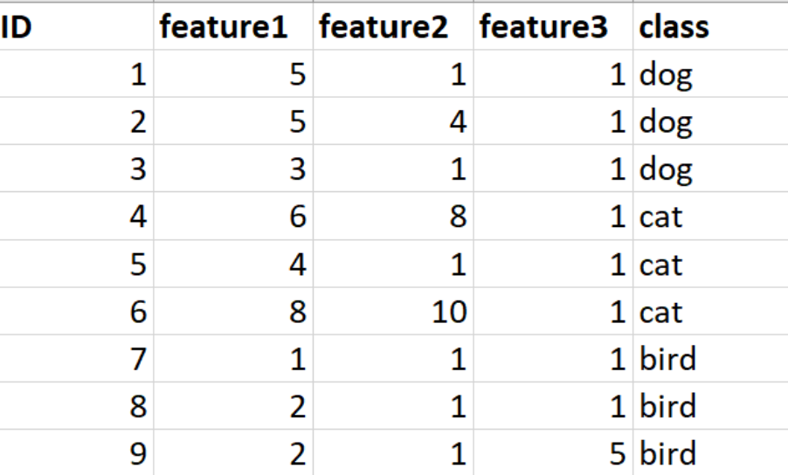

## Requirements

* Windows 10

## Install and Run

1. Download DV.zip
2. Unzip DV.zip
3. Run “DV.exe”
4. Follow instruction in “Run Instructions.pdf”

## Dataset Links

[Iris dataset](https://archive.ics.uci.edu/ml/datasets/iris)

[Breast Cancer Wisconsin (Original) dataset](https://archive.ics.uci.edu/ml/datasets/breast+cancer+wisconsin+%28original%29)

[Seeds dataset](https://archive.ics.uci.edu/ml/datasets/seeds)

## Visualizations

Iris dataset: Iris-Setosa (upper graph) vs Iris-Versicolor and Iris-Virginica (lower graph)

Breast Cancer Wisconsin: Benign (upper graph) vs malignant (lower graph)

Seeds: class 1 (upper graph) vs classes 2 and 3 (lower graph)

