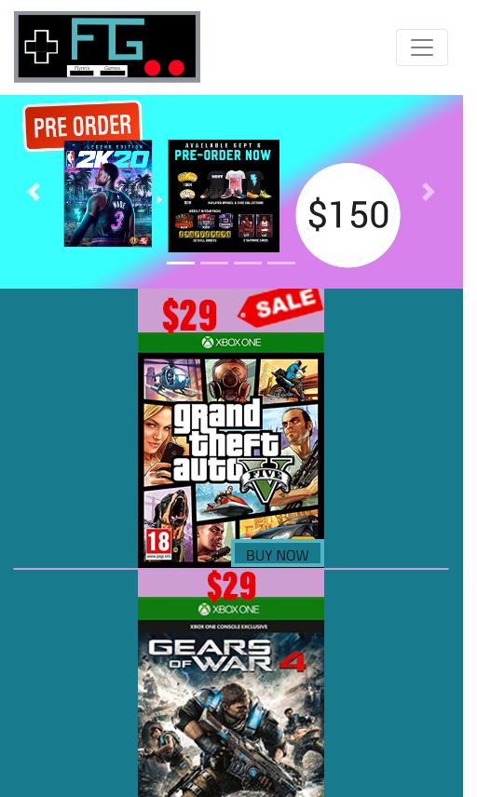

Flynn’s Website

website

Austin spears | IST | 29/08/2019

Contents

Design Breif 2

Heading 2 2

Design brief:

I have created a web site for Sam Flynn and his arcade business, the goal of creating this web site is to start to target the home gaming market. Sam Flynn is an arcade owner that always tries to expand the business and help his business get more people to trust it. Sam Flynn inherited his arcade form his father (Kevin Flynn) who was a very innovative person that loved to create new things and attempt to revolutionist the gaming industry. Sam Flynn is trying to sell product to everyone in the world, these products are games and gaming equipment, he is also promoting his arcade where people can come in to play old school games. Flynn’s goal is to create an easy to use service that anyone can use and enjoy; this is so he can get loyal customers that will keep coming back for more products.

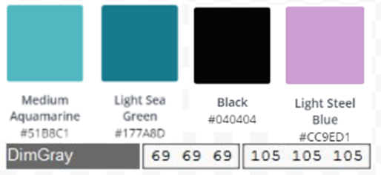Flynn needed a logo as well as a web site so I had to create the logo that represented his business the best and that is the controller logo that I made. This project was a large task to take on because I had to start from scratch and create my own mood board that I though Flynn would like. The mood board that I created has basic colours that relate to the theme of the arcade, all the designs that I added to the website relate to gaming in a way or relate to Tron the move. This project was started to create all the necessary items you need to start a website such as a basic template and logo. The web site is basted off Tron. Tron the movie is based on an old game named Tron that was popular and the goal was to cut of the other person with your line of light, if you successful did that the other person lost a life and if you lost all three you would be eliminated.

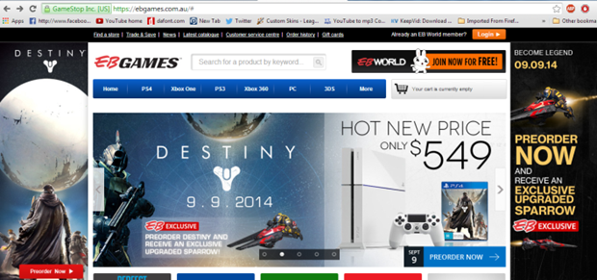The target audience for this web site is gamers mainly children but we also want to appeal to adults. This is a very difficult balance between the two because some parents might deem some things to inappropriate to show kids but we need to advertise to our 18+ costumers so we needed to rustic graphic content but advertise the games just by showing the game cover. Our competition is high profile companies that have loyal customers that swear by the company’s service, this is a tough market to corner because it is easy to mess up peoples orders and they may not find what they are looking for. Our competition is Eb Games, JB HI FI and Game Traders, these companies have built a reputation that is unmatched and will be hard to make people come to our website.

We are trying to portray a happy family friendly company that is happy to deal with any complaints or criticisms that people would chose to give us. We will try to make the business better any way we can and would love for people to give use rating good or bad and if it is bad we will attempt to improve upon what we have already created. We are trying to set a tone that everyone will enjoy and agree with so we can diversify our targeted customers, if we can diversify our customers we can make more money therefore gaining our credibility in the industry of gaming. If we want to dominate the gaming industry we need to seem relatable and use social media as a tool to promote our business. Using social media as a promoting tool is a huge asset for a small companies and even large corporations, you can use social media so spread you slogan or logo so when they see and advertisement for you company they will remember it. If you advertise through a social media site you can be associated with peoples everyday life and make your company easy to remember/well known in the gaming community’s.