**PAGE data description**

1. Primary/index SNPs

PAGE_Lipids_Replication_Table_updated.csv

Created from table in PAGE_Lipids_Replication_updated.docx

Location: ~/Documents/lipids/PAGE_materials/

54 rows, each represents a significant SNP for a given trait

Trait distribution - HDL: 18, LDL: 8, TC: 14, TG: 14

51 unique SNPs, since 3 SNPs significant for both LDL and TC

12:623129 (rs35882350), 2:17472023 (rs57520889), 7:137559799 (rs73729083)

2. Proxy SNPs

PAGE_Lipids_Replication_Proxies_updated.csv

Created from PAGE_Lipids_Replication_Proxies_updated.xlsx

Location: ~/Documents/lipids/PAGE_materials/

716 rows, each represents a proxy SNP for the 51 primary/index SNPs

Trait distribution - HDL: 415, LDL: 28, TC: 64, TC_LDL: 45, TG: 164

Proxy number distribution per index SNP

0 (only self): 9, 1-15 proxies: 35, 29-66 proxies: 6, 220 proxies: 1

**MVP data description**

1. Transethnic

Downloaded from Box folder:

MVP-CAP other local/Manuscripts/MVP lipids GWAS/Summary_Statistics/

Location: ~/Documents/lipids/MVP_materials/

4 files, 1 per trait

MVP.te.HDL.gwas.tsv.gz

MVP.te.LDL.gwas.tsv.gz

MVP.te.TC.gwas.tsv.gz

MVP.te.TG.gwas.tsv.gz

Each row is a SNP, 9 column names are:

MarkerName, Allele1, Allele2, Freq1, FreqSE, Effect, StdErr, P.value, Direction

All files are ~570mb and contain ~29million SNPs

2. Race/ethnicity-specific

Downloaded from Box folder:

MVP GWAS/Lipids GWAS/1000G_GWAS_OUT_GENESIS_KLARIN/

12 files, 1 per trait per race/ethnicity

allchr.AFR.HDL.results_10_31_17.gz

allchr.AFR.LDL.results_10_31_17.gz

allchr.AFR.TC.results_10_31_17.gz

allchr.AFR.TG.results_10_31_17.gz

allchr.EUR.HDL.results_10_31_17.gz

allchr..EUR.LDL.results_10_21_17.gz (2 dots after allchr not a typo)

allchr.EUR.TC.results_10_31_17.gz

allchr.EUR.TG.results_10_31_17.gz

allchr.HIS.HDL.results_10_31_17.gz

allchr.HIS.LDL.results_10_31_17.gz

allchr.HIS.TC.results_10_31_17.gz

allchr.HIS.TG.results_10_31_17.gz

Each row is a SNP, 16 column names are:

rsid, chromosome, position, alleleA, alleleB, average_maximum_posterior_call, info, all_AA, all_AB, all_BB, all_total, missing_data_proportion, cohort_1_hwe, frequentist_add_pvalue, frequentist_add_beta_1, frequentist_add_se_1

AFR and HIS files are ~1.4gb each and contain ~32million SNPs

EUR files are ~850-900mb each and contain ~20million SNPs

**Results**

Location of scripts: ~/Documents/scripts/

lipids_replication_transethnic_updated.R

lipids_replication_ethnic-specific_updated.R

Scripts (and this file) backed up at <https://github.com/AustinTHilliard/MVP/tree/master/lipids/>

Note that nothing can be reproduced with just the scripts, nor do they contain any results or sensitive information. They’re on github solely for backup purposes and are just pure R code with references to files on my local machine.

**Transethnic MVP**

PAGE_Lipids_Replication_MVP.transethnic_updated.xlsx

Sheet 1: all_PAGE_index_SNPs

Same as PAGE_Lipids_Replication_Table_updated.csv, but with columns added containing the MVP results from the 4 transethnic files.

Sheet 2: all_proxies_for_missing_SNPs

Each row is a proxy for one of the missing primary/index SNPs. Columns 1-3 list the trait, index SNP, and proxy SNP, and remaining columns contain results for the proxy SNPs from the appropriate MVP transethnic file.

1. Primary PAGE SNPs

PAGE_Lipids_Replication_MVP.transethnic_updated.xlsx – Sheet 1

6 were not found in the MVP results

3 from HDL, and 1 each from LDL, TC, and TG

Rows with NA in all_PAGE_index_SNPs

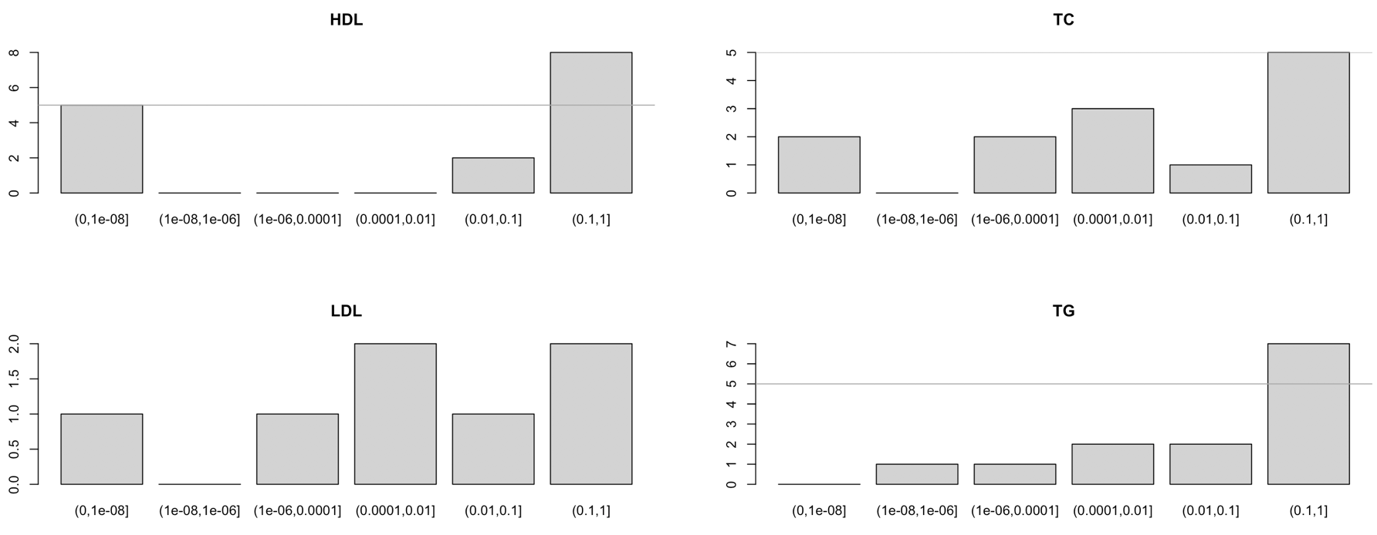 MVP p-values for other primary PAGE SNPs in all_PAGE_index_SNPs

y-axis is number of SNPs in each p-value range

2. Proxy SNPs for primary PAGE SNPs missing from MVP data

PAGE_Lipids_Replication_MVP.transethnic_updated.xlsx – Sheet 2

3 missing primary SNPs were listed as their own proxy, i.e. they didn’t have a proxy.

1 missing primary SNP had 3 proxies but none were found in MVP.

2 had at least 1 proxy SNP with results in MVP (1 had 1/2 proxies, 1 had 2/12)

**Race/ethnicity-specific MVP**

PAGE_Lipids_Replication_MVP.ethnic-specific_updated_newSep.24.xlsx

Sheets are named and mostly organized the same way as transethnic results

3x the number of rows as PAGE_Lipids_Replication_Table_updated.csv.

Each primary PAGE SNP was searched in each of 3 MVP race/ethnicity groups.

Columns 1-5 are the same as PAGE_Lipids_Replication_Table_updated.csv

Other columns contain results from the correct race/ethnicity-specific MVP file.

1. Primary PAGE SNPs

PAGE_Lipids_Replication_MVP.ethnic-specific_updated_newSep.24.xlsx – Sheet 1

Distribution by trait of primary PAGE SNPs missing from MVP data

HDL – 10 SNPs missing from 1 or more race/ethnicities

1 from AFR only

6 from EUR only

2 from EUR and HIS

1 from AFR, EUR, and HIS

LDL – 2 SNPs missing from 1 or more race/ethnicities

2 from EUR only*

TC – 3 SNPs missing from 1 or more race/ethnicities

3 from EUR only*

TG – 3 SNPs missing from 1 or more race/ethnicities

3 from EUR only

*1 is same SNP (rs73729083), i.e. it’s missing in EUR from both LDL and TC

MVP p-values for other primary PAGE SNPs by trait

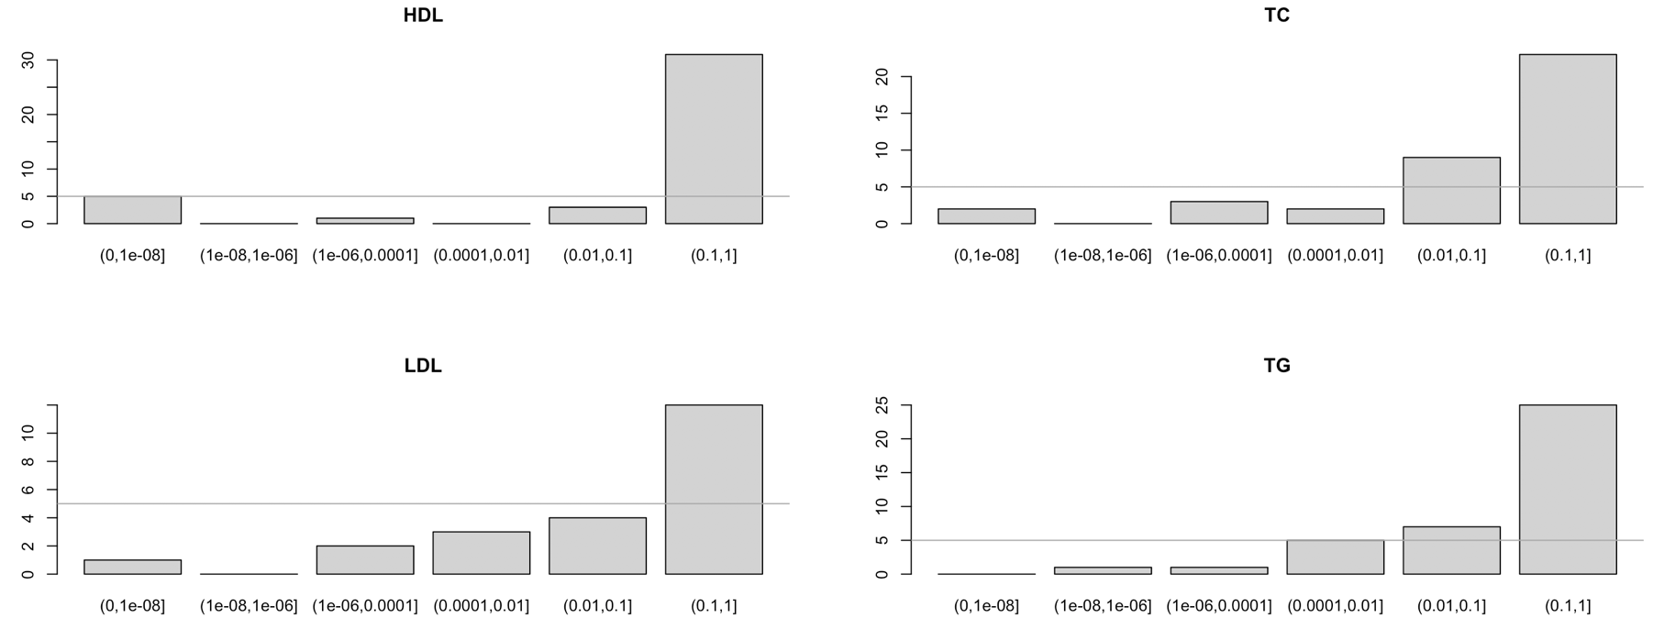y-axis is number of SNPs in each p-value range

2. Proxy SNPs for primary PAGE SNPs missing from MVP data

PAGE_Lipids_Replication_MVP.ethnic-specific_updated_newSep.24.xlsx – Sheet 2

Out of 58 proxy SNPs, only 5 were found in the relevant MVP results

These 5 represented 2 missing primary/index SNPs

**Note:** Although I haven’t systematically explored this, from spot-checking proxy SNPs it looks like proxies sometimes have p-values that are more significant than those of their primary/index SNPs.