CIS – 163 Final Project Proposal

Name: Assassin

Category: Game

App Description:

* multiplayer
* can add players to a group of players, then select start
  + multiple game modes
    - traditional (free-for-all)
    - order of who joins the game, choose a target(bounty hunter)
* map shows where kills occur
  + click on the marker, see info about the kill
* info screen shows picture of each player in your current game
* Select kill when it happens(maybe…Senses when phones bump (select ‘kill’))

Supported Features:

WebService: store info about players

A photo, name, optional nickname

Intent links to camera to capture initial image

Gives notification when a kill is made

Integrates map to show where kills occur

StoryBoard:

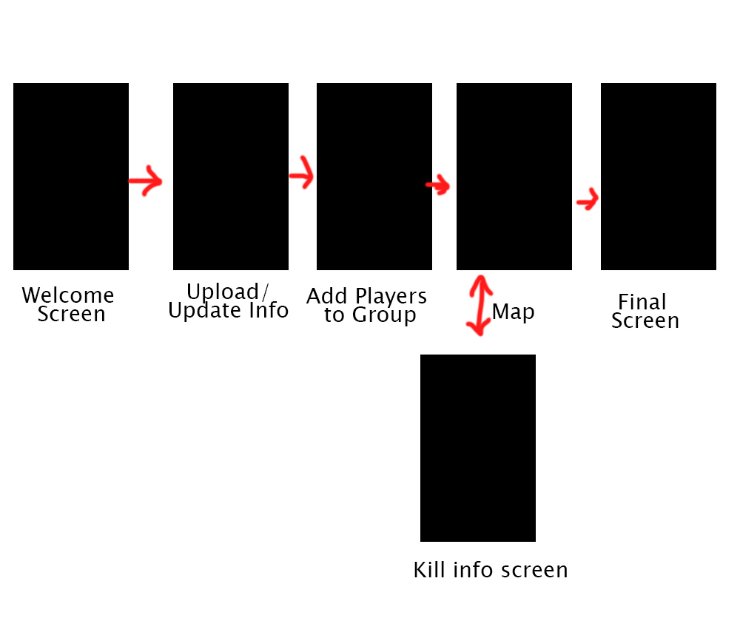

TimeLine:

Week of 3/16 – create the UI

Week of 3/23 -

Week of 3/30 -

Week of 4/6 -

Week of 4/13 -