Austin Van Kempen

Katherine Klinefelter

Michael Strating

**CIS-163 Final Project Proposal**

Category: Game

App Description:

This game allows players to follow a mystery storyline around a Google Map (not physically, but by clicking on markers). At each marker, an event occurs when the user clicks it. Events include mini-games (word search, find-an-object in a picture, etc) and story dialog, which tells users where to go next. A list of ‘clues’ is saved on the device and accessible via a button on each screen so that a player can keep track of what’s going on (can also include a sentence or two about what they’re supposed to be doing next). Before each game starts, an instructions screen appears. One of the game utilizes a feature which allows players to erase/reset when they shake the device.

Supported Features:

* Web Service – use in a mini-game
* Stores user data (progress, list of clues - RecyclerView) on device or webservice
* Uses Intent to launch
* Uses sensor – shake device to erase/reset the mini-game
* Uses a Google Map for the player to move between locations (should probably include a go-to option in case the player doesn’t want to find the marker on the map manually, or travel mini-game if they wish to do that instead of use the map)
* Will be designed to be sued on phones and tablets
* Will include one case – it is open-source so others can add additional storylines at other locations (or the same location) using the mini-games we create, as well as their own.
* Stored on github repository https://github.com/klinefk1/CIS163FinalProject

Storyboard: 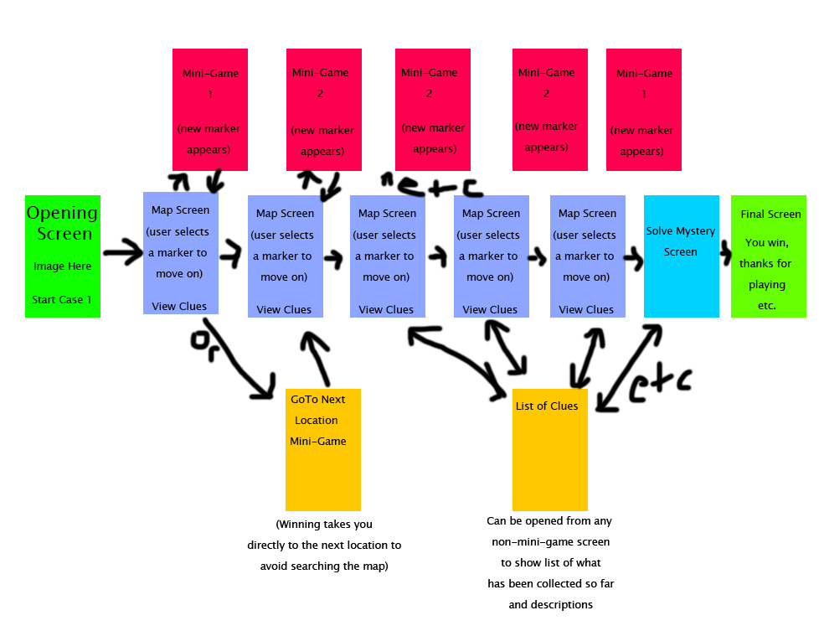

Time Line:

* Week of 3/16 design UI, solidify storyline, figure out what the mini-games will be
* Week of 3/23 begin work on map screen, opening screen, mini-games
* Week of 3/30 continue work on mini-games, work on storing user data/clues
* Week of 4/6 finish working on mini-games, make sure Intents between mini-games and map are working properly
* Week of 4/13: final testing/debugging, ideally distribute to users/deploy