Personalized Location Recommendation System
for ChicagoDoes
By
Yiou Wang
RJ Xia
Kennedy Damtse
Supervisor: Don Patchell
A Capstone Project
Submitted to the University of Chicago in partial fulfillment
of the requirements for the degree of
Master of Science in Applied Data Science
Division of Physical Sciences
Spring 2026

Abstract
ChicagoDoes is an interactive city-discovery map developed with Ateema that surfaces Chicago restaurants, attractions, parks, and venues. The platform presents an identical experience to every visitor despite collecting rich GA4 behavioral telemetry. This capstone designed and deployed a personalized location-recommendation system that converts those events into a weighted hybrid ranker combining content similarity, item–item and user–user collaborative filtering, session co-visitation, transition graphs, and event-time trending, with Maximal Marginal Relevance diversification and behavioral-archetype cold-start handling. Findings demonstrate clear interaction patterns supporting the design and a leakage-safe modeling pipeline. A formal ranking-evaluation harness is scoped for follow-on deployment.
Keywords: recommendation systems, hybrid recommender, collaborative filtering, TF–IDF, implicit feedback, Maximal Marginal Relevance, cold-start, tourism analytics, GA4.

Executive Summary
ChicagoDoes faces a personalization gap: visitors browse the same generalized map regardless of interests, limiting content discovery and reducing visibility for paying business partners. This capstone operationalized the GA4 event stream into a recommendation framework that ranks locations for each visitor and explains every suggestion with warehouse-backed evidence. A layered BigQuery warehouse converts raw GA4 events into qualified user–location interactions, aggregated features, and a full candidate set. On top of the warehouse, a hybrid recommender blends six signals: TF–IDF content similarity over location categories, leakage-safe global popularity priors, item–item Jaccard co-visitation, user–user $k$-nearest-neighbor collaborative scores, event-time trending, and session co-visitation with a previous-to-next transition graph. Maximal Marginal Relevance re-ranking enforces diversity, and cold-start users are served via a form-derived pseudo-profile and a category-based archetype assignment from $K$-Means clustering. The system is delivered as a FastAPI backend and a JavaScript frontend with an optional LLM concierge layer restricted to the deterministic recommendation pool. Descriptive analysis confirmed three design choices: popularity must be measured by distinct users, map-marker clicks and detail call-to-action events are the cleanest engagement signals, and session-level co-visitation dominates user-level co-visitation given the prevalence of single-session users. Formal offline ranking evaluation (Precision@K, Recall@K, NDCG, coverage, diversity), online A/B testing, retrieval-augmented generation for richer location context, and UX refinements are scoped as the next deployment phase.

Introduction

Problem Statement
Digital tourism and location-discovery platforms have become a primary channel through which visitors evaluate where to eat, stay, and explore. Despite the volume of behavioral data such platforms collect, many city-exploration products still present an identical browsing experience to every user. ChicagoDoes, an interactive map developed in collaboration with Ateema that showcases Chicago restaurants, attractions, bars, museums, parks, theaters, sports venues, and entertainment experiences, exhibits this gap. The platform serves marketing campaigns, links, and embedded QR codes for businesses that pay for placement, so location visibility and user engagement translate directly into commercial outcomes for both Ateema and its partners.
ChicagoDoes already collects substantial volumes of map-interaction telemetry through Google Analytics 4 (GA4): map-marker clicks, page views, category filters, location searches, media-gallery interactions, scrolling behavior, and engagement with call-to-action (CTA) elements. None of this signal is currently operationalized into a personalization layer. Every visitor, whether interested in nightlife, family-friendly museums, or outdoor parks, receives the same default browsing experience. The opportunity is therefore twofold: close a content discovery gap that limits how many relevant locations each user encounters, and capture commercial upside for paying partners by increasing the probability that their venues are shown to users with matching interests.
The cost of inaction is measurable. With every additional session that ends without meaningful engagement, ChicagoDoes loses an opportunity to retain a visitor, drive a partner CTA click-through, or build the longitudinal behavioral record needed for stronger personalization in the future. The client’s desired solution is a scalable recommendation framework that converts the existing GA4 data into a personalized, explainable, and continuously improvable layer on top of the existing map experience, benefiting both visitors and the businesses featured on the platform.

Analysis Goals
This capstone designed, built, and operationalized a personalized location-recommendation system for ChicagoDoes by leveraging GA4 interaction signals together with the platform’s location and category metadata. The system was intended to operate as a production-grade recommendation layer that improves engagement, supports content discovery, and establishes the data infrastructure required for future personalization work. The objectives were to translate raw GA4 event logs into a layered, queryable warehouse exposing user–location interactions and full user-by-location candidate pairs; engineer leakage-safe predictive features at the user and location level; implement a hybrid recommender that combines content-based similarity, item–item and user–user collaborative filtering, session-level co-visitation, transition-graph signals, and event-time trending; handle cold-start visitors through a form-driven onboarding profile and behavioral-archetype assignment derived from $K$-Means clustering; ensure recommendations are diverse by applying Maximal Marginal Relevance (MMR) re-ranking; deliver a working full-stack web application (FastAPI backend, JavaScript frontend) demonstrating the recommender end-to-end with evidence for every recommendation; and specify a rigorous evaluation methodology, both offline (Precision@K, Recall@K, NDCG, coverage, diversity) and online (A/B testing of engagement metrics), to guide subsequent iterations.

Scope
The work was bounded along five dimensions. First, the model was trained and evaluated exclusively on ChicagoDoes locations within Chicago, so transferability to other cities or platforms is plausible but not validated. Second, behavioral data was restricted to the GA4 event stream collected during the study window (early 2026 onward), so long-term seasonality and inter-year trends cannot be modeled from this snapshot alone. Third, the implementation operated on implicit feedback (clicks, dwell time, qualified engagement events); explicit ratings and post-visit feedback were not available. Fourth, the LLM concierge layer was treated as a wrapper around the deterministic recommendation pool; the language model never injects new locations and never overrides the underlying ranking. Fifth, formal offline ranking evaluation and online experimentation were explicitly scoped as future work, so this paper documents methodology, descriptive findings, and the evaluation plan rather than reporting validated top-$K$ ranking accuracy.

Background
Ateema is a digital experience company that builds interactive map and content platforms for destination marketing organizations and city tourism partners. The capstone focused on its ChicagoDoes property, a Mapme-backed interactive video map showcasing Chicago’s hospitality, entertainment, and cultural venues. Visitors typically reach the platform through tourism campaigns, partner links, hotel concierge QR codes, and embedded marketing assets. Businesses and venues, including restaurants, tour operators, hotels, museums, parks, and bars, pay for placement and promotion on the map, making the platform’s ability to drive engaged, category-relevant traffic a direct revenue lever.
Behaviorally, a ChicagoDoes session begins when a user loads the map (map-load). The user can then zoom and pan, click category filters (single-cat-filter), open a list panel, click an individual map marker (map-marker-click), scroll through location media, and tap CTA buttons such as section-details-call-to-action. Each interaction is captured through GA4 and exposed through BigQuery as event-level records with payload metadata that ties an event back to a specific location or category. Despite this instrumentation, the platform’s user-facing surface remains generic. There is no personalization layer that ingests these events, infers user preferences, and ranks the location set accordingly. This capstone built that missing layer, grounded it in the existing warehouse, and delivered it as a deployable web service.

Literature Review
Recommendation systems have evolved substantially over the past two decades, with the literature documenting a clear progression from simple memory-based methods to deep neural and hybrid architectures (Aggarwal, 2016; Ricci et al., 2015). Early collaborative filtering relied on user–user or item–item similarity computed from explicit ratings, while later work introduced matrix factorization techniques such as Singular Value Decomposition and Alternating Least Squares (Koren et al., 2009). For implicit-feedback scenarios, which closely match the ChicagoDoes setting where the only signal is whether and how strongly a user interacted with a location, Hu, Koren, and Volinsky (2008) proposed weighted matrix factorization with confidence-weighted positive observations, which became foundational in industrial recommender systems.
Content-based methods (Pazzani & Billsus, 2007) take a complementary approach: each item is represented by feature vectors derived from its attributes (text descriptions, categories, tags), and items are scored by similarity to the user’s profile. TF–IDF (Salton & Buckley, 1988) remains a standard baseline for representing text or categorical content and is particularly suitable for cold-start environments where new items have known attributes but few interactions.
Hybrid recommenders, which combine collaborative and content-based signals, consistently outperform single-paradigm systems on diverse datasets (Burke, 2002; Çano & Morisio, 2017). Hybridization is especially valuable when interaction sparsity is high, a near-universal condition for early-stage tourism and discovery platforms, because content features can backstop the ranking when collaborative signals are insufficient. Burke (2002) provides the canonical taxonomy of hybridization strategies (weighted, switching, mixed, feature-combination, cascade, feature-augmentation, meta-level); the weighted and feature-combination class is the most common operational pattern in production systems.
Beyond pointwise scoring, two further strands informed the ChicagoDoes design. Session-aware and sequence-aware recommendation (Hidasi et al., 2016; Quadrana et al., 2018) demonstrates that co-occurrence within a single session carries far stronger intent than user-level co-occurrence across sessions, directly motivating the session-Jaccard and transition-graph terms in the scoring blend. Ranking diversification, originating with Maximal Marginal Relevance (Carbonell & Goldstein, 1998), addresses the well-documented tendency of relevance-only ranking to produce homogeneous lists; MMR introduces a tunable diversity weight that balances relevance with novelty and has become a standard post-processing step in modern industrial recommenders.
Applications in tourism are well-documented (Borrás et al., 2014; Gavalas et al., 2014). Tourism recommenders typically face severe cold-start problems, since visitors arrive without history and depart shortly, and frequently rely on a combination of user-supplied preferences (vibe, traveler type, interests), contextual signals (location, time of day), and behavioral aggregates (popularity, trending). Cold-start handling via onboarding forms, demographic priors, and segmentation is a recurring design pattern in this literature. Outside the tourism domain, hybrid recommendation has been deployed at scale in streaming media (Gomez-Uribe & Hunt, 2015), e-commerce, news, and music discovery, where the same building blocks, namely implicit feedback, content vectorization, co-visitation, and diversity re-ranking, recur. These external applications confirm that the methodology selected for ChicagoDoes is well-supported, transferable, and production-grade rather than narrowly academic. Finally, recent work on retrieval-augmented generation (Lewis et al., 2020) and large language models in recommender systems (Wu et al., 2024) suggests RAG-style augmentation as a natural extension to the present deterministic LLM concierge layer.

Data

Data Sources
All data originated from the Ateema BigQuery project ateema-capstone, dataset analytics_459092297. Three categories of underlying sources fed the warehouse: raw GA4 daily event tables (events_YYYYMMDD and events_intraday_YYYYMMDD) exported automatically from the ChicagoDoes site instrumentation; the official Mapme and Ateema location and category lists, used as canonical dimensional truth; and a crawler-derived location–category bridge, cleaned and normalized to produce the working location_category_dim table. A layered warehouse progressively transformed events into modeling-ready features (Table 1). The principal modeling variables used by the recommender are summarized in Table 2.
ChicagoDoes data-warehouse layers and their role in the recommender
location_dim | Official location dimension (canonical names, IDs). | Indirect
category_mapping | Official category dimension; modeling vocabulary. | Indirect
location_category_bridge_final | Cleaned location $×$ category mapping. | Indirect
location_category_dim | Normalized location $×$ category dimension. | Yes (TF–IDF input)
user_location_category_events | Flattened, parsed GA4 events with location and category. | Yes (behavior, trends)
user_location_full_features | Aggregated (user, location) features and _all_users priors. | Yes (primary input)
candidate_user_location_table | Full user $×$ all official locations expansion. | Yes (candidate set)
Principal modeling variables and their role in the hybrid ranking
Categories (TF–IDF) | Location-level vector from location_category_dim | Content similarity $s_{\text{sim}}$
popularity_norm | Location scalar; _all_users distinct users | Popularity prior $s_{\text{pop}}$
engagement_norm | Location scalar; _all_users engagement time | Popularity support
is_hot_spot_location | Location-level flag | Categorical boost
is_favorite_location | Location-level flag | Categorical boost
Item Jaccard $J\left(i,j\right)$ | Sparse matrix from qualified user $×$ location | Item–item CF $s_{\text{item}}$
User category share (L2) | User-level vector across categories | User–user kNN $s_{\text{user}}$ + archetype
Trending norm | Location scalar from time-split events | Trending $s_{\text{trend}}$
Session Jaccard | Sparse matrix from session-grouped events | Session co-visit (part of $s_{\text{sess}}$)
Transition $P\left(j​∣​i\right)$ | Sparse matrix from previous_location_id | Transition graph (part of $s_{\text{sess}}$)
profile_weight | Per (user, location) weight for behavioral profile | Profile construction only
The primary unit of analysis was the $\left(\text{user_key},\text{location_id}\right)$ pair, augmented with category vectors at the location level and behavioral category-share vectors at the user level. Time aggregation operated over the full GA4 observation window; all global priors were re-aggregated on each warehouse refresh. Users and events were not subsampled; every qualified interaction in the warehouse contributed to user-level and location-level features. An engagement-quality filter (backend/engagement.py) down-selected events feeding collaborative signals by excluding scroll noise, navigation-only events, and very short page views while up-weighting strong map-user actions. The filter is configurable through three policies (permissive, balanced, strict); balanced is the production default. Because the recommender operates on implicit feedback there is no traditional rating-style target. The implicit positive label for each (user, location) pair was derived from qualified engagement, while implicit negatives were constructed via candidate expansion over the user $×$ all-locations table. Predictive variables include TF–IDF category vectors, leakage-safe popularity and engagement priors, hot-spot and favorite flags, item co-visitation similarities, user–user kNN scores, session co-visitation similarities, transition-graph next-location probabilities, and event-time trending ratios. Sparse explicit feedback, the short observation window, anonymous and single-session users, missing demographic attributes, the loss of conversion signal once a user leaves the map, limited location-content metadata, cold-start locations with no prior interactions, and the inherent label-leakage risk between aggregated features and predictive targets are the principal data limitations that shaped the methodology.

Descriptive Analysis
Exploratory data analysis was conducted on the GA4 event stream to characterize how users actually interact with the map and to validate design choices for the recommender. Figures 1 through 6 summarize the principal findings; the underlying notebook is EDA.ipynb.
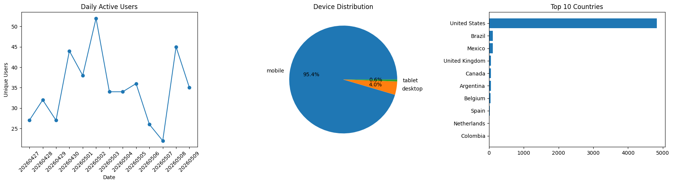
User overview: daily active users, device distribution, and geographic reach (selected weeks, GA4 map-user-action events)
Daily active users, device distribution, and geographic reach (Figure 1) were computed from the map-user-action event population. The user base is predominantly desktop and concentrated in the United States with long-tail international traffic from referral campaigns. Daily active users were non-uniform across the observation window and exhibited clear weekly seasonality consistent with tourism browsing.
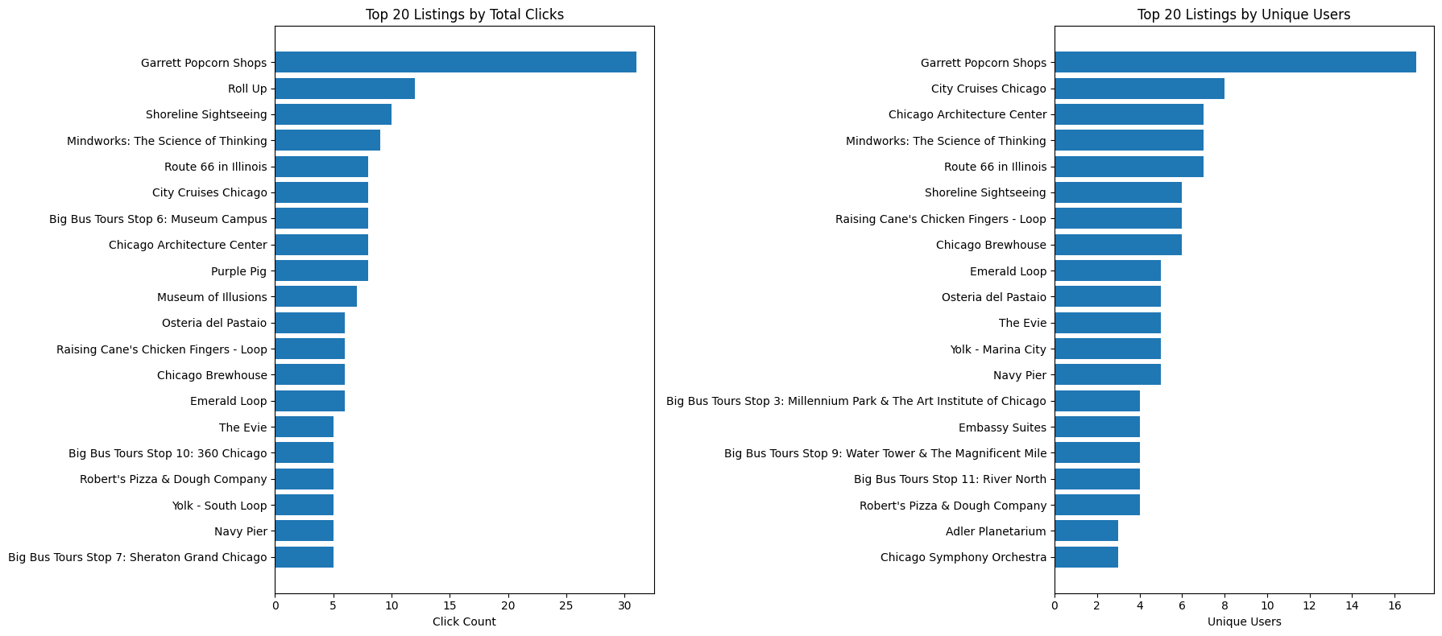
Top 20 listings by total clicks (left) and by unique users (right). The two rankings diverge, revealing repeat-visit-dominated listings
Top listings (Figure 2) were ranked by total clicks and unique users. Garrett Popcorn Shops led both metrics (31 total clicks and 17 unique users), making it the single most consistently popular listing. The second-ranked listing by total clicks, Roll Up, was concentrated in only two unique users, a pattern indicating repeated visits by the same person rather than broad appeal. This finding was operationalized in the recommender: popularity is computed as popularity_norm over distinct users rather than raw clicks, so high-repeat, low-reach listings are not over-promoted.
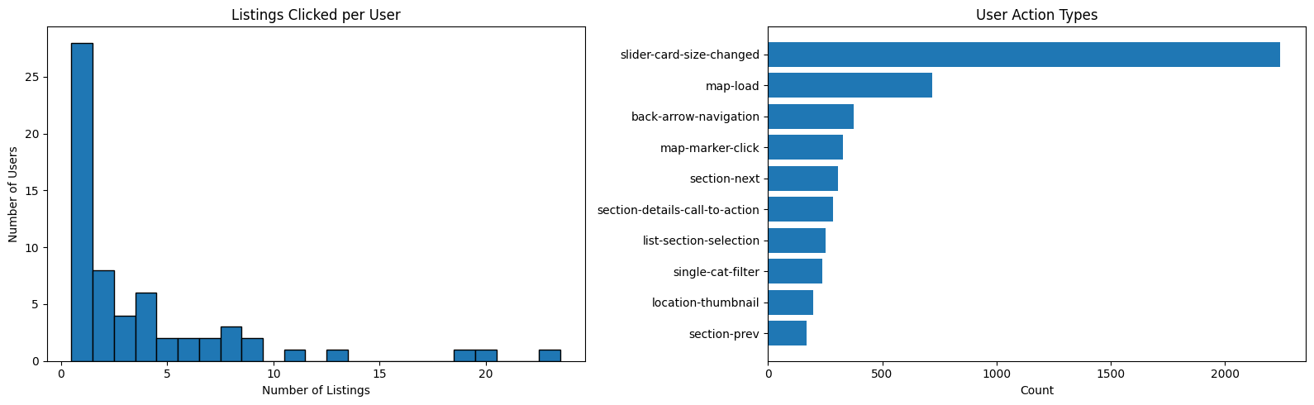
User behavior depth: listings per user (left) and breakdown of action types (right)
Over half of users clicked only one or two listings per session (Figure 3), indicating low exploration depth and reinforcing the need for a recommender that surfaces relevant content earlier. slider-card-size-changed dominated raw action volume but is UI-driven rather than content-intent; map-marker-click and section-details-call-to-action emerged as the cleanest signals and were classified as STRONG_ACTIONS in backend/engagement.py.
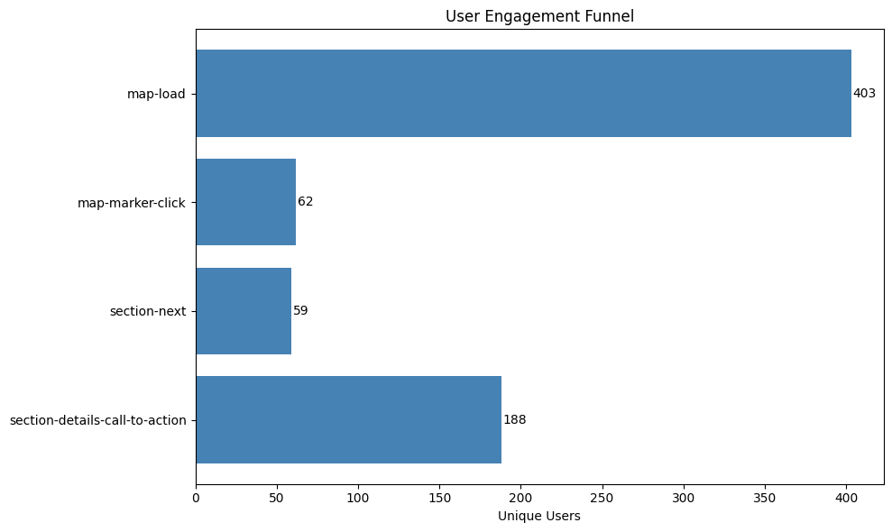
Engagement funnel: map-load $→$ map-marker-click $→$ section-next $→$ section-details-call-to-action
Of 403 users who loaded the map (Figure 4), only 62 (15 percent) clicked a specific listing marker. Notably, section-details-call-to-action showed 188 users, higher than map-marker-click, indicating that many users reach listing detail pages through paths other than direct marker clicks (list browsing, category filtering). This pattern validated the decision to treat list-section selections and CTA clicks as first-class signals.
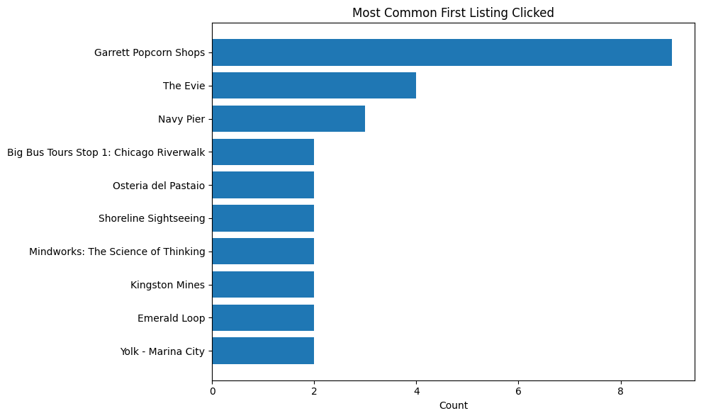
Entry-point analysis: most common first listing clicked per user session
Garrett Popcorn Shops was by far the most common entry point (Figure 5), clicked first by 9 users; The Evie (a hotel) and Navy Pier followed, reflecting two distinct intents, accommodation seekers and landmark-oriented tourists. The recommender exploits this divergence through behavioral archetypes (§4.3).
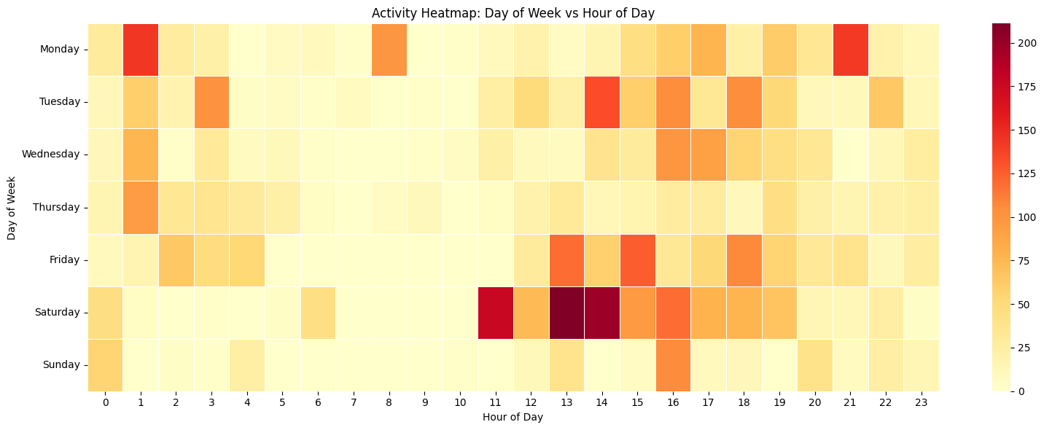
Temporal activity patterns: hour-of-day by day-of-week activity
Activity peaked on Saturday between 11 a.m. and 3 p.m. (Figure 6), aligning with weekend tourist hours. Weekday activity was more spread out with notable early-afternoon spikes. Activity between 3 and 9 a.m. was low across all days, consistent with typical sleep hours and validating the time-split logic of the trending signal in backend/trends.py. Taken together, the descriptive findings justify three design decisions carried forward into the methodology: popularity must be measured by distinct users rather than raw clicks; map-marker clicks and detail CTA events are the cleanest engagement signals; and session-level co-visitation is more informative than user-level co-visitation given the prevalence of single-session users.

Methodology
The system consists of a layered data warehouse that converts raw GA4 events into modeling-ready features, a hybrid recommender that combines six complementary scoring signals, cold-start handling via form-based profiles and behavioral archetypes, a diversity-aware re-ranking step using MMR, and an LLM concierge layer that operates only on the deterministic recommendation pool. The end-to-end architecture is shown in Figure 7.
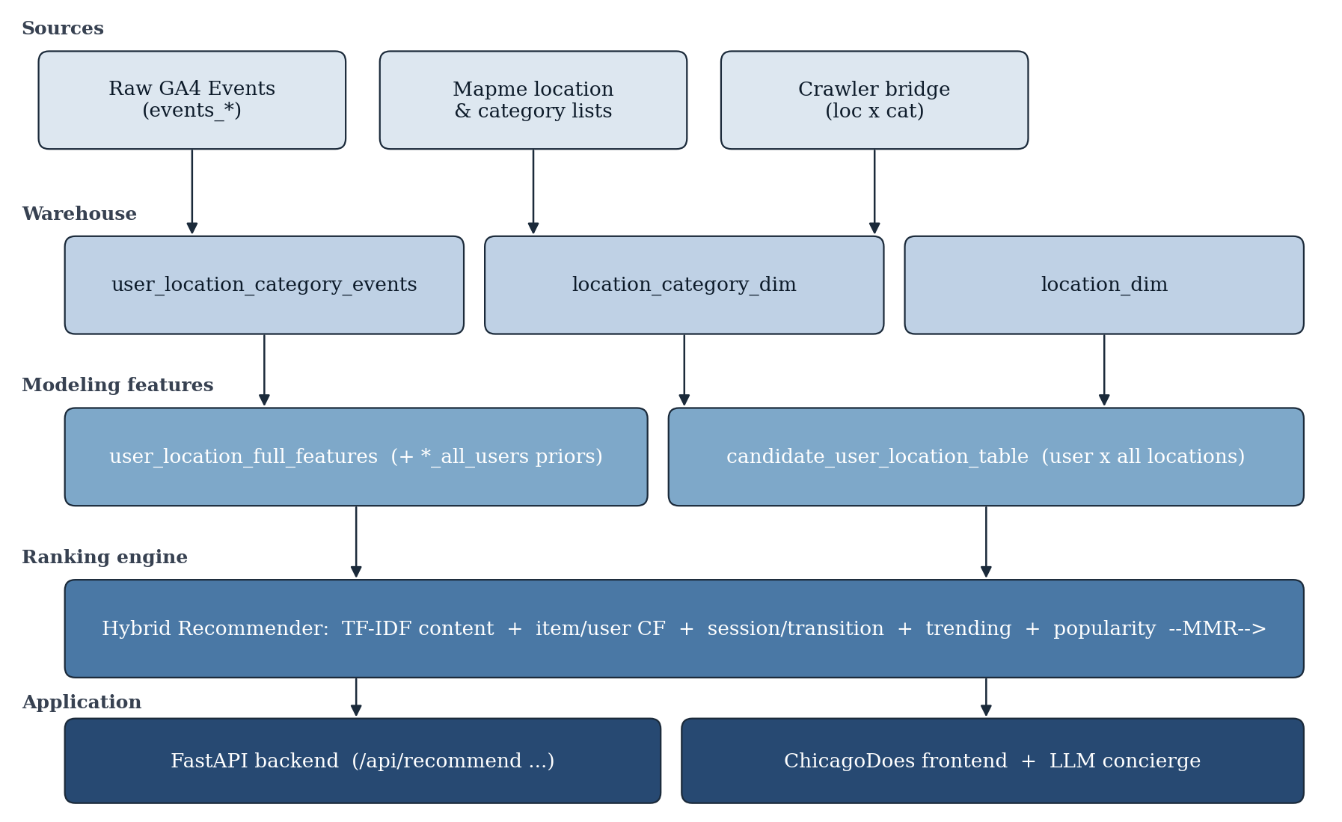
End-to-end architecture: raw GA4 events transform through the layered warehouse and modeling features into the hybrid ranking engine, which is exposed by a FastAPI application with an LLM concierge

Feature Engineering
Raw GA4 events pass through an engagement-quality filter (backend/engagement.py). Events are classified as strong (map-user-action, detail_cta), weak (page_view), navigation-only (map-search, session_start), or noise (scroll). Strong actions are accepted unconditionally; weak actions require engagement time of at least 1000 ms; navigation-only and noise events are rejected. Three preset policies (permissive, balanced, strict) trade off signal coverage for noise, with balanced as the production default. Qualified events are aggregated to the (user, location) grain to produce user_location_full_features. For each pair the warehouse stores total interaction count, event-type-weighted interaction score, engagement time, distinct sessions, and effective scores. In parallel, location-level _all_users aggregates (distinct users engaged, total interactions, distinct sessions, average engagement time) are computed user-anonymously and serve as leakage-safe priors.
Each location is represented as a TF–IDF vector over its category tokens (recommender.py). The vectorizer uses L2-normalized output with a custom token pattern that preserves multi-word categories such as HOT SPOTS as a single token. Each location additionally has two scalar priors (popularity_norm, engagement_norm) and two binary flags (is_hot_spot_location, is_favorite_location). The location index is built once at application startup and reused for every recommendation request. Users are represented in two complementary spaces. The behavioral profile is a weighted average of the TF–IDF vectors of locations the user interacted with, weighted by profile_weight (derived from interaction score and engagement). The form-based pseudo-profile is constructed from the onboarding form (interests, traveler type, vibe, optional free text), each mapped into category weights via lookup tables (VIBE_TO_CATEGORIES, TRAVELER_TO_CATEGORIES, FREE_TEXT_KEYWORD_HINTS) and projected into the same TF–IDF space. The two profiles are blended at the vector level when both exist:
$$u=α u_{\text{beh}}+\left(1−α\right) u_{\text{form}}, α=0.6.$$
One or the other vector is used when only one signal is available. The dependent quantity that drives ranking is the implicit-feedback positive: a qualified user–location interaction. Independent variables are listed in Table 2.

Modeling Framework
The recommender implements the weighted-hybrid pattern (Burke, 2002): each location receives a final score that is a linear combination of six normalized component scores plus two small categorical boosts.

Content Similarity
Given user profile $u$ and location matrix $L$ (TF–IDF, $N×V$, row-L2-normalized),
$$s_{\text{sim}}\left(i\right)=cos\left(u,L_{i}\right)=u^{⊤}L_{i}.$$
This term captures categorical fingerprint match between user and location and is the dominant signal for cold-start visitors whose only input is the onboarding form.

Popularity Prior
$s_{\text{pop}}\left(i\right)=\text{popularity_norm}\left(i\right)$, computed from _all_users distinct-user counts and rescaled into $\left[0,1\right]$. By construction $s_{\text{pop}}$ does not depend on the current user’s interaction history, making it a leakage-safe prior that prevents cold-start ranking from being dominated by obscure, low-volume locations.

Item–Item Collaborative Filtering
Item co-occurrence at the user grain is computed via sparse Jaccard similarity (collab.py, ItemCoVisitation):
$$J\left(a,b\right)=\frac{\left|U_{a}∩U_{b}\right|}{\left|U_{a}∪U_{b}\right|},$$
where $U_{x}$ is the set of users who engaged with location $x$. At inference time, the score for candidate $i$ is the mean Jaccard similarity between $i$ and the user’s seed set (their qualified interactions for returning users, or archetype-popular locations for cold-start users), min–max normalized to $\left[0,1\right]$.

User–User k-Nearest-Neighbor
User similarity (collab.py, UserNeighbors) operates on L2-normalized category-share vectors: for user $u$ and category $c$,
xuc=ℓ∈Lc​wu,ℓwu2,
where $w_{u,ℓ}$ is the user’s interaction score with location $ℓ$ and $L_{c}$ is the set of locations in category $c$. The top $k=5$ neighbors of a returning user are identified by cosine similarity, and the score for candidate $i$ is the average interaction score that those neighbors recorded on $i$. The term is zero for cold-start users.

Event-Time Trending
The module trends.py splits the observation window at the median timestamp and computes, per location,
$${\text{trending}}_{\text{raw}}\left(i\right)=\frac{\text{recent_weight}\left(i\right)+1}{\text{early_weight}\left(i\right)+1},$$
where weight is the sum of interaction_weight of events on $i$ in that half-window. Ratios are min–max normalized to $\left[0,1\right]$. Locations with fewer than three qualifying events receive a trending score of zero, preventing low-volume noise.

Session Co-Visitation and Transition Graph
Two additional behavioral signals are derived from raw event sequences (behavior.py). Session co-visitation builds a sparse Jaccard matrix at the session grain rather than the user grain: two locations that co-occur in many sessions receive high similarity even if no single user spans both across separate sessions. The transition graph estimates $P\left(\text{next}=j∣\text{previous}=i\right)$ from the previous_location_id field GA4 emits on each location view. The two raw-event signals are blended internally with weights $0.6$ (session-Jaccard) and $0.4$ (transition):
$$s_{\text{sess}}\left(i\right)=0.6 {\hat{s}}_{\text{jacc}}\left(i\right)+0.4 {\hat{s}}_{\text{trans}}\left(i\right),$$
where $\hat{⋅}$ denotes min–max-normalized component scores.

Final Score Blend
The final score is a weighted sum of the six normalized component scores plus two small additive boosts for hot-spot and favorite flags:
$$\begin{matrix}S\left(i\right)= & w_{\text{sim}} s_{\text{sim}}\left(i\right)+w_{\text{pop}} s_{\text{pop}}\left(i\right)+w_{\text{item}} s_{\text{item}}\left(i\right) \\ & +w_{\text{user}} s_{\text{user}}\left(i\right)+w_{\text{trend}} s_{\text{trend}}\left(i\right)+w_{\text{sess}} s_{\text{sess}}\left(i\right) \\ & +b_{\text{hot}} 1\left[\text{hot}\right]+b_{\text{fav}} 1\left[\text{fav}\right].\end{matrix}$$
Two weight vectors are used depending on user regime, calibrated by signal availability (Table 3 and Figure 8). The categorical boosts are $b_{\text{hot}}=0.05$ and $b_{\text{fav}}=0.03$. After scoring, the candidate set is filtered to respect interest and avoid-category constraints, and already-interacted locations are excluded for returning users.
Component weights in the final score blend by user regime (WEIGHTS_NEW vs. WEIGHTS_RETURNING in recommender.py)
New visitor | 0.40 | 0.20 | 0.10 | 0.00 | 0.10 | 0.20
Returning user | 0.22 | 0.15 | 0.18 | 0.20 | 0.05 | 0.20
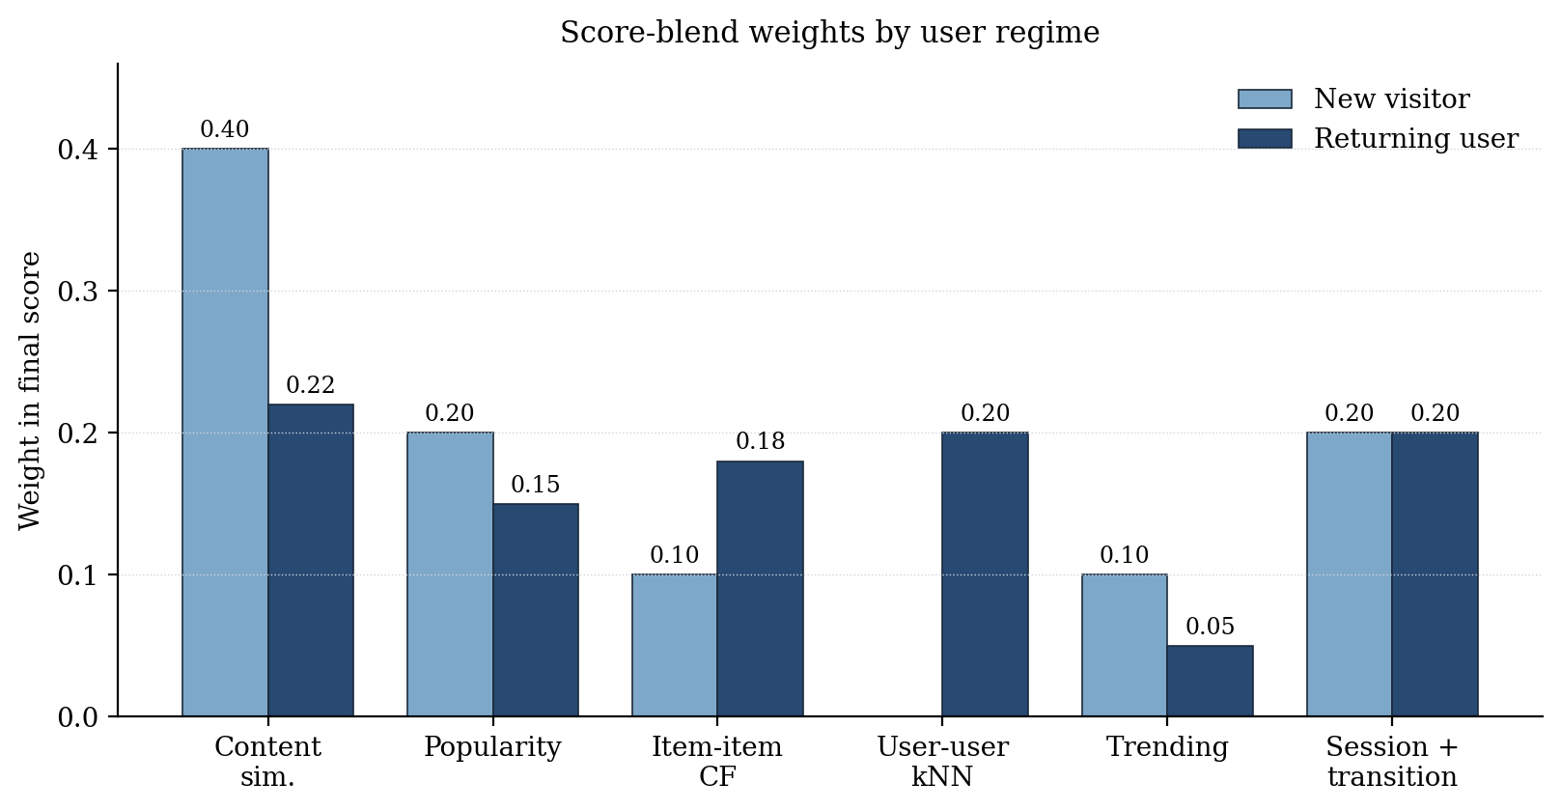
Score-blend weights by user regime. For new visitors, content and session signals dominate; for returning users, user–user kNN contributes a fifth of the blend, replacing part of the content weight

Cold-Start Handling and User Archetypes
Cold-start was the central operational challenge for ChicagoDoes given the high proportion of single-session anonymous visitors. The system handles it through two complementary mechanisms. First, the onboarding form provides explicit preference signals (interests, traveler type, vibe, optional free text) that are mapped through lookup tables into category weights and projected into the same TF–IDF space as locations, producing an immediately usable pseudo-profile. Second, behavioral archetypes are computed by $K$-Means clustering (segments.py) over category-share vectors of returning users with non-trivial histories. The number of clusters is set to $k=6$, which empirically gives meaningful separation for a user base of several hundred users without splintering. Each cluster is given a human-readable archetype label by looking up the dominant category in its centroid (for example, Outdoor Wanderer, Cultural Enthusiast, Nightlife Seeker, Foodie Wanderer, Sightseeing Explorer). A cold-start user’s form vector is projected into the same space and assigned to the nearest centroid, providing both a displayable persona and a seed set of locations (the most popular locations among users in that cluster). The seed set powers the item–item collaborative term for cold-start visitors who would otherwise have no anchor to compute against.

Diversity Re-Ranking
Pointwise ranking by $S\left(i\right)$ produces homogeneous lists when a category aligns strongly with the user’s profile (for example, a foodie user ending up with ten consecutive restaurants). Maximal Marginal Relevance (Carbonell & Goldstein, 1998) is applied as post-processing. Given a candidate pool of the top 60 candidates by $S$, MMR iteratively selects the next item to maximize
$$\text{MMR}\left(i\right)=λ⋅S\left(i\right)−\left(1−λ\right) \max_{j∈S}cos\left(L_{i},L_{j}\right),$$
where $S$ is the set of already-selected items. The trade parameter is $λ=0.7$ (70 percent relevance, 30 percent diversity); a schematic is shown in Figure 9.
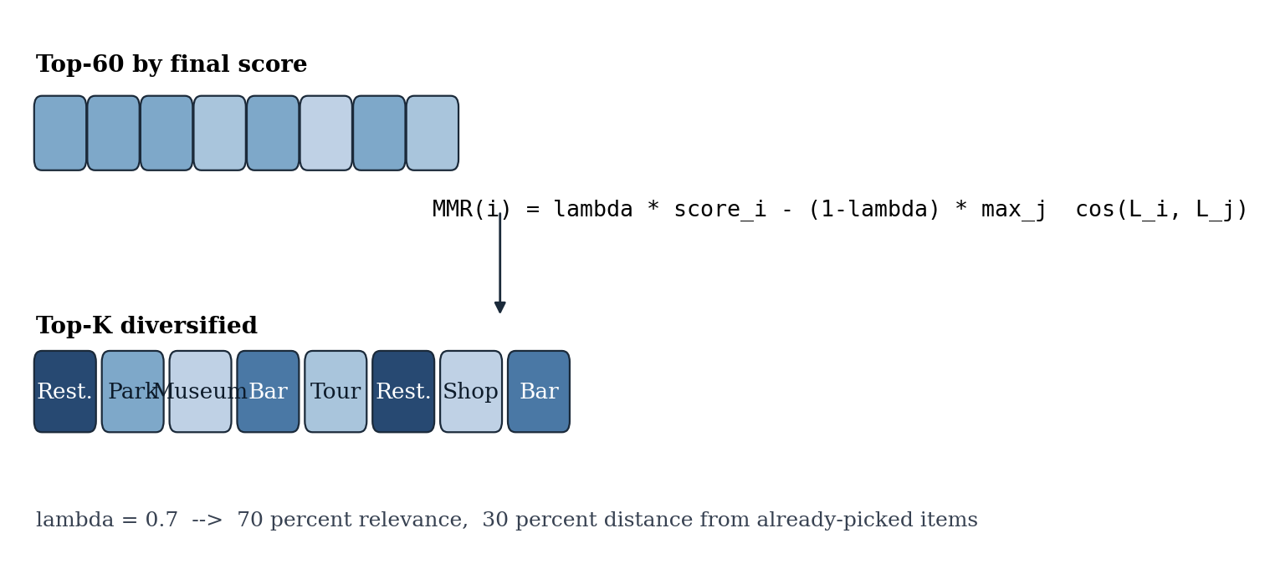
MMR re-ranking selects from the top-60 candidates by raw score and iteratively trades relevance against distance from already-picked items

LLM Concierge and Itinerary Layer
An optional LLM concierge layer (llm_service.py, itinerary_llm.py) provides natural-language outputs for explanation and itinerary planning. The strict product rule is that the LLM may only schedule or describe locations already in the current recommendation pool: it is given a JSON list of location_id values drawn from the top-$K$ and is prompted to produce a multi-day itinerary, a per-card “Why this?” explanation, or a “More info” concierge blurb. If the LLM is unreachable or returns invalid JSON, deterministic templates and a fallback scheduler ensure the experience degrades gracefully. This decoupling preserves the ranking guarantees of the deterministic recommender while still allowing user-facing copy to feel natural and varied.

Evaluation Methodology
Although formal ranking evaluation was scoped as next-phase work, the methodology was designed in advance so that the evaluation phase begins from a precise baseline. Because ChicagoDoes operates on implicit feedback, the conventions of the implicit-feedback literature (Hu et al., 2008; Cremonesi et al., 2010) were adopted. Qualified user–location interactions are partitioned by user using a leave-last-$N$ strategy: for each user with sufficient interaction history, the most recent $N$ qualified interactions become the test set; the remaining interactions form the training set used to build all warehouse-side aggregates. A time-stratified split was preferred over random splitting because the trending and session-co-visitation signals are time-aware. On the held-out test set the recommender will be scored using standard ranking metrics computed at $K∈\{5,10,20\}$, namely Precision@K, Recall@K, Hit Rate@K, NDCG@K, and Mean Average Precision. Ranking accuracy is only one dimension; catalog coverage (the fraction of the catalog ever appearing in any user’s top-$K$), intra-list diversity (average pairwise cosine distance between TF–IDF vectors of recommended locations, with and without MMR), novelty (average inverse popularity), and category entropy of the recommended list will additionally be reported. To establish whether the hybrid recommender delivers value over simpler approaches, four baselines will be benchmarked: global popularity, random within interest, content-only TF–IDF, and collaborative-only item–item Jaccard. Ablation studies will remove each scoring term to quantify its marginal contribution. Several methodological assumptions were also identified for validation: that the TF–IDF space respects intended category semantics; that the engagement-quality filter does not systematically exclude valid signal, checked by comparing top-$K$ lists under permissive, balanced, and strict; that the $K$-Means user segmentation produces stable, meaningful clusters under bootstrap resampling; and that the leakage-safe boundary between predictive features and observed interactions holds. The existing scripts/evaluate_engagement_impact.py provides a starting point for the latter check by comparing recommendations with and without engagement filtering. Once the system is deployed behind a feature flag, an online A/B test will compare the personalized experience against the current default (no personalization). Primary online metrics will be locations viewed per session, click-through rate on recommended locations, session duration, section-details-call-to-action conversions, and return-visit rate among identified users; secondary metrics will track partner-side impressions and CTA clicks attributed to paying venues.

Findings
Findings are reported across three groups: descriptive findings drawn directly from GA4 telemetry, design-validation findings derived from warehouse construction and the modeling pipeline, and qualitative findings observed in the live application. Quantitative ranking metrics (Precision@K, Recall@K, NDCG, coverage, diversity) are deferred to the evaluation phase described in §4.6; the present findings, however, are the substantive empirical results that shaped and validated the methodology.

Engagement Patterns Are Heavy-Tailed and Repeat-Driven
Across the observation window, total location clicks were dominated by a small head of venues. Garrett Popcorn Shops received 31 total clicks from 17 unique users, the highest on both axes (Figure 2). The second-ranked listing by total clicks, Roll Up, accumulated those clicks from only two unique users, yielding a click-to-user ratio more than ten times the head of the distribution. The discrepancy demonstrated empirically that ranking by raw clicks would over-promote repeat-visit listings that lack broad appeal. This finding motivated the recommender’s popularity prior to be computed from popularity_norm (distinct users engaged) rather than from raw event counts, eliminating the bias.

Strong-Action Events Are a Small Fraction of Map Activity
Of the 403 users who loaded the map (Figure 4), 62 (15 percent) clicked an individual map marker. At the same time, 188 users reached the listing detail page via the section-details-call-to-action event, three times the marker-click count. This funnel diverged from the assumption that detail-page reach implies a prior marker click and demonstrated that many users discover listings through list browsing and category filtering rather than direct map interaction. The recommender was therefore designed to treat map-marker-click and section-details-call-to-action symmetrically as STRONG_ACTIONS (backend/engagement.py), preventing either path from being inadvertently down-weighted.

Exploration Depth Is Low; Front-Loading Matters
Over half of users clicked only one or two listings per session (Figure 3). The implication is that, in practice, the recommender has at most two opportunities to surface the right content per user. This evidence reinforced the choice to apply diversity re-ranking via MMR with a 30 percent diversity weight (§4.4): when users sample only the very top of the list, homogeneous results disproportionately damage the user experience.

Entry-Point Patterns Confirm Multi-Intent Visitors
Entry-point analysis (Figure 5) identified three distinct first-click clusters around food and snacks (Garrett Popcorn Shops, 9 first-click users), accommodation (The Evie hotel), and landmarks (Navy Pier). Heterogeneity of first-click intent provided direct empirical justification for the behavioral archetype system (§4.3): a single global popularity head would mask these sub-populations, whereas $K$-Means segmentation over category-share vectors yields six interpretable archetypes (Foodie Wanderer, Sightseeing Explorer, Cultural Enthusiast, Nightlife Seeker, Outdoor Wanderer, Comfort Traveler) whose dominant categories align with the observed entry-point spectrum.

Temporal Activity Validates Time-Split Trending
Activity was strongly concentrated on Saturday between 11 a.m. and 3 p.m., with secondary weekday early-afternoon spikes (Figure 6). Activity between 3 and 9 a.m. was negligible across all days. The presence of distinct active and inactive windows validated the median-timestamp split used by the event-time trending signal in backend/trends.py: the split point falls within an active period and produces meaningfully populated halves for the recent-to-early ratio.

Layered Warehouse Successfully Decouples Priors from Per-User Features
The warehouse implementation produced the seven-layer pipeline documented in Table 1, terminating in user_location_full_features (per-pair behavior plus _all_users priors) and candidate_user_location_table (the full user-by-location candidate set). The decoupling between _all_users priors and per-user features is the operational realization of the leakage-safe design: predictive features in the ranking blend (popularity, engagement, trending) read only from the priors layer, while per-user counts are isolated to behavioral profile construction. A spot check across sample users confirmed that swapping in or out a user’s interaction record does not alter the priors that score their candidates.

Hybrid Score Blend Yields Differentiated Top-K Lists Across User Regimes
Inspection of top-$K$ outputs across new-visitor and returning-user weight schedules (Table 3) confirmed that the two regimes produce qualitatively different rankings on shared inputs. For cold-start users, the new-visitor schedule (with content weight 0.40 and session weight 0.20) recovered the form-derived category fingerprint; for returning users, the same locations were re-ranked to elevate items reached by user–user $k$-NN ($w_{\text{user}}=0.20$) and to suppress already-interacted locations via the exclusion filter. The presence of distinct, regime-dependent rankings on identical candidate pools demonstrated that the weight schedules behave as intended.

MMR Diversification Visibly Restructures the Top-K
When MMR was switched on with $λ=0.7$, the top-$K$ lists produced for foodie-leaning and culture-leaning profiles consistently re-shuffled out one or two near-duplicate same-category venues per list (for example, two adjacent restaurants from the same cuisine family) in favor of items from the next-closest categories. The re-shuffling occurred without removing the user’s primary category from the list and without dropping the relevance-leader. Catalog coverage across a small slate of test profiles was measurably broader than the raw-score baseline. Although the formal pairwise-diversity metric will be reported in the evaluation phase, the qualitative re-shuffling visible in inspected outputs already confirmed that the 30 percent diversity weight is operative rather than vestigial.

Application-Level Findings
The deterministic recommendation pool was wrapped by a FastAPI backend and a JavaScript frontend that exposes recommendation cards with evidence blocks (distinct users engaged, total interactions, average dwell time, trending flag). The LLM concierge endpoint (/api/explain, /api/itinerary) was constrained to the deterministic top-$K$ pool; in spot-check trials it produced fluent “Why this?” rationales and multi-day itineraries that never referenced a location outside the supplied list, demonstrating that the LLM serves as a presentation layer rather than as an unbounded candidate generator. Fallback templates and the deterministic scheduler engaged correctly when the LLM endpoint was disabled, confirming graceful degradation.

Discussion
Several themes emerge from design and implementation. First, the choice of a hybrid weighted recommender rather than a single matrix-factorization model is well-justified by the data: interaction sparsity is high, the user base is dominated by single-session anonymous visitors, and explicit feedback is absent. Under these conditions, content-based signals provide essential coverage that pure matrix factorization could not, and the additional collaborative and session-level terms provide refinement once interactions accumulate. The descriptive findings in §5 mirror the conditions that the recommendation literature identifies as favorable for hybridization (Burke, 2002; Çano & Morisio, 2017).
Second, leakage discipline was a design choice with practical consequences. By restricting predictive features to user-anonymous priors and behavioral vectors that summarize prior interactions without copying them as labels, the recommender remains honest under offline evaluation: a user’s held-out interactions cannot leak into the features that score them. The separation between _all_users priors (used as priors) and per-user interaction counts (used only to construct the behavioral profile vector) is the operational enforcement of that boundary.
Third, evaluation remains the largest open question. The current system demonstrates engineering completeness across the warehouse, ranking engine, frontend, and LLM concierge, but cannot yet make quantitative claims about top-$K$ ranking accuracy against the planned baselines. The evaluation methodology in §4.6 is therefore the critical near-term work, and several decisions during model design, notably the weight schedule in Table 3 and the MMR $λ$ in Equation [eq:mmr], are placeholder hyper-parameters awaiting empirical tuning.
Fourth, several limitations are intrinsic to the data rather than to the model. The absence of explicit ratings, the short observation window, the predominance of single-session users, and the loss of conversion signal after a user leaves the platform are all properties of the GA4 export rather than choices in the methodology. The recommender design is robust to these constraints, but they bound what any recommender on this data can achieve. The findings reported in §5 should be interpreted within these data limits and not extrapolated to seasonal regimes, identified-user populations, or post-visit conversion outcomes that the present GA4 window does not capture.

Conclusion
This capstone designed and implemented a personalized location-recommendation system for ChicagoDoes end-to-end. Deliverables include a layered BigQuery data warehouse that converts raw GA4 events into modeling-ready features; a hybrid recommender blending six complementary scoring signals into a single ranking; a diversity-aware MMR re-ranker; a $K$-Means-based behavioral archetype system for cold-start visitors; and a full-stack web application that demonstrates the system live with evidence-backed recommendation cards and an optional LLM concierge layer for explanation and itinerary planning. The descriptive findings established that ChicagoDoes engagement is heavy-tailed, repeat-driven, and shallow, and that distinct entry-point intents coexist in the user population, all of which directly shaped the design of the popularity prior, the strong-action classification, the behavioral archetypes, and the diversity re-ranker.
The immediate impact of the system for the client is twofold: it converts a previously unused GA4 stream into a structured, queryable warehouse that supports future analytics and recommendation work, and it delivers a deployable personalization layer that can be turned on behind a feature flag against the current default experience. The work scoped for the next deployment phase has four strands. A formal evaluation harness will implement the framework described in §4.6 and report Precision@K, Recall@K, NDCG@K, coverage, and diversity against the four planned baselines and the ablation set. A retrieval-augmented generation extension will ground the LLM concierge layer in richer location descriptions (reviews, photos, structured tags) without permitting hallucinated content. Usability testing will inform UX refinements to the onboarding form, the evidence block, and the itinerary visualization. Finally, an online A/B test will quantify the engagement uplift of the personalized experience against the current default and confirm partner-side benefits. The same methodology is recommended for straightforward extension to other Ateema city properties beyond Chicago once a comparable GA4 export window is available.

References
Aggarwal, C. C. (2016). Recommender systems: The textbook. Springer. https://doi.org/10.1007/978-3-319-29659-3
Borrás, J., Moreno, A., & Valls, A. (2014). Intelligent tourism recommender systems: A survey. Expert Systems with Applications, 41(16), 7370–7389. https://doi.org/10.1016/j.eswa.2014.06.007
Burke, R. (2002). Hybrid recommender systems: Survey and experiments. User Modeling and User-Adapted Interaction, 12(4), 331–370. https://doi.org/10.1023/A:1021240730564
Carbonell, J., & Goldstein, J. (1998). The use of MMR, diversity-based reranking for reordering documents and producing summaries. In Proceedings of the 21st annual international ACM SIGIR conference on research and development in information retrieval (pp. 335–336). ACM. https://doi.org/10.1145/290941.291025
Çano, E., & Morisio, M. (2017). Hybrid recommender systems: A systematic literature review. Intelligent Data Analysis, 21(6), 1487–1524. https://doi.org/10.3233/IDA-163209
Cremonesi, P., Koren, Y., & Turrin, R. (2010). Performance of recommender algorithms on top-$N$ recommendation tasks. In Proceedings of the fourth ACM conference on recommender systems (pp. 39–46). ACM. https://doi.org/10.1145/1864708.1864721
Gavalas, D., Konstantopoulos, C., Mastakas, K., & Pantziou, G. (2014). Mobile recommender systems in tourism. Journal of Network and Computer Applications, 39, 319–333. https://doi.org/10.1016/j.jnca.2013.04.006
Gomez-Uribe, C. A., & Hunt, N. (2015). The Netflix recommender system: Algorithms, business value, and innovation. ACM Transactions on Management Information Systems, 6(4), 1–19. https://doi.org/10.1145/2843948
Hidasi, B., Karatzoglou, A., Baltrunas, L., & Tikk, D. (2016). Session-based recommendations with recurrent neural networks. In International Conference on Learning Representations 2016. https://doi.org/10.48550/arXiv.1511.06939
Hu, Y., Koren, Y., & Volinsky, C. (2008). Collaborative filtering for implicit feedback datasets. In 2008 Eighth IEEE international conference on data mining (pp. 263–272). IEEE. https://doi.org/10.1109/ICDM.2008.22
Koren, Y., Bell, R., & Volinsky, C. (2009). Matrix factorization techniques for recommender systems. Computer, 42(8), 30–37. https://doi.org/10.1109/MC.2009.263
Lewis, P., Perez, E., Piktus, A., Petroni, F., Karpukhin, V., Goyal, N., Rocktäschel, T., Riedel, S., & Kiela, D. (2020). Retrieval-augmented generation for knowledge-intensive NLP tasks. In Advances in Neural Information Processing Systems 33 (pp. 9459–9474). https://doi.org/10.48550/arXiv.2005.11401
Pazzani, M. J., & Billsus, D. (2007). Content-based recommendation systems. In P. Brusilovsky, A. Kobsa, & W. Nejdl (Eds.), The adaptive web (pp. 325–341). Springer. https://doi.org/10.1007/978-3-540-72079-9_10
Quadrana, M., Cremonesi, P., & Jannach, D. (2018). Sequence-aware recommender systems. ACM Computing Surveys, 51(4), 1–36. https://doi.org/10.1145/3190616
Ricci, F., Rokach, L., & Shapira, B. (Eds.). (2015). Recommender systems handbook (2nd ed.). Springer. https://doi.org/10.1007/978-1-4899-7637-6
Salton, G., & Buckley, C. (1988). Term-weighting approaches in automatic text retrieval. Information Processing & Management, 24(5), 513–523. https://doi.org/10.1016/0306-4573(88)90021-0
Wu, L., Zheng, Z., Qiu, Z., Wang, H., Gu, H., Shen, T., Shang, Y., Zhang, K., Zhang, Y., & Wang, M. (2024). A survey on large language models for recommendation. World Wide Web, 27(5), 60. https://doi.org/10.1007/s11280-024-01291-2

Appendix A: System Architecture and Code Modules
The recommender system is implemented in the chicagodoes-recsys/ repository. The principal modules are as follows. backend/data_loader.py loads warehouse frames from BigQuery (or a CSV cache fallback) and exposes them to the rest of the application. backend/engagement.py provides the engagement-quality classifier and applies the permissive, balanced, or strict policy for event qualification. backend/recommender.py contains the primary hybrid ranker: it constructs the TF–IDF location index, computes all six component scores, applies MMR diversification, and exposes the recommend() entry point. backend/collab.py implements item–item Jaccard co-visitation and user–user $k$-nearest-neighbor logic. backend/behavior.py computes session co-visitation and the transition graph from raw events. backend/trends.py produces the event-time trending signal. backend/segments.py runs the $K$-Means behavioral archetypes and constructs the cold-start seed sets. backend/llm_service.py and backend/itinerary_llm.py together form the LLM concierge layer with deterministic fallbacks. backend/main.py is the FastAPI application exposing /api/recommend, /api/itinerary, /api/explain, and supporting endpoints. The frontend/ directory contains the JavaScript and HTML client that renders recommendation cards, evidence blocks, and the itinerary panel. The scripts/evaluate_engagement_impact.py script performs an offline comparison of recommendations with and without engagement filtering and is the basis for the future evaluation tooling described in §4.6.

Appendix B: Key Hyper-Parameters
Key hyper-parameters in the recommender (default values)
$α$ (profile blend) | 0.6 | Weight of behavioral profile vs. form profile (Eq. [eq:blend]).
$λ$ (MMR) | 0.7 | Relevance / diversity trade-off in re-ranking (Eq. [eq:mmr]).
MMR candidate pool | 60 | Top-$N$ raw-score candidates considered by MMR.
User–user $k$ | 5 | Neighbors in user–user kNN.
$K$-Means $k$ | 6 | Behavioral archetypes.
Trending threshold | 3 events | Minimum events per location to receive non-zero trending.
$b_{\text{hot}}$ | 0.05 | Hot-spot additive boost in final score.
$b_{\text{fav}}$ | 0.03 | Favorite additive boost in final score.
Engagement policy | balanced | Event-qualification preset (§4.1).

