Leaderboard

This is a ‘dashboard’ style of app. It is to be used on displays around the office to show staff rankings at various things – sales leaders, demos booked, Mario Kart times – all the important things that a company can rally around.

Here’s one I prepared earlier:

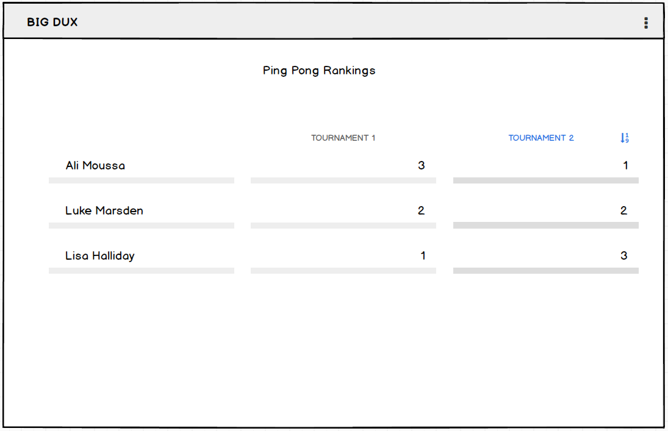

Bloody beautiful. But we’re getting ahead of ourselves.

Functionality – in brief:

* Allow the creation of ‘Boards’
* Each board has a
  + Title
    - Appears at the top of the board
    - Appears in the list on the main-menu
  + Datagrid/table
    - Column for names (mandatory)
    - Columns for scores
      * Min 1
      * Max of 52 score columns
    - Allow easy adding of rows and cols
    - Click to edit fields
    - Make ‘scores’ numbers only
    - Allow sorting of scores – restrict to single col
    - Allow adding of column-headers as labels
    - Allow deleting of score-columns (requiring at least one though)
    - Allow relocation of score-columns amongst themselves
    - Name-column always remain in place
      * Cannot be deleted or relocated

Navigating between boards is done on the main menu, which lists out all non-archived Boards. From the main menu, you can

* View boards
* Duplicate boards
  + Copies all content
  + Copies the Title, but appends (copy) at the end
  + LOW PRIORITY – skip if necessary
* Archive Boards.
  + Make the archived accessible via a link at the end of the main menu.

# Questions:

How does this handle times? MM:SS.FFF for example, would this format sort nicely? Does the leaderboard need to specify the number format?

Tried to keep User profiles out of this to lighten the load. How much work is it to get a name-auto-complete widget which works off of previously entered names?