SHIRTS: (need option to pay now or pay Ride day)

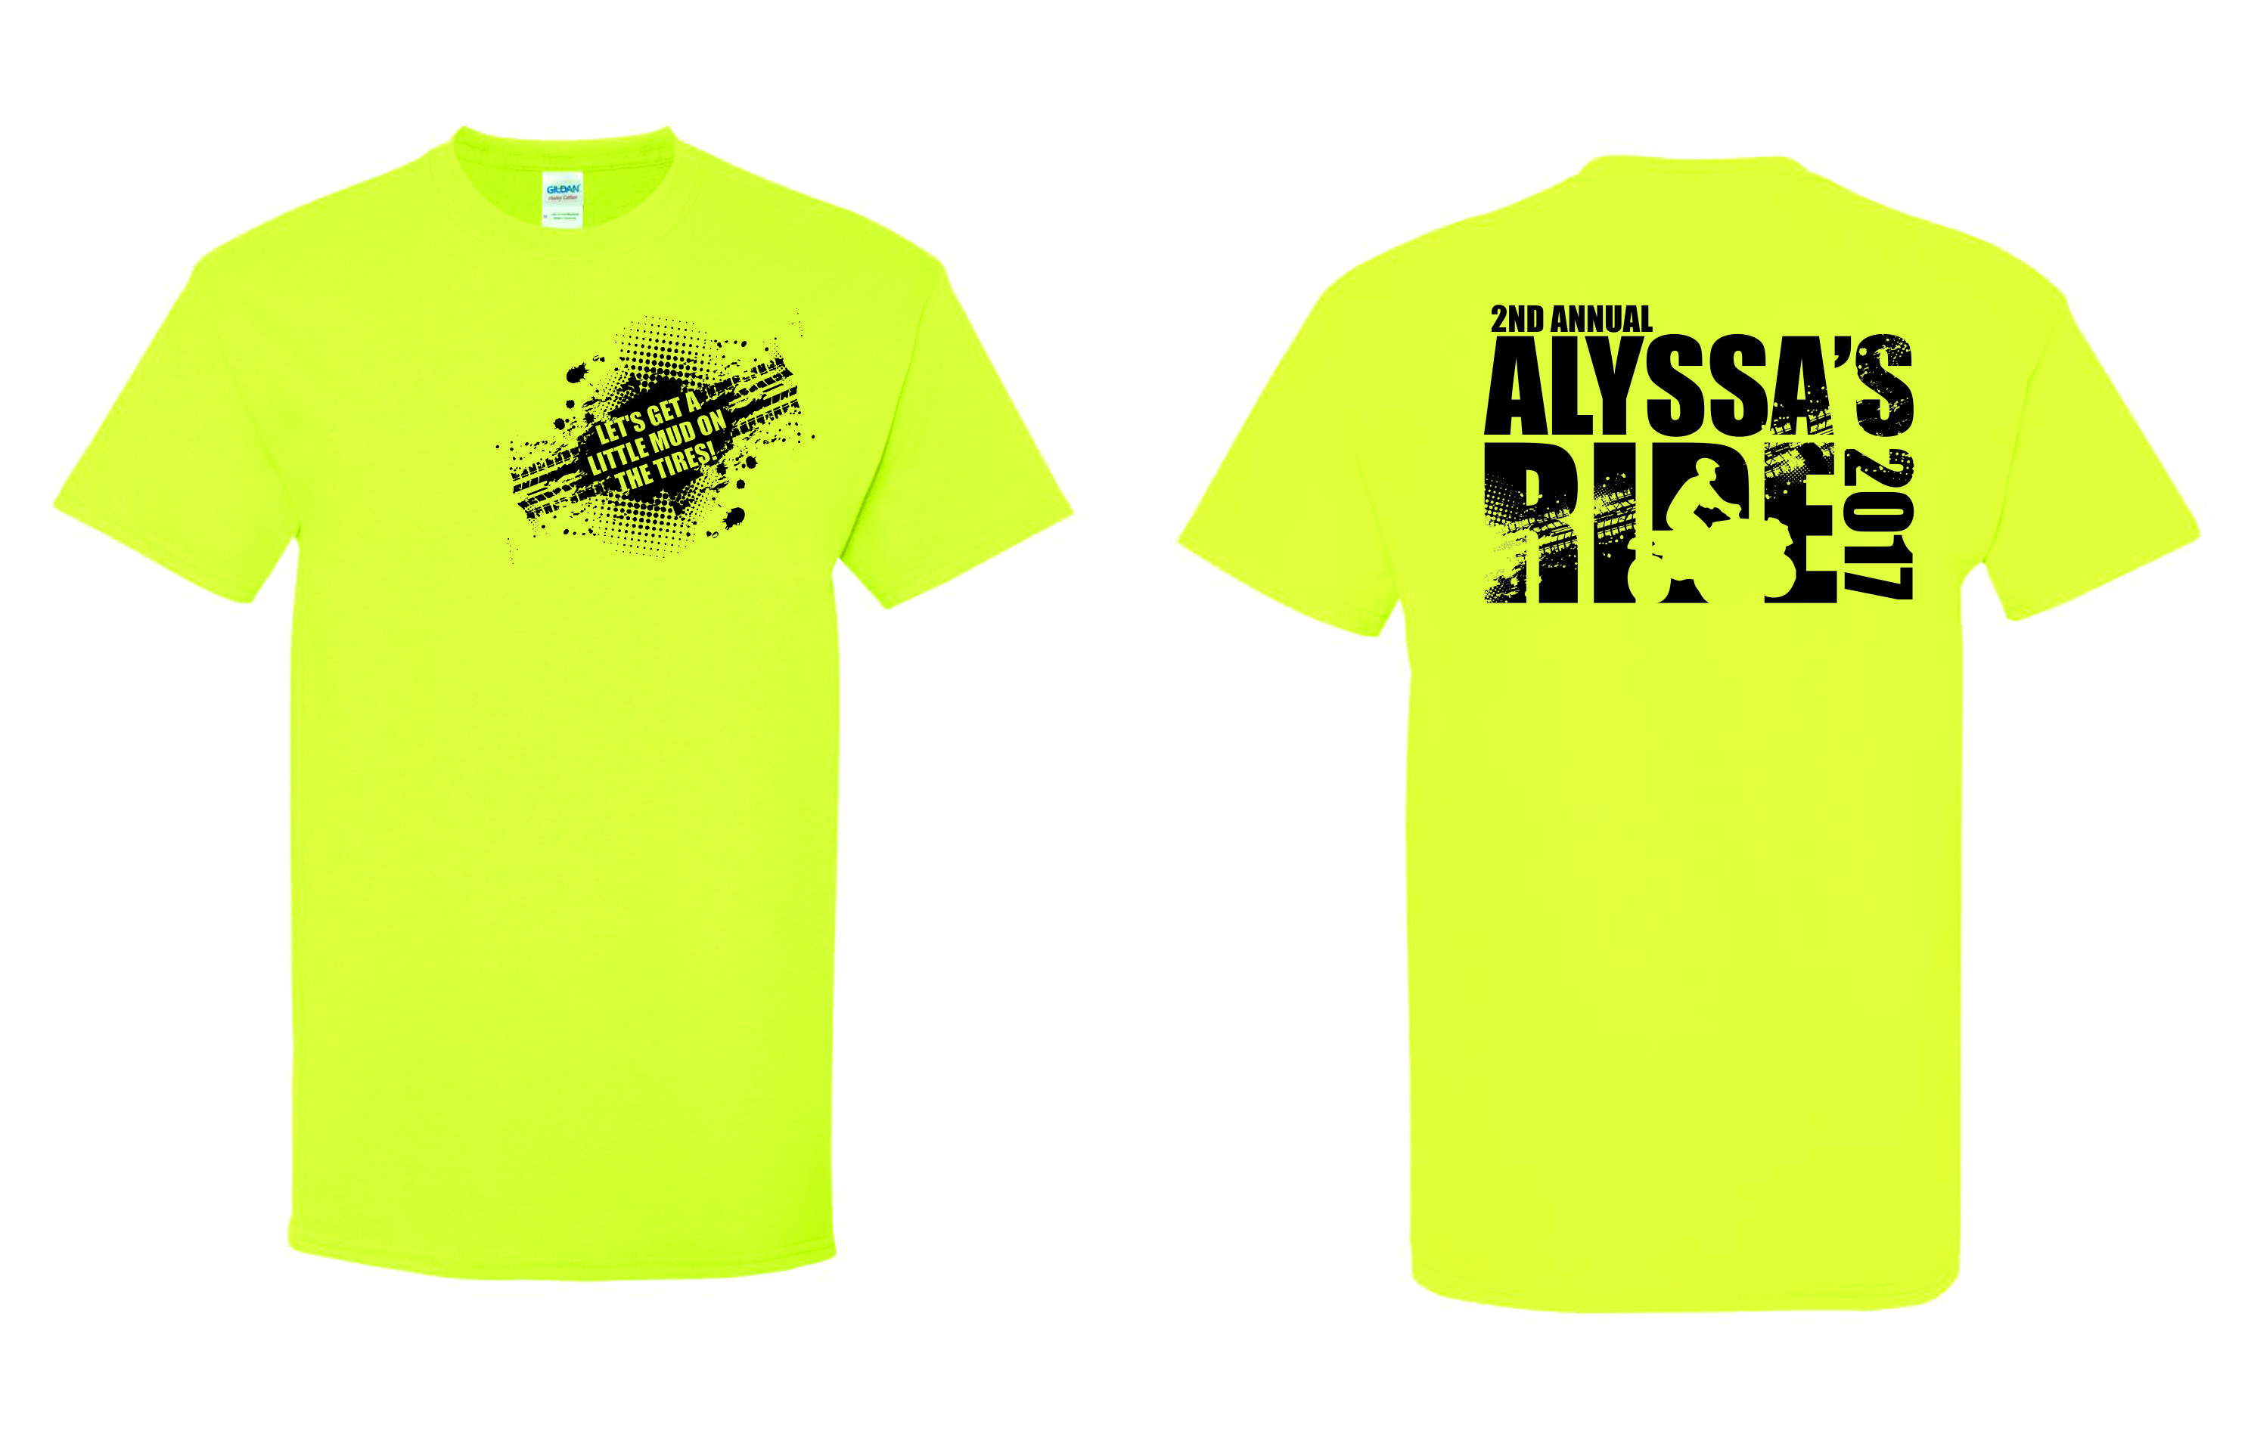

|  |  |  |
| --- | --- | --- |
| Unisex Adult Alyssa’s Ride  Safety Green Short Sleeve Shirt | Price (each)  $10.00 (S-XL)  (additional charge for 2X-4X) | (Add to Cart button)  Size  (drop down with sizes and for  2X +$2.00, 3X + $4.00, 4X + $4.00)  Quantity  (drop down with numbers) |
| Unisex Youth Alyssa’s Ride  Safety Green Short Sleeve Shirt | Price (each)  $10.00 (S-XL)  Small – 6/8  Medium – 10/12  Large – 14/16  X-Large – 18/20 | (Add to Cart button)  Size  (drop down with sizes)  Quantity  (drop down with numbers) |

T-shirts will be available on Ride day.

Can’t make it to the ride but would still like a shirt, click here to print order form.