**WORLD HEGHLITED PLACES RECOMMENDER AND ITS DETAILS USING REACT.JS AND REACT HOOKS**

**Abstract:**

The world highlighted places recommender and its details. In today's world, tourism has taken its place as one of the major sources of foreign exchange for both developed and developing economies. Therefore, efficient management of tourists and tourism has become important in accessing the benefits accruing from this sector of the world economy. This system is made for customer can easily know the details about the other places and it travel cost. This site gives new packages on flexible price and this project is flexible on both mobile view and website view with good user Interface

**Existing System:**

* High travel cost
* It have slow render system
* No much information about the current innovative places

**Propose System:**

* Flexible costs according to the places
* Have correct information about the tour places
* Better user interface

**System Architecture:**

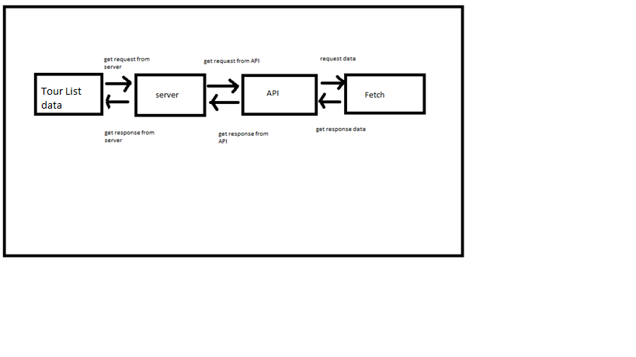

**Software Requirements**

* Operating System**:** Windows XP
* Compiler: Visual studio code
* CMD(command prompt)

**Hardware Requirements**

* Hard Disk – 2 GB.
* RAM – 1 Gaga Byte.
* Processor – Dual Core or Above.
* Mouse
* Keyboard
* Monitor
* CD Drive