Accessible  
bar graphs

In html and CSS

Adina Halter

Sr. Product Manager, Accessibility

Comcast

Problem

TABLES VS GRAPHED TABLE DATA

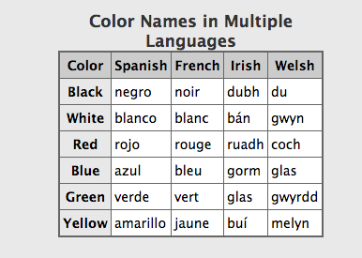 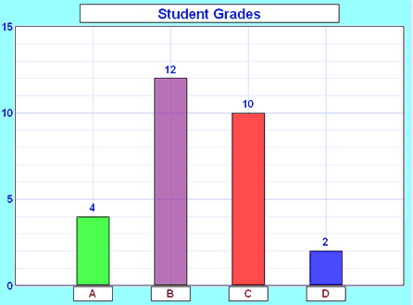

**Slide notes:**

(Well-formed) tables triangulate headings in screen readers

Bar charts without table relationships:

This example reads *”Student Grades, 15, 10, 5, 0, 4, 12, 10, 2, A, B, C, D*”. How many students got a grade of B?

GRAPHS ARE VISUAL

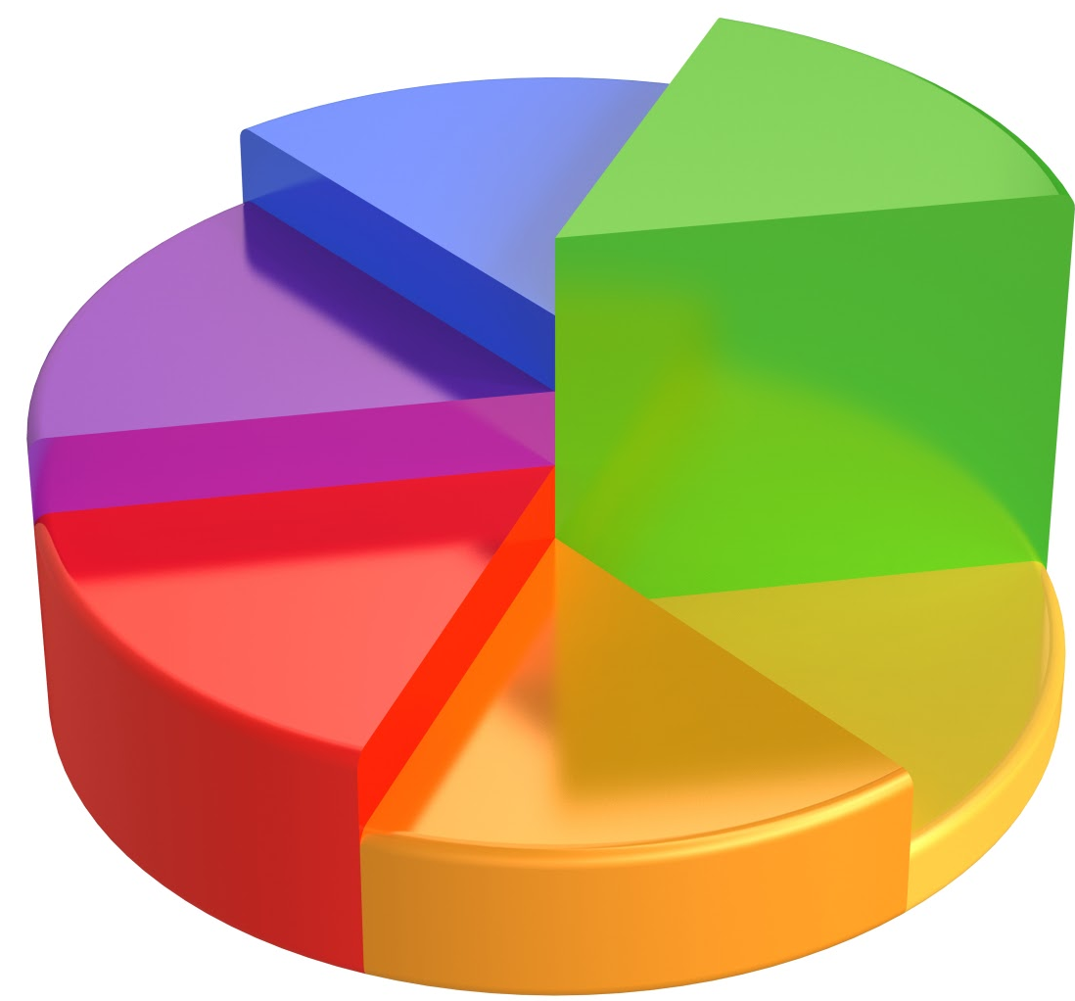

**Slide Notes:**

Graphs can be beautiful works of visual art.

But often the more beautiful they are the more chance they will be an image without text reference to what they represent.TABLES ARE BORING…

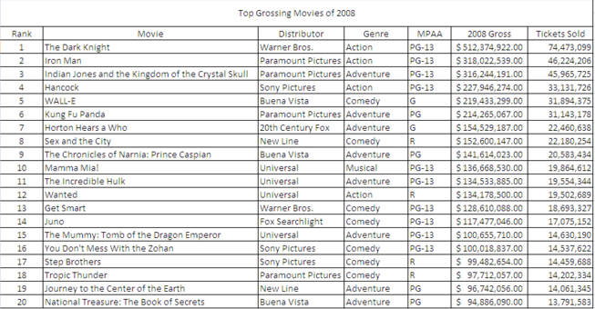

**Slide Notes:**

On the flip side, tables are visually BORING……EVEN WHEN YOU ADD COLOR

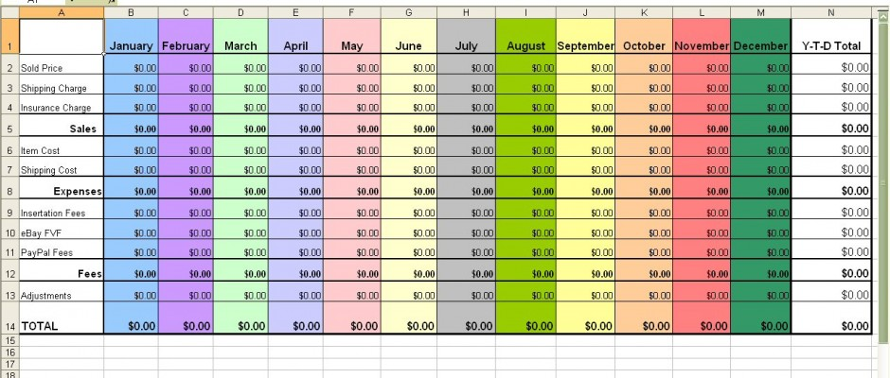

Current Methods

IMAGE WITH DESCRIPTION

* Triangulate data?
* Descriptive?
* Maintenance

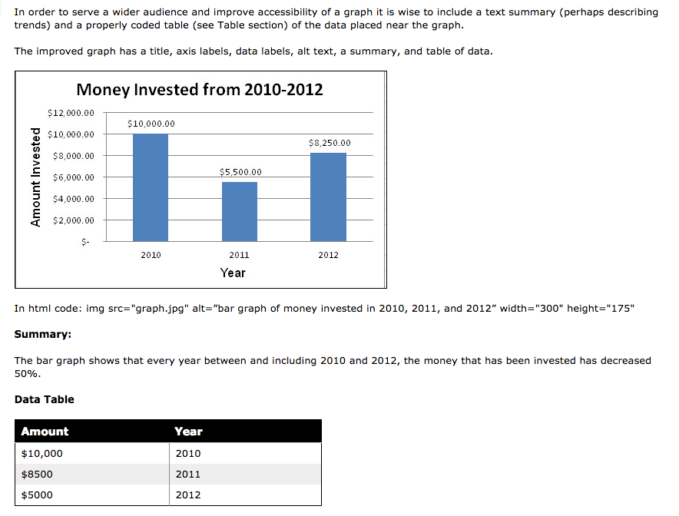

**Slide notes:**

* Will not be able to triangulate the data
* Often not descriptive enough
* Need to rewrite as data changes
* This bar graph image has an alt tag: “bar graph of money invested in 2010, 2011 and 2012”. Not very descriptive.
* The summary attribute says “The bar graph shows that every year between and including 2010 and 2012, the money that has been invested has decreased 50%.
* Again: not very descriptive AND Inaccurate. No one took the time to rewrite the summary when the data changed.GRAPH + TABLE
* 2X code
* 2X real-estate

**Slide notes:**

* Twice as much code to maintain per graph
* Double the real estate

JAVASCRIPT PLUGINS

* Milliseconds count
* JSON data?
* Accessible?
* Support?

**Slide notes:**

* Increased download time
* Data may need to be translated to JSON (loses the relationship)
* Rendering doesn’t mean accessibility
* Is plugin support maintained through lifecycle?

Our Solution

OUR SOLUTION

* HTML
* CSS
* No JS
* It’s only a table!!

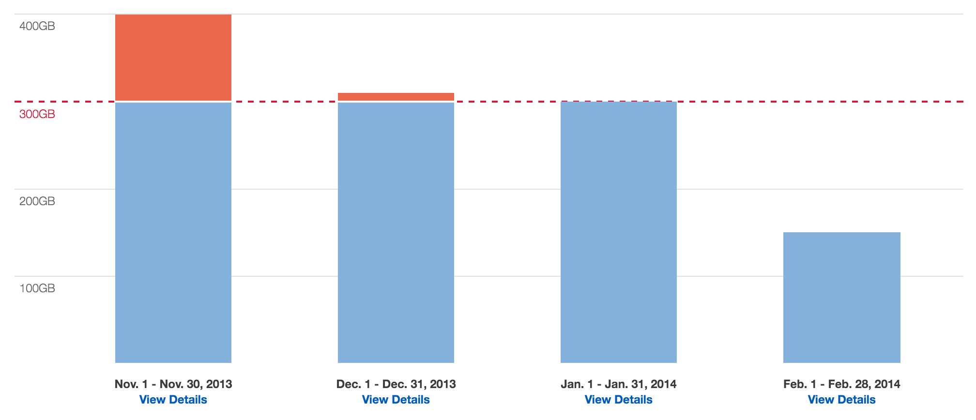

SOLUTION EXAMPLE

http://haltersweb.github.io/accessibility/barchart.html

STUMBLING BLOCKS

* <thead>
* <tfoot>

**Slide notes:**

* How to place thead as labels below data
* Tfoot is not supported in screen readers

Resources

LINKS AND CONTACT INFO

Helpful links:

* Link to solution: http://haltersweb.github.io/Accessibility/barchart.html
* Link to powerpoint slides: http://haltersweb.github.io/Accessibility/slides/barchart.pptx
* Link to word version of slides: http://haltersweb.github.io/Accessibility/slides/barchart.docx

Adina Halter:

* Email: adina_halter@cable.comcast.com
* Twitter: @haltersweb

