Abstract

Adders are of fundamental importance in a wide variety of digital systems. Many fast adders exist, but adding fast using low area and power is still challenging. This paper presents a new bit block structure that computes propagate signals called “carry strength” in a ripple fashion. Several new adders based on the new bit block structure are proposed. Comparison with well-known conventional adders demonstrates that the usage of carry-strength signals allows high-speed adders to be realised at significantly lower cost and consuming lower power than previously possible.

Introduction.
The importance of a fast, low-cost binary adder in a digital system is difficult to overestimate. Not only are adders used in every arithmetic operation, they are also needed for computing the physical address in virtually every memory fetch operation in most modern CPUs. Adders are also used in many other digital systems including telecommunications systems in places where a full-fledged CPU would be superfluous. Many styles of adders exist. Ripple adders are the smallest but also the slowest. More recently, carry-skip adders [1, 2, 3] are gaining popularity due to their high speed and relatively small size. Normally, in an N-bit carry-skip adder divided into a proper number of M-bit blocks [1, 4], a long-range carry signal starts at a generic block B_{i}, rippling through some bits in that block, then skips some blocks, and ends in a block B_{j}. If the carry does not end at the LSB of B_{j} then rippling occurs in that block and an additional delay is needed to compute the valid sum bits. Carry-look-ahead and carry-select adders [1] are very fast but far larger and consume much more power than ripple or carry-skip adders. Two of the fastest known addition circuits are the Lynch-Swartzlander’s [5] and Kantabutra’s [6] hybrid carry-look-ahead adders. They are based on the usage of a carry tree that produces carries into appropriate bit positions without back propagation. In order to obtain the valid sum bits as soon as possible, in both Lynch-Swartzlander’s and Kantabutra’s adders the sum bits are computed by means of carry-select blocks, which are able to perform their operations in parallel with the carry-tree.

This paper presents two new families of adders, both based on a new bit block structure that computes propagate signals called “carry-strength” in a ripple fashion. The first family of adders is a family of new carry-skip adders that are significantly faster than traditional carry-skip adders while not much larger. The second family of adders is a family of hybrid lookahead adders similar to those presented in [5, 6] but significantly smaller and still comparable in speed.

In our new type of carry-skip adder, the new block structure eliminates the delay due to the rippling at the end of the life of a long-range carry signal. The main idea is, that for each bit position k in a block B_{j} we compute whether the carry-in to position k comes from the carry-in to block B_{j}, or whether this carry is internally generated in block B_{j}. To this purpose we will use a new type of bit block, in which we will compute propagate signals that start at the LSB of the block and end at every bit position. We find it helpful to call the complements of these “carry-strength” signals, because they indicate for each bit position whether the carry-in to that position originates within the same bit block.

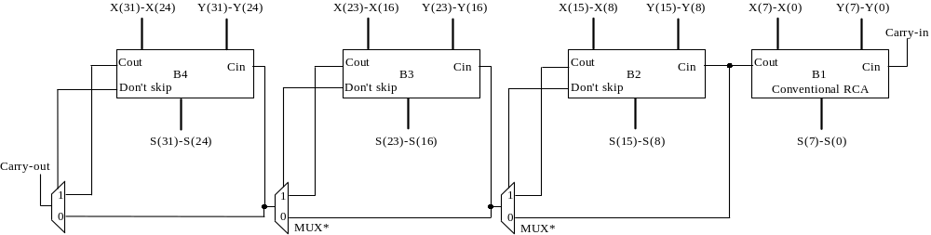

Figure 1. N-bit one-level carry-skip adder.

As mentioned above we will also show that carry-strength signals can also be successfully used in hybrid carry-look-ahead adders. The same principle described above for the carry-skip addition mechanism is applied to bit blocks to replace the larger blocks designed for Lynch-Swartzlander’s and Kantabutra’s adders. These new bit blocks allow us to avoid carry-select stages, saving significant area and power with little speed loss.

In Section 2, the meaning of the carry-strength signals and their computation are detailed. Then the new bit blocks for carry-skip and hybrid carry-look-ahead adders, as well as complete adders of these types, are presented in Sections 3 and 4, respectively. Section 5 discusses an optimisation procedure for bit block sizes and compares an optimised carry-skip adder of our type with a related design called the Carry-Increment Adder (CIA) (arrived at independently using a very different approach) by Zimmermann and Kaeslin [7], extending the work of Tyagi [8]. In these papers the authors found a way to reduce the redundancy in carry-select adders, and came up with adders that are minimally slower than regular carry-select adders, requiring significantly less space. Interestingly enough, our blocks do have similarity to theirs, even though the two kinds of blocks were designed from very different points of view. Our adders are faster and require less silicon area.

Section 6 contains all the simulation results. The new bit blocks have been used in a 32-bit carry-skip adder and a 32-bit hybrid carry-look-ahead adder realised in AMS 0.6μm CMOS standard cells. In order to compare the new addition circuits to existing ones, several conventional adders have been also realised using the same technology. The new carry-skip adder has shown a speed of only 5% lower than a traditional carry-look-ahead adder, taking only 59% of the layout area and consuming only 58% of the power. Surprisingly the new hybrid carry-look-ahead adder shows a slight speed advantage with respect to the Lynch-Swartzlander’s scheme (also realised using the AMS 0.6μm CMOS standard cells library), while taking only 76% of the layout area and consuming only 67% of the power.

- II. Carry-skip addition and carry strength signals.
The main observation that led to the carry-skip adder is that, any bit position where the two operand bits differ will propagate its carry in. That is, if x_{i} and y_{i} are the two operand bits, c_{i} the carry in and c_{i+1} the carry out, then x_{i} ≠ y_{i} implies c_{i+1}=c_{i}. For the sake of simplicity, let us assume that as shown in Figure 1 an N-bit one-level carry-skip adder is divided into N/M equal-length blocks (B₁,....,B_{N/M}), each of which contains M bits [1,4]. (Our ideas are used even when the block sizes are unequal in order to optimise speed, as shown in Section V). Moreover, let’s X and Y be the two N-bit operands of the adder. Any block in which all the positions i have unequal operands (x_{i} ≠ y_{i}) will propagate the carry into the block. That is, all the carries inside the block as well as the carry out of the block are going to be the same as the carry into the block. We will call a block with this property a skip block.

Normally a long-range carry signal starts at a block B_{i}, rippling through some bits in that block, then skips some blocks, and ends in a block B_{j}. If the carry does not end at the LSB of B_{j} then rippling occurs in that block. The worst case delay occurs when i=1, j=N/M, the carry signal starts at the LSB of B_{i} and ends at the MSB of B_{j}. In such a scenario rippling occurs through (M-1)-bit positions of B_{j}. In order to eliminate the delay due to this rippling, we define the carry-strength (CS) signal for each bit position in an M-bit block as follows:
if k is the LSB of the block then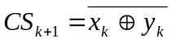, otherwise 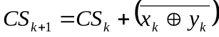.

In other words, for bit position k that is not the LSB of a block of bits, the incoming carry-strength CS_{k} is high if and only if the carry into the same position (C_{k}) is independent of the carry-in of the block containing that bit position. In case CS_{k}=1, we also say that the carry-in C_{k} is strong. Otherwise C_{k} is weak. Carry-strength signals are useful in a block in which a long-range carry signal ends. To demonstrate the usefulness of carry-strength signals, let us consider the following two

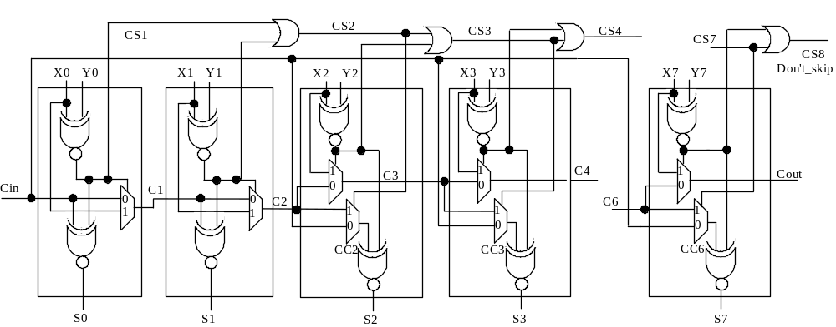

Figure 2. The new 8-bit block for carry-skip adders.

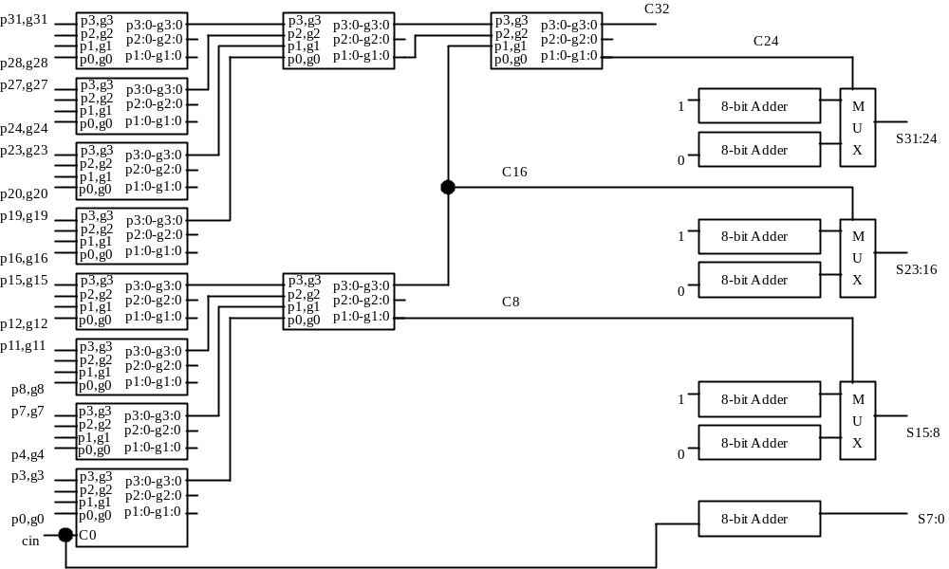

Figure 3. The carry tree of the 32-bit Lynch-Swartzlander’s adder.

complementary cases. If CS_{k}=0, that is, the carry is weak, it is easy to verify that C_{k} corresponds to the block carry-in. Thus, we can just select C_{k} to be the same as the block carry-in, eliminating the delay due to rippling. On the other hand, if CS_{k}=1, then C_{k} is independent of the carry-in, and is therefore known quickly. (In other words the computation of C_{k} starts as soon as the adder’s operands appear, without waiting for an incoming block carry-in). For these reasons, the existence of carry-strength signals trivialises the delay in the ending block of a long-range carry signal, provided that the block carry-in is fed into a large enough buffer. Carry-strength signals can be easily computed in a ripple fashion implementing the above recursive definition. However, the latter rippling starts right when the operand are ready, not having to wait for the carry-in signal.

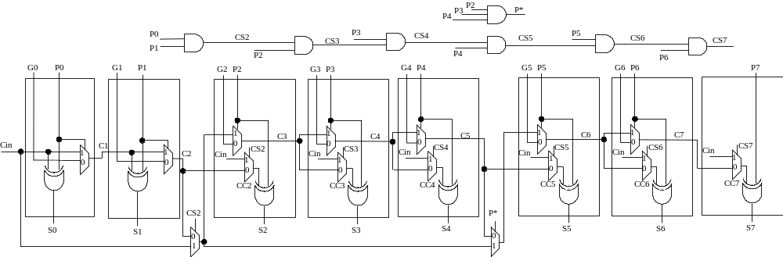 Figure 4. The 8-bit block for our version of Lynch-Swartzlander-style adder.

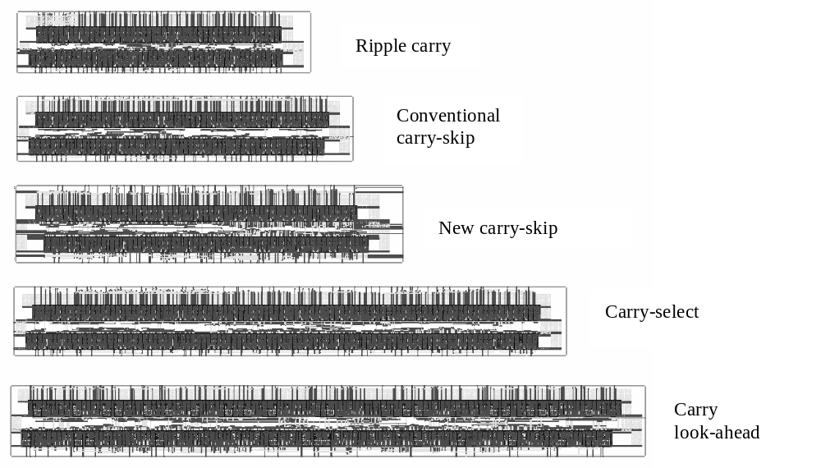

Figure 5. Layouts of the adders of section III.

For this reason, their computation does not influence the critical path. It is worth pointing out that the carry-strength signal of the MSB position in a block (CS_{M}) indicates whether that block can be skipped. Thus, no additional circuitry is required to compute that event.

III. A new eight-bit block for carry-skip adders.
The new 8-bit block for carry-skip adders is depicted in Figure 2. It can be seen that it has been designed to exploit the carry-strength signals without increasing the delay of the block when the carry is internally generated. In fact, the carry propagation path is unchanged with respect to that of a conventional ripple-carry adder and totally new signals are formed to compute sum bits. These new signals (namely CC_{i}) exploit in the best manner the parallelism allowed by the carry-strength signals (CS2,...,CS7). In fact, even though a long-range weak carry will ripple through the carry propagation path (i.e. C1, C2, C3, ... C6) the sum bits will always be valid after just τ_{MUX}+τ_{XNOR} from the time at which the carry arrives to the block. On the other hand, if the k-th FA receives a strong carry-in, produced in the LSB of the block calculates the carry-out after a delay τ_{XNOR}+(k+1)*τ_{MUX} and the sum bit after a delay 2*τ_{XNOR} +(k+1)*τ_{MUX} from the time at which the operands arrive.

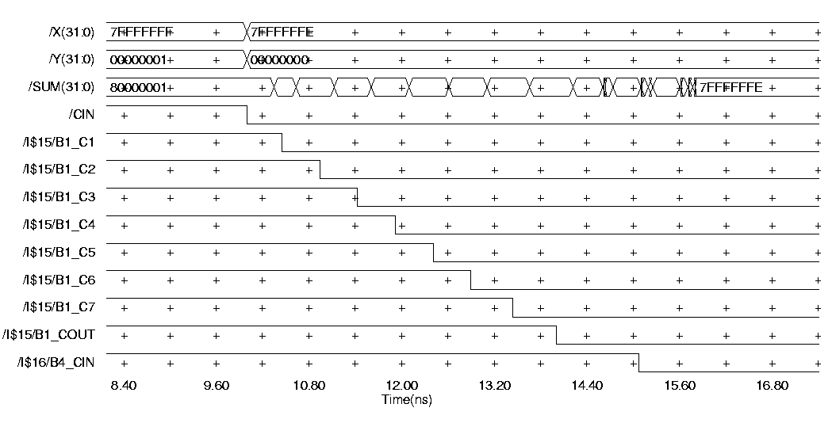

Figure 6. Gate level simulation results: worst operating transition for the new carry-skip adder.

IV. Introduction of modules based on carry strengths in the Lynch-Swartzlander adder.
Lynch-Swartzlander’s [5] and Kantabutra’s [6] hybrid carry-look-ahead adders are two of the fastest known adders whose area requirements are high because of the usage of carry select stages. Using carry select stages implies a duplication of the sum computation circuitry and the use of a large number of multiplexers. As shown in Figure 3, the carry tree of the 32-bit version of the Lynch-Swartzlander’s adder uses 4-bit lookahead generators (CLAG) to generate the carries into bit positions 8, 16, 24 and 32. The sum bits are obtained by means of 8-bit carry-select blocks, which perform their operations in parallel with the carry tree. The carries generated by the tree are then used to select the valid 8-bit sum words.

The same principle is applied to the Kantabutra’s adder, which reaches higher speed performance due to a non-uniform carry-tree and recursive structure. Also the Kantabutra’s adder generate the sum bits by means of carry-select stages. Thus in both these hybrid carry-look-ahead adders the delay introduced by the sum computation circuitry from the time in which the carry tree ends its computation is just 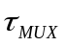.

We investigate the possibility of using non-duplicate stages to obtain sum bits. These stages could be realised as carry-skip adders, which use the carry-strength logic. Since the blocks we are planning to use must work in parallel with the carry tree, we must make sure that when a carry is generated in such blocks, the blocks will complete their computations during the time in which the tree performs carries calculations.

The 8-bit block shown in Figure 4 has been designed specifically for our version of Lynch-Swartzlander-style adder. The signals P0,...,P7 and G0, ..., G6, correspond to the propagate and generate terms, respectively.

The new block is organised as a carry-skip adder using carry-strength signals (CS2,...,CS7). It contributes to the global delay with 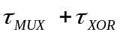 when a weak carry-in (generated by the carry tree) dies in that block. On the other hand, when a carry is internally generated the worst case delay of such block is 7*. Thus its worst-case delay is not greater than that shown by a carry-select 8-bit block.

V. Optimisation of Bit Block Lengths
The bit block lengths can be optimised using a procedure adapted from that which was presented by Kantabutra [2]. We will only describe it roughly here. The procedure starts off by finding the largest MSB m-

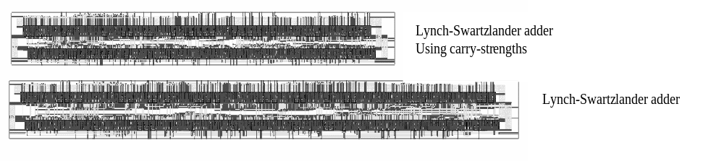

Fi gure 7. Layouts of the Lynch-Swartzlander style adders.

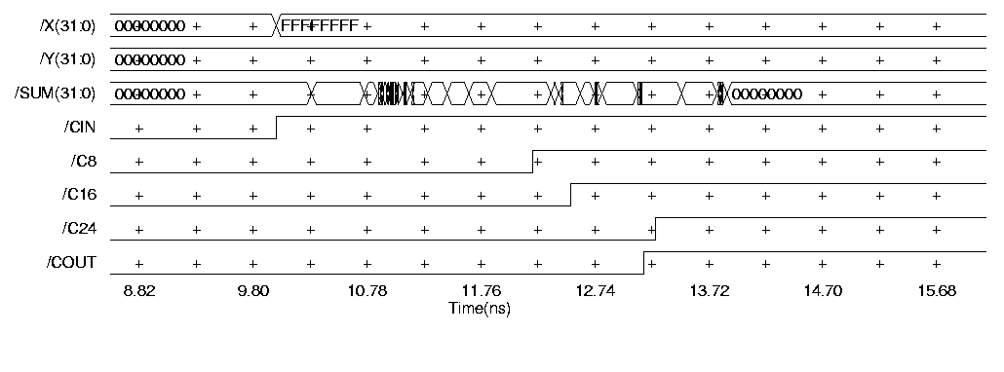

Figure 8. Gate level simulation results: worst operating transition for the new spanning tree adder.

bit block such that its delay generated from the least significant bit of this block and terminated at the MSB

of the same block is no more than some figure d, which we try to minimise. Then, the procedure must add less significant blocks to the left of the first one without making the worst case delay path longer than d. To this end, we must take into account the fact that a carry generated in such less significant blocks will terminate (in the worst case) in a more significant block, increasing its delay by just 1 MUX.

Using this optimisation procedure gave rise to the following block sizes for a 32-bit adder: 2-4-5-6-7-8, with the largest block on the MSB side. The delay, area, and power are reported in the next section along with all the other simulation results.

VI. Results.
The new 8-bit block described in Section 3 has been used realising a new carry-skip adder. It has been compared to a conventional ripple-carry, a BCLA (implemented using 4-bit CLA blocks and two levels of look-ahead-carry generator [4]), a conventional carry-skip, and a carry-select adder (carried out by means of 4 8-bit blocks). All the above adders have been realised using Austria Mikro Systeme p-sub, 2-metal, 1-poly, 5 V, 0.6μm CMOS process (CUB process) and have been implemented for 32-bit wide operands. Their layouts have been obtained using Mentor Graphics tools and the same level of optimisation has been used for each one. In Figure 5, the obtained layouts are depicted.

Gate-level and transistor-level (using BSIM3v3 device models at 27°C) simulations have been performed.
Worst-case delays have been identified considering the worst transition on operands inputs. This implies the asymmetric behaviour of logic gates being taken into account. As an example, note that the analysed adders for the operand transition 7FFFFFFF+00000001+1 -> 7FFFFFFE+00000000+0 shows a delay slightly greater than the transition 00000000+00000000+0 -> 7FFFFFFF+00000001+0, which corresponds to an opposite carry transition.

Power measurements have been carried out for the operand transition which appears to produce the maximum number of gates switching (FFFFFFFF+ FFFFFFFF +0 -> FFFFFFFF +00000000+0), assuming a 40-MHz repetitive frequency.

In Figure 6, gate level simulation results showing the low carry propagation through the critical path of the new carry-skip adder are reported. It can be seen that normal rippling occurs in block B₁. Then, the travelling carry reaches block B₄. There, each full-adder receives a weak carry-in. Thus, B₄ computes sum bits in just 860ps, avoiding the need of rippling.

Post-layout simulation results summarised in Table 1 demonstrate that the new adder has a performance comparable to that of the BCLA, while its area requirement and power consumption are similar to that of a conventional carry-skip adder.

32-bit adders | Area [μm²] | Delay [ns] | Max Power [mW]
Ripple-Carry | 137700 | 15.8 | 15.8
Carry-skip | 160173 | 9 | 17.1
Newest Implementation | 181944 | 5.8 | 21
Carry-Select | 264966 | 5.9 | 26
BCLA | 310168 | 5.5 | 36.4
Table 1. Performances and costs comparison.

The new 8-bit block described in Section 4 has been used to realise a 32-bit hybrid carry-look-ahead adder and it has been compared to the 32-bit version of the Lynch-Swartzlander’s adder. Both circuits have been carried-out using the above-mentioned technology and their layouts are depicted in Figure 7.

In Figure 8, gate level simulation results related to the new hybrid adder are reported. Note that sum bits are computed just 700ps later than C₂₄. Post-layout simulation results summarised in Table 2 show that the new implementation allows power dissipation and area to be significantly reduced without compromising speed.

It is worth pointing out that under the crude gate-counting delay model the new hybrid carry-look-ahead adder was expected to be slower than the conventional one by about τ_{XOR}. However, post-layout simulations have shown that the new adder is in fact slightly faster than the original! This is due to the lower loads on the carry signals produced by the carry tree in the new implementation. In fact in the new adder the above lines are loaded by the input I1 of eight multiplexers (25fF×8), while in the Lynch-Swartzlander’s implementation they drive the selection input of eight multiplexers (45fF×8). Moreover, a reduction in net congestion leads more compact layout and shorter interconnection delays.

32-bit adders | Area [μm²] | Delay [ns] | Max Power [mW]
Lynch-Swartzlander | 419244 | 4.08 | 51
New implementation | 318550 | 3.88 | 34
Table 2. Performances and costs comparison.

Finally we turn our attention to the carry-skip adder with optimised block sizes introduced in Section V. Using the same 0.6 micron, 5V AMS standard cell technology as before, we report our result in Table 3:

Delay | 4.51ns
Area | 194766 μm²
MaxPower | 28 mW @ 40MHz
Table 3. Characteristics of the optimised carry-skip.

Table 4 shows a summary of Zimmermann’s study, using a 0.8-micron standard-cell process. The figures are normalised so that they are 1 for the ripple adder. Table 5 shows a summary of our study, likewise normalised. All results shown in these tables are for 32-bit adders.

32-Bit Adders | Area | Delay | Avg. Power
Ripple | 1 | 1 | 1
Carry-Skip | 1.3 | 0.45 | 1.13
Carry-Select | 1.8 | 0.36 | 1.72
Lookahead | 1.8 | 0.36 | 1.4
CIA-1Level | 1.48 | 0.37 | 1.24
CIA-2Level | 1.57 | 0.35 | 1.29
Table 4. Relative comparison obtained in [7].

32-Bit Adders | Area | Delay | Max Power
Ripple | 1 | 1 | 1
Carry-Skip | 1.16 | 0.57 | 1.08
Carry-Select | 1.92 | 0.37 | 1.65
Lookahead | 2.25 | 0.35 | 2.3
New, not opt. | 1.32 | 0.37 | 1.33
New, optimised | 1.41 | 0.28 | 1.78

Table 5. Our relative comparison results.

It can be seen that our new optimised adder outperforms both CIAs saving silicon area.

VII. Conclusions.
In this paper adders based on the carry-strength signals have been presented. Carry strength signals are the negation of propagate signals, but represented as functions of one variable (bit position) instead of two. Such clearer representation gave rise to an entirely new bit block structure that has been applied to two families of adders. In these new results we have, apparently for the first time since the carry itself, utilised a ripple signal that uses regular gate logic. We demonstrated here that our new principle allows reaching very high speed at a low cost. The new carry-skip adder implementation is only ∼5% slower than traditional BCLAs, while requiring much less silicon area and power dissipation. Significant reduction in silicon area and power has been also obtained in hybrid carry-look-ahead adders using the carry-strength signals without compromising speed. Finally, comparison with 1-level and 2-level carry-increment adders, though not direct, also gives favourable results.

VIII. References.
- Koren, I.: “Computer arithmetic algorithms”, Prentice-Hall, 1993
- Kantabutra, V.: “Designing optimum one-level carry-skip adders”, IEEE Trans. on Comp., 1993, Vol. 42, n°6, pp.759-764.
- Chan, P.K., Schlag, M.D.F., Thomborson, C.D., Oklobdzija, V.G.: “Delay optimization of carry-skip adders and block carry-look-ahead adders”, Proc. of Int’l Symposium on Computer Arithmetic,1991, pp.154-164.
- Nagendra, C., Irwin, M.J., Owens, R.M.: “Area-time-power tradeoffs in parallel adders”, IEEE Trans. CAS-II, 43, (10), pp. 689-702.
- T. Lynch, E.E. Swartzlander, “A spanning-tree carry-look-ahead adder”, IEEE Trans. on Comp., Vol. 41, n°8, Aug. 1992.
- V. Kantabutra, “A recursive carry-look-ahead/carry-select hybrid adder”, IEEE Trans. on Comp., Vol. 42, n°12, Dec. 1993.
- R. Zimmermann and H. Kaeslin, “Cell-Based multilevel Carry-Increment Adders with Minimal AT- and PT-Products, unpublished manuscript. http://www.iis.ee.ethz.ch/~zimmi/
- A. Tyagi, “ A reduced-area scheme for carry-select adders” IEEE Trans. on Comp., Vol. 42, n°10, Oct. 1993.

IX. Biographies

Vitit Kantabutra was born in Bangkok, Thailand in 1958, and graduated from the Demonstration School of the Srinakharinwirot University, Patumwan in 1975. He graduated with Bachelor’s Degree in Electrical Engineering, Honours Program at McGill University, Canada in 1979, and a Ph.D. in Electrical Engineering

Engineering and Computer Science at The Johns Hopkins University, U.S.A., in 1985. He is currently an associate professor of computer science at Idaho State University, Pocatello, Idaho, U.S.A. He has numerous publications in international journals and conferences in the fields of computer algorithms, computational geometry, computer arithmetic circuits, and VLSI. He also holds U.S. patents on computer arithmetic circuits. Dr. Kantabutra is a senior member of the IEEE.

Pasquale Corsonello was born in 1964. He received his Masters degree in Electronics Engineering from the University of Naples, Italy, in 1988. He joined the Institute of Research on Parallel Computer System (IRSIP) of National Council of Research of Italy, working on the design and modeling

of electronic transducers for high precision measurement. Since 1992 he joined the Department of Electronics, Computer Sciences and Systems of the University of Calabria, where he was involved in application specific IC design. Currently he is assistant professor at the Department of Electronics Engineering and Applied Mathematics of the University of Reggio Calabria. His main research interests are in arithmetic circuit, reconfigurable computing and VLSI design. Prof. Corsonello is a member of the IEEE.

Stefania Perri was born in 1971. In 1996 she received her degree in Computer Science Engineering from the University of Calabria, Italy. Since 1996 she joined the Department of Electronics, Computer Sciences and Systems of the University of Calabria, where she is working towards the Ph.D. degree on Electronics Engineering.

Her current research interests include arithmetic circuit, reconfigurable computing and VLSI design.

 (1) College of Engineering Idaho State University, Pocatello, Idaho 83209, USA url: www.isu.edu/~kantviti e.mail: vkantabu@computer.org This author was supported in part by an Idaho State University Faculty Research Committee grant. (2) Department of Electronics Engineering and Applied Mathematics University of Reggio Calabria, Loc. Vito de Feo, url: www.ing.unirc.it/didattica/elettr01/index.html 89060 Reggio Calabria, ITALY e.mail: pascor@deis.unical.it (3) Department of Electronics, Computer Science and Systems University of Calabria, Arcavacata di Rende 87036 - Rende (CS), ITALY e.mail: perri@deis.unical.it

