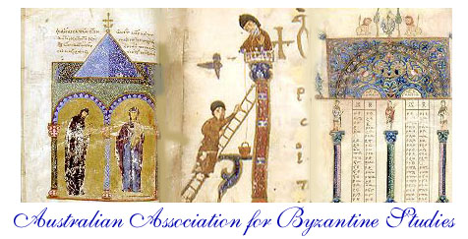

ABN 68 068 565 011

http://www.aabs.org.au

Notice of Meeting

The Biennial General Meeting of the Australian Association for Byzantine Studies will be held at the Monash University Law Chambers (555 Lonsdale St., Melbourne) on Saturday, February 25, 2017, commencing at 4 pm.

Agenda for the General Meeting

1. Apologies

2. Approval of the Minutes from the last General Meeting held in Brisbane, Nov. 30, 2014

3. Any business arising from the Minutes

4. Report of the President, Ken Parry

5. Report of the Treasurer, Andrew Stephenson

6. Report on Membership, Andrew Stephenson

7. Report on Website, Andrew Stephenson

8. Report of the Secretary, Amelia Brown

9. Report on Byzantine Australiensia, past and future

10. Election of nominated candidates to open positions: Treasurer, Books Manager, General Member

11. Selection of next biennial meeting and conference site and host(s)

12. Any General Business

