Macquarie University Conference
Thursday 6th- Friday 7th April 2017
Eastern Christianity and Late Antique Philosophy
Venue: Museum of Ancient Cultures, Building X5B

[Sponsors: The Ancient Cultures Research Centre
The Society for the Study of Early Christianity
The Department of Ancient History]

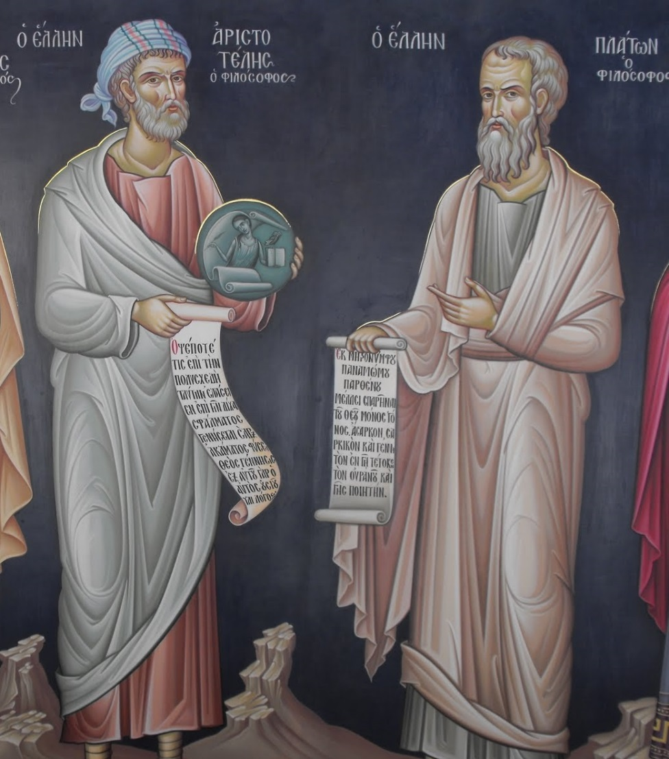
Aristotle and Plato: 17th c. wall painting, Great Meteoron Monastery, Greece
Convenor:
Ken Parry [Department of Ancient History]

Eastern Christianity and Late Antique Philosophy

Program
Thursday 6th April, 2017
09.15 – Welcome and Acknowledgement of Country, Dr Ken Parry
09.20 – Welcome by Dr Ian Plant, Head of Department, Ancient History
09.25 – The Ancient Cultures Research Centre, A/Prof Malcolm Choat
First Session: Chair - Dirk Baltzly
09.30 – 10.30 Ken Parry (Macquarie University):
Late Ancient Philosophy and Eastern Christianity: A Conspectus
10.30 – 11.00 Morning Tea
11.00 – 12.00 Christophe Erismann (University of Vienna):
Between Christology and Alexandrian Philosophy: Theodore of Raithu on Essence, Hypostasis and Logical Concepts
12.00 – 1.00 Bronwen Neil (Macquarie University):
Pagan and Christian Traditions of Dream Interpretation in Byzantium
1.00 – 2.00 Lunch
Second Session: Chair – Raoul Mortley
2.00 – 3.00 Dirk Baltzly (University of Tasmania):
Political Virtues and the Goal of Likeness to God in Proclus’ Republic Commentary
3.00 – 4.00 Meaghan McEvoy (Macquarie University):
Constantinopolitan Christian and Pagan Holy Men and the Imperial Court in the Fifth Century
4.00 – 4.30 Afternoon tea
4.30 – 5.30 Vassilis Adrahtas (University of New South Wales):
Translating Crisis into Logic: John Damascene’s Iconic Conceptualisation of History vis-à-vis Late Neoplatonic Symbolism
5.30 – First day finishes
6.15 Gather for walk (about 15 minutes) to The Mediterranean Restaurant at Marsfield for conference dinner (conference speakers only)

Eastern Christianity and Late Antique Philosophy

Program
Friday 7th April, 2017
Third Session: Chair – Bronwen Neil
09.15 – 10.15 Elvira Wakelnig (University of Vienna):
The Use of Late Antique Prolegomena by Christian Arabic Authors
10.15 - 10.45 Morning Tea
10.45 – 11.45 Michael Champion (Australian Catholic University):
Godlikeness and Ordering Knowledge in Early Christianity
11.45 – 12.45 Raoul Mortley (Bond University):
The Idea of Hope and Dionysius the Areopagite
12.45 – 1.30 Lunch
Fourth Session: Chair – Ken Parry
1.30 – 2.30 Han Baltussen (University of Adelaide):
Eunapius’ Lives: Pro-Pagan Hagiography or Anti-Christian Polemic?
2.30 – 3.30 Graeme Miles (University of Tasmania):
Summarising Platonic Education in Proclus’ Reading of Plato’s Cave
3.30 – 4.00 Afternoon Tea
4.00 – 5.00 Sergei Mariev (Ludwig Maximilian University, Munich):
Cardinal Bessarion as a Mediator between the Greek East and the Latin West
5.00 – Conferences finishes
…

The conference papers will be peer-reviewed together with additional invited papers, and published in the Texts and Studies in Eastern Christianity series with Brill, volume to be edited by Meaghan McEvoy and Ken Parry

Anyone interested in attending the conference should contact the convenor Dr Ken Parry: ken.parry@mq.edu.au

